

Examine examples of students writing samples.

Learn about the writing task

Study the writing samples: What information are you getting about students’ level of mastery of the tenses?

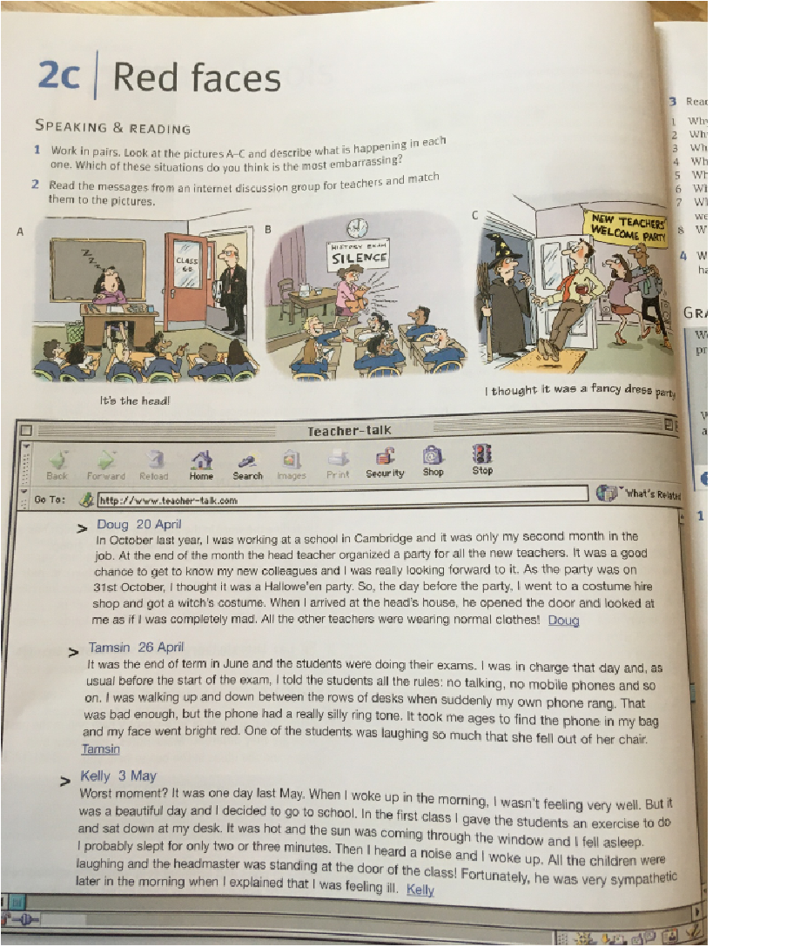

A. Read the article and match the texts with pictures A, B, C.
Doug 20 April picture C
Tamsin 26 April picture B
Kelly 3 May picture A

B. Read the text again and answer the questions.
1) Why did Doug´s head teacher organize a party?
2) Why was Doug looking forward to (těšit se) the party?
3) Why did he wear witch´s clothes?
4) Why was Tamsin in an examination room?
5) What was special aboutTamsin´s phone? She had a silly ring tone.
6) Why didn´t Tamsin turn off her phone immediately?
7) Why did Kelly decide to go to work when she wasn´t feeling well?
8) Why did Kelly wake up?

C. Write about a story from your past. (Napiš vyprávění – můžeš použít svůj pravdivý nebo smyšlený zážitek)
- Writeat least 40 words.
- In the story you must include at least twice past continuous.
- Nezapomeňte si zkontrolovat, že píšete v minulém čase a že jste alespoň dvakrát použili minulý čas průběhový (past continuous)
story 1
I think it was that day whenI knocked out my tooth on PE. Well i was running and i sort of had blackout of my mind i think? And i forgot to brake and hit the ladders. Every body was i think shocked and i was smiling. The next day whole school knew about it and i was super emberassed.

story 2
This is the story of how I did my first scooter trick. When I rode a scooter, I just jumped up and gave the trick and it was nothing more and nothing less. I was very happy. But I never did the trick for days.

story 3
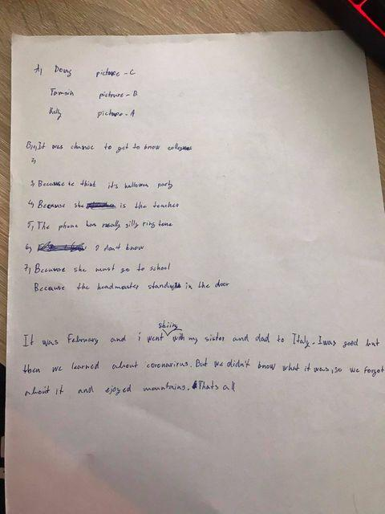

story 4
One morning on my way to school I was walking to the bus station. When I got on the bus I was using my Pilsen card to buy a ticket I saw a rabbit from the bus window. I was thinking if was my own rabbit I would call him Cheese. When I go to the bus I went straight to school and after I was telling my friend Marek about it..
story 5
One day, Kelly woke up and didn’t feel too good. But it was beautiful day she went to school.When she arrived she gave students an exercise and fell asleep. Suddenly she heard a voice and woke up the class was laughing. So she look around and saw headmaster standing in the door. But he took it calmly so she explained why she fell asleep.
She told him that she wasn’t feeling too well so he send her backhome to get some rest.

story 6

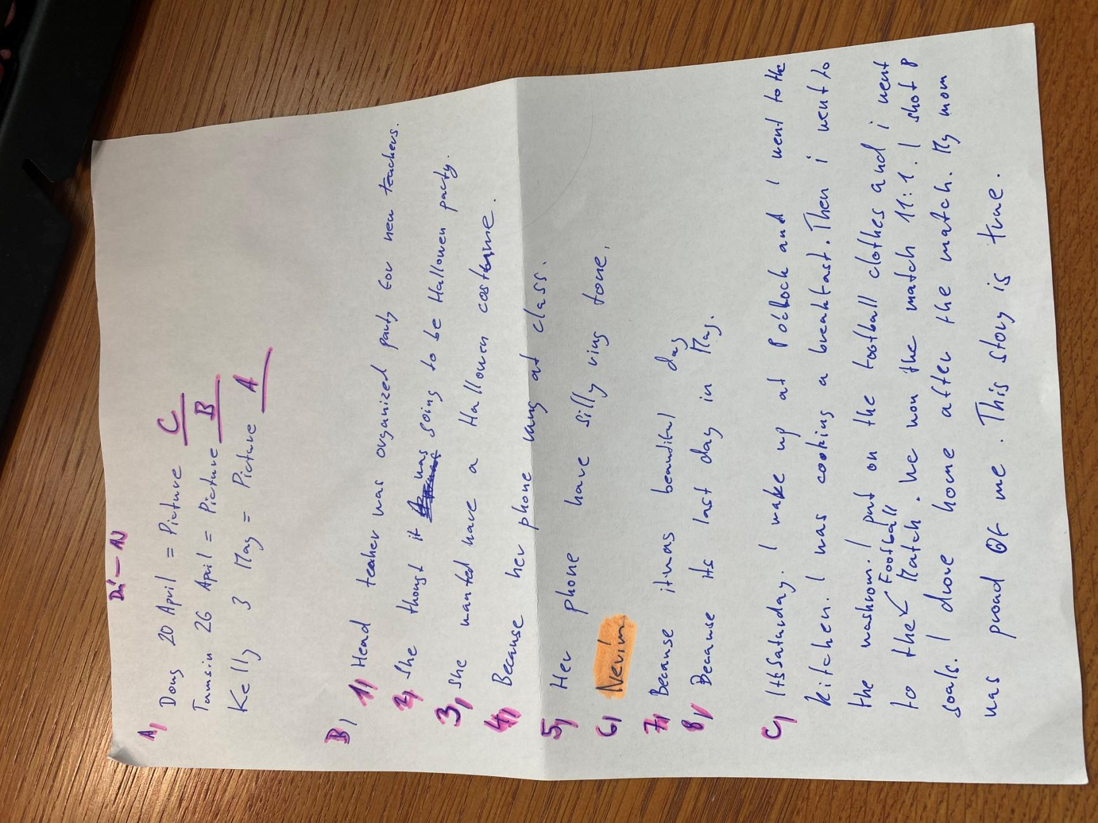

story 7

