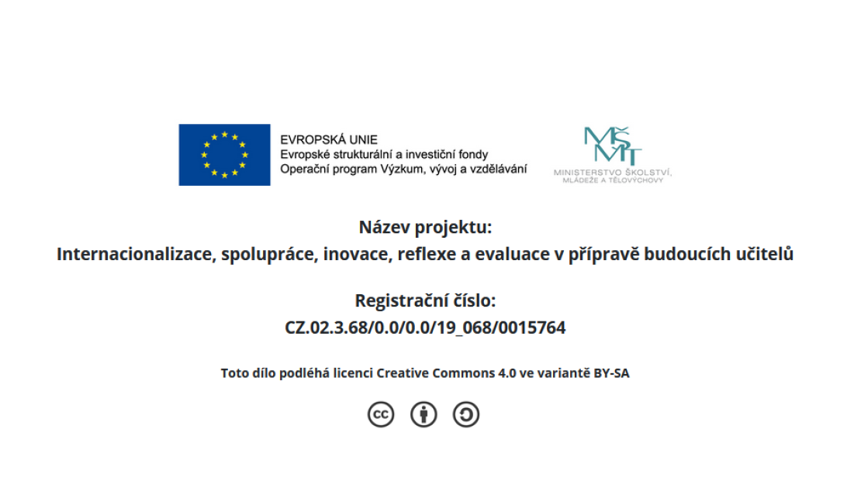
Task 1: Chat about formative assessment n pairs:
What should we keep in mind to support students’ learning?

Task 2: Review principles of formative assessment and share in groups of 4: what it is, how it is done, provide an example

- Clarifying, sharing, and understanding learning intentions and criteria for success – getting the students to really understand what their classroom experience will be and how their success will be measured.
- Engineering effective classroom discussions, activities, and learning tasks that elicit evidence of learning – developing effective classroom instructional strategies that allow for the measurement of success.
- Providing feedback that moves learning forward – working with students to provide them the information they need to better understand problems and solutions.
- Activating learners as instructional resources for one another – getting students involved with each other in discussions and working groups can help improve student learning.
- Activating learners as owners of their own learning

Task 3: Present a formative assessment strategy you have identified as useful in groups of 4

Task 4: Brainstorm in groups of 4 what you will consider in calculating the final mark and their relationship to the overall learning outcomes for your course. Draft an assessment plan.

