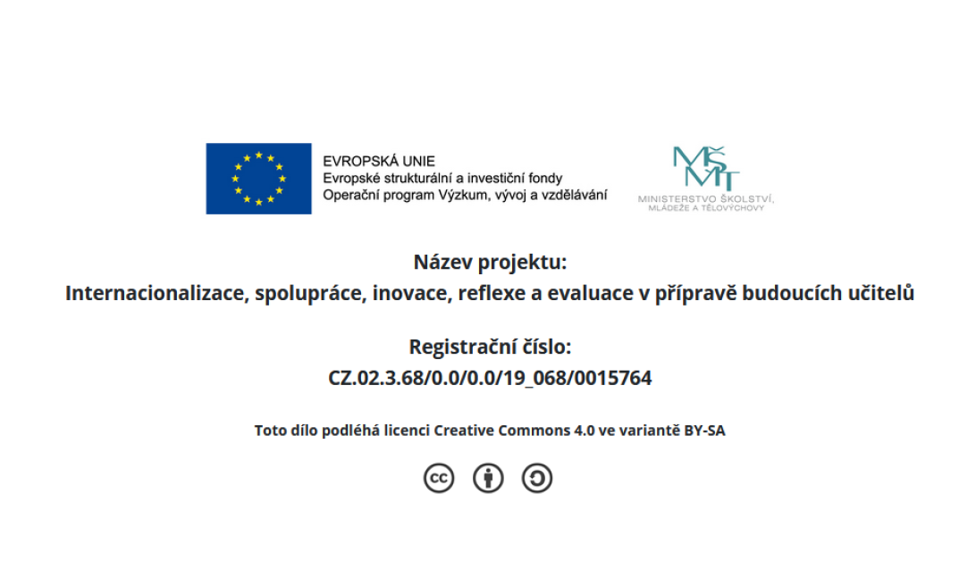

Name: _________________________
Vocabulary
1 Read. Complete the sentences with the words from the box.
children daughter husband is married to son wife

1 My uncle called his _______________ John.
2 How many _______________ have they got?
3 Her grandson _______________ my granddaughter.
4 Tony has been married three times. Rosa is his third _______________. 5 My mum’s second _______________ is my step-father.
6 They’ve got three children – two sons and a _______________.
(6 points)
2 Tick the correct option, a) or b).
1 a messy …
a) colour ✝ b) bedroom ✝ 2 a noisy …
a) animal ✝ b) book ✝ 3 a friendly …
a) cat ✝ b) flower ✝ 4 an annoying …
a) school ✝ b) girl ✝ 5 a funny …
a) person ✝ b) country ✝ 6 a mean …
a) tooth ✝ b) child ✝ (6 points)
Copyright © National Geographic Learning. 1 Permission granted to photocopy for classroom. Impact Foundation Level Unit 1 Test
Grammar
3 Complete the sentences with the correct present simple form of the verb to be.
1 My grandparents _______________ very kind to me.
2 My step-father _______________ an engineer.
3 _______________ they your children?
4 I _______________ ten years old.
5 _______________ you in my class at school?
6 I don’t like that boy because he _______________ mean.
(6 points)
4 Circle the correct option.
1 Have / Has you got any brothers?
2 They hasn’t / haven’t got your phone number.
3 He isn’t going to France because he has / hasn’t got a passport.
4 Has / Have we got a packed lunch today?
5 We have / haven’t got any pets.
6 I has / have got three sisters.
(6 points)
5 Complete the dialogue with the words or phrases from the box.
a any is isn't some ’ve got

Jin: Have we got (1) _________________ eggs, Mum?
Mum: Yes, we (2) _________________ six. What for?
Jin: I want to make (3) _________________ cake.
Mum: Oh, OK. You need (4) _________________ sugar and butter, too. Jin: Oh dear. There (5) _________________ any sugar.
Mum: Yes, there (6) _________________. It’s here!
Jin: Great. Thank you.
(6 points)
Copyright © National Geographic Learning. 2 Permission granted to photocopy for classroom. Impact Foundation Level Unit 1 Test
Reading
6 Read. Then answer the questions.
School lunches around the world
Hyun lives in South Korea. She loves her school lunches. She usually eats a small bowl of fish soup, then some rice with tofu and lots of fresh vegetables such as broccoli, cabbage and peppers.
Miguel is from Brazil. He, too, enjoys his lunch at school. He eats rice with black beans, pork and vegetables and mixed salad. He sometimes has baked fruit for pudding.
Ricardo lives in Arezzo in Italy. His school lunches are healthy and delicious. He often eats fresh fish and vegetables, pasta with tomato sauce, a fresh salad and fruit. He sometimes eats some freshly made bread, too.
Lunches in Finland are often colourful. Matti enjoys green pea soup, carrot and beetroot salad, freshly baked bread and a sweet pancake with fresh berries.
1 Who lives in South Korea? _______
2 Who lives in Italy? _______
3 Who sometimes eats baked fruit for pudding? _______
4 Who often has some pasta with their lunch? _______
5 Who often has soup for lunch? _______ and _______ 6 Does everyone eat vegetables for lunch? _______
(7 points)
Writing
7 Read the sentences. Complete them using either and or but.
1 My brother is noisy, _________________ my sister is very quiet.
2 He’s got four sisters _________________ one brother.
3 My step-father is funny _________________ he’s really good at telling jokes. 4 My grandmother hasn’t got any grandsons, _________________ she’s got four granddaughters.
5 My sister is very good at swimming, _________________ I’m not. 6 I’m interested in travelling _________________ taking photos.
(6 points)
Copyright © National Geographic Learning. 3 Permission granted to photocopy for classroom. Impact Foundation Level Unit 1 Test

