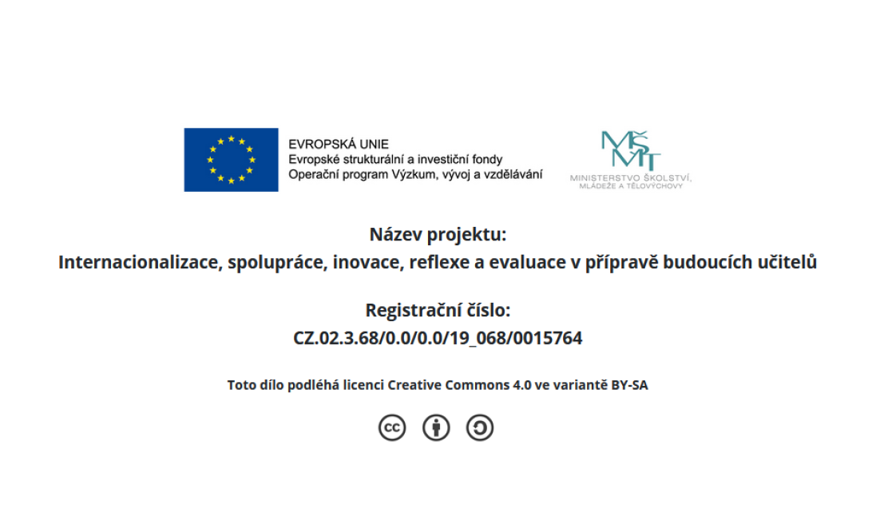

Task:
- Examine the work sample and think of feedback you would give to the student.
- Share in groups of 3 and agree on your feedback.

Writing task: Write a narrative about your summer vacation. Use adjectives to add detail to your descriptions. Write clear and simple sentences and organize your ideas chronologically.

