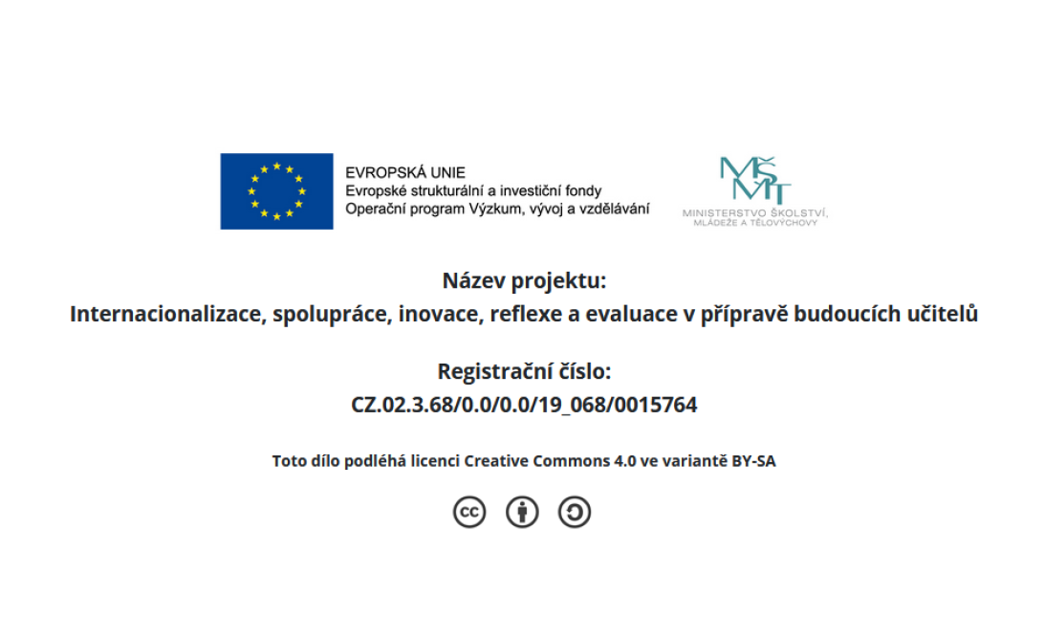
Source: Brown, H.D. (2004). Language assessment: Principles and classroom practices. White Plains, NY: Pearson Education.

Assessing Speaking
Imitative speaking  Simple phonological imitation | - Word/phrase repetition task
Intensive speaking  Short bits of discourse/sentence level | - Direct response tasks (i.e. tell me that you like rock music)  - Read aloud tasks  - Sentence/dialogue completion tasks and oral questionnaires  - Picture cued tasks (i.e. use a comparative form to compare the objects in the picture, follow the map and give me directions to the bank)
Responsive speaking  Brief interactions | - Question and answer  - Giving instructions and directions  - Paraphrasing
Interactive speaking  Longer pieces of discourse - interaction | - Interview  - Role play  - Discussion and conversations  - Games
Extensive speaking  Longer pieces of discourse – limited interaction | - Oral presentations  - Picture-cued story-telling  - Retelling a story, news event

Assessing Listening
Intensive listening  (phonemes, words, intonation etc.) | - Recognizing phonological and morphological elements  - Paraphrase recognition (choosing a correct paraphrase)
Responsive listening  (short sample) | - Question/answer format
Selective listening | - Listening cloze  - Information transfer (i.e. hear a daily schedule – fill in calendar)
Extensive listening | - Dictation  - Communicative stimulus-response task (i.e. questions about extensive listening)  - Authentic listening tasks (i.e. note taking)

Assessing Reading
Perceptive reading  (bottom-up/recognition ) | - Reading aloud  - Picture-cued items (i.e. point to the part of the picture that you read about here, match words with pictures)
Selective reading | - MC (i.e. vocabulary/grammar tasks)  - Matching tasks (i.e. filling in using word bank)  - Editing tasks (i.e. editing inappropriate word/phrase)  - Picture-cued tasks (i.e. identifying pictures based on text)  - Gap-filling tasks
Interactive reading | - Cloze tasks  - Reading + comprehension questions  - Short answer tasks  - Editing longer texts (i.e. inappropriate sentences)  - Scanning (i.e. locating info in the text)  - Ordering tasks  - Information transfer – reading charts, maps, graphs, diagrams
Extensive reading | - Skimming tasks (often questions/answers)  - Summarizing and responding  - Note-taking and outlining

Assessing Writing
Imitative writing  Words, very brief sentences | - Tasks in writing letters, words, punctuation  - Copying  - Listening cloze selection tasks  - Picture-cued tasks  - Form completion tasks  - Converting number and abbreviations into words
- Spelling tasks and detecting phoneme-grapheme correspondences
  - Spelling tests
  - Picture-cued tasks
  - MC techniques
Intensive (controlled, form focused) writing  Sentences | - Dictation  - Grammatical transformation tasks (i.e. change the tenses, combine two sentences)  - Picture-cued tasks (i.e. describe, sequence and describe)  - Ordering tasks (i.e. reordering words in a sentence)  - Short-answer and sentence completion tasks
Responsive writing  Limited discourse | - Paraphrasing  - Guided question and answer  - Paragraph construction tasks
Extensive writing
Larger text/essay

