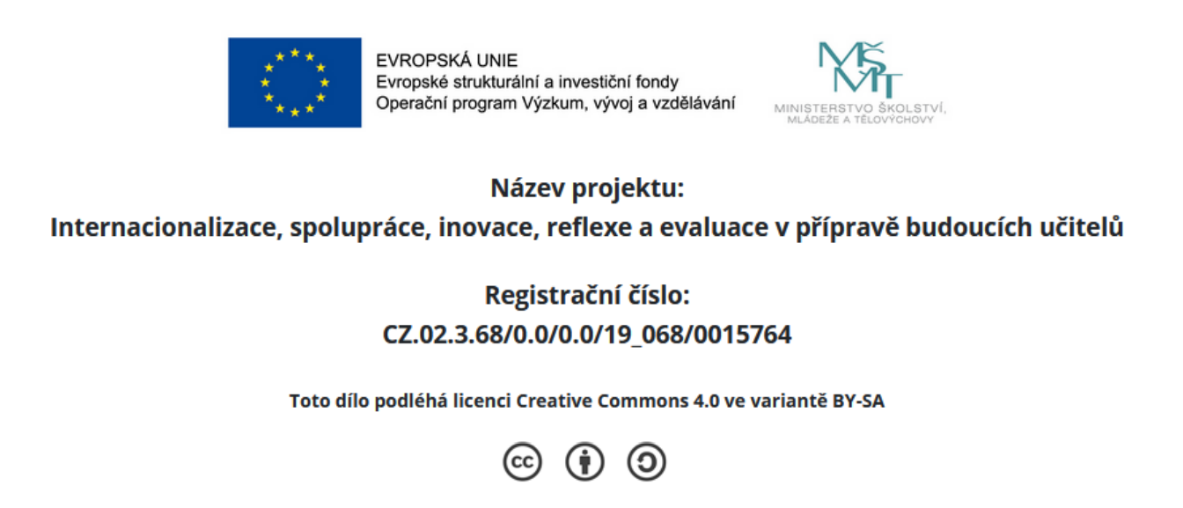

Tasks in Class 1

Task 1 - Walking interview
write a question that you would like to ask your peers about the teaching practice
walk around stop and ask the question – collect data
Report to the class – is there any information that makes you arrive at certain conclusions?

Task 2 – Teaching practice
Complete the questions based on your teaching practice experience
Complete the questions/share in groups – summary of the experiences

Task 3 – Effective language classes
Work in a group and answer this question:
What should we find in a class that results in language knowledge and skills?

