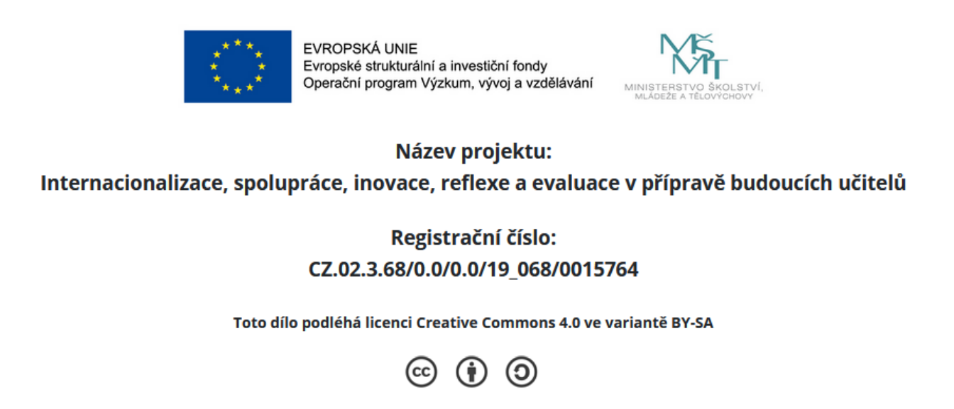

Reflect on your teaching practice and respond to the following prompts:

- Write one thing you would change about the Czech school and explain why:

- What is your favourite language skill to teach?

- What was your useful teaching tool?

- Describe a student you remember from your teaching practice and explain why s/he is memorable:

- What was your worst/hardest moment during your teaching practice?

- What was your least favourite thing about teaching?

- What was your most favourite lesson during your teaching practice and why?

- What did you like the most about your teaching practice?

- Name one lesson about teaching, students etc. you learned during your teaching practice:

- Name one thing you learned about yourself during your teaching:

- What would be your ideal teaching position/job (type of school, age group, school culture etc.)?

- What do you wish we had done more of in our methods classes?

