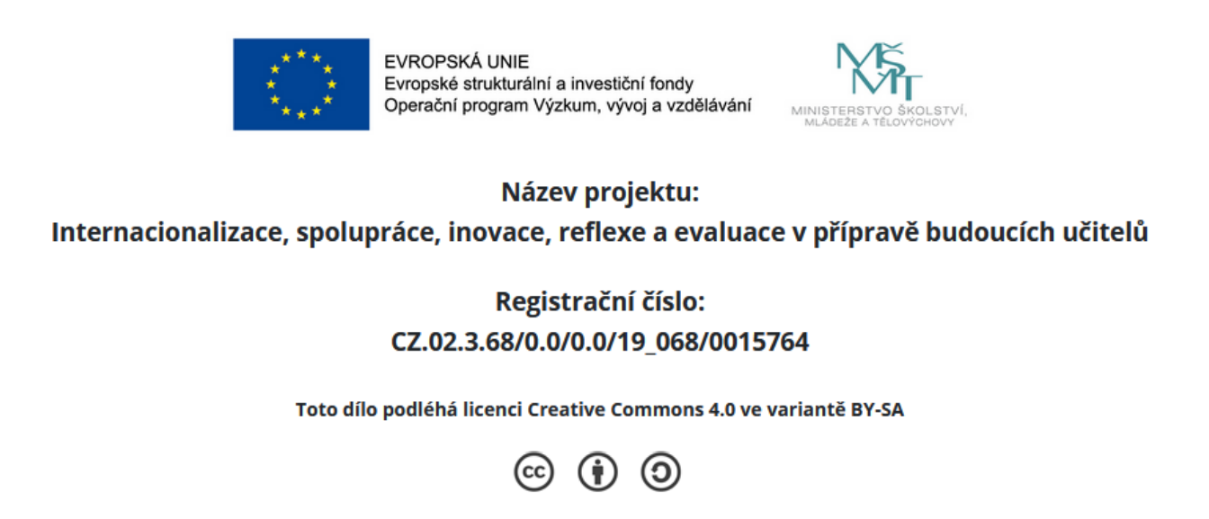

Effective language lessons should meet these criteria:

- It is clear what the students will achieve/gain by the end of the lesson.
- Every single activity supports these outcomes. The lesson only includes activities related to the teaching goal.
- There is a smooth transition between individual activities. The lesson is a coherent sequence of learning activities that link together to form a whole.
- The lesson provides opportunities for the learners to take part in extended practice with using language in a meaningful way.
- The plan includes strategies to support learners at critical moments.
- It is clear what exactly learners will do with selected teaching materials/activities.
- The lesson creates a motivation to learn and provides opportunities for success.
- There is a wrap up/feedback section at the end of the lesson.

