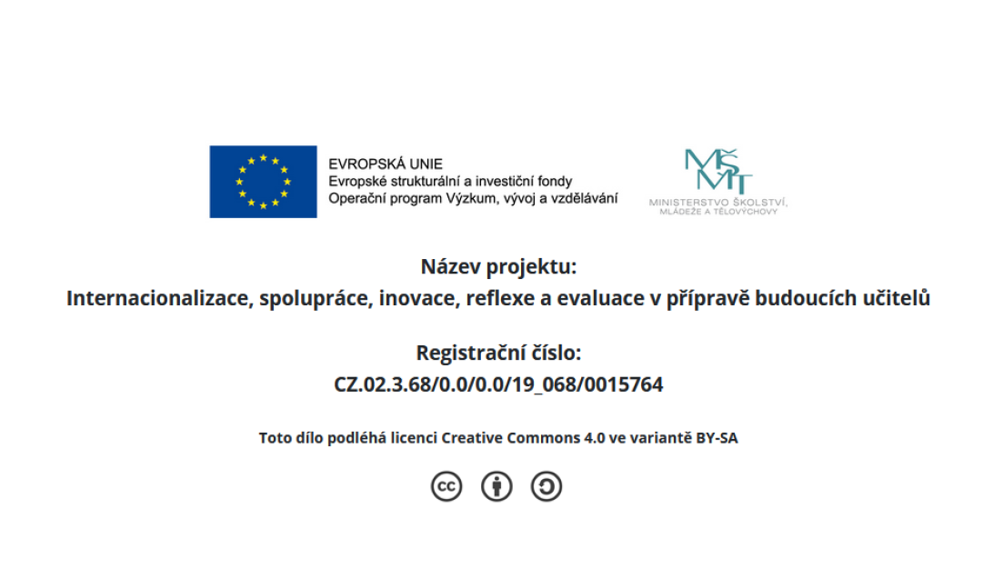
Observations

Being observed: If you ask somebody to come to observe your lesson, select one of the areas for your observer to focus on. You are familiar with the forms for you used the forms during your fall observations

• Planning – evidence of effective lesson planning and preparation
• Instructing – effective language and lesson objective scaffolding
• Learning
• Interpersonal dynamics – supportive environment that engages all learners
• The teacher and learners – performance in class

Observing: Use the observation form that your peer selects. Feel free to note down any other comments and/or questions about the lesson that would be valuable to your peer.

Shortly after the lesson, meet and reflect on the lesson using the criteria in the observation tasks. Discuss other elements that you would consider valuable. Please, be supportive of each other. Consider ration 5:1 – 5 appreciations and 1 constructive piece of advice. It is always good to allow the one being observed first talk about the lesson. These question could help you get started:

- Jak se ti dnes v hodině dařilo realizovat věci/naplnit cíl/e, které sis naplánoval/a?
- Co podle tebe mělo největší dopad na učení dětí?
- V které části hodiny jsi se dnes cítil/a nejjistěji?
- Cítil/a jsi naopak v nějaké části hodiny/dne nějaký problém, že se něco nedařilo, tak jak jsi chtěla? V čem konkrétně?

