
Some information about teaching grammar

What is the role of grammar in language teaching?

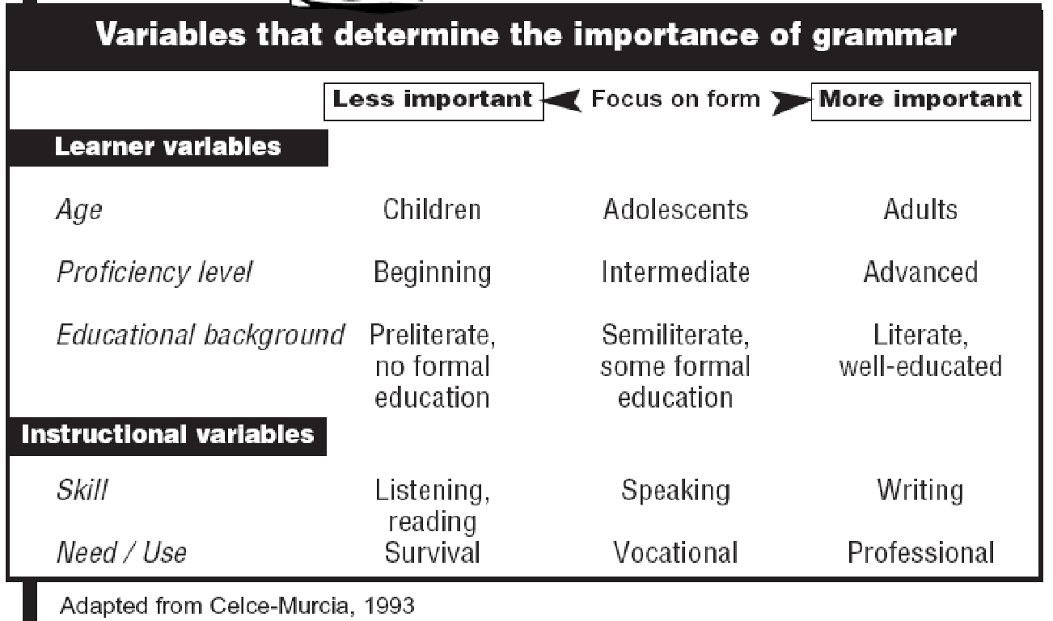

How do learners learn grammar?
- Learners don’t learn structures one at a time. Learning is a gradual process.
- Learners easily backslide when new forms are introduced to their interlanguage.
- Learners hypothesize about how L2 works.

What do language learners need to learn a language item?
- Be exposed to a lot of language while reading or listening
- Notice specific items when they are being used
- Understand the form, meaning and use of an item
- Try things out in a safe environment
- Have opportunities to practice
- Use the new language when speaking and writing to communicate in different contexts
- Remember items

What are some characteristics of effective grammar-focusing techniques:
- They are presented in meaningful and communicative contexts.
- They contribute to communicative goals.
- They promote accuracy within fluent, communicative language.
- They do not overwhelm students with linguistic terminology.
- They are lively and intrinsically motivating.

What should I think about when teaching grammar?
- What grammar item do I want to teach?
- Am I clear about what exactly I will or will not include?
- What are the situations/contexts in which the item is used?
- What are the most common examples of everyday sentences that have this item?
- What is the one sentence – target sentence- that includes the item?
- What situational context or text will I use to focus on the item?
- What is the form of the item in the target sentence?
- What is the meaning of the target sentence?
- What is the pronunciation of the target sentence?
- What are some possible or typical student problems with the target sentence?
- What can learners achieve in a lesson on this item?

Reference:
Brown, D.H. (2000). Principles of language learning and teaching (3rd ed.). White Planes, NY: Addison Wesley Longman.
Celce-Murcia, M. (Ed.) (2001). Teaching English as a second or foreign language (3rd ed). Boston, MA: Heinle & Heinle.
Harmer, J. (2007). The practice of English language teaching (4th ed.). Oxford, UK: Pearson Longman.
Scrivener, J. (2005). Learning teaching (2nd ed.). Oxford, UK: Macmillan.
Ur, P.(1996). A Course in Language Teaching. United Kingdom: CUP

