Electrodynamic braking - resistance (E 499.2 )

Entering example
You create a suitable script for simulating electrodynamic brakes at locomotive E 499.2. The locomotive parameters are in table 1 and the machine parameters are in Table 2. The course of the induced voltage at 900 rpm is known (see figure1, equation 1 and Table 3). The induced voltage is dependent on the excitation current. The schema of the electrodynamic brake is shown in the figure 2.
The starting speed of the locomotive is 140 kph and the electrodynamic brake will be used up to a speed of 45 kph. Only the electrodynamic brake is used for braking, another braking mechanism does not consider. The minimum braking force is determined by the operator.
You plot the required values of these variables dependent on time: machine speed, induced voltage, excitation current, battery current, braking force, vehicle speed and resistance of the braking grid
Table 1: Locomotive parameters E499.2 [1,3]
Rated current (A) | 715
Gear ratio (-) | 2.441
Wheel diameter (m) | 1.25
Weight (t) | 82
Resistance of braking grid (Ω) | 3.359 (27 taps)
Wheel arrangement | Bo´ Bo´
Machine | Al 4741 FlT

Table 2: Machine parameters Al 4741 FlT [1,3]
Type of machine | Series wound DC machine.
Nominal current (A) | 715
Rotor winding resistance (Ω) | 0.135
Stator winding resistance (Ω) | 9.6
Minimum excitation current (A) | 100
Maximum current when braking (A) | 95% nominal current

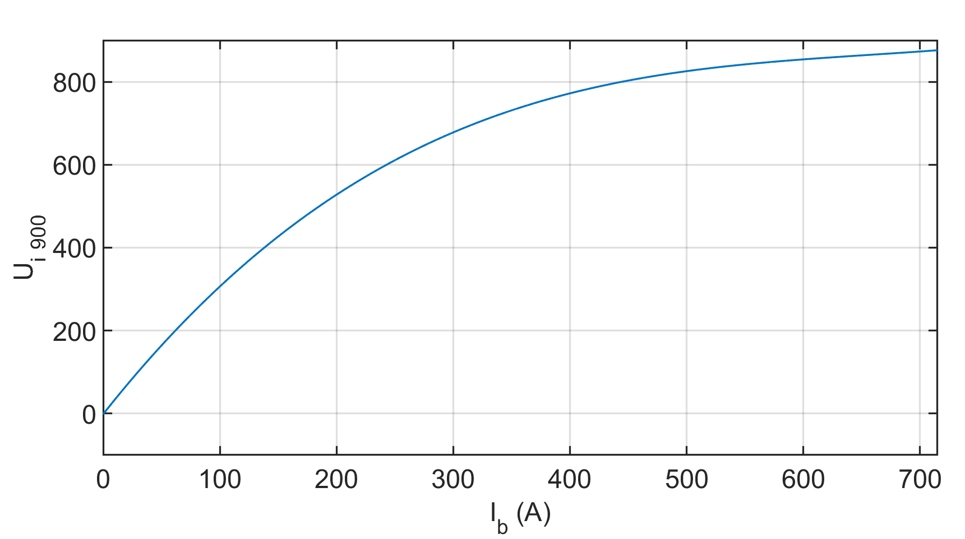
Figure 1: The course of the induced voltage for 900 rpm

 | $U_{i}=p_{1}∙{I_{b}}^{4}+p_{2}∙{I_{b}}^{3}$+$p_{3}∙{I_{b}}^{2}$+$p_{4}∙I_{b}$+$p_{5}$ | (1)

Table 3: Values p for calculating the induced voltage for 900 rpm
p₁ | 6.551e-11
p₂ | 2.473e-6
p₃ | -0.005063
p₄ | 3.559
p₅ | -1.394

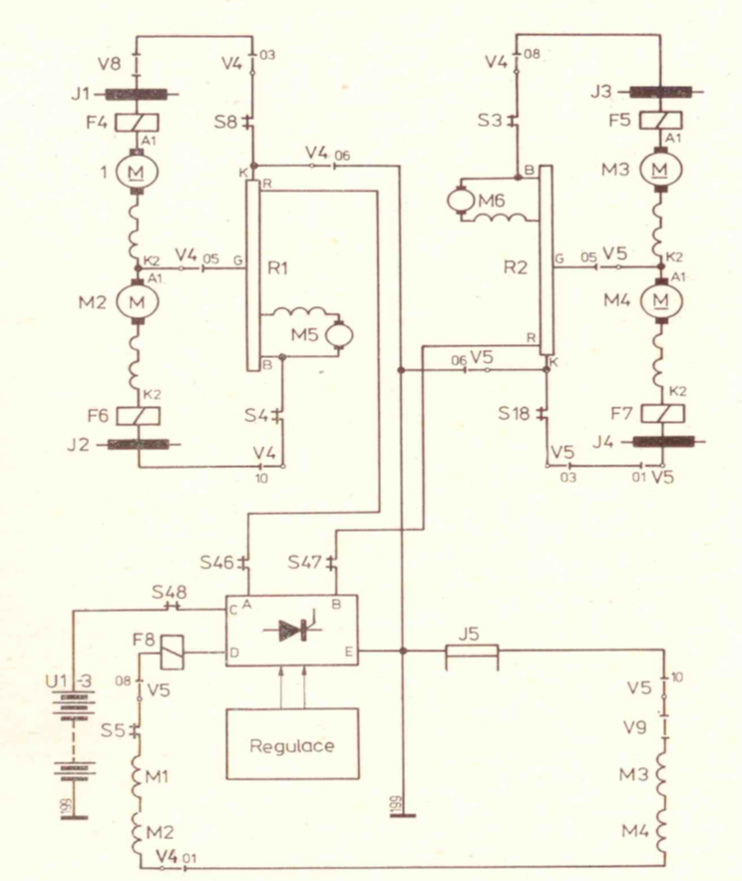
Figure 2: Connection of motors in brake mode [1]

Analysis
Figure 3 shows a simplified scheme of electrodynamic brakes for one machine. Since it is a serial DC machine, so stator winding is in the series with Rotor winding. To ensure the excitation of the machine, the battery is connected to the excitation winding. The battery can deliver the necessary current. A diode is inserted between the battery and the winding to maintain the desired current direction. The induced voltage can be calculated from equation 2 and the braking force can be determined from equation 3 for one machine
The locomotive has a total of 4 machines. When you need to increase the braking force, it is necessary to increase the induced voltage or the machine current. The induced voltage depends on the speed and the excitation current.

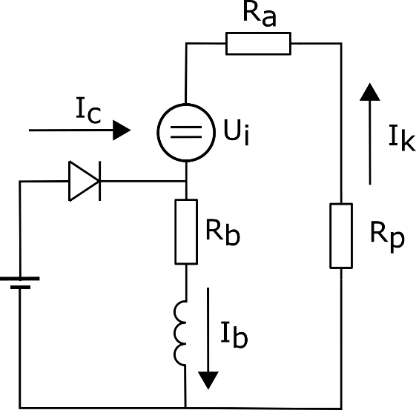
Figure 3: Simplified scheme of electrodynamic brake

 | $$U_{i}=U_{i0}\frac{V}{V_{0}}=RI_{k}⇒V=V_{0}\frac{RI_{k}}{U_{i0}(I_{k})}$$ | (2)

 | $$F_{B}=3.6\frac{P}{V}=3.6\frac{R{I_{k}}^{2}}{V}=3.6\frac{U_{i0}(I_{k})I_{k}}{V_{0}}$$ | (3)

The simulation contains one loop "while" with a suitable condition for speed. The recommended sequence of the script is as follows:
- suitable speed conversion
- calculation of induced voltage
  - for speed 900 rpm (equation 1)
  - for current speed (equation 2)
- to determine the current of the motor
  - current of the armature coil is equal to the exciting current
  - calculation of the total resistance
  - current limitation of 95%
- calculation of braking force
- checking the braking force
  - change of the braking grid value (27 taps)
- change of vehicle speed => slowdown (4 machines)

Description of the script
t = 0;  h=1e-2; | start time to set to zero and step of the simulation is 10 ms
while V > 45 | The loop that simulates the operation of the electrodynamic brake. The brake will turn on when the vehicle's speed is above 45 kph. One of the requirements is to meet.
v = V/3.6 ; | speed from kph was convert to m·s⁻¹
n_wheel = v/(d/2)/(2*pi)*60; | linear speed of vehicle (m·s⁻¹) was converted to rotation speed of wheel (rpm)
n_machine = n_wheel*GR; | wheel speed was converted to the machine speed via the gearbox
Ui_900 = p(1)*I_b^4+p(2)*I_b^3+p(3)*I_b^2  +p(4)*I_b+p(5) | calculation of induced voltage for 900 rpm, changing the excitation current I_b
Ui_n = Ui_900* n_machine /n_900 | recalculation of induced voltage to required speed with knowledge of induced voltage for 900 rpm
R_all= Ra_m + Rb_m + Rp; | The sum of all resistors in the circuit: rotor winding, braking grid and stator winding  The beginning of the simulation is considered the full value of the braking grid.
I_k = Ui_n/R_all; | calculation of armature coil current
if I_k < 100  I_c = 100;  else  I_c = 0;  end | The battery adds the necessary current when the armature coil current is insufficient (at least 100 A).  In this case, it is always 100 A
I_b = I_k + I_c; | calculation of the excitation current  the sum of armature coil current and battery current
if I_b > 0.95*In_m  I_b = 0.95*In_m;  end | Control that the current does not exceed 95% of the rated current value.
F_B = 3.6*R_all*I_b^2/V; | calculation of braking force according to equation 3 for one machine
F_B_all = 4*F_B; | calculation of braking force for four machines
if F_B_all < F_min  Rp = Rp - Rpmax/27;  if Rp <= Rpmax/27  Rp = Rpmax/27;  end  end | If the braking force is too low compared to the operator's requirement (f_min), the resistance of braking grid value should be reduced to increase the machine current.  The braking grid has 27 taps in this case and the resistance can be changed after 1/27. Value of braking grid cannot be the negative.  It must be ensured that the minimal value of braking grid will be 1/27 from nominal value.
V = V – 3.6*F_B_all/m*h; | Determining the speed of the vehicle after the brake intervention. The formula is used $F=a∙m$ .
out = [out;[t, n_machine, Ui_n, I_b, I_c, F_B_all/1000, V, Rp]]; | Subsequently, the necessary variables are stored. The braking force is converted to kN.
t =t+h; | increase the time t by step simulation
end | end loop while

The last task is to plot curves of the required variables.

Results
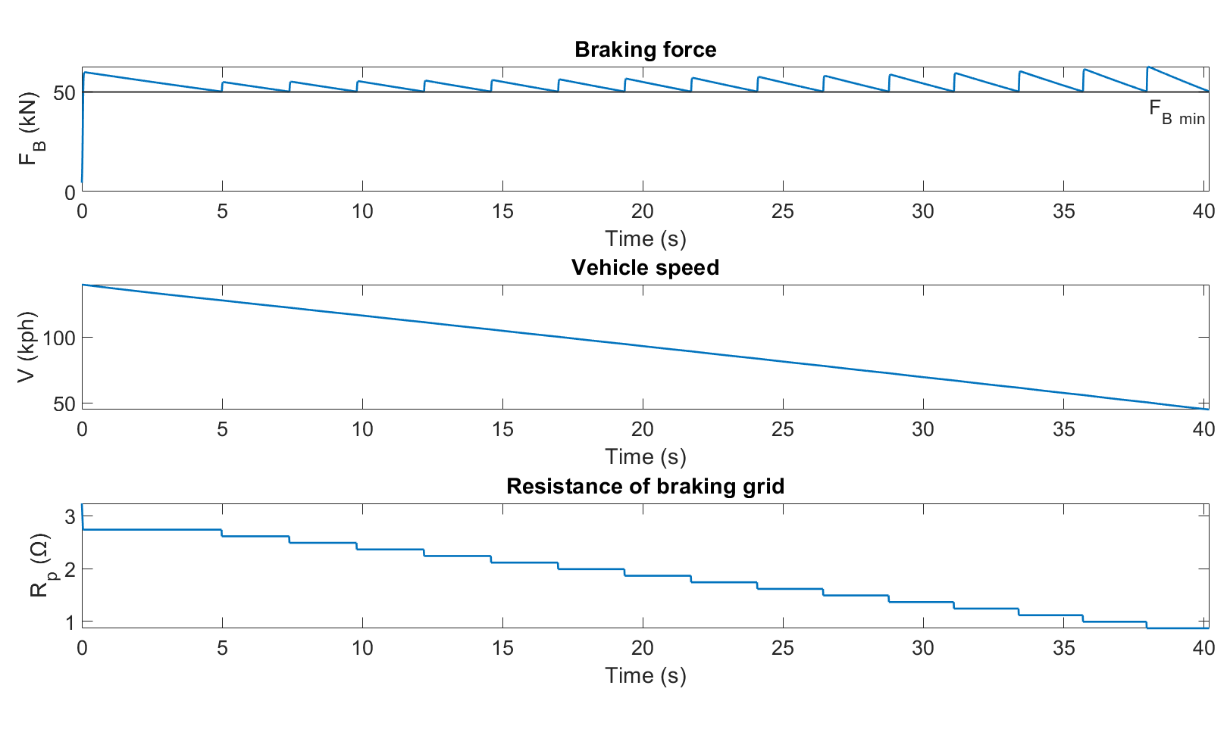
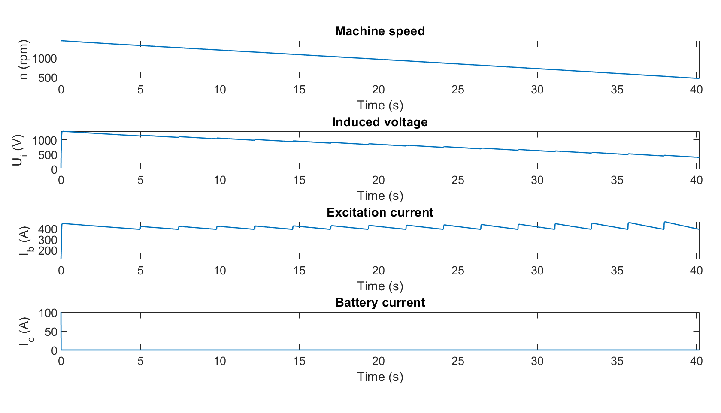

List of symbols and abbreviations
U_{i 900} (V) | Induced voltage at 900 rpm
I_{b} (A) | Excitation current
U_{i} (V) | Induced voltage
p | Coefficients for calculation of induced voltage
R_{a} (Ω) | Rotor winding resistance
R_{p} (Ω) | Resistance of braking grid
R_{b} (Ω) | Resistant of stator winding
I_{k} (A) | Current of armature coil
I_{c} (A) | Battery current
F_{B} (N) | Braking force
V (km/h) | Vehicle speed

References
- KOŽUŠKO, Július. Elektrická lokomotiva řady E 499.2. Praha: Nakladatelství dopravy a spojů, 1981. Knižnice nové techniky a technologie na železnici.
- Danzer, Jiří. Elektrická trakce. 2, Stupňové řízení sériového motoru. Vyd. 1. Plzeň: Západočeská univerzita, 2009. 79 s. ISBN 978-80-7043-770-4.
- AtlasLokomotiv.net: 150, 151 | E 499.2 Dostupné z: www.atlaslokomotiv.net/loko-150.html

