

ESF II project of the University of West Bohemia in Pilsen, reg. number: CZ.02.2.69/0.0/0.0/18_056/0013239

The Principles of Clinical Massage Therapy

Clinical massage therapists operate according to certain assumptions that are so self-evident that they might be considered axioms of the field.

- The individual is a whole organism: Everything is connected and related. Complex systems are more than the mere sum of their parts; that is, it is essential to see the forest and the trees. Although this book is necessarily reductionist to some degree we cannot understand the whole without knowledge of the parts, and they must be examined in a linear way the therapist should remember that the part must also be seen in the context of the whole. For example, a client with a sprained ankle will favor the injured leg, causing muscles in the hip and low back to tighten. The resulting imbalance in the back can affect the neck muscles, causing a headache. Treating the neck muscles alone will not solve the problem.

- Shortened muscle tissue can do no work. Muscle tissue does its work by contracting and, therefore, can do no further work if shortened. What we are concerned with as therapists is persistently or pathologically shortened tissue; in other words, tissue that has shortened, in all likelihood for defensive reasons, is unable to work, and resists lengthening.

A muscle may be shortened actively or passively. Examples of chronic passive shortening are the shortening of biceps brachii when the arm is kept in a sling for a period of healing, and the flexed position of the iliopsoas muscles (hip flexors) in a baby who is not yet standing and walking. Postural misalignment always involves habitual passive shortening of many postural muscles.

Active shortening, on the other hand, is muscular contraction, and may be either the intentionalcontraction that is the work of the muscle, or defensive contraction representing the muscle's response to a threat such as overload, repetitive motion, or excessive stretch. When a portion of muscle tissue is contracted in this way, it cannot contract further and is unavailable to do the work of the muscle.

- The soft tissues of the body respond to touch. One of the most persuasive theories of the many thatseek to explain this is that myofascial pain is caused by a self-perpetuating neuromuscular feedbackcircuit in which the stimulation of touch interferes, thus restoring normal function. Depending on thechoice of technique, manual intervention in the dysfunctional tissues interrupts this feedback process,
forcing some change in the neural response and, therefore, in the functioning of the affected tissue itself.The intervention may take the form of ischemic compression, passive stretching, passive shortening, or any simultaneous or sequential combination of these.

Clinical massage therapy, and therefore this book, is based firmly on these three principles. The clinicalmassage therapist is one who approaches persistently shortened soft tissues and attempts to restore their
natural, pain-free function through touch, while keeping the whole client in mind.

Structure and Function of Muscles

Although we treat muscles as distinct entities for anatomical convenience, we must remember that the neuromuscular system does not activate muscles in that way. The nervous system stimulates portions of contractile tissue to contract in patterns that will produce the desired effect, and this activation usually involves parts of several muscles acting in fine coordination. No action recruits all of a muscle, and no action recruits only one muscle. When we say, for example, that biceps brachii flexes the arm at the elbow, we are making a broad generalization. Depending on the position of the arm when we make the movement, certain portions of biceps brachii will be activated. In addition, portions of brachialis will also contract, as well as portions of certain muscles in the forearm. Portions of triceps brachii will be recruited to temper the movement and keep it smooth. As the movement occurs, a shift in weight occurs, and parts of muscles throughout the torso and legs respond to maintain
balance. Therefore, it is not so much individual muscles that do the work of the body as it is patterns of portions of muscle tissue. To gain an understanding of these broad patterns of muscular action over the whole body, we must first acquaint ourselves with the elemental parts of muscle tissue and how they work.

The Muscle Cell

The contractile filaments that perform the work of the muscle are called myofilaments. Two basic types of myofilaments perform the work of the muscle. One type is the thick myosin filament; the other is the thin actin filament. The myosin filament has molecular heads that extend to attractor sites on the adjacent actin filament and bend to bring about contraction. These myosin and actin filaments lie parallel to each other in an overlapping pattern that produces the characteristic striped (striated) appearance of skeletal muscle. Several of these myofilaments together form a sarcomere, which is considered the unit of contraction in a muscle cell. A string of sarcomeres lined up in sequence form a myofibril (muscle thread) (Fig. 1-1). Surrounding and penetrating the myofibrils is a system of microscopic tubes called transverse tubules and the sarcoplasmic reticulum. These tubules carry the chemical trigger, calcium, necessary to initiate contraction at the molecular level. A muscle cell is composed of
several myofibrils.

Fig. 1-1

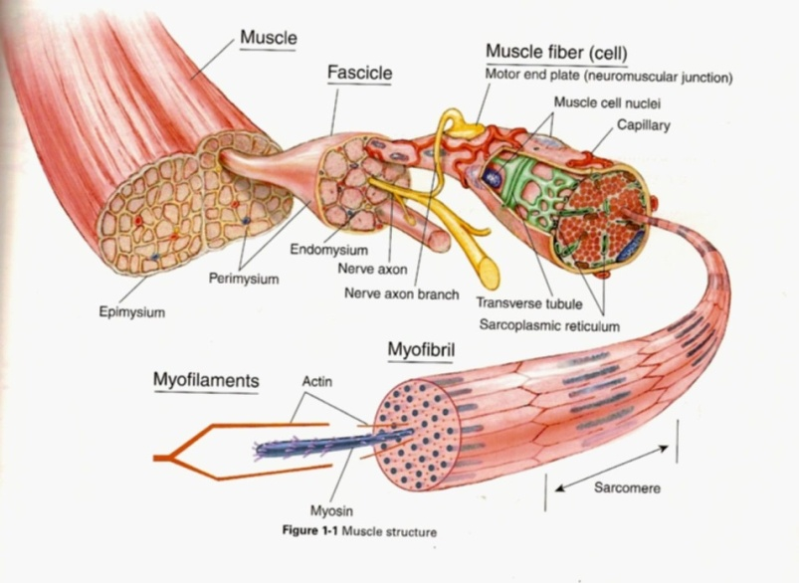
The expression muscle cell is equivalent to the expression â€œmuscle fiber.â€• The number of muscle cells in the body is believed to remain constant; when we strengthen muscles or increase their size and bulk, it is the contractile content, not the number, of the cells or fibers that is changed. Unlike most cells, muscle cells contain many nuclei scattered along the length of the cell. Multiple nuclei are necessary because muscle cells can be quite long, and their internal needs, which must be assessed and met by the nuclei, vary from one part of the
cell to the next. Muscle cells are second only to nerve cells in length and can be over 11 inches long in some muscles.

The Cross-Bridge Theory

The most commonly accepted theory of muscle function is the cross-bridge theory. It attempts to explain the contractile action of muscle tissue that is, how muscle tissue shortens when stimulated by a motor neuron.
When a nerve impulse excites the neuromuscular junction, calcium is released from the sarcoplasmic reticulum into the fluid surrounding the myofilaments. This causes a molecular response in which attractor sites on the actin filaments are exposed, attracting heads from the myosin filaments, which cross the gap between the filaments, attach themselves to their sites on the actin filaments, and bend, propelling the actin filaments into a more deeply overlapped and interlocked position in relation to the myosin filaments. This shortens the sarcomere and, as all the sarcomeres in many muscle cells shorten, muscle contraction occurs (Fig. 1-2). Muscle tissue is capable of shortening by about 40% of its length.

When nerve stimulation ceases, the calcium is actively transported back into the transverse tubules, the myosin heads release, and contraction stops. The muscle, however, cannot lengthen on its own. The contractile units (sarcomeres) must be stretched back to their starting position by an outside force, such as the pull of gravity or an opposing muscle, before it can again shorten in contraction.
When nerve stimulation ceases, the calcium is actively transported back into the transverse tubules, the myosin heads release, and contraction stops. The muscle, however, cannot lengthen on its own. The contractile units (sarcomeres) must be stretched back to their starting position by an outside force, such as the pull of gravity or an opposing muscle, before it can again shorten in contraction.

Fig. 1-2



