

ESF II project of the University of West Bohemia in Pilsen, reg. number: CZ.02.2.69/0.0/0.0/18_056/0013239

Poles (Nottingham, 2009)
Although they are simple, Nordic walking poles have distinguishing features that set them apart from poles used for skiing or trekking, as well as from other brands used for Nordic walking. The following section discusses the handle, wrist strap, shaft, and rubber tip in detail. (Nottingham, 2009)

Handle
The handle, located at the top of the Nordic walking pole (figure x.1), is one of the unique features of this piece of equipment. In contrast to trekking poles, which are thicker in diameter, most Nordic walking poles have a narrow profile. This sleek and purposeful design encourages you to hold the poles loosely, allowing them to float in your hands during movement. Handles can be made of soft and shaped rubber, cork, or neoprene, depending on the model and manufacturer. Some walkers prefer cork, which is cooler to the touch in hot weather, and others prefer rubber or neoprene, which retain body heat in cooler weather.

Wrist Strap
Most poles have a wrist strap, which is attached to the handle approximately 1 inch (2.5 cm) below the top of the pole, and some are remove-able by clicking out of a Nordic walking pole. Unlike the looping strap of trekking poles (figure x.2a), the wrist strap conforms to the hand and passively attaches the wrist to the pole. In contrast, the looping straps on trekking poles require you to actively grip the handle. By design, the passive wrist strap (figure x.2b) allows you to effortlessly move the pole with your hand while maintaining a neutral wrist.
Wrist straps are usually constructed of soft, breathable material, and some models offer different sizes to ensure a glove like fit. This unique design provides several benefits. For example, the passive hand contact around the pole handle reduces unnecessary activation of muscles in the wrist and forearm. Contracting smaller arm muscles often leads to over-activation of the neck and shoulders.
Golfers know that hand contact around the club that results in gripping that is too tight wreaks havoc on an otherwise relaxed and accurate golf swing and leads to premature fatigue over the course of a game. Similarly, you should minimize unnecessary muscle tension, which causes inefficient movement, premature fatigue, and possible muscle strain.
One of the many reported benefits of Nordic walking is the reduction of muscle tension in the neck and shoulders (Anttila et al. 1999, Karvonen et al, 2001), which also relieves the stress commonly held in that area of the body.
Maintaining loose hand contact around the pole handle during exercise may decrease blood pressure from contracted muscles and encourage blood flow.
Finally, individuals who cannot make tight hand contact around a pole due to arthritis or other conditions can still use the poles effectively.
Some wrist straps have a release button or trigger mechanism that detaches them from the pole. This convenient design allows you to easily sip a bottle of water or take off a jacket without removing the straps altogether. Choose the design of your poles according to your needs and your skill level. Regardless of design, you should wear the wrist strap appropriately to minimize the risk of injury. With most designs, place your hand through the largest opening and your thumb through the smaller opening and tighten the Velcro strap around your wrist until the fit is snug but does not cause friction or hinder circulation. If your model has a removable wrist strap that offers multiple attachment settings, attach it as close to the handle as possible to reduce excessive movement between your wrist and the pole (figure x.3)
Shaft
The pole shaft connects the handle with the tip, which makes con-tact with the ground. Like the poles used in trekking and skiing, the shafts of Nordic walking poles are made from a variety of alloys, including aluminum, carbon fiber, and fiberglass. To increase the efficiency of aerobic exercise, Nordic walking poles are light and have little swing weight, sometimes weighing as little as 13 ounces (370 g). Heavier swing weights are counterproductive for Nordic walking, since the poles’ tips should remain behind the body to propel you forward. To minimize swing weight, some poles are designed so you can adjust the height at the top of the shaft. The strong shafts of Nordic walking poles dampen vibration and absorb shock to ensure comfort, safety, durability, and efficiency. Materials that are too soft absorb your energy, but stiffer materials transfer kinetic energy to propel you forward. Nordic walking poles are also incredibly strong. One manufacturer, Leki, offers a lifetime warranty against breakage and states that their adjustable pole locking mechanism can withstand approximately 300 pounds (140 kg) of holding force.

Tips
Where the rubber meets the road, a uniquely designed tip clearly differentiates Nordic walking poles from other types of equipment. Trekking poles typically have hard and pointed metal tips or rounded rubber tips that are placed in front of the walker for support and balance. In contrast, Nordic walk-ing poles have angled rubber tips (figure x.4a) that propel you forward when placed on the ground behind you. This little rubber piece is special because it allows you to dictate the intensity of the workout by the amount of effort you apply to it, regardless of your speed. Rubber tips vary in shape, length, and width. However, virtually all designs let you remove the tip to expose a sharper point for traction on softer and more varied terrain (figure x.4b). The rubber tips are typically used for asphalt and cement and the heavy metal or tungsten carbide tips are used on dirt, grass, gravel, sand, and ice. You may determine which tip is most appropriate for you to avoid slipping. A few manufacturers now sell rubber tips that are embedded with carbide points. These models are designed for use on both hard and soft surfaces, including slick, wet surfaces and ice. Like the tires on a car, rubber tips wear out over time. Replace them every six months for heavy use and once a year for moderate use. Replacement tips cost between 50 and 400Kč.
Baskets
The small rubber baskets at the base of Nordic walking poles prevent the tips from bending or breaking in soft ground or gravel. Some manufacturers also offer an interchangeable webbed basket for use in the snow that costs between 150 and 500kč.

Figure x.1(a) Nordic walking pole’s handle (right) versus a trekking pole’s handle (left).
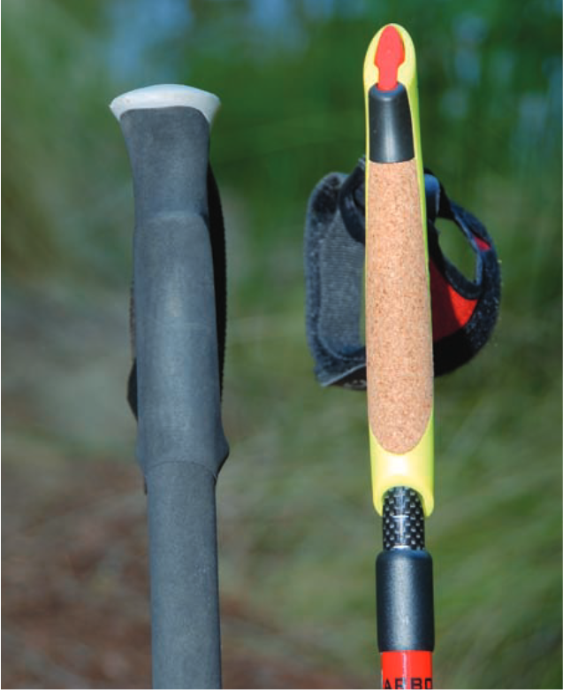
(Nottingham, 2009)

Figure x.2 (a) The looping strap of a trekking pole and (b) the passive strap of a Nordic walking pole.
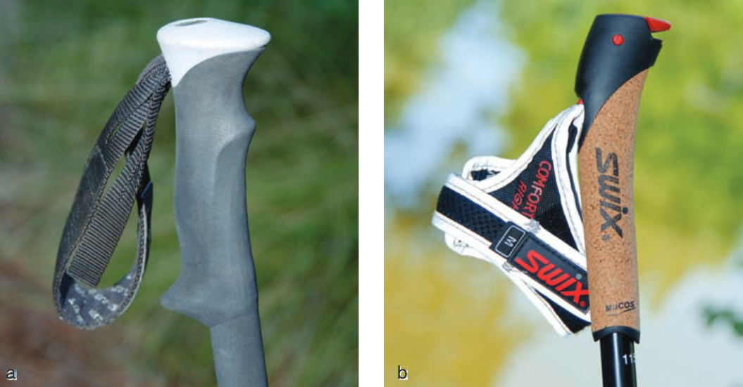
(Nottingham, 2009)
Figure x.3 there are variety of strap systems. Some poles come with removable straps, which can be a convenience to grab with. Regardless of the type, be sure the strap fits snugly.
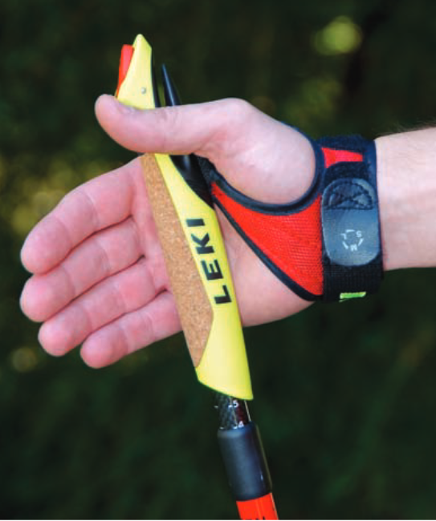
(Nottingham, 2009)
Figure x.4 (a) A pole with a rubber tip attached for walking on pavement and (b) with the rubber tip removed for walking on dirt and other off-road surface conditions.
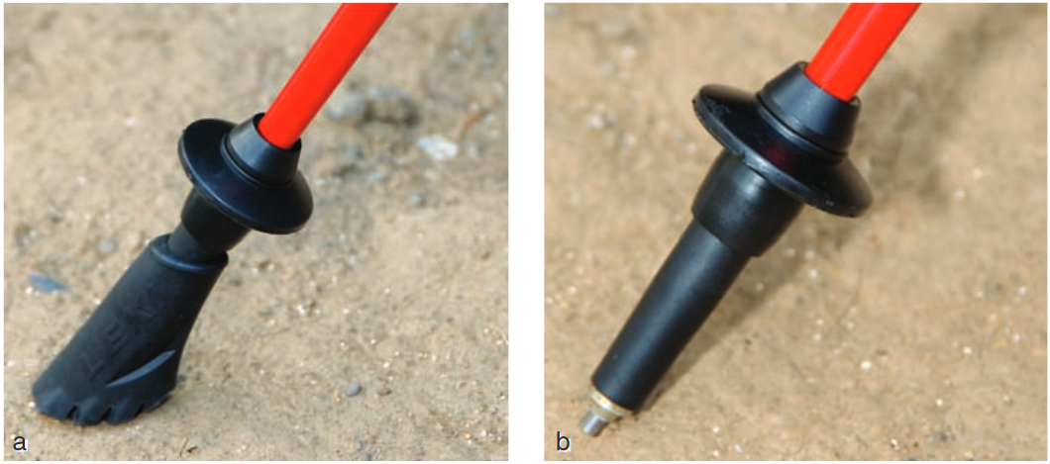
(Nottingham, 2009)

