

ESF II project of the University of West Bohemia in Pilsen, reg. number: CZ.02.2.69/0.0/0.0/18_056/0013239

Health Benefits
Modern lifestyle, with its lack of everyday physical activity and exercise training, predisposes people to chronic diseases such as diabetes mellitus, obesity, hypertension, and coronary artery diseases. Brisk walking as a simple and safe form of exercise is undisputedly an effective measure to counteract sedentary lifestyle risks even in the most unfit and could lead to a reduction of the prevalence of chronic diseases in all populations. (Tschentscher, 2012)
Workouts may vary in intensity from slow, calculated walking to swift, heart-pumping paces, but every choice yields results. Everyone from grandmas to athletes can reap these benefits of Nordic walking, regardless of fitness level, ability, speed, or age. (Nottingham, 2009)
Full-Body Fitness.
Nordic walking uses poles to connect the entire body to the pull of gravity, creating comprehensive muscle activity and resistance. With proper use, the tips of the poles redistribute the physical effort of your lower extremities to include your core and upper body.
Healthier Heart
Nordic walking is a perfect cardio-respiratory activity for people at every fitness level. The benefits of Nordic walking are directly related to the amount of effort put forth; as your fitness level improves, you progressively reap greater benefits. As will be discussed, it is a perfect activity for enhancing cardio-respiratory stamina and strength.
Weight Loss
Nordic walking results in greater weight loss than traditional walking does because more muscles are active, therefore burning more calories. However, when you are learning a new sport, your heart rate is sometimes too high to burn fat. Once you master the new skills and adapt to the demands of the activity, you can establish a fat-burning heart rate that helps you literally walk your butt off!
Healthier Back and Improved Posture
Improving the health of your spine is a top reason for Nordic walking. Regardless of your knowledge and skill level, simply gripping the handles of the poles and touching their tips to the ground activates key postural muscles of your torso and core. One of the most beneficial results of tip resistance is spine rotation, which physical therapists prescribe as one of four daily movements for a healthy back. Rotational movements create gentle resistance around the axis of the spine, activating all the core muscles. By incorporating the rotational element that many fitness programs miss, Nordic walking reenergizes postural awareness. Better posture results in greater coordination, stronger back muscles, and increased endurance.
Reduced Impact on Joints
Because poles distribute effort throughout the body and provide instant stability, Nordic walking places less strain on the knees and back. After only one trip uphill and downhill, you will appreciate the extent to which poles help you remain upright. Never again will you have to break at the waist or load your knees beyond a comfortable angle.
Greater Bone Density.
Avid Nordic walkers report stronger bones in all parts of the body.
Reduced Stress.
Nordic poles activate all the joints in the body, including the spine, causing the body to buzz with endorphins. Many Nordic walkers liken this feeling to the classic runner’s high. Other benefits associated with increased endorphins include reduced stress, better pain management, and greater muscle endurance. Both Nordic walking and meditation draw the participant’s awareness to rhythms, such as the heart’s beat, the of breath, and the coordination of a sym-metrical gait. Nordic walkers claim to lose track of time, letting the peaceful rush of rhythm and momentum occupy their minds throughout the workout. Others focus on one quality of their gait for several seconds at a time. Examples include noticing how their feet feel as each portion, from the heel to the toes, make contact with the ground, or concentrating on subtly coordinating the rotation of the upper and lower portions of the body.
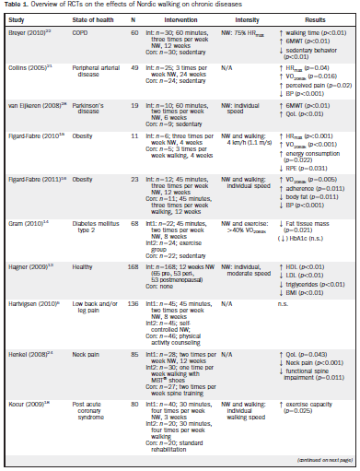
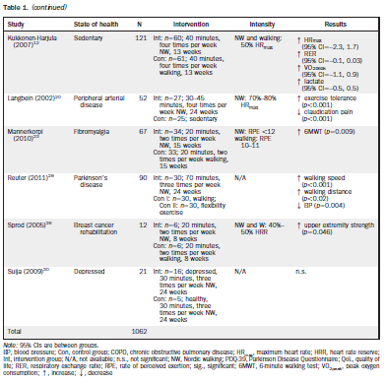
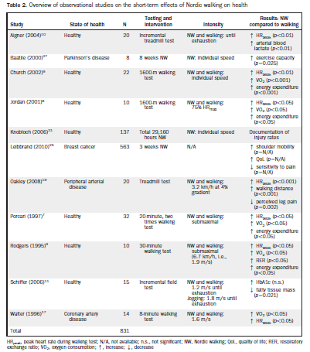(Tschentscher, 2012)

