

ESF II project of the University of West Bohemia in Pilsen, reg. number: CZ.02.2.69/0.0/0.0/18_056/0013239

Walk and Swing - Technique Progression 1
Rediscover the qualities of a natural gait. Walk and Swing gives you time to feel the oppositional long lever movements of the legs and arms as they swing, and to feel the location of the swings. Instructors refer back to Walk and Swing more than any other skill. If you do not have an awareness of oppositional movement, you will have difficulty master in gall the others skills. (Nottingham, 1999)
- Before beginning to walk, draw your awareness to your posture. Stand upright (a).
- Begin walking slowly on a flat, paved surface, as if you were strolling on the beach. Your stride should feel slower at first (b).
- Let go of your poles. Forget they are hanging from your wrists, forget the tips and do not be concerned if they are dragging at first. That will disappear with practice.
- Use this time to become aware of the oppositional movement of your arms and legs. Work on feeling rhythmical, coordinated, and somewhat automated.
- Try not to look down at the ground. Instead, hold your chin level with the walking surface. This practice appropriately balances the head’s weight to maintain excellent posture and promote lower-back health.
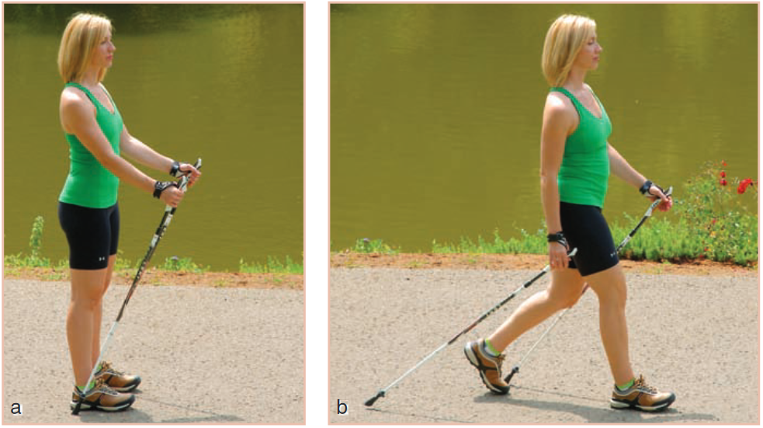
(Nottingham, 1999)

