

ESF II project of the University of West Bohemia in Pilsen, reg. number: CZ.02.2.69/0.0/0.0/18_056/0013239

Long Legs - Technique Progression 2
Focusing on extending the leg from the hip and making efficient contact between the foot and the walking surface reduces impact on the lower body. The feet and lower legs become alive with sensation. Reduce impact by rolling the whole foot along the ground with each stride. This practice helps your knees and lower legs cushion surface contact and stimulates key muscles of the lower body that are responsible for balance and stability. (Nottingham, 2009)
- Start slowly with Walk and Swing to establish opposition. Become aware of your legs swinging forward from the hips.
- Now bring attention to your feet and ankles. The most efficient strides utilize the entire foot. Your foot makes first contact by gently touching the heel to the ground, then rolls, touching each portion to the walking surface. As the toes make contact, use them to push off or the stride of the other leg. This practice strengthens the ankles and improves balance.
- As you walk, extend your stride by an inch (2.5 cm) and maintain your rhythm.
- After several minutes of practice, the pelvis may also move in opposition to the upper body.

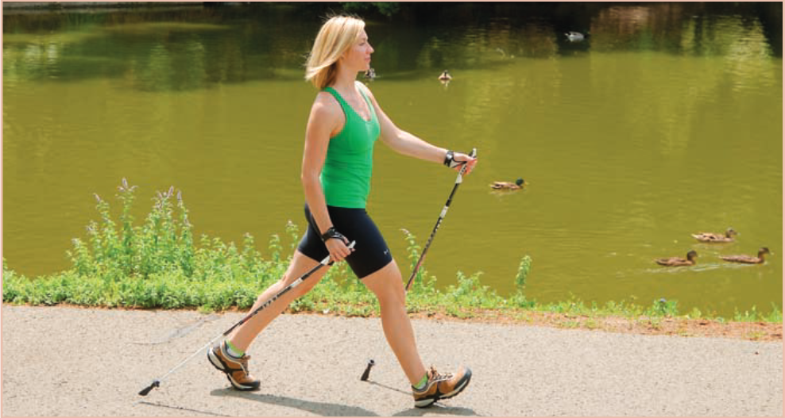
(Nottingham, 2009)

