

ESF II project of the University of West Bohemia in Pilsen, reg. number: CZ.02.2.69/0.0/0.0/18_056/0013239

Cupping for Grip Development - Technique Progression 4
Once you have established oppositional awareness and longer arms, develop a better relationship with the pole handles. The most efficient way to hold the pole handles is to cup them, using relaxed effort to guide the poles. As you practice, you may develop several inefficient movements of the hand and wrists, which are discussed later in „common errors“ part. (Nottingham, 2009)
1. Rest the pole handle in the middle of your palm.
2. Wrap your thumb gently around your fore-finger to create a light bond.
3. Lightly wrap the remaining fingers around the pole. Cupping the poles allows you more control during forward propulsion.

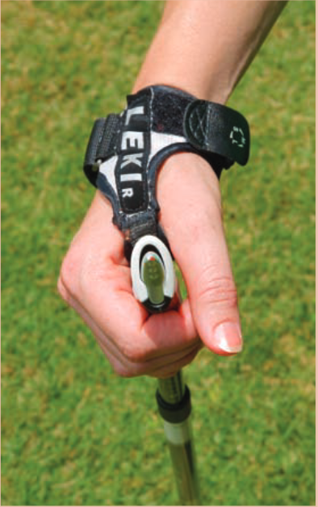 (Nottingham, 2009)

