

ESF II project of the University of West Bohemia in Pilsen, reg. number: CZ.02.2.69/0.0/0.0/18_056/0013239

Behavioral Learning Theories
Behavioral learning theories assume that learning takes place as the result of responses to external events. For example, if a song we remember fondly from high school gets repeatedly paired with a brand name, over time our warm memories about the tune will rub off onto the advertised product—think about the likes of Swiffer (featuring Blondie song, “One Way or Another”).
According to this perspective, the feedback we receive as we go through life shapes our experiences. Similarly, we respond to brand names, scents, jingles, and other marketing stimuli because of the learned connections we form over time. People also learn that actions they take result in rewards and punishments; this feedback influences the way they will respond in similar situations in the future. Consumers who receive compliments on a product choice will be more likely to buy that brand again, but those who get food poisoning at a new restaurant are not likely to return to it in the future.

2. Classical Conditioning
Although Ivan Pavlov won a Nobel Prize for studying digestion, he is much more famous for something else: working with a dog, a bell, and a bowl of food. Many people are familiar with the classic study of “Pavlov’s dog,” but rarely do they understand the significance of its discovery. In his famous experiment, Pavlov rang a bell and then gave a dog some food. After repeating this pairing multiple times, the dog eventually treated the bell as a signal for food, and began salivating in anticipation of the treat.
In fact, Pavlov’s work helps explain why some people get anxious just looking at a crowded bus, why the sound of a morning alarm is so hated, and even why we swear off certain foods we’ve only tried once. Classical (or Pavlovian) conditioning is one of the fundamental ways we learn about the world around us. But it is far more than just a theory of learning; it is also arguably a theory of identity. For, once you understand classical conditioning, you’ll recognize that your favorite music, clothes, even political candidate, might all be a result of the same process that makes a dog drool at the sound of bell.
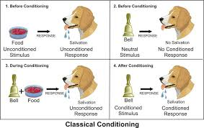
The dog food in Pavlov’s experiment is called the unconditioned stimulus (US) because it elicits an unconditioned response (UR). That is, without any kind of “training” or “teaching,” the stimulus produces a natural or instinctual reaction. In Pavlov’s case, the food (US) automatically makes the dog drool (UR). Other examples of unconditioned stimuli include loud noises (US) that startle us (UR), or a hot shower (US) that produces pleasure (UR).
On the other hand, a conditioned stimulus (CS) produces a conditioned response (CR). A conditioned stimulus is a signal that has no importance to the organism until it is paired with something that does have importance. For example, in Pavlov’s experiment, the bell is the conditioned stimulus. Before the dog has learned to associate the bell (CS) with the presence of food (US), hearing the bell means nothing to the dog. However, after multiple pairings of the bell with the presentation of food, the dog starts to drool at the sound of the bell. This drooling in response to the bell is the conditioned response (CR). Although it can be confusing, the conditioned response is almost always the same as the unconditioned response. However, it is called the conditioned response because it is conditional on (or, depends on) being paired with the conditioned stimulus (e.g., the bell).
To help make this clearer, consider becoming really hungry when you see the logo for a fast food restaurant. There’s a good chance you’ll start salivating. Although it is the actual eating of the food (US) that normally produces the salivation (UR), simply seeing the restaurant’s logo (CS) can trigger the same reaction (CR).
We now believe that this same learning process is engaged, for example, when humans associate a drug they’ve taken with the environment in which they’ve taken it; when they associate a stimulus (e.g., a symbol for vacation, like a big beach towel) with an emotional event (like a burst of happiness); and when they associate the flavor of a food with getting food poisoning.
Although classical conditioning may seem “old” or “too simple” a theory, it is still widely studied today as a type of associative learning, a form of learning that relies on the repetitive pairing of stimuli. Swedish car brand, “Volvo” has successfully paired its name with the concept of “safety” for years, giving consumers the sense that Volvo’s are among the safest cars on the road (and ideal for young families).

Operant Conditioning
Although classical conditioning is a powerful explanation for how we learn many different things, there is a second form of conditioning that also helps explain how we learn. First studied by Edward Thorndike, and later extended by B. F. Skinner, this second type of conditioning is known as operant (instrumental) conditioning. Operant conditioning occurs when a behavior (as opposed to a stimulus) is associated with the occurrence of a significant event. In the best-known example, a rat in a laboratory learns to press a lever in a cage (called a “Skinner box”) to receive food. Because the rat has no “natural” association between pressing a lever and getting food, the rat has to learn this connection. At first, the rat may simply explore its cage, climbing on top of things, burrowing under things, in search of food. Eventually while poking around its cage, the rat accidentally presses the lever, and a food pellet drops in. This voluntary behavior is called an operant behavior, because it “operates” on the environment (i.e., it is an action that the animal itself makes).
Now, once the rat recognizes that it receives a piece of food every time it presses the lever, the behavior of lever-pressing becomes reinforced. That is, the food pellets serve as reinforcers because they strengthen the rat’s desire to engage with the environment in this particular manner. In a parallel example, imagine that you’re playing a street-racing video game. As you drive through one city course multiple times, you try a number of different streets to get to the finish line. On one of these trials, you discover a shortcut that dramatically improves your overall time. You have learned this new path through operant (instrumental) conditioning. That is, by engaging with your environment (operant responses), you performed a sequence of behaviors that that was positively reinforced (i.e., you found the shortest distance to the finish line). And now that you’ve learned how to drive this course, you will perform that same sequence of driving behaviors (just as the rat presses on the lever) to receive your reward of a faster finish.
Operant conditioning research studies how the effects of a behavior influence the probability that it will occur again. For example, the effects of the rat’s lever-pressing behavior (i.e., receiving a food pellet) influences the probability that it will keep pressing the lever. For, according to Thorndike’s law of effect, when a behavior has a positive (satisfying) effect or consequence, it is likely to be repeated in the future. However, when a behavior has a negative (painful/annoying) consequence, it is less likely to be repeated in the future. Effects that increase behaviors are referred to as reinforcers, and effects that decrease them are referred to as punishers.
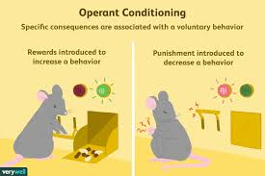
An everyday example that helps to illustrate operant conditioning is striving for a good grade in class—which could be considered a reward for students (i.e., it produces a positive emotional response). In order to get that reward (similar to the rat learning to press the lever), the student needs to modify their behavior. For example, the student may learn that speaking up in class gets them participation points (a reinforcer), so the student speaks up repeatedly. However, the student also learns that they shouldn’t speak up about just anything; talking about topics unrelated to school actually punishes the students in their costs points (a form of punishment). Therefore, through the student’s freely chosen behaviors, they learn which behaviors are reinforced and which are punished.
Understanding classical and operant conditioning provides psychologists with many tools for understanding learning and behavior in the world outside the lab.
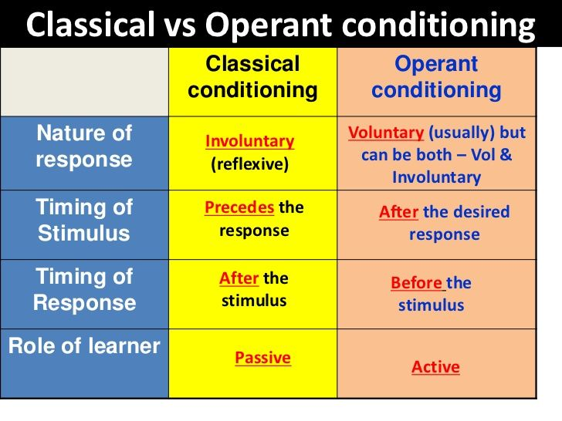
Some principles of behavioral theories:
- Behavioral learning theory has its own language to describe how consequences of behavior shape later behavior.
- Reinforcers increase the frequency of a behavior, and punishers decrease its frequency. Reinforcement can be primary or secondary, positive or negative.
- Punishment involves weakening behavior by either introducing aversive consequences or removing reinforcers.
- The Premack Principle states that a way to increase less- enjoyed activities is to link them to more-enjoyed activities.

Some critical points:
Perhaps the most important principle of behavioral learning theories is that behavior changes according to its immediate consequences.
Pleasurable consequences strengthen behavior; unpleasant consequences weaken it.
In other words, pleasurable consequences increase the frequency with which an individual engages in a behavior, whereas unpleasant consequences reduce the frequency of a behavior.

