

ESF II project of the University of West Bohemia in Pilsen, reg. number: CZ.02.2.69/0.0/0.0/18_056/0013239

Social learning theory

Taking a more interactive view of social and emotional development, Bandura’s social learning theory, (Bandura, 1977), holds that children’s behaviour is influenced by observing others being rewarded (or disadvantaged) – both parents and peers – for behaving in a certain way, and then imitating those rewarded behaviours. Bandura also believed that this observation, imitation and modelling enabled older children to ‘self-regulate’ their actions. This concept proposes children develop observed new behaviour via intrinsic reinforcement which must conform to acquired internal standards – a sense of pride, satisfaction and personal achievement – and suggests they will thus experience a sense of personal failure if they do not meet those standards.

Therefore, what begins as a natural response to external rewards eventually becomes a more ‘mature’ internalised response involving a gradual shift of the child’s locus of control .
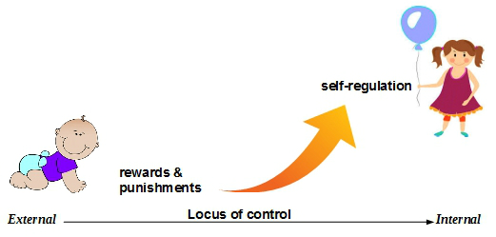
The evolution of social learning (https://www.firstdiscoverers.co.uk/wp-content/uploads/2017/06/social-learning-theory.jpg)

Bandura believes observation, imitation, and modelling are central components of the learning process, and that behaviourism alone can’t account for every kind of learning. Thus his theory is a blend of:
Behavioural theory – which posits behaviours are the result of conditioning, and
Cognitive theory – which gives weight to psychological features like attention and memory.
Bandura added a social element to the behaviourist concepts of conditioning, reinforcement, and punishment, pointing out that watching other people is a common way to learn new information and behaviours. For instance, just watching others play cricket (even on TV) will give you a good idea of what a cricket bat actually does.

Social learning’s core concepts (Bandura, 1977)
1. Observation is part of learning
Bandura’s ground-breaking Bobo doll experiment showed children can imitate violent behaviour. However, Bandura classified three types of observational modelling:
Active – imitating a real person’s behaviour
Verbal – following descriptive accounts of behaviour
Symbolic – taking inspiration from the exploits of real or fictional media characters.
2. Mental states are key
The best learning only occurs when the learner is fully motivated. Bandura maintains this implies intrinsic reinforcement (e.g. pride, satisfaction and a sense of achievement) is also present.
3. Learning won’t guarantee behavioural change
Some learning produces instant new behaviours – e.g. riding a bike. However, other types of learning may not always produce observable behavioural change.
For learning to take place, the following features must always be present:
- Attention – non-engagement or distraction impairs learning.
- Retention – what is learned must also be retrievably stored.
- Reproduction – practising the learning is essential to refine and advance any new learning.
- Motivation – the quality of motivation will influence the quality of learning, seeing others experience reinforcement and punishment can be as effective as personal experience.
Bandura’s theory has received biological support via the discovery of ‘mirror neurons’. These neurons may constitute neurological evidence of our human drive to imitate, and have been shown to fire in the same way when an animal does something itself, and when it observes the same action performed by another.

