

ESF II project of the University of West Bohemia in Pilsen, reg. number: CZ.02.2.69/0.0/0.0/18_056/0013239

Vygotsky and Piaget – Were they in conflict?

Theory of social constructivism

Jean Piaget (1896-1980)
Piaget observed how children learn and adapt to their environment. He believed cognitive development – the emergence of thinking and memory functions – to be the key element of the whole process, with language development, for instance, contingent upon the acquisition of knowledge and understanding via cognitive advances.
According to Piaget, learning and adaptation occur as a direct result of the dynamic interplay between:
- Assimilation: interpreting and adjusting new experiences to fit existing concepts, and
- Accommodation: altering and adjusting concepts to encompass new experiences.
Thus children develop a view of their world, discover new experiences which don’t fit, then deal with the new situation by adjusting their view accordingly. Not only does this interactive process inform short-term learning, it also underpins and characterises a child’s long-term development.
Piaget’s cognitive theory maps how all children gradually acquire the ability to think logically and understand abstract ideas. Most importantly, the theory suggests this birth-to-adolescence process has four distinct stages, with each new transition observing these four primary characteristics:
- The sequence of stages never varies.
- No stage is omitted.
- Each stage is an integrated whole and a significant transformation of the preceding stage.
- Each new stage accommodates and assimilates the preceding stages.

Jean Piaget’s four stages of cognitive development:

Sensorimotor stage:
(Birth to 2 years) Intelligence in action. The child interacts with his world by manipulating objects.

Pre-operational stage:
(2-7 years) Thinking is dominated by perception, but symbolic functioning increases. Language development also occurs, but the child is still strongly influenced by his own view of the world.

Concrete operational stage:
(7-11 years) The child can apply logical reasoning, but only to real objects which can be seen.

Formal operational stage:
(11 years and upwards) The individual can think logically about hypothetical events or abstract ideas.
Lev Vygotsky
Whilst both Piaget and Vygotsky describe children as active, hands-on learners, Piaget believed child development was universal, whilst Vygotsky maintained each culture provides different ‘tools of intellectual adaptation’. Thus, for example, some societies rely on note-taking to store information, whereas oral cultures value memorisation and rote learning – an idea which has implications for teachers in multicultural contexts.
Vygotsky’s greatest theory was the Zone of Proximal Development. Piaget asserted that cognitive development had to occur before learning, and learning had to be initiated by the child; this became the basis for Discovery Learning. Vygotsky believed that children developed cognitively when they were assisted by a More Knowledgeable Other (MKO: parent, teacher, older sibling, peer) to learn and practice new skills in a supported environment as a precursor to using them independently. Even a brief reflection of basic parenting activities supports this practice: children often lack skills which parents model for them and help them practice. Riding a bike, putting away toys, learning how to hold a book, doing a jigsaw puzzle — all fall into this category. Even the classic tea party could be viewed as a supported practice of table manners for some children. Children have learned important skills at the knees of their parents and tutors since forever – skills they could not have easily developed without adult guidance and support. What those skills were was determined by the child’s culture. Cloth weaving, playing the zither, memorization of lists of battles, use of the abacus, interpretation of law, cheese making, surveying, calligraphy, metal working; whatever the culture deemed important. A child would be moved incrementally along a continuum of skills by a MKO, who would support the child’s development until he or she could use the skills independently.
For Vygotsky, child learners had a ‘zone of proximal development’ (depicted in Figure 5) representing all the skills and knowledge a child alone cannot presently understand, but is potentially capable of learning through some form of guided social interaction. This concept explains, for example, why a child appears to lack certain knowledge, yet demonstrates the expected competence with prompting, or often just in the presence of a teacher or other learners.
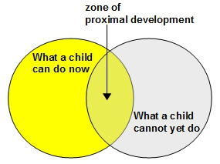
Vygotsky: zone of proximal development theory

Exist the differencies between Pigat and Vygotsky?

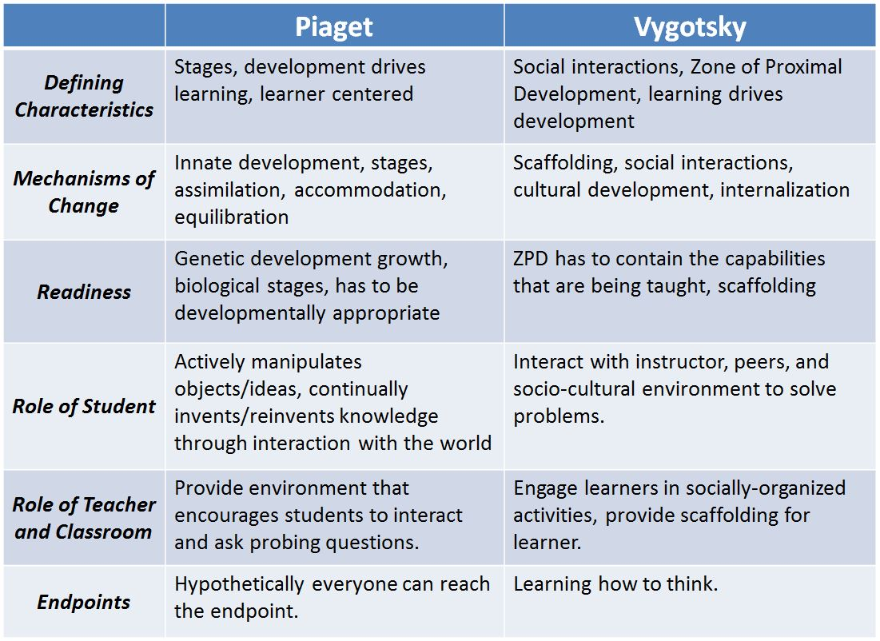

For better understanding watch this video:

https://www.youtube.com/watch?v=brNQZjsrdi4

Erikson’s psychosocial theory
In an overarching work about the ego which adopted a developmental focus, the American psychologist and psychoanalyst Erik Erikson proposed what is described as a psychosocial theory. This attempted to classify social maturation as an eight-stage model of psychosocial development spanning infancy to adulthood. Erikson’s theory held that each developmental phase required the individual to resolve a conflict between ego development and social factors. According to Erikson (1959), everyone’s development follows the same path, but each individual experiences varying (positive or negative) outcomes during each phase, and a child suffering negative setbacks will have to deal with unresolved crises in later life. (The teenage ‘identity crisis’, for example, is Erikson’s own phrase describing the ‘adolescent’ phase in his model).
The first four of Erikson’s stages, which are relevant to early childhood, are illustrated in Figure 6 below:
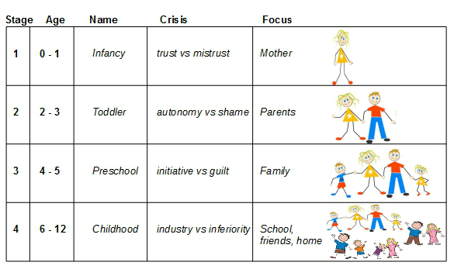
Stages 1-4 of Erikson’s psychosocial theory
In more detail, these early stages of psychosocial development are characterised as follows:
1. Infancy (0-1 year) – the infant develops trust or mistrust in itself and others; the attachment figure – the mother, or another primary carer – is central.
2. Toddler (2-3 years) – the child develops autonomy or shame, becoming either more independent or developing shame and doubt; parents and significant carers are central at this stage.
3. Pre-school (4-5 years) – the child shows initiative or guilt, and is on a quest to discover what sort of person he is; the extended family are significant at this point.
4. Childhood (6-12 years) – the child is industrious or feels inferior, with an attitude proclaiming ‘I am what I learn’; in an expanding social world, home, school and friends are all important.

Opportunities for social and emotional development
Primary socialisation occurs within a child’s family during the early years of life. However, a nursery or similar preschool context will often be a child’s first experience of secondary socialisation and it is true to say that every social interaction in this new environment represents a developmental occasion. In practice, it is the opportunities for children’s play – even, or perhaps especially, the free, unstructured types of play – which usually provide the optimum chance for the reinforcement and extension of such vital life skills.

Relating theory to practice
Childcare professionals are, of course, engaged in work which is essentially practical, and it would be entirely wrong to suggest any psychological theory has the final answer to every question facing those who have children in their care on a daily basis. Theory is of most use to professionals as a means of analysing care and learning situations – which includes evaluating resources, and its use as a language to describe what is taking place. Simple discussions and sharing of experiences between colleagues are often the best means of relating contextual issues to the underlying theoretical concepts. And whilst such exchanges can sometimes highlight the useful limits of a certain theory, they can also unearth productive new approaches too.

