Capillary testing - examples
- Define and describe the capillary phenomenon.
- The term capillarity refers to a group of physical phenomena (capillary phenomena) that are closely related to the existence of surface tension, adhesion and cohesion. Capillary phenomena are observed mainly in narrow tubes, capillaries, where their designation also comes from.
- What is surface tension and how is it defined? Which substance has the highest and which has the lowest surface tension?
- Surface tension is an effect in which the surface of liquids behaves like an elastic membrane (thickness 10-9 to 10-8 m) and tries to achieve the smoothest possible state with a minimum area. This means that the surface of the fluid tries to reach the state with the least energy. The higher the surface tension, the "rounder" the droplet of this liquid.
- The surface of the liquid thus behaves as if it were formed by a very thin elastic layer, which tries to contract the surface of the liquid so that it has the smallest possible content at a given volume of liquid. If the liquid were not acted upon by external forces, it would have a spherical shape, because the sphere has the smallest surface of all bodies of the same volume. Under external forces, the situation is somewhat more complicated. However, the free surface of the liquid always tries to reduce the size of the total surface to the smallest possible extent. If the external forces are very small against the surface tension forces, the fluid will try to assume an approximately spherical shape.
- Surface tension is monitored not only for liquids, but also for solid or gaseous phases.
- Liquid mercury has the highest value; helium has the lowest value.
- How is surface wettability defined?
- The property of a liquid to adhere to the surface of a solid. It results from the value of the wetting angle.
- What is capillary elevation and capillary depression? In which substances does it occur?
- Capillary elevation = if we immerse the capillary (a tube with a very small diameter) in a container with water, the level in the capillary rises higher than the level in the container. Conversely, if we immerse the same capillary in a container of mercury, the level in the capillary will be lower than the level in the container - in which case we are talking about capillary depression.
- Capillary elevation occurs, for example, with a glass capillary and alcohol, capillary depression occurs with a glass capillary and a column of mercury.
- Describe the individual means used in the capillary test and describe them in detail.
- Cleaner - used to clean dirt from the surface of the examined part
Penetrant - an indication liquid based on which an indication is detected
Developer - a crystalline substance whose high capillarity allows the penetrant to be "sucked out" from the defect to the surface

- Describe the capillary test procedure.
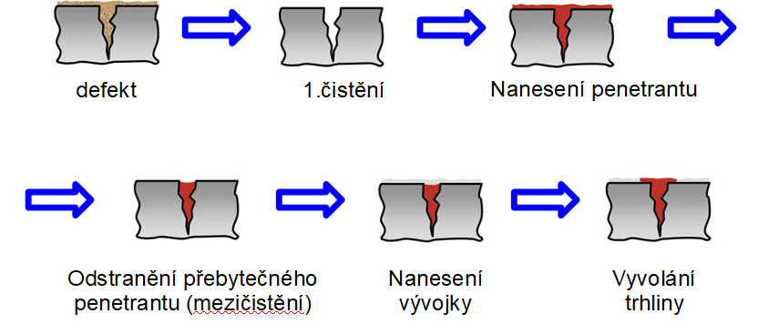
- What is an emulsifier and what is it used for in a capillary test?
- It is a substance that prevents the immiscibility of two substances that are immiscible under normal conditions (they form a system with complete insolubility in liquid and solid state).
- In the capillary test, it serves to allow the otherwise oily penetrant to be washed away with a stream of water.
- What properties must the penetrant and developer have in terms of optimal performance in the capillary test?
- Penetrant: high penetration capacity, i.e., low wetting angle, low surface tension, high flash point, low volatility, chemical inertness, low toxicity and odour
- What does the post-emulsification process mean? How is it different from the emulsifying method?
- In the case of the post-emulsification process, the emulsifier is not part of the penetrant, but is applied to the penetrant before its washing, i.e., before intermediate cleaning.
- What is the limit of resolution of defects or sensitivity in the capillary test?
- Linear defect: 1 µm
- Round defect: 3 µm
- What gauges are used in capillary testing?
- Gauges with natural incompleteness - aluminium gauge, chrome gauge, bending gauge
- Gauges with artificial incompleteness - Voest gauge, conical gauge, US Navy test block, IIW gauge
- What are the limits of the capillary test?
- Internal defects or surface defects hidden under a layer cannot be detected.
- There are also problems with the use of porous materials and materials that can be attacked by the solvent contained in the developer or penetrant.
- What is a capillary set?
- It is a capillary set consisting of a developer, penetrant and cleaner - always from one manufacturer.
- What is the difference between the capillary test using the colour method and the fluorescence method?
- In the case of the colour method, a coloured penetrant (usually red) is used; in the case of the fluorescent method, a penetrant with a fluorescent dye is used.
- What type of radiation is used in the UV test?
- UVA
- What are the advantages and disadvantages of the capillary test?
- Advantages: speed of execution, price, reliability, no need for electricity, not demanding
- Disadvantages: only surface indications, poor occupational hygiene, long test time
- What are false indications?
- Indications that are not really indications and are related to non-compliance with the correct test technology.
- What is the ISIHARA test?
- A test to detect possible colour blindness of the capillary tester
- Is it possible to find out how big the defect is based on the size of the indication detected by the capillary test?
- Not possible - the volume of liquid raised on the surface does not correspond to the internal volume of the defect

