ESF II project of the University of West Bohemia in Pilsen, reg. number: CZ.02.2.69/0.0/0.0/18_056/0013239



SEMESTER PAPER 1

TECHNOLOGICAL PROCEDURE OF HEAT TREATMENT (TZ)

NAME: Disc
Requirements for TZ: Perform soft annealing
Profile of the equipment for TZ: Select a suitable device, state its advantages, its disadvantages and under what conditions it is appropriate to use it
Material: 15NiCr6 (ČSN 16 220 standard)
TASK: Prescribe the complete heat treatment technology of the specified component
- Purpose of heat treatment in terms of expected operational requirements
- Assessment of the suitability of the structure, choice of material and semi-finished product
- Characteristics of the material used
- Choice of types of heat treatment and their heat regimes
- The position of individual heat treatment technologies in the production cycle
- Description of the design of the required production equipment or fixtures
- Expected final values and the method of their control
- Completed progress sheet

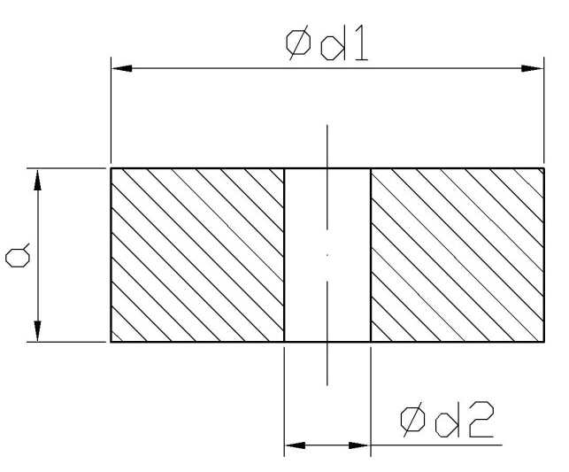

Allocation | Dimensions
a | 150
d1 | 800
d2 | 200
NAME: Weldment
Requirements for TZ: Perform refinement to reduce stress
Profile of the equipment for TZ: Select a suitable device, state its advantages, its disadvantages and under what conditions it is appropriate to use it
Material: S 235JR (ČSN 11375 standard)
TASK: Prescribe the complete heat treatment technology of the specified component
- Purpose of heat treatment in terms of expected operational requirements
- Assessment of the suitability of the structure, choice of material and semi-finished product
- Characteristics of the material used
- Choice of types of heat treatment and their heat regimes
- The position of individual heat treatment technologies in the production cycle
- Description of the design of the required production equipment or fixtures
- Expected final values and the method of their control
- Completed progress sheet
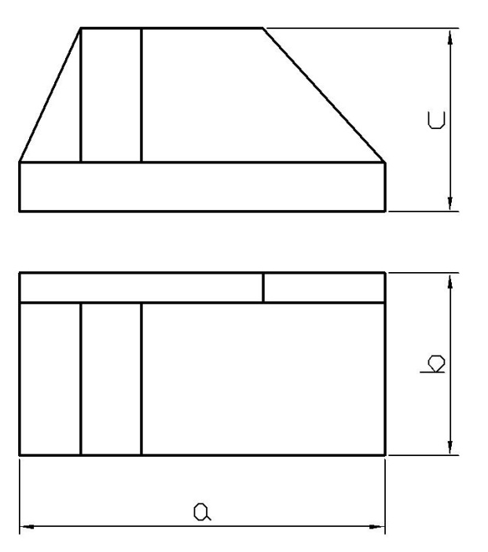
Allocation | Dimensions
a | 300
b | 200
c | 120

NAME: Clamping jig
Requirements for TZ: Perform refinement to Rm min 750 MPa
Profile of the equipment for TZ: Select a suitable device, state its advantages, its disadvantages and under what conditions it is appropriate to use it
Material: C 35 (ČSN 12040 standard)
TASK: Prescribe the complete heat treatment technology of the specified component
- Purpose of heat treatment in terms of expected operational requirements
- Assessment of the suitability of the structure, choice of material and semi-finished product
- Characteristics of the material used
- Choice of types of heat treatment and their heat regimes
- The position of individual heat treatment technologies in the production cycle
- Description of the design of the required production equipment or fixtures
- Expected final values and the method of their control
- Completed progress sheet
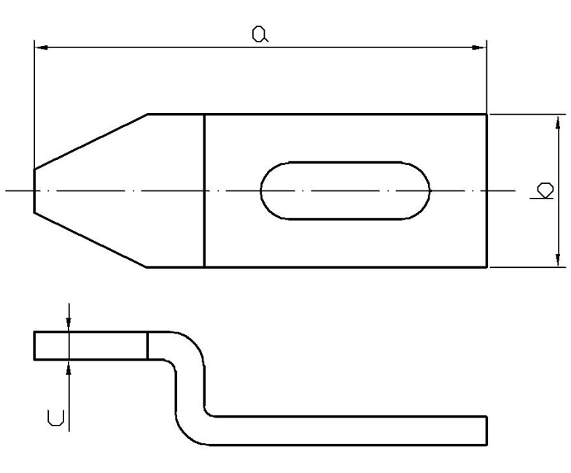
Allocation | Dimensions
a | 450
b | 200
u | 20

NAME: Drilling rod
Requirements for TZ: Perform refinement to Rm min 800 MPa
Profile of the equipment for TZ: Select a suitable device, state its advantages, its disadvantages and under what conditions it is appropriate to use it
Material: C45 (ČSN 12050 standard)
TASK: Prescribe the complete heat treatment technology of the specified component
- Purpose of heat treatment in terms of expected operational requirements
- Assessment of the suitability of the structure, choice of material and semi-finished product
- Characteristics of the material used
- Choice of types of heat treatment and their heat regimes
- The position of individual heat treatment technologies in the production cycle
- Description of the design of the required production equipment or fixtures
- Expected final values and the method of their control
- Completed progress sheet
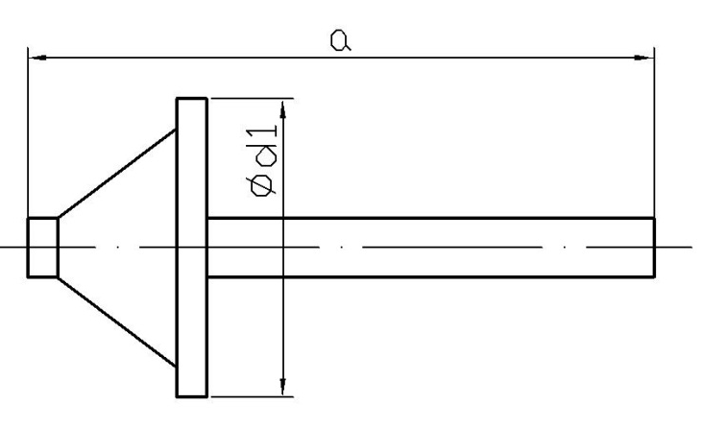

Allocation | Dimensions
a | 350
d1 | 100

NAME: Baseplate
Requirements for TZ: Perform refinement to a hardness of 290 HB
Profile of the equipment for TZ: Select a suitable device, state its advantages, its disadvantages and under what conditions it is appropriate to use it
Material: 28Mn6 (ČSN 13141 standard)
TASK: Prescribe the complete heat treatment technology of the specified component
- Purpose of heat treatment in terms of expected operational requirements
- Assessment of the suitability of the structure, choice of material and semi-finished product
- Characteristics of the material used
- Choice of types of heat treatment and their heat regimes
- The position of individual heat treatment technologies in the production cycle
- Description of the design of the required production equipment or fixtures
- Expected final values and the method of their control
- Completed progress sheet

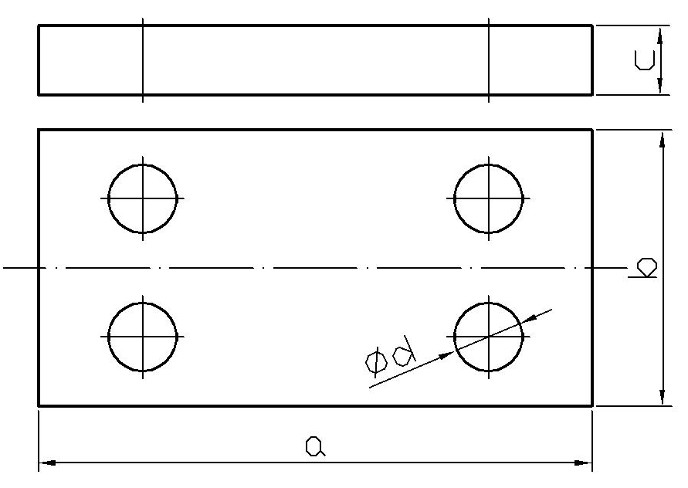

Allocation | Dimensions
a | 800
b | 600
c | 20
d | 40

NAME: Shaft
Requirements for TZ: Perform refinement to Rm min 1200 MPa
Profile of the equipment for TZ: Select a suitable device, state its advantages, its disadvantages and under what conditions it is appropriate to use it
Material: 25CrMo4 (ČSN 15 131 standard)
TASK: Prescribe the complete heat treatment technology of the specified component
- Purpose of heat treatment in terms of expected operational requirements
- Assessment of the suitability of the structure, choice of material and semi-finished product
- Characteristics of the material used
- Choice of types of heat treatment and their heat regimes
- The position of individual heat treatment technologies in the production cycle
- Description of the design of the required production equipment or fixtures
- Expected final values and the method of their control
- Completed progress sheet
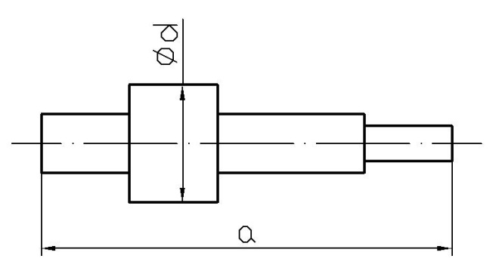

Allocation | Dimensions
a | 600
d | 100
NAME: Cogwheel

Requirements for TZ: Perform refinement to a hardness of 330 HB
Profile of the equipment for TZ: Select a suitable device, state its advantages, its disadvantages and under what conditions it is appropriate to use it
Material: 41CrMo4 (ČSN 15 142 standard)
TASK: Prescribe the complete heat treatment technology of the specified component
- Purpose of heat treatment in terms of expected operational requirements
- Assessment of the suitability of the structure, choice of material and semi-finished product
- Characteristics of the material used
- Choice of types of heat treatment and their heat regimes
- The position of individual heat treatment technologies in the production cycle
- Description of the design of the required production equipment or fixtures
- Expected final values and the method of their control
- Completed progress sheet
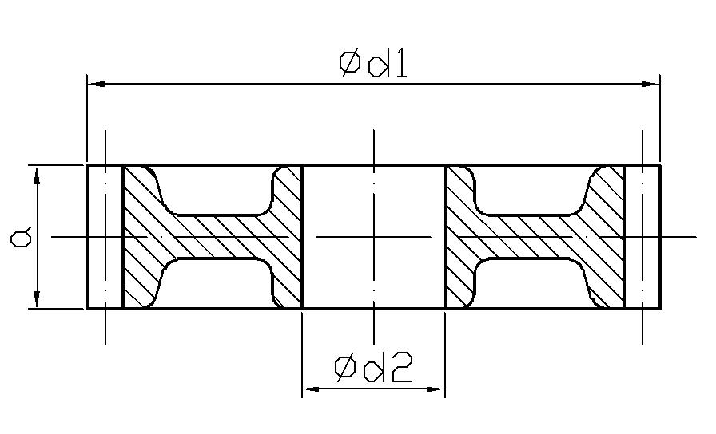
Allocation | Dimensions
a | 40
d1 | 300
d2 | 75

NAME: Hook
Requirements for TZ: Perform refinement to Rm min 1300 MPa, hardness 350 HB
Profile of the equipment for TZ: Select a suitable device, state its advantages, its disadvantages and under what conditions it is appropriate to use it
Material: 50CrV4 (ČSN 15 260 standard)
TASK: Prescribe the complete heat treatment technology of the specified component
- Purpose of heat treatment in terms of expected operational requirements
- Assessment of the suitability of the structure, choice of material and semi-finished product
- Characteristics of the material used
- Choice of types of heat treatment and their heat regimes
- The position of individual heat treatment technologies in the production cycle
- Description of the design of the required production equipment or fixtures
- Expected final values and the method of their control
- Completed progress sheet
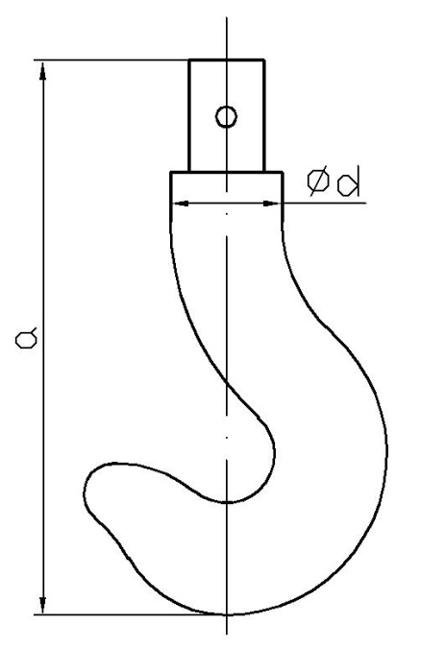
Allocation | Dimensions
a | 400
d1 | 25

NAME: Hollow shaft
Requirements for TZ: Perform refinement to Rm min 1350 MPa
Profile of the equipment for TZ: Select a suitable device, state its advantages, its disadvantages and under what conditions it is appropriate to use it
Material: 36CrNiMo4 (ČSN 16 341 standard)
TASK: Prescribe the complete heat treatment technology of the specified component
- Purpose of heat treatment in terms of expected operational requirements
- Assessment of the suitability of the structure, choice of material and semi-finished product
- Characteristics of the material used
- Choice of types of heat treatment and their heat regimes
- The position of individual heat treatment technologies in the production cycle
- Description of the design of the required production equipment or fixtures
- Expected final values and the method of their control
- Completed progress sheet
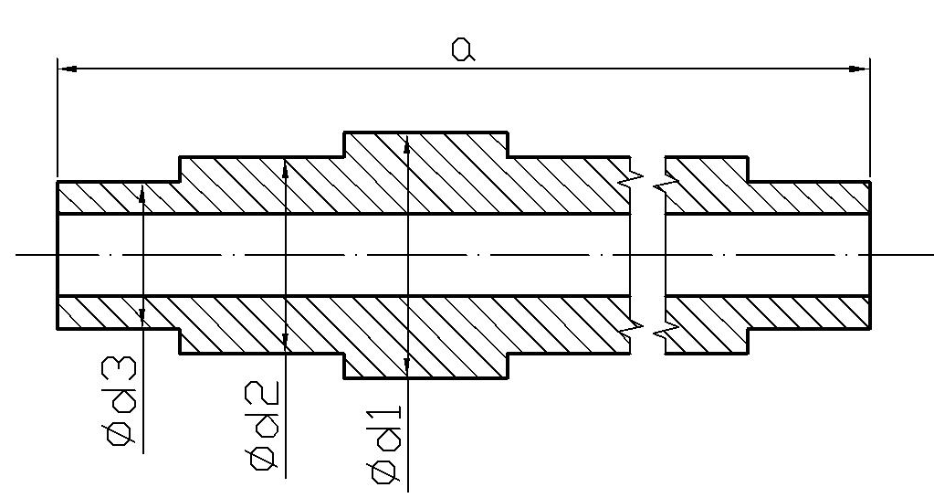

Allocation | Dimensions
a | 750
d1 | 100
d2 | 80
d3 | 60
NAME: Disc
Requirements for TZ: Perform refinement to a hardness of 320 HB
Profile of the equipment for TZ: Select a suitable device, state its advantages, its disadvantages and under what conditions it is appropriate to use it
Material: 36CrNiMo4 (ČSN 16 341 standard)
TASK: Prescribe the complete heat treatment technology of the specified component
- Purpose of heat treatment in terms of expected operational requirements
- Assessment of the suitability of the structure, choice of material and semi-finished product
- Characteristics of the material used
- Choice of types of heat treatment and their heat regimes
- The position of individual heat treatment technologies in the production cycle
- Description of the design of the required production equipment or fixtures
- Expected final values and the method of their control
- Completed progress sheet
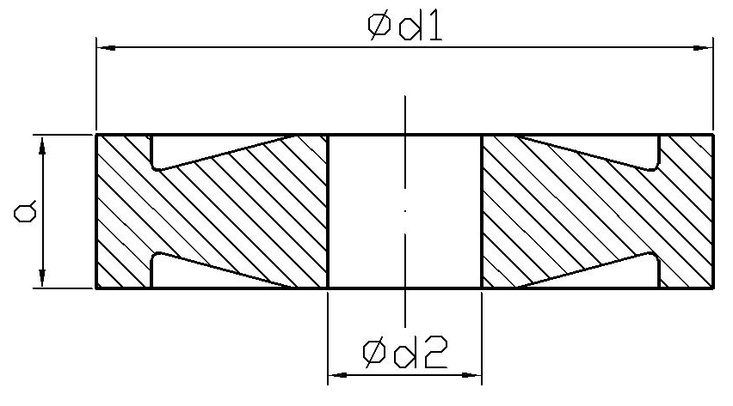
Allocation | Dimensions
a | 40
d1 | 200
d2 | 80

NAME: Chain segment
Requirements for TZ: Perform cementation on Rm core, min 850 MPa, thickness of cementation layer 0.2 mm, hardness 800 HRC
Profile of the equipment for TZ: Select a suitable device, state its advantages, its disadvantages and under what conditions it is appropriate to use it
Material: 16MnCr5 (ČSN 14 220 standard)
TASK: Prescribe the complete heat treatment technology of the specified component
- Purpose of heat treatment in terms of expected operational requirements
- Assessment of the suitability of the structure, choice of material and semi-finished product
- Characteristics of the material used
- Choice of types of heat treatment and their heat regimes
- The position of individual heat treatment technologies in the production cycle
- Description of the design of the required production equipment or fixtures
- Expected final values and the method of their control
- Completed progress sheet
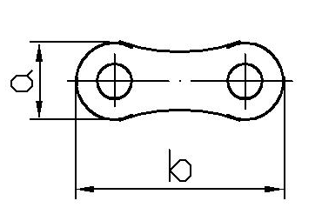
Allocation | Dimensions
a | 10
b | 30

NAME: Cogwheel
Requirements for TZ: Perform cementation on Rm core, min 1000 MPa, thickness of cementation layer 1.8 mm, hardness 60 HRC
Profile of the equipment for TZ: Select a suitable device, state its advantages, its disadvantages and under what conditions it is appropriate to use it
Material: 15NiCr6 (ČSN 16 220 standard)
TASK: Prescribe the complete heat treatment technology of the specified component
- Purpose of heat treatment in terms of expected operational requirements
- Assessment of the suitability of the structure, choice of material and semi-finished product
- Characteristics of the material used
- Choice of types of heat treatment and their heat regimes
- The position of individual heat treatment technologies in the production cycle
- Description of the design of the required production equipment or fixtures
- Expected final values and the method of their control
- Completed progress sheet
- 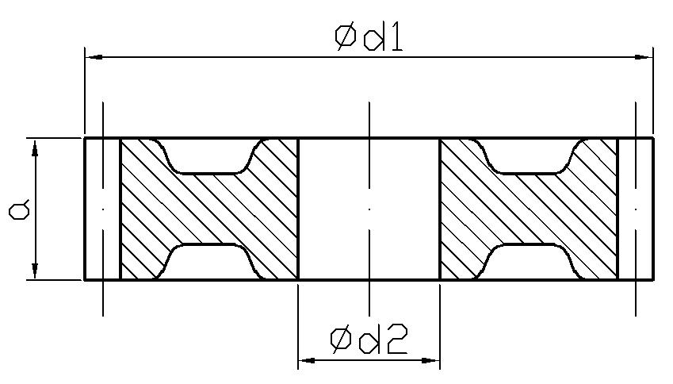

Allocation | Dimensions
a | 30
d1 | 400
d2 | 30

NAME: Pressure disc
Requirements for TZ: Perform cementation on Rm core, min 950 MPa, thickness of cementation layer 1.0 mm, hardness 59 HRC
Profile of the equipment for TZ: Select a suitable device, state its advantages, its disadvantages and under what conditions it is appropriate to use it
Material: 16MnCr5 (ČSN 14 220 standard)
TASK: Prescribe the complete heat treatment technology of the specified component
- Purpose of heat treatment in terms of expected operational requirements
- Assessment of the suitability of the structure, choice of material and semi-finished product
- Characteristics of the material used
- Choice of types of heat treatment and their heat regimes
- The position of individual heat treatment technologies in the production cycle
- Description of the design of the required production equipment or fixtures
- Expected final values and the method of their control
- Completed progress sheet
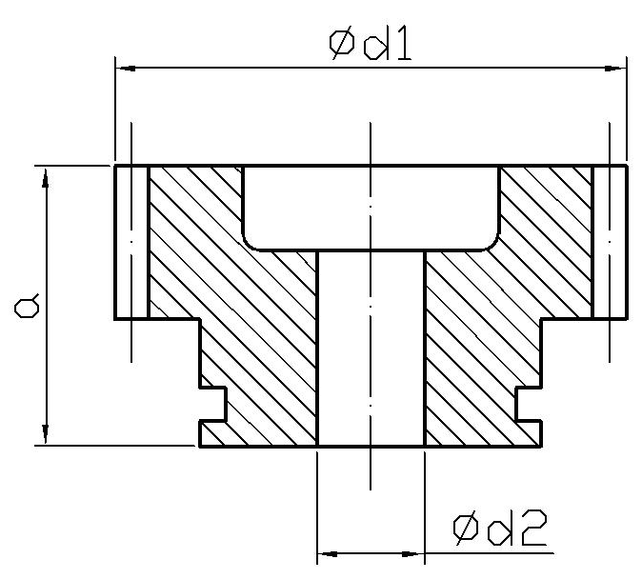

Allocation | Dimensions
a | 100
d1 | 350
d2 | 20
NAME: Cutting knife
Requirements for TZ: Perform refinement to a hardness of 56 HRC
Profile of the equipment for TZ: Select a suitable device, state its advantages, its disadvantages and under what conditions it is appropriate to use it
Material: X210CrW12-1 (ČSN 19 437 standard)
TASK: Prescribe the complete heat treatment technology of the specified component
- Purpose of heat treatment in terms of expected operational requirements
- Assessment of the suitability of the structure, choice of material and semi-finished product
- Characteristics of the material used
- Choice of types of heat treatment and their heat regimes
- The position of individual heat treatment technologies in the production cycle
- Description of the design of the required production equipment or fixtures
- Expected final values and the method of their control
- Completed progress sheet

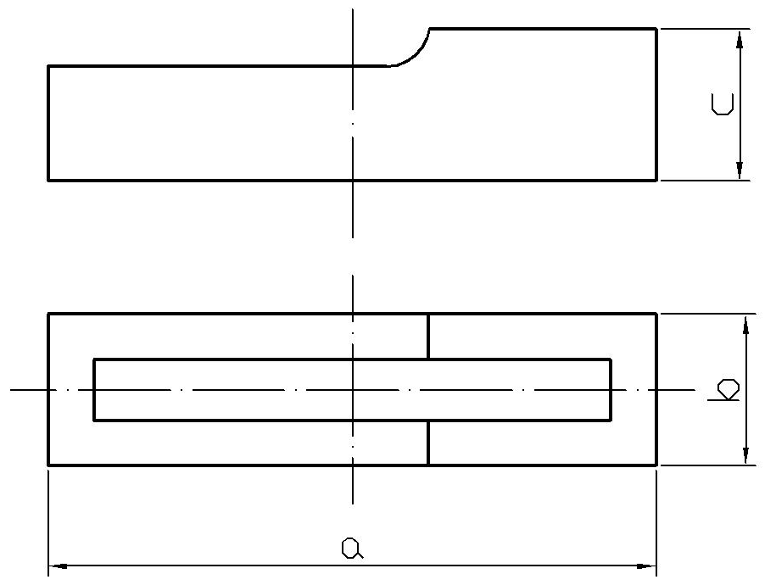

Allocation | Dimensions
a | 350
d1 | 40
d2 | 40
NAME: Heat treatment of a cutting board
Requirements for TZ: Perform refinement to a hardness of 290 HB 60 HRC
Profile of the equipment for TZ: Select a suitable device, state its advantages, its disadvantages and under what conditions it is appropriate to use it
Material: C120U (ČSN 19 221 standard)
TASK: Prescribe the complete heat treatment technology of the specified component
- Purpose of heat treatment in terms of expected operational requirements
- Assessment of the suitability of the structure, choice of material and semi-finished product
- Characteristics of the material used
- Choice of types of heat treatment and their heat regimes
- The position of individual heat treatment technologies in the production cycle
- Description of the design of the required production equipment or fixtures
- Expected final values and the method of their control
- Completed progress sheet
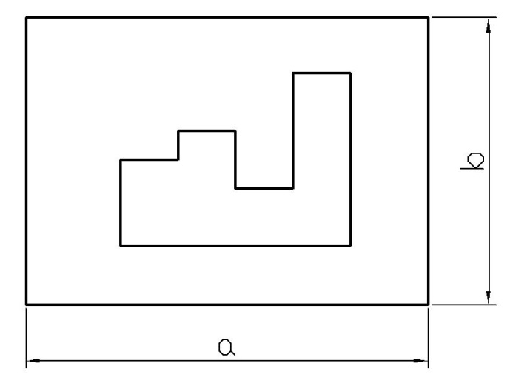

Allocation | Dimensions
a | 400
b | 400

NAME: Heat treatment of a cutter
Requirements for TZ: Perform refinement to a hardness of 60 HRC
Profile of the equipment for TZ: Select a suitable device, state its advantages, its disadvantages and under what conditions it is appropriate to use it
Material: C120U (ČSN 19 221 standard)
TASK: Prescribe the complete heat treatment technology of the specified component
- Purpose of heat treatment in terms of expected operational requirements
- Assessment of the suitability of the structure, choice of material and semi-finished product
- Characteristics of the material used
- Choice of types of heat treatment and their heat regimes
- The position of individual heat treatment technologies in the production cycle
- Description of the design of the required production equipment or fixtures
- Expected final values and the method of their control
- Completed progress sheet
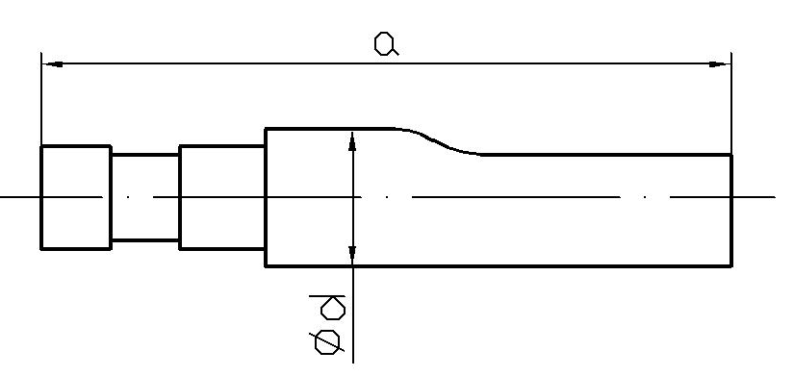

Allocation | Dimensions
a | 500
d | 35

NAME: Heat treatment of an insert
Requirements for TZ: Perform refinement to a hardness of 51 to 55 HRC
Profile of the equipment for TZ: Select a suitable device, state its advantages, its disadvantages and under what conditions it is appropriate to use it
Material: 40CrMnMo8-6 (ČSN 19 520 standard)
TASK: Prescribe the complete heat treatment technology of the specified component
- Purpose of heat treatment in terms of expected operational requirements
- Assessment of the suitability of the structure, choice of material and semi-finished product
- Characteristics of the material used
- Choice of types of heat treatment and their heat regimes
- The position of individual heat treatment technologies in the production cycle
- Description of the design of the required production equipment or fixtures
- Expected final values and the method of their control
- Completed progress sheet

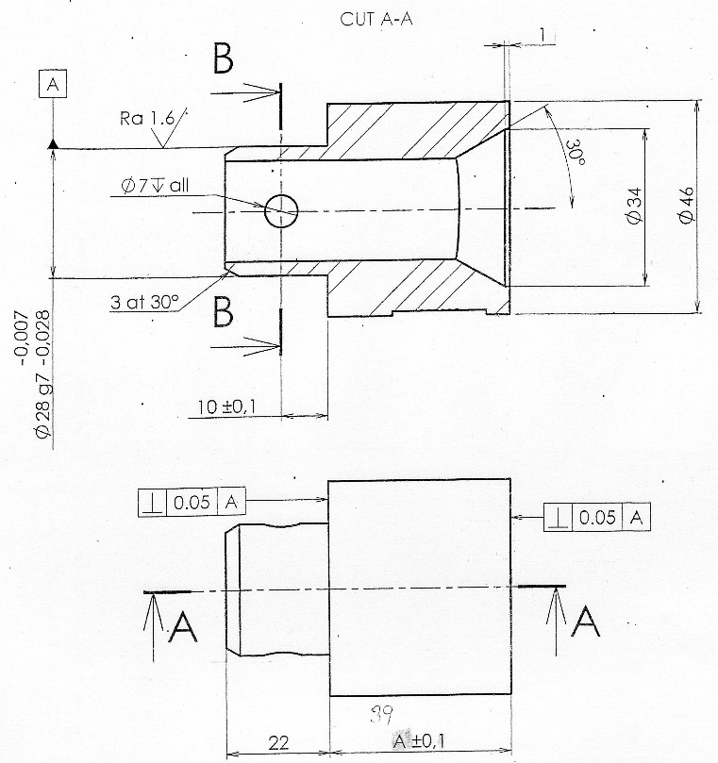

NAME: Heat treatment of a pad
Requirements for TZ: Perform refinement to a hardness of 51-55 HRC
Profile of the equipment for TZ: Select a suitable device, state its advantages, its disadvantages and under what conditions it is appropriate to use it
Material: 40CrMnMo8-6 (ČSN 19 520 standard)
TASK: Prescribe the complete heat treatment technology of the specified component
- Purpose of heat treatment in terms of expected operational requirements
- Assessment of the suitability of the structure, choice of material and semi-finished product
- Characteristics of the material used
- Choice of types of heat treatment and their heat regimes
- The position of individual heat treatment technologies in the production cycle
- Description of the design of the required production equipment or fixtures
- Expected final values and the method of their control
- Completed progress sheet

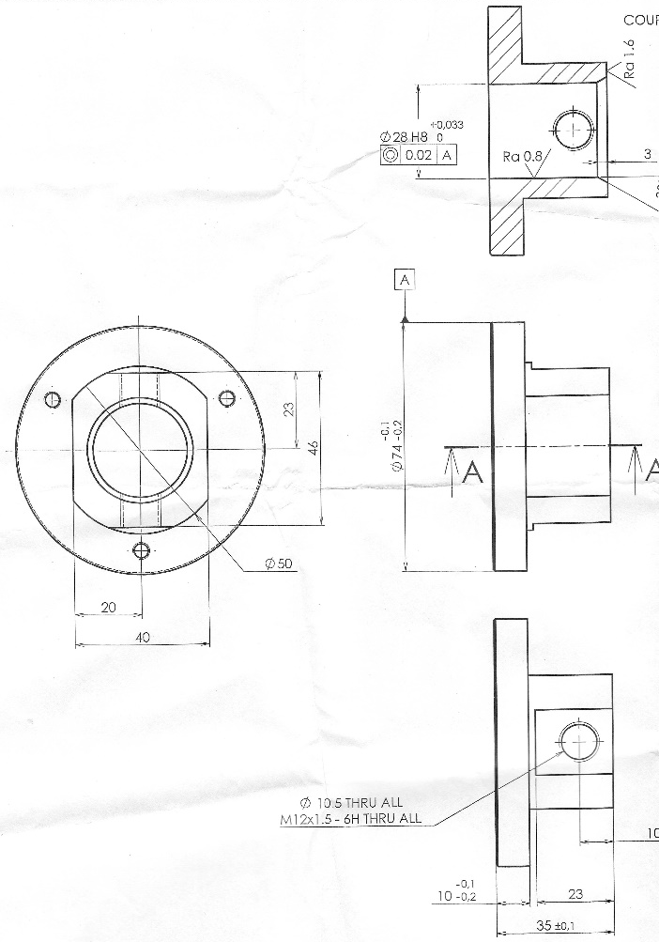



Course title: HEAT TREATMENT AND POWDER METALLURGY

Title of semester paper: TECHNOLOGICAL PROCEDURE

NAME AND SURNAME:

