Configuration of switched-mode power supply without galvanic isolation

The behavior of the convertors is described by the transfer function M depending on the switching ratio D.
These basic configurations are suitable for output power 100 W — 150W
Operating frequency range 30 kHz do 1 MHz.
Control circuits PWM modulation
Constant t on
Constant t off
Using integrated circuits, they have a low number of components and a "simple circuit"
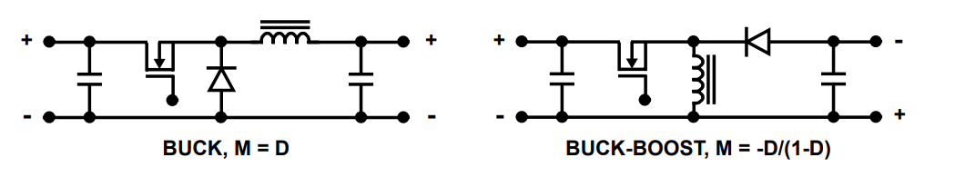
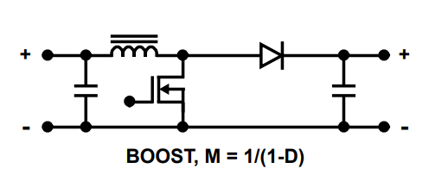
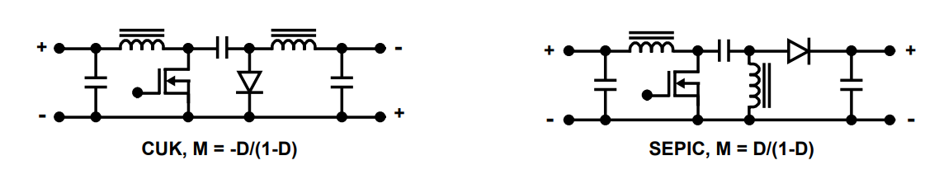
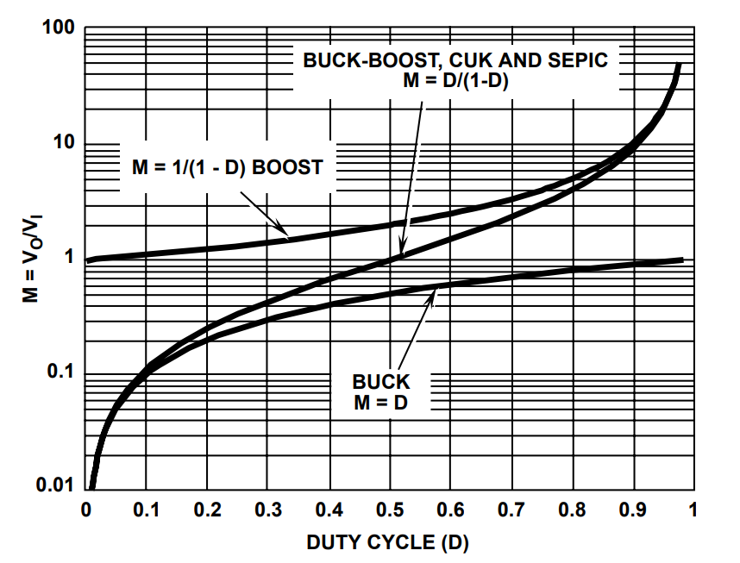
Voltage transfer as function of duty cycle for various topologies
D = t on / T , M = Uout / Uin

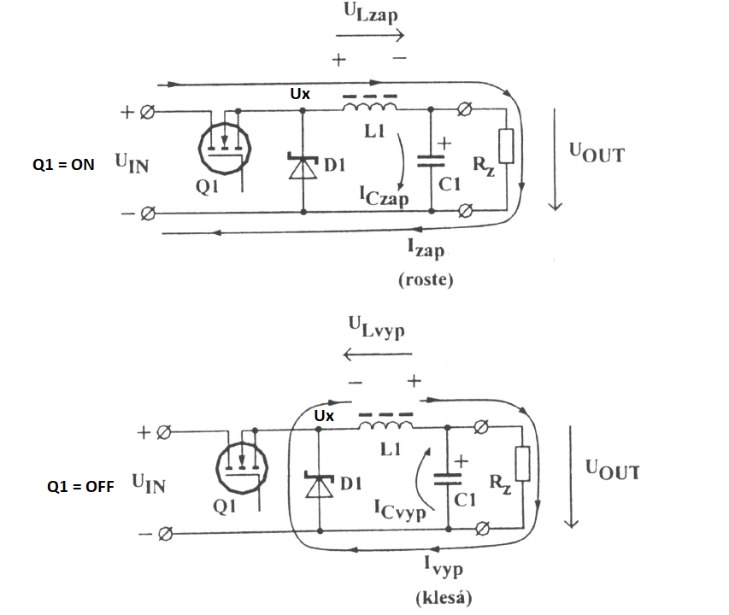
Step down (buck)
Explanations:
Zap = ON
Vyp = OFF
Roste = rise
Klesá = fall

STEP DOWN
$W_{a}=\frac{1}{2}LI_{\left(ta\right)}^{2}$ ; $W_{b}=\frac{1}{2}LI_{\left(tb\right)}^{2}$
For Continuous Mode: $W_{a}=W_{b}$
$$I_{L_{\left(ta\right)}}=\frac{1}{L}\int_{o}^{ta}{(}U_{IN}-U_{OUT})∙dt= \frac{1}{L}{(U}_{IN}-U_{OUT})∙t_{a}$$
$$I_{L_{\left(tb\right)}}=\frac{1}{L}\int_{o}^{tb}{U_{OUT}}∙dt= \frac{1}{L}U_{OUT}∙t_{b}$$
$$\frac{1}{L}U_{IN}∙t_{a}-\frac{1}{L}U_{OUT}∙t_{a}=\frac{1}{L}U_{OUT}∙t_{b}$$
$U_{IN}∙t_{a}=U_{OUT}\left(t_{b}+t_{a}\right)$ / $t_{a}+t_{b}=T$
$$U_{IN}∙t_{a}=U_{OUT}∙T$$

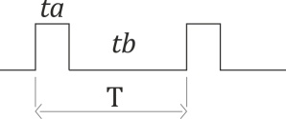
$U_{OUT}=U_{IN}∙\frac{ta}{T}$ / $\frac{ta}{T}$ = D DUTY CYCLE
$$U_{OUT}=U_{IN}∙D$$

Transfer function $M=\frac{U_{OUT}}{U_{IN}}$

M = D

In continuous mode, the voltage conversion is given only by the input voltage UIN and the duty cycle.
In discontinuous mode, the conversion is given: UIN; D; output load, magnitude of induktance
For discontinuous mode:
$$U_{OUT}=U_{IN}∙\frac{2}{1+\sqrt{\frac{4∙K}{D^{2}}}}$$

$$K=\frac{2∙L}{R_{z}∙T}$$

INDUCTANCE VALUE
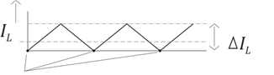
Discontinuous current - Critical current $I_{ocrit}$
$I_{ocrit}$ is define as the minimum current to maintain continuous conduction mode.
$I_{ocrit}=\frac{∆I_{L}}{2}$ $I_{L}=\int_{o}^{t_{Io}}{U_{OUT}}∙ dt$ / $I_{L}=∆I_{L}$
/ $∆I_{L}=2I_{OCRIT}$
$2I_{OCRIT}=\frac{1}{L}U_{OUT}∙t_{b}$ / $t_{b}=t_{OFF}$

$$I_{ocrit}=\frac{U_{OUT}∙t_{OFF}}{2L}$$

$$L_{min}=\frac{U_{OUT}∙t_{OFF}}{2I_{OCRIT}}$$

CAPACITOR VALUE:

→ $I_{c}= \frac{∆I_{L}}{4}$
$$U_{c}=\frac{1}{c}\int_{o}^{\frac{T}{2}}{i_{c\left(t\right)}dt}=\frac{1}{c}∙ \frac{∆I_{L}}{4}∙\frac{T}{2}=\frac{∆I_{L}∙T}{8C}=\frac{∆I_{L}}{8Cf}$$
$∆U_{c}=\frac{∆I_{L}}{8Cf} →$ $C_{min}=\frac{∆I_{L}}{8f∙∆U_{c}}$ for continuous Mode
$→$ $C_{min}=\frac{I_{OUT∙(1-\frac{I_{OUTmax}}{∆I_{L}})^{2}}}{8∙∆U_{OUT}}$ for discontinuous Mode

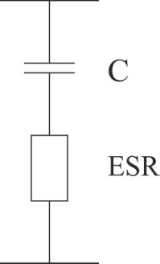

→ $E_{{SR}_{nax}=\frac{∆U_{c max}}{∆I_{L}}}$
$U_{{ESR}_{\left(t\right)}=i_{c\left(t\right)}}∙ESR$
$U_{OUT}=U_{c}+U_{ESR}$

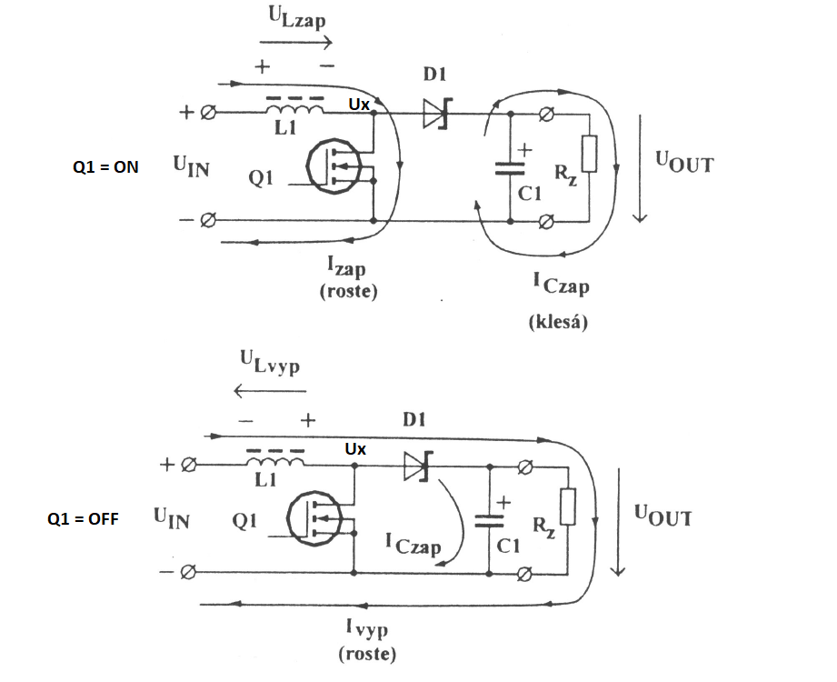
Step up - Boost
Explanations:
Zap = ON
Vyp = OFF
Roste = rise
Klesá = fall

Voltage curves Ux and current IL1 for three operation modes.

BOOST = STEP-UP
$W_{ta}=\frac{1}{2}{LI}_{(ta)}^{2}$ $W_{tb}=\frac{1}{2}{LI}_{(tb)}^{2}$

For continuous mode:
$$I_{L_{(ta)}}=\frac{1}{L}\int_{o}^{ta}{U_{IN}dt}=\frac{1}{L}U_{IN}∙ta$$
$$I_{L_{(tb)}}=\frac{1}{L}\int_{o}^{tb}{U_{L}dt}$$
$U_{L}=U_{OUT}-U_{IN}$ /$U_{OUT}=U_{IN}+U_{L}$ /
$I_{L_{(tb)}}=\frac{1}{L}\int_{o}^{t_{b}}{{(U}_{OUT}}-U_{IN})∙$dt=$\frac{1}{L}U_{OUT}t_{b}-\frac{1}{L}U_{IN}t_{b}$
↓
$\frac{1}{L}U_{IN}ta$=$\frac{1}{L}U_{OUT}t_{b}-\frac{1}{L}U_{IN}t_{b}$
$$U_{{IN}^{ta}}+U_{{IN}^{tb}}=U_{{OUT}^{tb}}$$
$\frac{U_{{IN}^{(ta+tb)}}}{tb}=U_{OUT}$ / T=ta+tb

$$U_{OUT}=U_{IN}∙\frac{T}{tb}$$

$D=\frac{ta}{T}$; $D=\frac{ta}{ta+tb}$ ; $D∙ta+D∙tb=ta$
$M=\frac{U_{OUT}}{U_{IN}}$ $D_{ta}+D_{tb}=ta$
$tb=\frac{ta(1-D)}{D}$

$$\frac{U_{IN}(ta+tb)}{tb}=U_{OUT}$$

$$\frac{U_{OUT}}{U_{IN}}=\frac{(ta+tb)}{tb}$$

$$M=\frac{ta+ \frac{ta(1-D)}{D}}{\frac{ta(1-D)}{D}}=\frac{\frac{taD+ta-taD}{D}}{\frac{ta-taD}{D}}$$

$$M=\frac{ta}{D}∙\frac{D}{ta(1-D)}$$

$$M=\frac{1}{1-D}$$

For discontinuous mode:

$$U_{OUT}=U_{IN}∙\frac{1+\sqrt{\frac{1+4∙D^{2}}{K}}}{2}$$
$$K=\frac{2L}{RT}$$

INDUCTANCE VALUE

Discontinuous current - Critical current $I_{ocrit}$ (calculated independently on I0)

$I_{o crit}=\frac{∆^{I}L}{2}$
$I_{L}=\frac{1}{L}\int_{o}^{ta}{U_{{IN}^{dt}=} } /I_{L}=∆I_{L}$ $∆I_{L}$=2$I_{ocrit}$
$$I_{ocrit}=\frac{1}{{2L}_{min}}∙U_{IN}∙ta$$
$$L_{min}=\frac{1}{{2I}_{o crit}}U_{IN}∙t_{ON}$$

$$L_{min}=\frac{U_{IN}∙t_{ON}}{2I_{ocrit}}$$

Buck – boost
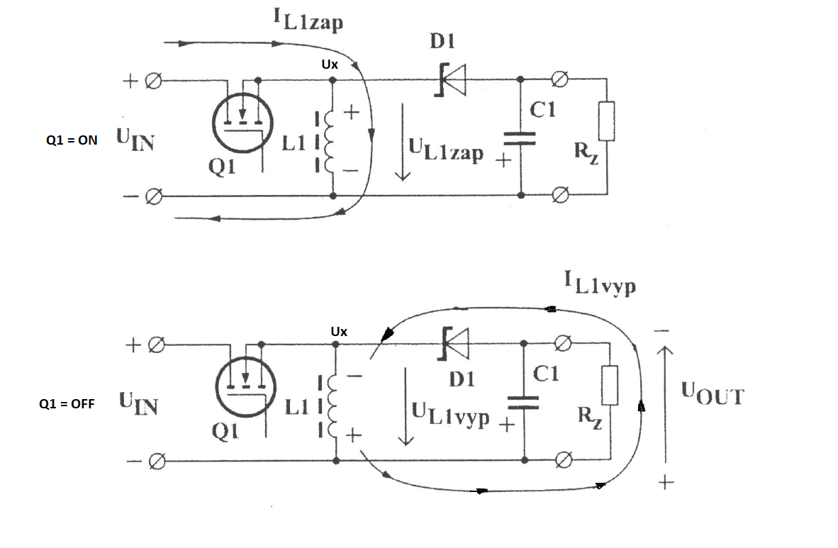
Explanations:
Zap = ON
Vyp = OFF
Roste = rise
Klesá = fall

BUCK-BOOST

$$W_{ta}=\frac{1}{2}{LI}_{I(ta)}^{2}$$
$$I_{L(ta)}=\frac{1}{L}\int_{o}^{ta}{U_{{IN}^{dt}}}=\frac{U_{IN}∙ta}{L}$$
$$I_{L(tb)}=-\frac{1}{L}\int_{o}^{tb}{U_{{OUT}^{dt}}}=-\frac{U_{IN}∙tb}{L}$$
$$\frac{U_{IN}∙ta}{L}=\frac{U_{OUT}∙tb}{L}$$

$$U_{OUT}={-U}_{IN}∙\frac{ta}{tb}$$

$$M=\frac{U_{OUT}}{U_{IN}}$$
$$D=\frac{ta}{T}=\frac{ta}{ta+tb}$$
$$D_{ta}+D_{tb}=ta$$
$$tb=\frac{ta(1-D)}{D}$$
$$M=-\frac{ta}{\frac{ta (1-D)}{D}}$$
$M=-\frac{D}{(1-D)}$ → for continuous mode
For discontinuous mode:
$U_{OUT}=U_{IN}∙\frac{D}{\sqrt{K}}$ $K=\frac{Z∙L}{R∙T}$

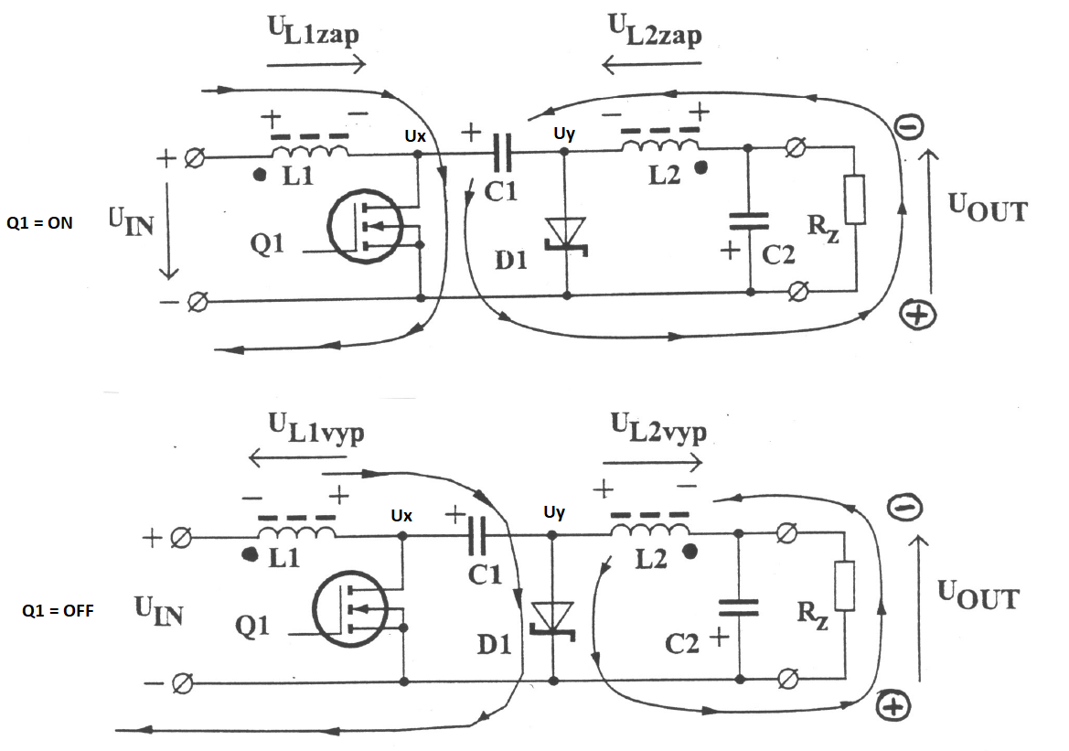
Inverting converter Ćuk

Explanations:
Zap = ON
Vyp = OFF
Roste = rise
Klesá = fall

Continuation of waveforms

ČUK SLOBODAN ČUK / CALIFORNIA INSTITUTE OF TECHNOLOGY 1976
$L_{1}=L_{2}$
$$W_{ta}=W_{tb}$$
$$I_{L_{\left(ta\right)}}=\frac{1}{L}\int_{o}^{ta}{U_{IN}}∙dt= \frac{1}{L}U_{IN}∙t_{a}$$
$$I_{L_{\left(tb\right)}}=-\frac{1}{L}\int_{o}^{tb}{U_{OUT}}∙dt= -\frac{1}{L}U_{OUT}∙t_{b}$$
$$U_{IN}∙ta={-U}_{OUT}∙tb$$
$$U_{OUT}={-U}_{IN}∙\frac{ta}{tb}$$
$$D=\frac{ta}{T}$$
$$D=\frac{ta}{ta+tb}$$
$$tb=\frac{ta(1-D)}{D}$$
$$M=\frac{U_{OUT}}{U_{IN}}$$
$$M=-\frac{ta}{\frac{ta(1-D)}{D}}$$
$$M=-\frac{ta}{1}∙\frac{D}{ta\left(1-D\right)}$$
$$M=-\frac{D}{(1-D)}$$

SEPIC Converter

Continuation of waveforms

MĚNIČ SEPIC
$$W_{ta}=W_{tb}$$
$$I_{L_{\left(ta\right)}}=\frac{1}{L}\int_{o}^{ta}{U_{IN}}∙dt= \frac{1}{L}U_{IN}∙t_{a}$$
$$I_{L_{\left(tb\right)}}=\frac{1}{L}\int_{o}^{tb}{U_{OUT}}∙dt= \frac{1}{L}U_{OUT}∙t_{b}$$
$$U_{IN}ta=U_{OUT}∙tb$$
$$\frac{U_{OUT}}{U_{IN}}=\frac{ta}{tb}$$
$$U_{OUT}=U_{IN}∙\frac{ta}{tb}$$
$$D=\frac{ta}{ta+tb}$$
$$D_{ta}+D_{tb}=ta$$
$$tb=\frac{ta\left(1-D\right)}{D}$$

$$M=\frac{ta}{tb}$$
$$M=\frac{ta}{1}∙\frac{D}{ta(1-D)}$$
$$M=\frac{D}{1-D}$$

