
ESF II project of the University of West Bohemia in Pilsen
reg. number: CZ.02.2.69/0.0/0.0/18_056/0013239

Simplified assessment of network disturbances caused by generation facilities

Reference:
[1] Czech Distribution Code – supplement no.4: Rules for parallel operation of electricity generation and accumulation facilities in distribution networks, 2019
[2] Czech standard PNE 33 3430-0 – Výpočetní hodnocení zpětných vlivů odběratelů a zdrojů distribučních soustav (Assessment of distribution network disturbances caused by customers and sources), 3rd edition, 2015
[3] D – A – CH – CZ Technical Rules for Assessment of Network Disturbances, 2nd edition 2007
[4] Standard EN 50 160 - Voltage characteristics of electricity supplied by public distribution systems, 3rd edition, 2011

Premisses
Proposed procedure for simplified assessment of network disturbances is intended for rough assessment emission levels for disturbing installations connected to low and medium voltage networks. Due to absence of source technical parameters only simplified assessment of source connectivity is feasible. The procedure is based on the limits or recommended values in actual standards (IEC 61000, EN 50160).
Individual electrical equipment or installations, which comply with the technical supply conditions of the DNO (Distribution Network Operator), can be connected to the network without inquiry. Otherwise or in the case of an accumulation of similar types of devices a connection assessment by the DNO is necessary. The connectivity assessment of the sources is made according to Czech Distribution Code – supplement no.4 [1] - chapter 10 and 11, and standard PNE 33 3430-0 [2].

Principal structure of the document D – A – CH – CZ Technical Rules for Assessment of Network Disturbances that is included in the Czech standard PNE 33 3430-0 used for connectivity assessment by the DNOs.

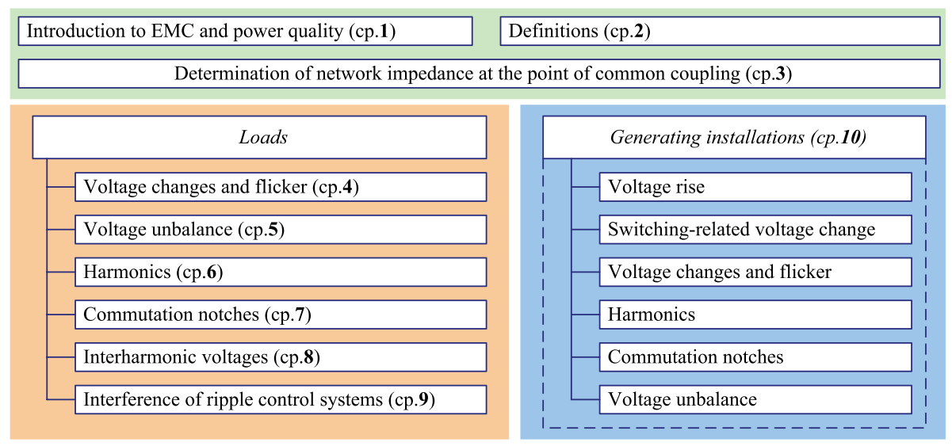
Principles of the assessment procedure
The general assessment procedure is divided in 2 stages.

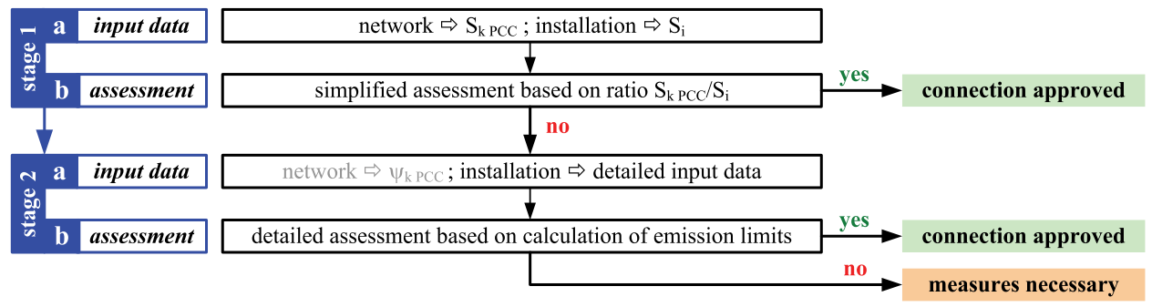
S_{k PCC} is the short-circuit power at the point of common coupling (PCC)
S_{i} is the agreed power of the network user (installation power)

The first stage consists of a very simple but more conservative assessment based on a few, easy-to-obtain parameters. If stage 1 fails, a more detailed assessment based on a more detailed description of the customer installation is necessary. In case of a positive result the connection of the customer installation can be allowed by the DNO. Otherwise corrective measures are required.
Furthermore in the case of a failing stage 2 assessment a more detailed network study (e.g. based on intensive simulations) that is usually done by external experts can be carried out and however may result in an approval of the customer installation.

In the project, only stage 1 for selected disturbances will be considered:
- voltage rise for permanent operation
- voltage change during starting
- long-term flicker intensity - only for radial network?

For assessment of other disturbances (start and switching-related voltage changes, harmonics, voltage unbalance, commutation notches) detailed data about the real generating installations at the specific PCC are needed. Because no details will be known about number of generating units connected to the PCC, type of generators (synchronous, asynchronous, and connected via converters) and their operation modes, start and switching-related voltage changes can not be assessed. Starting-related voltage changes will be evaluated only for wind power plants.

ASSESSMENT OF GENERATING INSTALLATIONS

Generally, 4 aspects have to be assessed:
- Capacity of network elements – we need to know the maximum delivered output of generating unit/units
- Voltage quality - voltage in all network nodes must be in limits after installation of generating unit/units
- Network disturbances caused by generation facilities
The emission limits for generating installations are usually stricter than for loads.
In addition to flicker, harmonics and voltage unbalance the specific disturbances voltage rise and switching-related voltage change has to be assessed for generating installations.
For the assessment it is important to take into account the totality of all generating installations in a considered network.
The most important disturbances caused by generation installations are voltage changes.
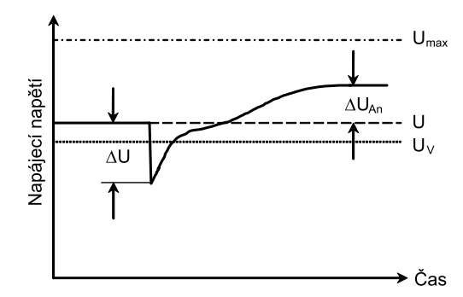
Umax – maximum limit of supply voltage
Uv – (nominal) voltage at PCC
U – supply voltage (napájecí napětí)
⊗U – voltage change
⊗U_{An} – voltage rise
⊗u_{An} =⊗U_{An} / Uv – relative voltage rise

- Requirements on static and dynamic support of the network according to the CENELEC standards related to Connection Network Code
CLC/TS 50549-1:2015 Requirements for generating plants to be connected in parallel with distribution networks - Part 1: Connection to a LV distribution network above 16 A
CLC/TS 50549-2:2015 Requirements for generating plants to be connected in parallel with distribution networks - Part 2: Connection to a MV distribution network

1. CONNECTION ASSESSMENT

Maximum delivered output of generating unit/units

For permanent operation, maximum output is S_{Emax} or in case of several generation units connected at one PCC ©S_{Emax} .
S_{Emax} , P_{Emax} – maximum apparent, active output of a generator
- Wind power plants: 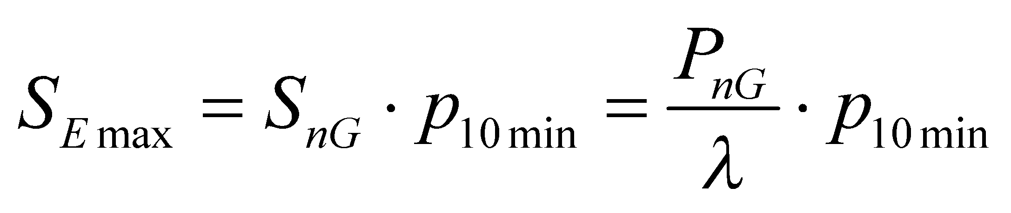 (1)
S_{nG,} P_{nG} - nominal apparent, active output of a generator
p_{10min} – maximum of average active power (10–min interval) – from generator test report (p_{10min} ≈ 1,01)
⎣ - power factor at maximum power
- Other generating plants: 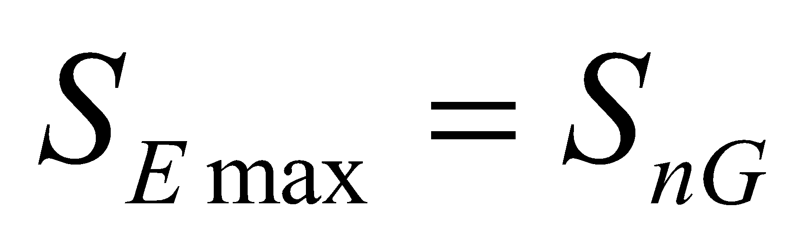 (2)

Relative voltage rise ⊗u_{A}

Voltage rise at each PCC in a network caused by the totality of all generating installations in this network must not exceed (worst case)
LV-networks: Δu _{LV} ≤ 3 % (3)
MV- and HV networks: Δu _{MV} ≤ 2 % (4)

During abnormal conditions (e.g. network configuration change due to reconstruction works)
MV- networks: Δu _{MV perm} ≤ 5 % (5)

Simultaneously, voltage at each PCC must not exceed voltage limit (Umax) according the standard EN 50160 [3].

The relative voltage change (for symmetrical conditions):
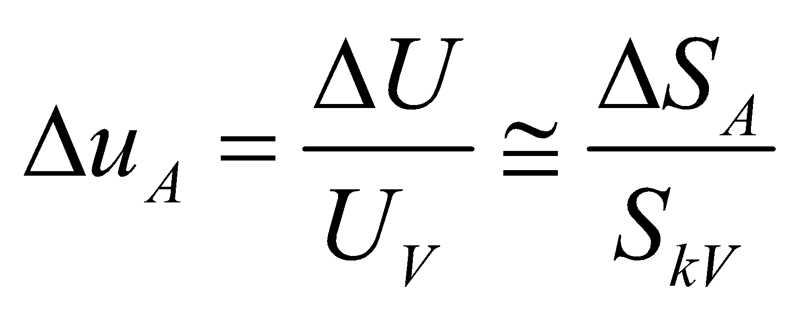 (6)
Uv – (nominal) voltage at PCC
ΔS_{A} – change of apparent output of a generator
S_{kV} – short-circuit power at point of connection (PCC)

The relative voltage change with respect of impedance phase angle ⎠
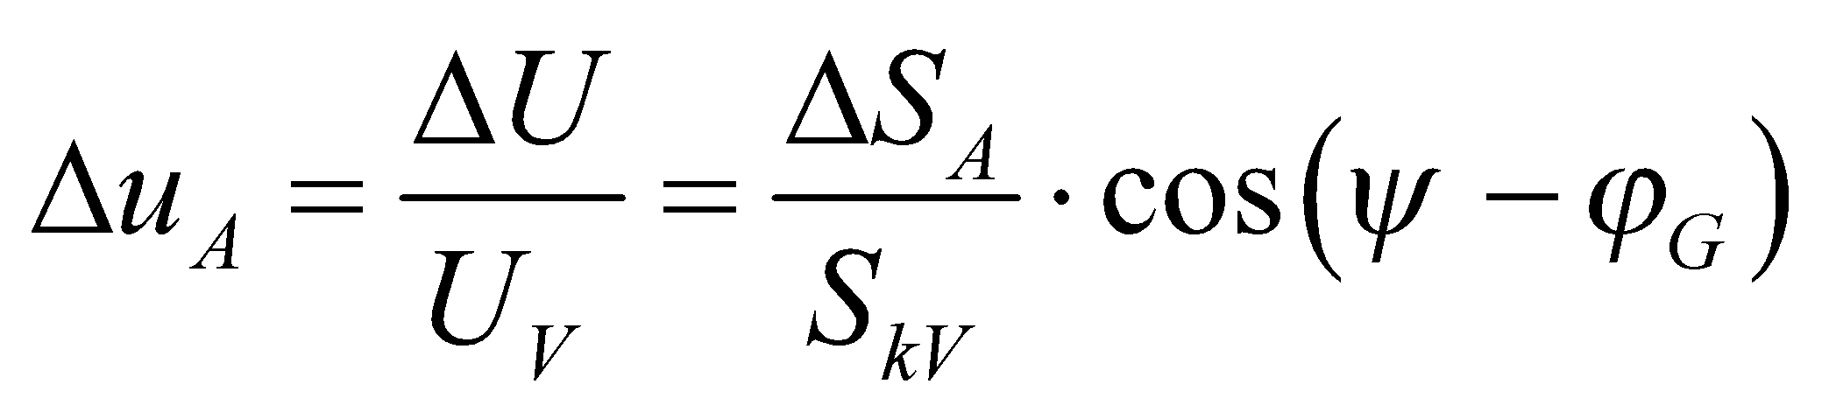 (7)
ϕ_{G} - phase angle between generator current and voltage of fundamental wave (50 Hz)
⎠ – short-circuit impedance phase angle at PCC 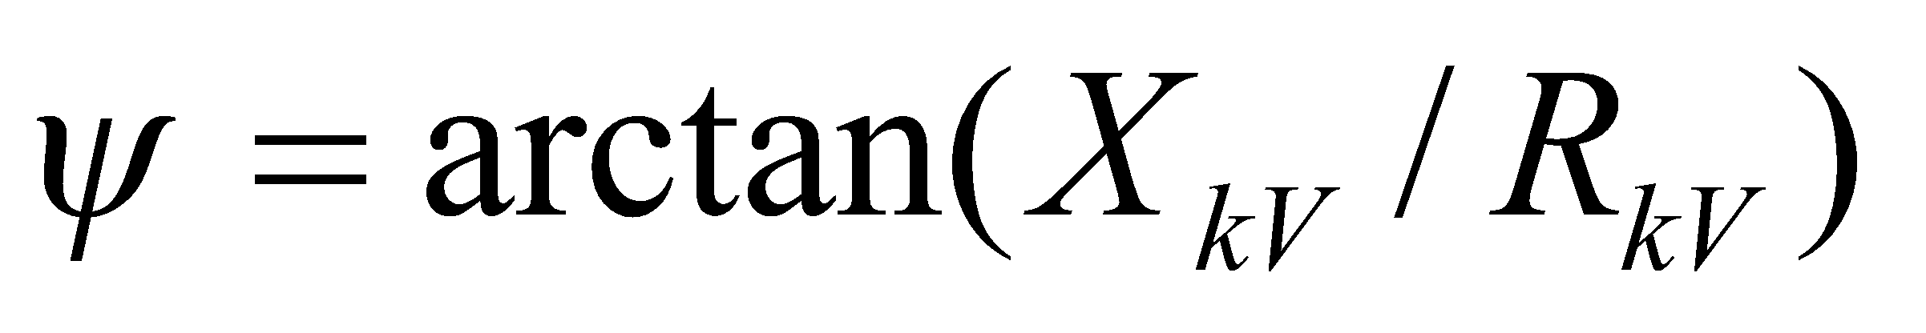
short-circuit impedance at PCC 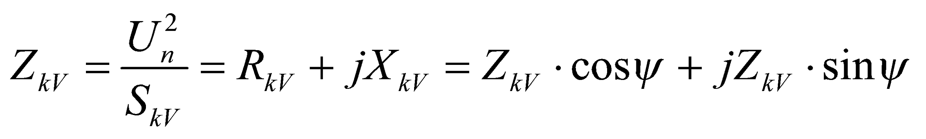
The (6) is more conservative attitude. If parameters of short-circuit impedance and generator power factor are known, it is recommended to use equation (7).
Derivation of equation (7) is in appendix.

A) Procedure for single point of connection in the network

ΔS_{A} is maximum apparent power change of a generator
- Wind power plant: 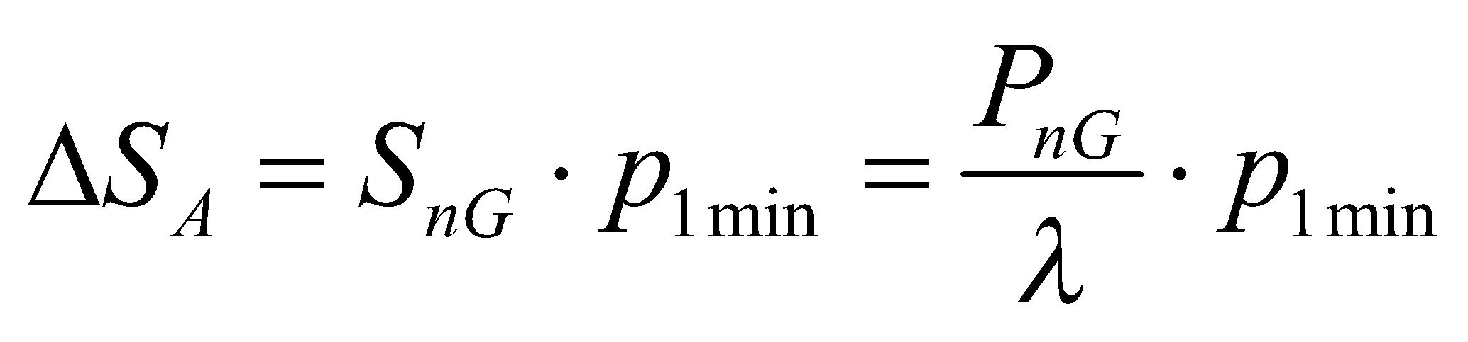
S_{nG,} P_{nG} - nominal apparent, active output of a generator
p_{1min} – maximum of average active power (1–min interval) – from generator test report (p_{1min} ≈ 1,05-1,1)
⎣ - power factor at maximum power

- Other generating plants: 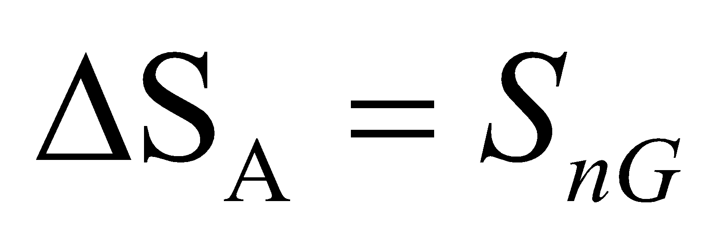

For several generating units at one PCC the summation ∑⊗S_{A} is formed from power changes of individual generators connected to the same PCC.

Phase angle between generator current and voltage ϕ_{E}:
Generating units delivering P and Q into network (e.g. overexcited synchronous generators, convertors - PWM rectifiers)
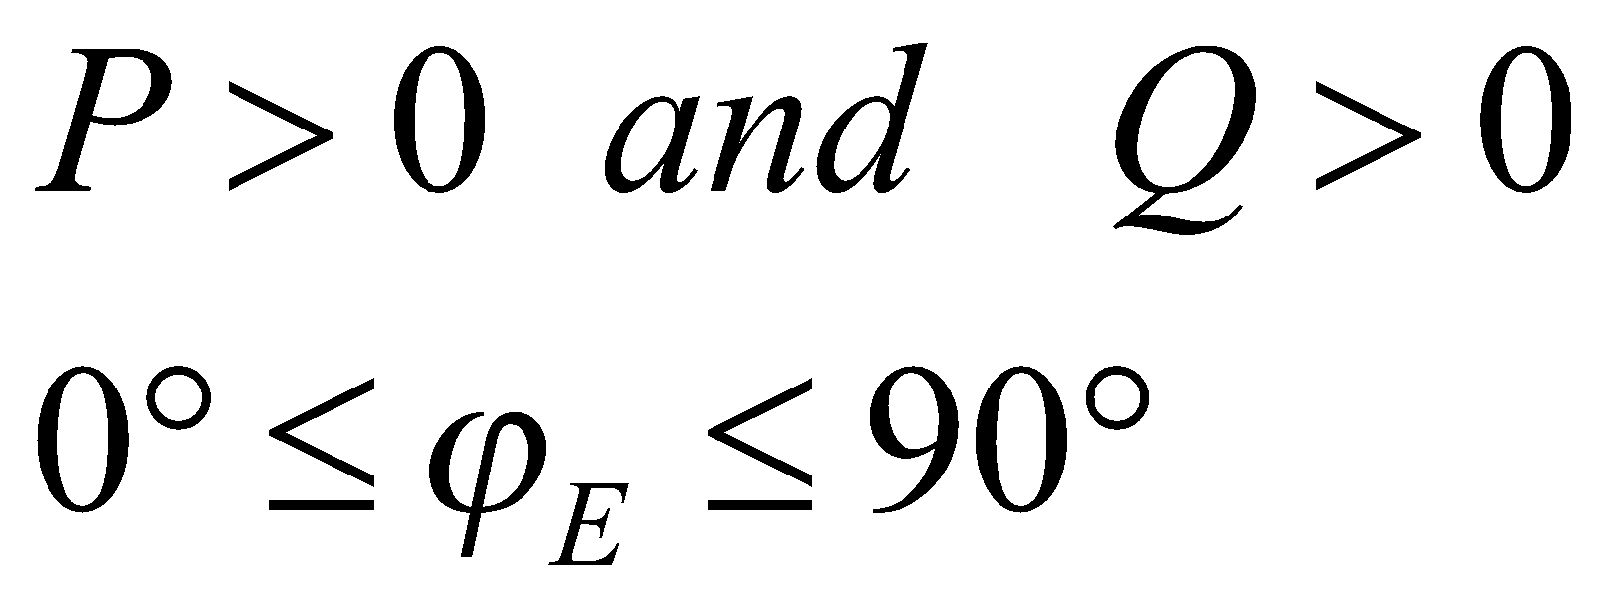
Generating units consuming Q from network (e.g. asynchronous generators, underexcited synchronous generators, line-commutated invertors)
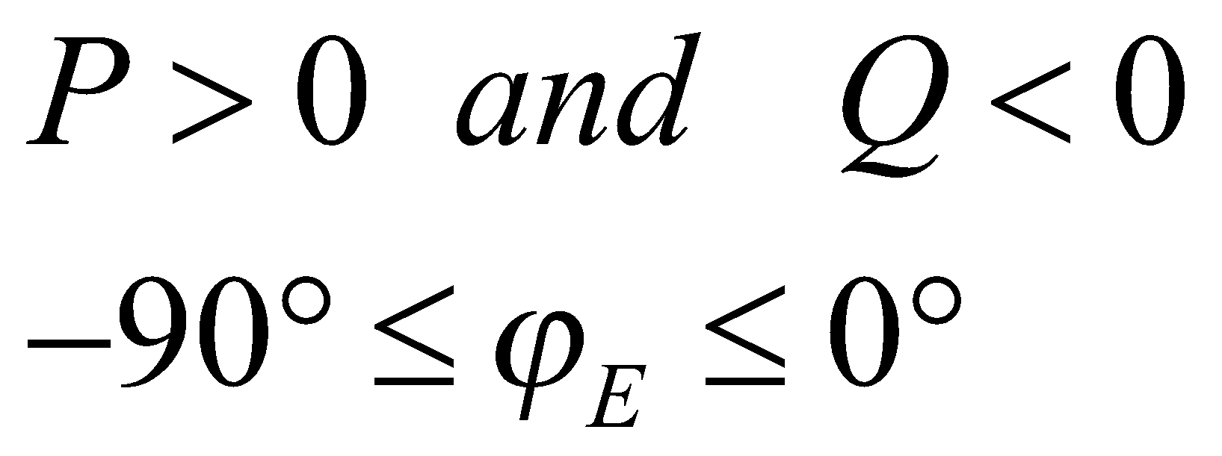

Short-circuit impedance phase angle
HV ⎠ ≈ 85° X/R ≈10
MV ⎠ ≈ 65 - 80°
LV ⎠ ≈ 5 - 80°

- 1-phase generating units connected in LV networks it can be used equation [2]:
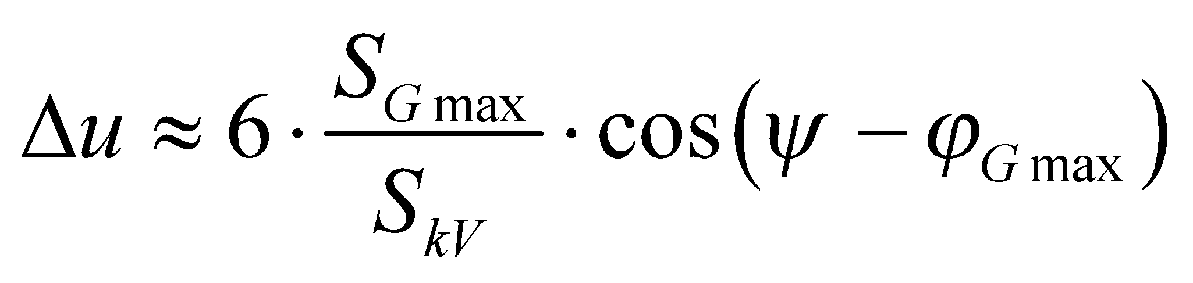 (8)
Total output of 1-phase generating installations at one PCC must be lower than 3,7 kVA.

In case of single point of connection in the network, the requirements (3) and (4) can be considered easy by using the short-circuit ratio (SCR = the ratio between short-circuit power S_{kV} at PCC and total installed capacity ∑S_{Gmax})
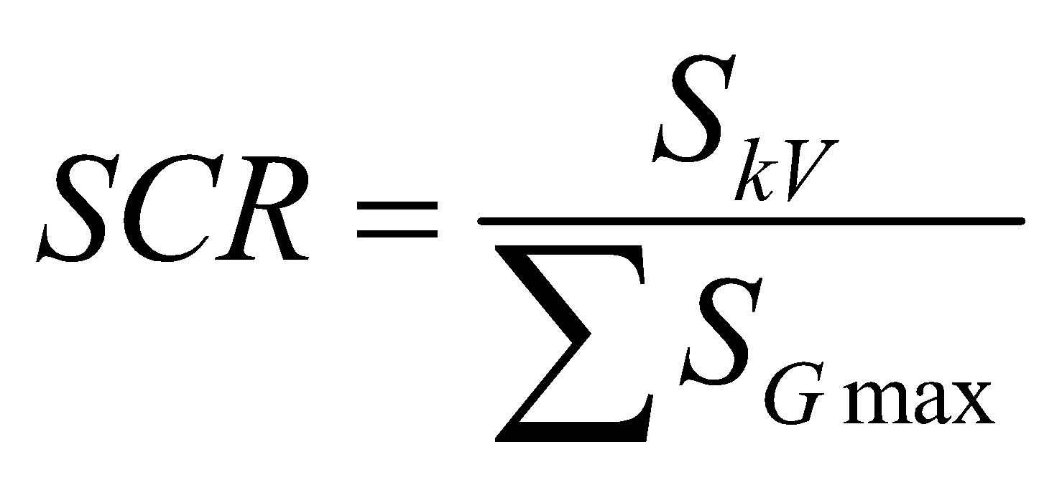
The requirements (3) and (4) are satisfied if
SCR _{LV} ≥ 33
SCR _{MV} ≥ 50

B) Procedure for several points of connection in the network

In case of generating units connected to several points of connection, or complicated network configurations (ring or meshed networks), the relative voltage rise must be calculated by power flow analysis.
If detailed data are not available, the worst case is estimated as [2]:
- LV networks: network without loading and with full outputs of generators
- MV networks: 25% loading of the network

For simulations, the power factor of generator at the point of connection must be considered cosφ_{E} = 1 if the DNO don’t set another value of power factor.

Connection-related voltage change (start or switching)

In contrast to voltage rise due to permanent operation, voltage changes due to connection-related operation (start, switching) are caused by transient effect mainly in electromechanical generators.
Voltage changes at the point of connection due to switching or starting must be
LV-networks: Δu _{LV max} ≤ 3 % (4)
MV- and HV networks: Δu _{MV max} ≤ 2 % (5)
For occasional voltage changes (e.g. intermittent starting no frequently than 1 times in day)
LV-networks: Δu _{LV max} ≤ 6 % (6)
MV-networks: Δu _{MV max} ≤ 4 % (7)

a) Start
The relative voltage change with respect of impedance phase angle ⎠
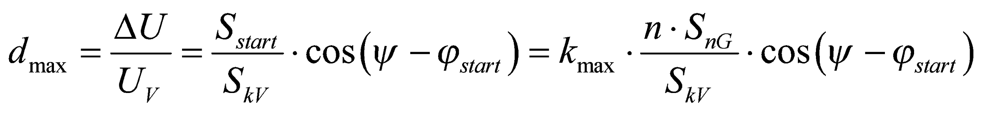
S_{start} – power change at start-up of generation unit (n=1) or group of n units
The factor k_{max} is rate of the biggest current during connecting the generator (switching surge current) and nominal current of the generator.
k_{max} = 1 synchronous generators, invertors
k_{max} = 4 asynchronous generators connected between 95% and 105% of the rated speed
k_{max} = 8 asynchronous generators starting as motor
If value of ϕ is not known, the worst case is estimated as 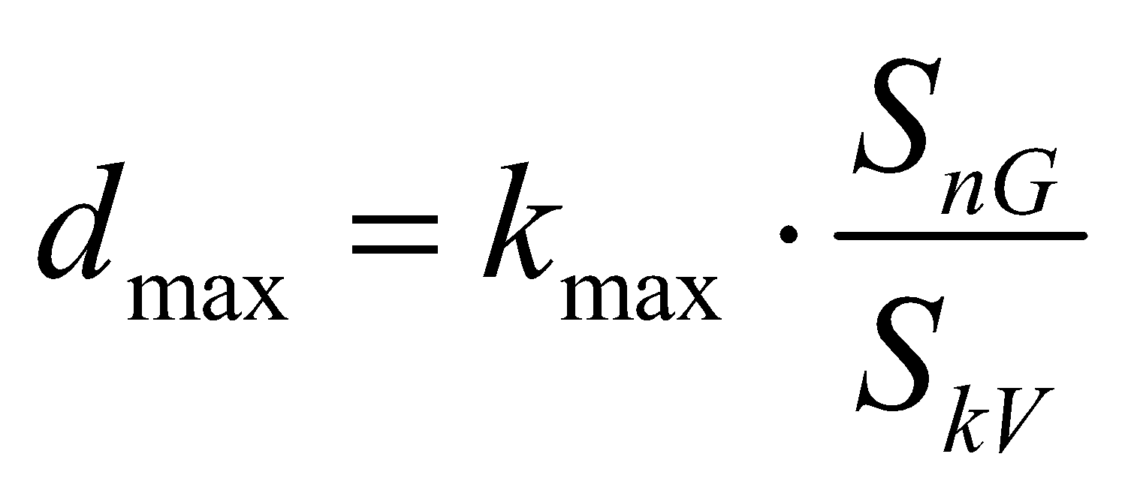

For wind power plant, k_{max} = p_{mom} is maximum of power for wind power plant (instantaneous value) – from generator test report (p_{mom} ≈ 1,2 – 1,3)
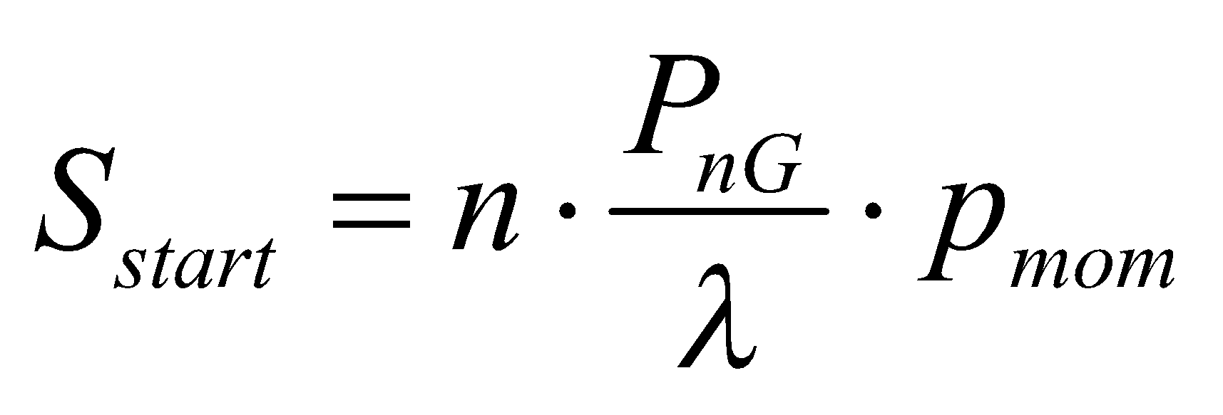, ⎣ - power factor at maximum power

b) Switching operation
S_{Z} – power change at switching of generation station
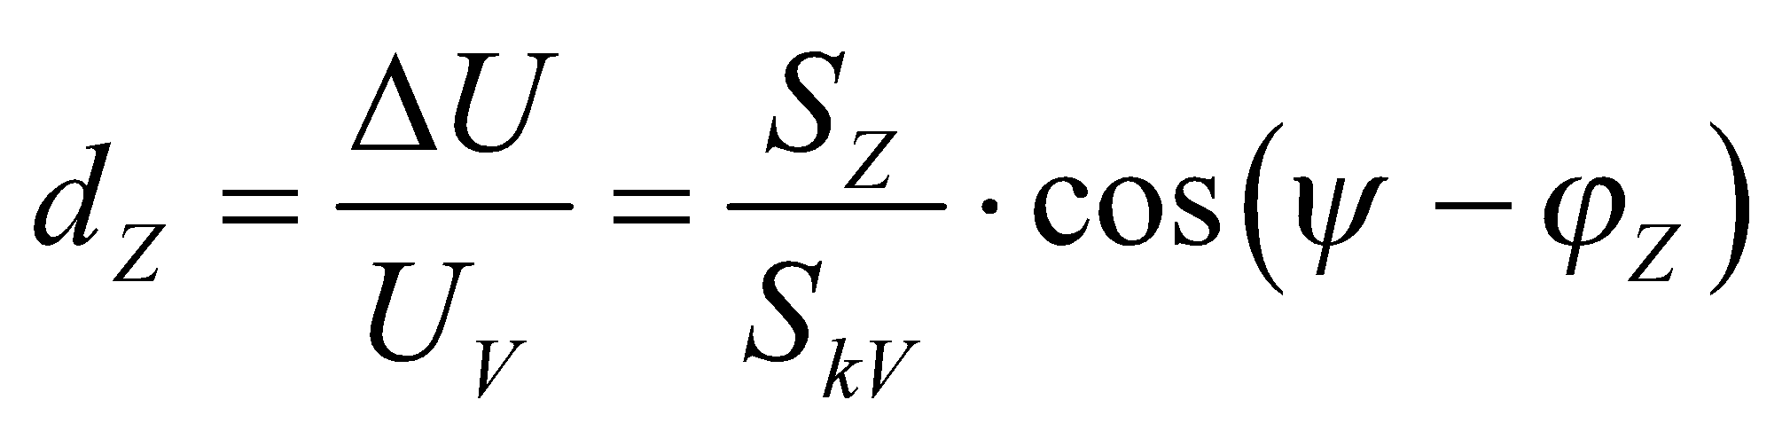
For wind plant special system dependent switched current factor k⎠ is considered: 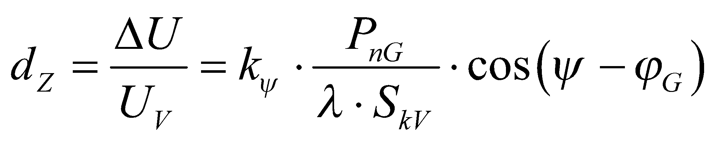 or 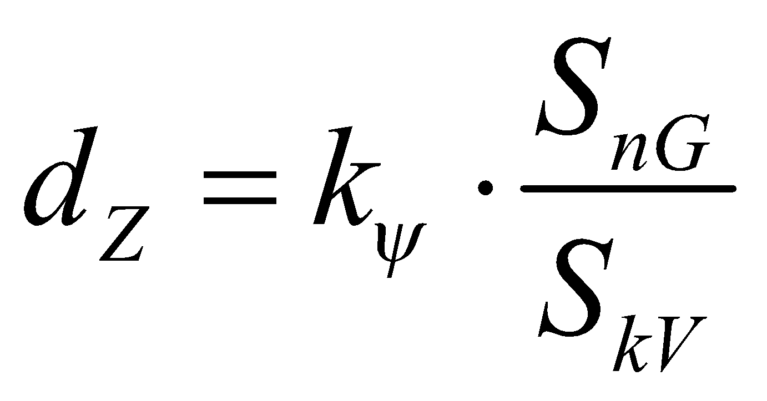
Value of k⎠ respect value of starting current as well as its time behavior, it is dependent on short-impedance angle ⎠ and is given in wind plant test report (k⎠ ≈ 0,3 – 0,5).

Voltage unbalance

The unbalance within normal operating conditions must be during any arbitrary week period 95 % of ten-minutes average effective values of inverse component in the range from 0 to 2 % of positive component.

The unbalance in PCC in specific territories can reach 3 %.

In case of 1-phase units, it is necessary to check the voltage unbalance. Acceptable value of inverse component is du2 ≤ 0,7 % from nominal voltage of LV grid.

Simultaneously, the unbalance must not exceed the limits according the standard EN 50160 .The voltage unbalance u2 in time period T is defined using method of symmetrical components as the ratio between negative sequence and positive sequence.

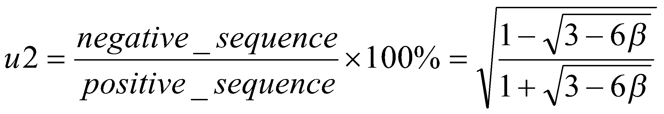

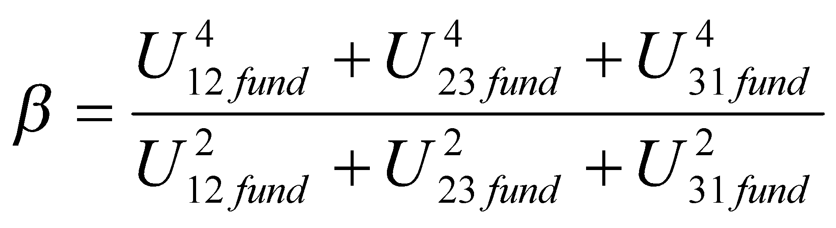

U₁₂, U₂₃, U₃₁, are line voltages of fundamental harmonic.

Zero sequence u₀ is assessed according to ratio:

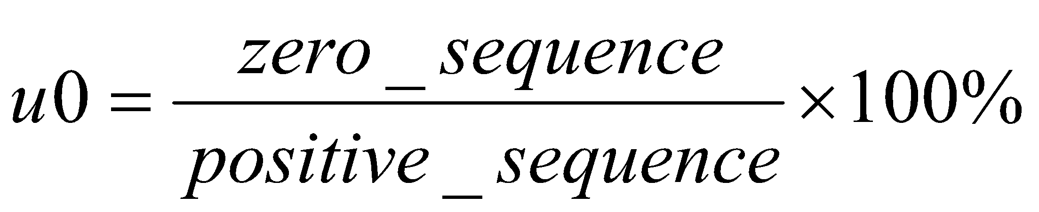

Measurements must be recorded for intervals T = 3 s, 10 min, 2 hrs.
Unbalance must be measured or calculated for each window of 10 cycles (50 Hz).

Only fundamental harmonic is to be used for the calculation. All other harmonics shold be excluded with filters or DFT algorithm.
2. DISTURBANCE ASSESSMENT

It is needed to assess the whole PQ operation range (between cosφ = 0,90 inductive and 0,90 capacitive) [1]. For generating units with output above 100 kVA, the reactive power has to be controllable in the above mentioned range.

For connectivity assessment, power factor cosφ = 1 is considered.
E.ON – cos φ_{E} = 1 is considered
ČEZ – since 2018 connectivity of MV generating facilities with Q(U) resp. P(U) regulation is assessed for cosφ according real voltage and power conditions in given MV network, e.g. cos φ_{E}= 0,95 with consumption of Q from network (that leads to increasing output of connected generating unit)

Simple rule
If the rate of short-circuit power S_{kV} and installed power capacity S_{nG} of new generating unit is higher than 500 [1], disturbance assessment is not required.
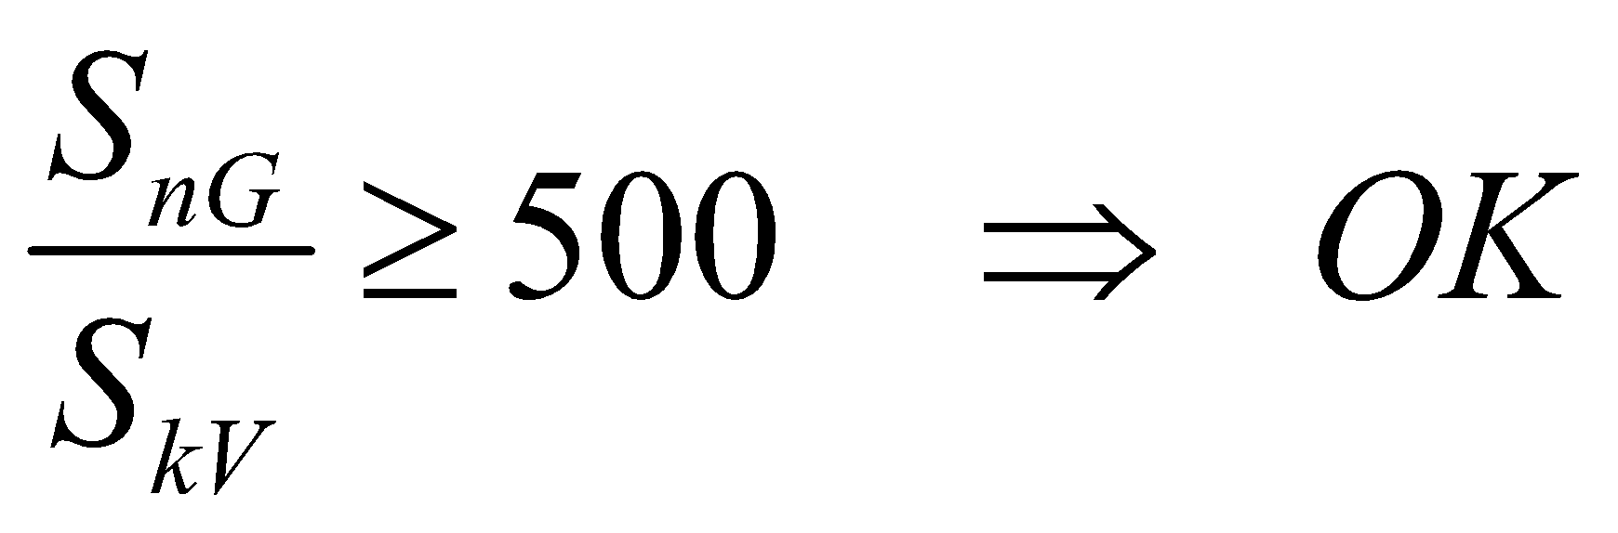

Disturbance assessment of single generating unit or group of units connected to PCC has to respect following conditions.

Voltage changes at the point of connection
LV-networks: Δu _{LV max} ≤ 3 %
MV- and HV networks: Δu _{MV max} ≤ 2 %

Long-term flicker intensity

According [1] in the MV, LV networks the limit value of long term flicker is
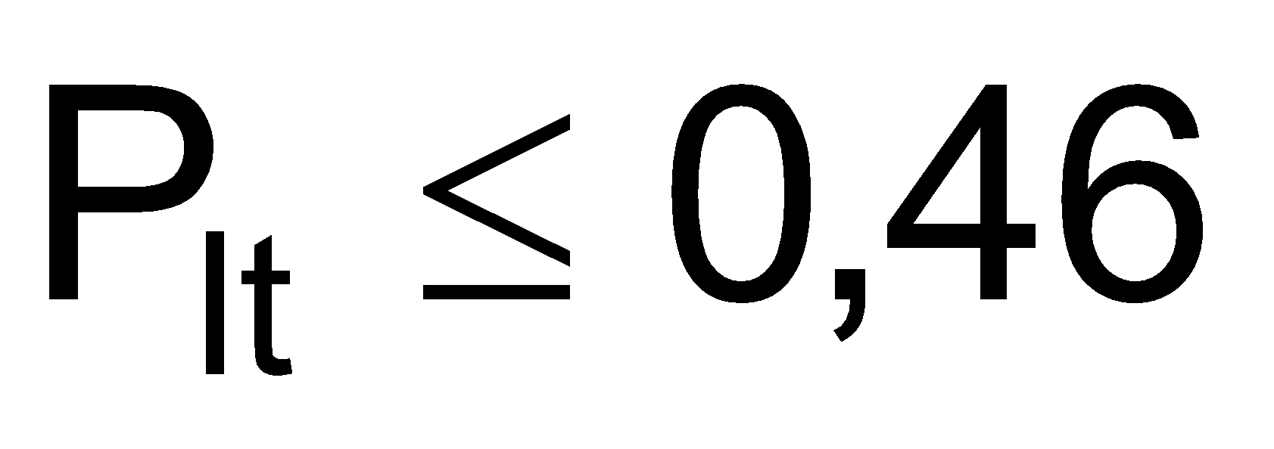
In the HV network the limit value is: 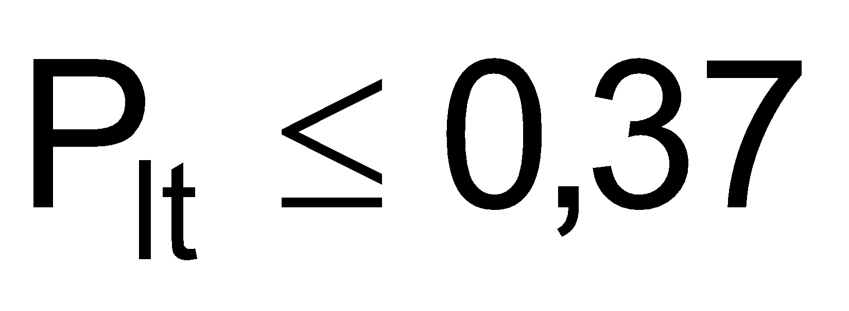

a) For single generating unit at one PCC,
the flicker can be also determined with a station flicker coefficient c (given in test report mainly for wind power plants, c ≈ 4):
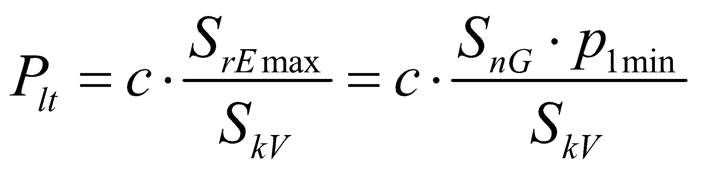
If the flicker P_{lt} is above the limit 0,46, the formula respecting short-circuit impedance phase angle ⎠ can be used:
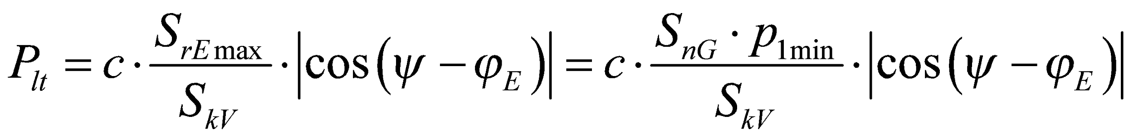

b) For several generating units at one PCC,
the summation is formed from individual P_{lti} values
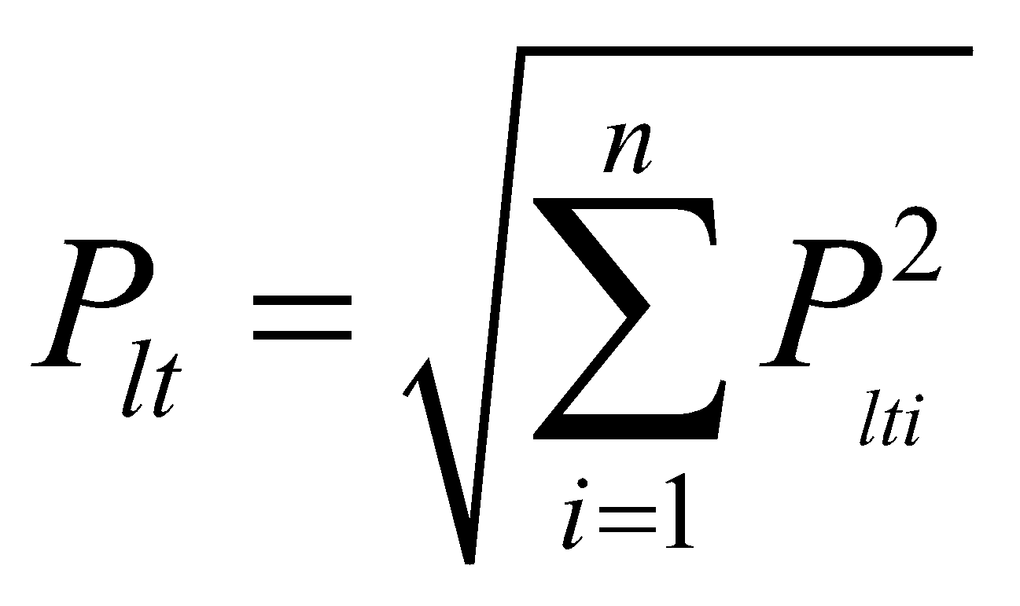 or for the plant with n same units 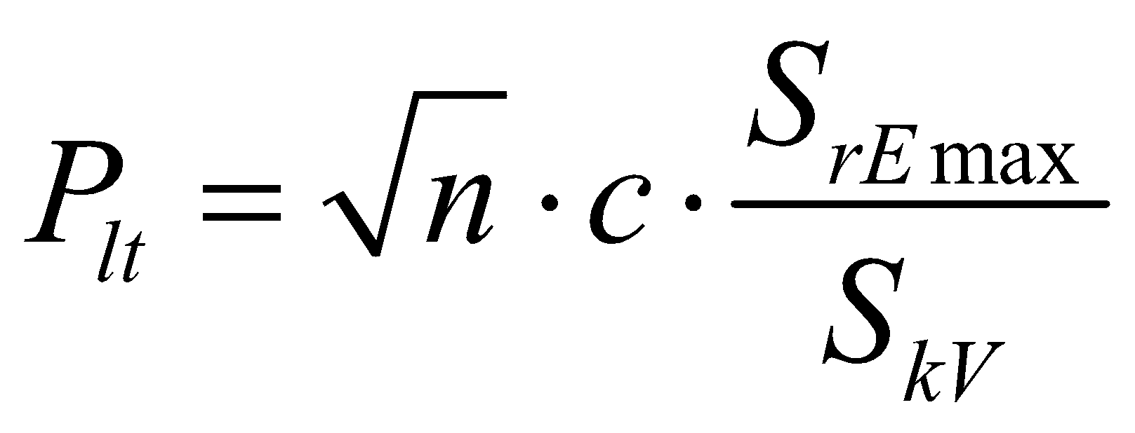

c) For several generating units at more PCC, radial feeder with n generating units
For each generating unit “j” is calculated flicker P_{lt jj} at its PCC “j” according a) or b).
For each generating unit “j” is calculated flicker P_{lt jk} at other PCCs “k” (k≠j) :

G

G

G

j

k1

k2

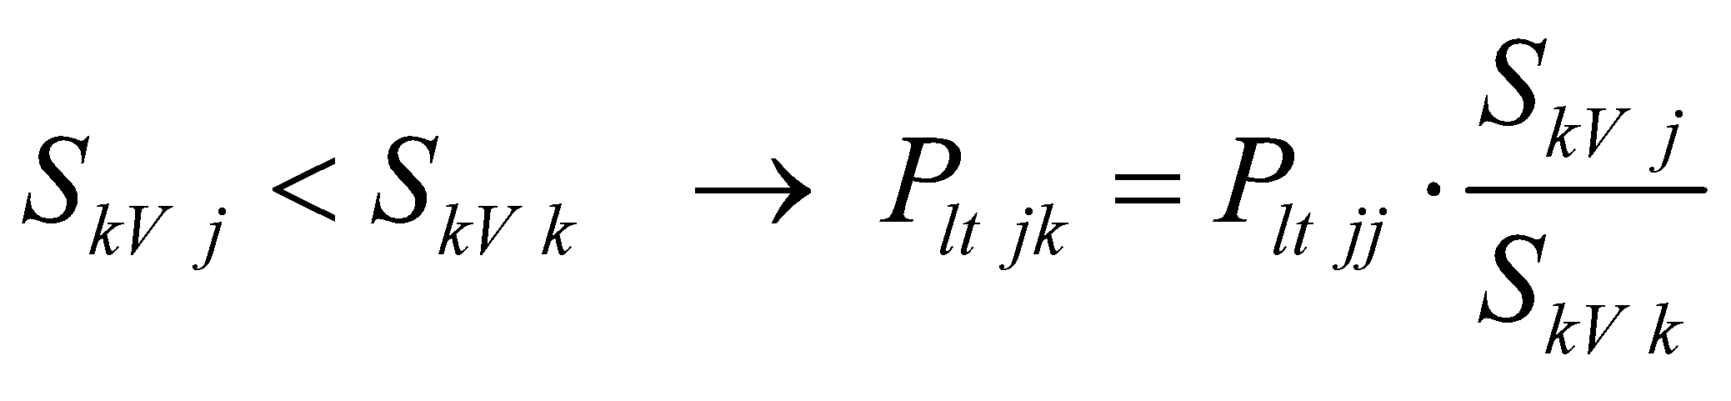 (e.g. k = k1)
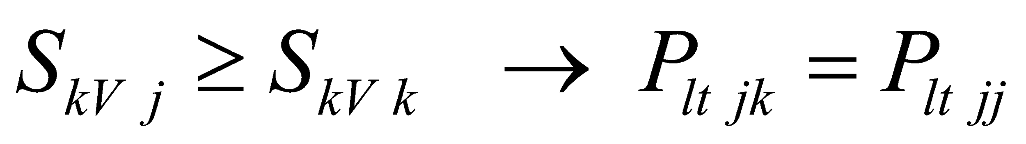 (e.g. k = k2)
P_{lt jk} is flicker at PCC “k” caused by a generating unit connected to PCC “j”
S_{kV j} is short-circuit power at PCC “j”
S_{kV k} is short-circuit power at PCC “k”
Flicker at PCC “k” is :
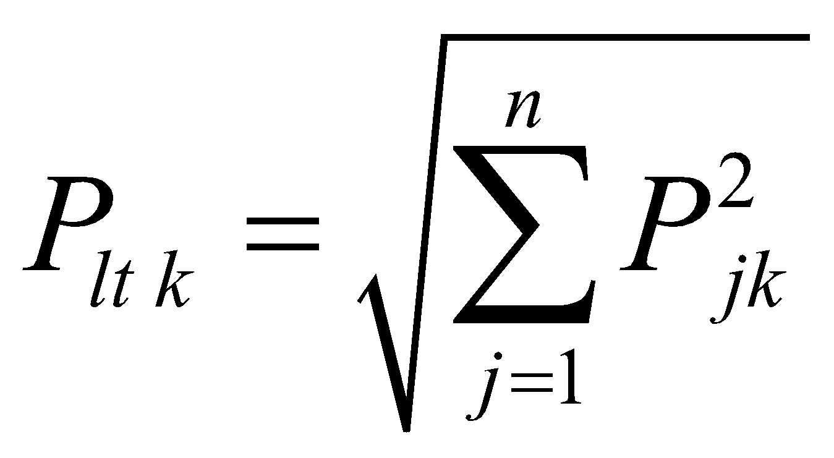 , e.g. 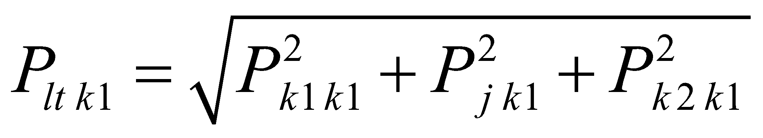
For complicated network configuration the simulation is needed.

Harmonics
Disturbance assessment only if generation units are connected to the network via frequency converters or inverters.
Harmonic currents emitted by equipment are given by its producer.

If the LV source comply with standard EN 61000-3-2 (current up to 16 A) or EN 61000-3-12 (current >16 A and ≤75A), the levels of emitted harmonic currents are permissible. If the levels in these standards are exceeded, then the following simple procedure has to be used:
Permissible harmonic currents
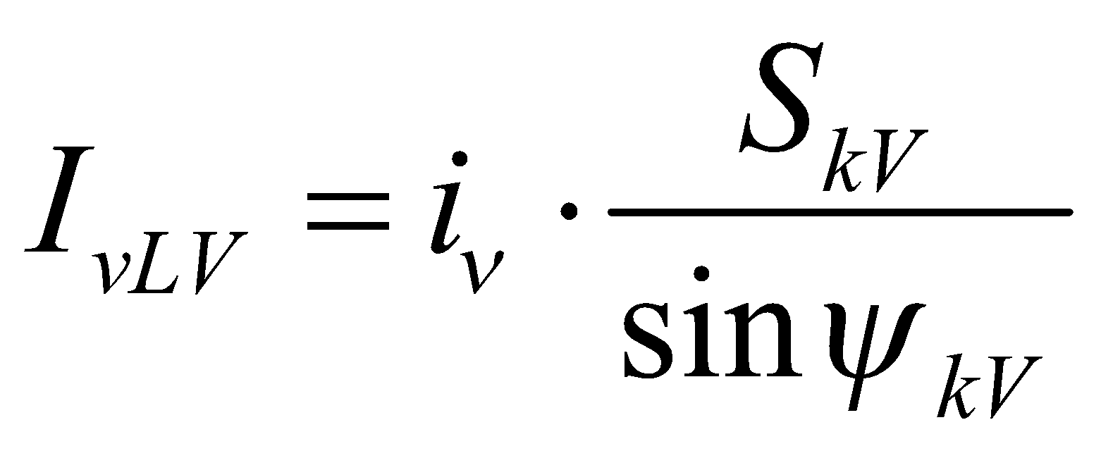
sin ψ_{kV} =X_{k}/Z_{k} is approximately equal 1, when the energy source is close to distribution transformer MV/LV [1].

Harmonic order ⎨ | Permissible reference current i⎨ (A/MVA)
3 | 3
5 | 1,5
7 | 1
9 | 0,7
11 | 0,5
13 | 0,4
17 | 0,3
19 | 0,25
23 | 0,2
25 | 0,15
25 < ⎨ < 40 | 0,15*25/⎨
In the MV network
a) For only one PCC in the network,
Permissible harmonic currents
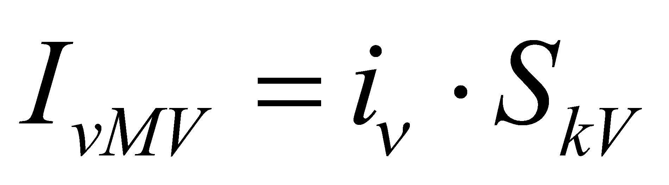

Harmonic order ⎨ | Permissible reference current i⎨ (A/MVA)
Harmonic order ⎨ | 10 kV | 22 kV | 35 kV
5 | 0,115 | 0,058 | 0,033
7 | 0,082 | 0,041 | 0,023
11 | 0,052 | 0,026 | 0,015
13 | 0,038 | 0,019 | 0,011
17 | 0,022 | 0,011 | 0,006
19 | 0,016 | 0,009 | 0,005
23 | 0,012 | 0,006 | 0,003
25 | 0,010 | 0,005 | 0,003
25 < ⎨ or odd harmonics | 0,06/⎨ | 0,03/⎨ | 0,017/⎨

b) For more sources at one PCC in the network,
Permissible harmonic currents for individual sources
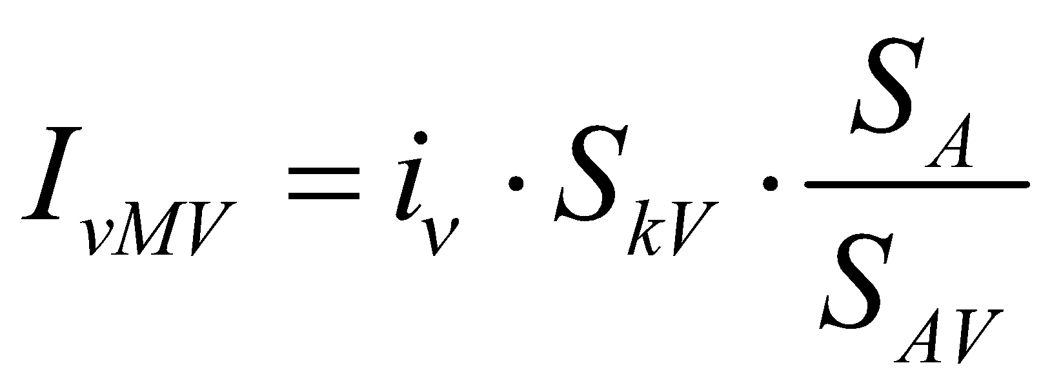
S_{A} is the installed output of the source,
S_{AV} is the installed power of all sources connected to point of common coupling PCC.

c) For more sources connected at more PCC in the network,
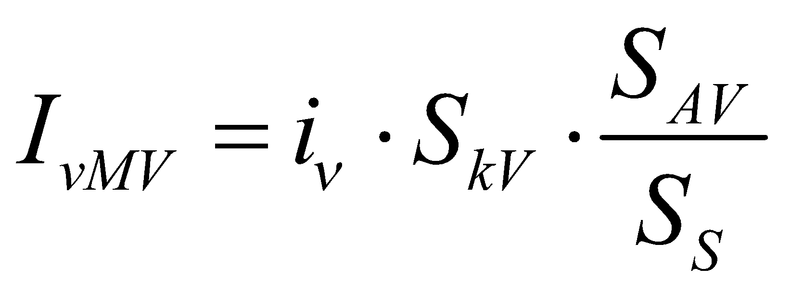
S_{AV} is the installed power of all sources connected to given PCC.
S_{S} is the total power for which the network is designed.

Apendix
Voltage change (phase to ground):

ΔI_{A} – change of (generating or consuming unit) current
ϕ - phase angle between current and voltage during the output change
short-circuit impedance at PCC
S_{kV} – short-circuit power at point of connection (PCC)
⎠ – short-circuit impedance phase angle at PCC

Relative voltage change:

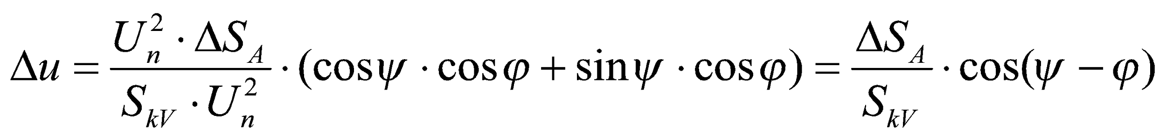

The relative voltage change with respect of impedance phase angle ⎠:
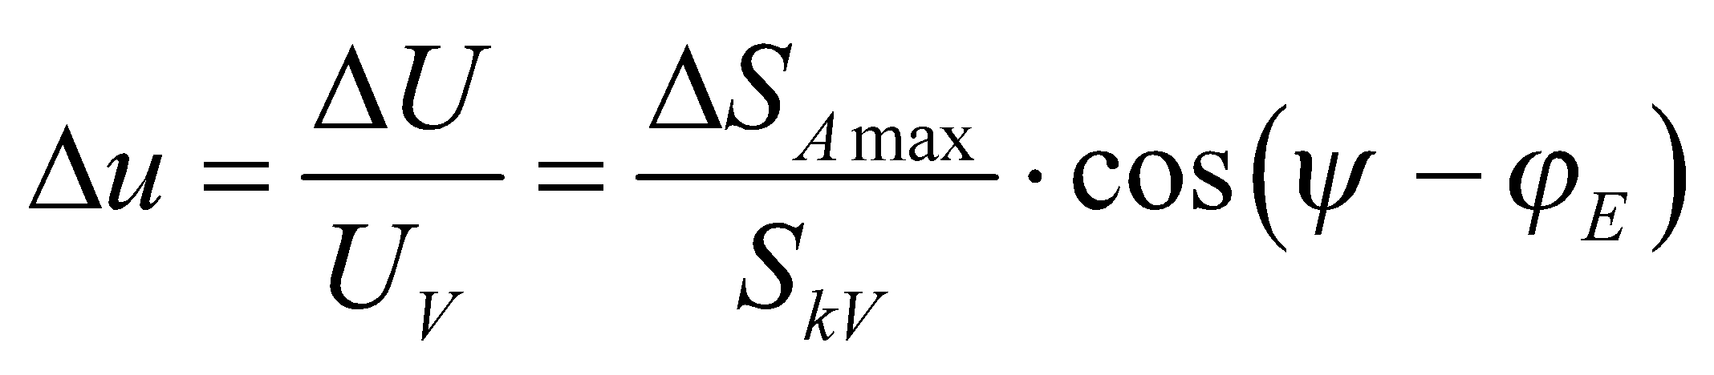

If the network load is strongly inductive it is necessary to calculate with the short-circuit impedance phase angle ⎠ and the phase angle between generator current and voltage of fundamental wave (50 Hz) ϕ.

Short-circuit impedance phase angle
HV ⎠ ≈ 85° X/R ≈10
MV ⎠ ≈ 65 - 80°
LV ⎠ ≈ 5 - 80°

Phase angle between generator current and voltage (for S_{Emax}) ϕ_{E}:
Generating units delivering P and Q into network (e.g. overexcited synchronous generators, convertors – PWM rectifiers)

then

Generating units consuming Q from network (e.g. asynchronous generators, underexcited synchronous generators, line-commutated invertors)

then 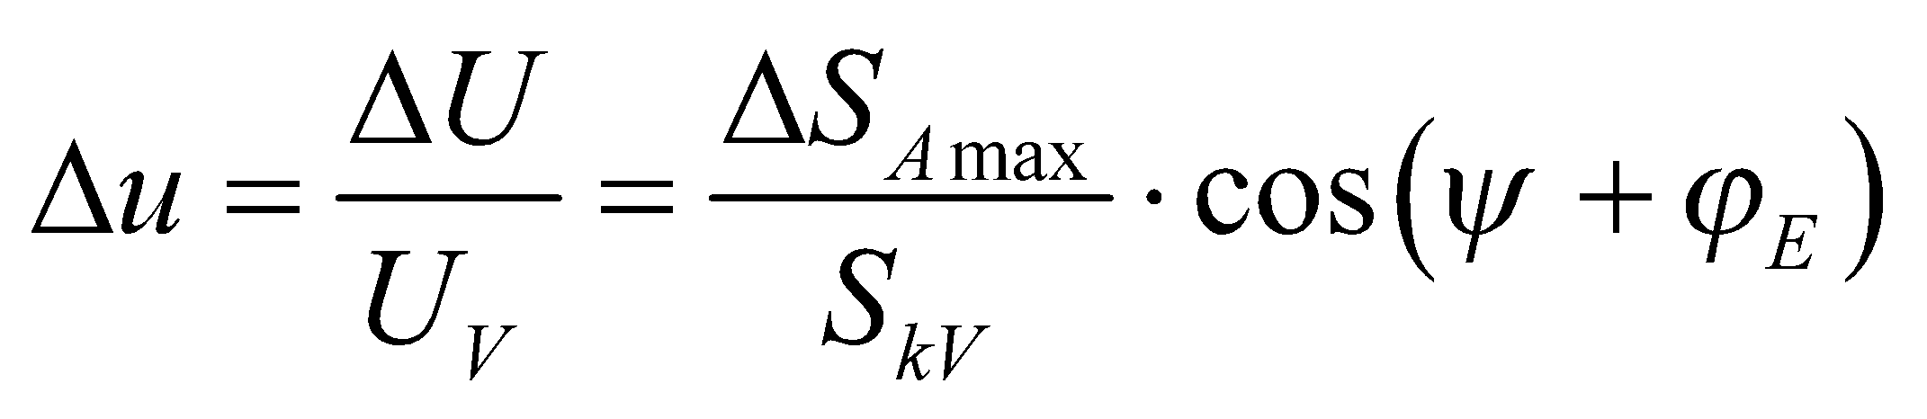

Requirements on generating units

Normal operating conditions
There is an effort that generating units are not to be disconnected from the grid during voltage and frequency changes. Operating range for voltage and frequency defines operating period for particular values of the change.

frequency range | period
47 – 47, 5 Hz | 20 s
47, 5 – 48, 5 Hz | 30 min
48, 5 – 49 Hz | 90 min
49 – 51 Hz | unlimited
51 – 51, 5 Hz | 30 min

According to new standards, all generating units except units upto 800 W must comply RoCoF, what means requirements on rate-of-change-of-frequency. According to this, the generating unit must not be disconnected upto value of +/- 2 Hz/s. This value is to be measured as average value during interval 500 ms.

Dealing with voltage changes, generating units upto 800 W, modules A1 and A2 connected to LV grid must be ready to operate, if the voltage behaves between -15 % Un and +10 % Un in PCC. If the voltage in PCC is lower than Un, the generating unit can decrease the power to match relative voltage change (Un – U) / Un.

voltage range | period
0, 8 – 0, 9 Un | 60 min
0, 9 – 1, 118 Un | unlimited
1, 118 – 1, 15 Un | 60 min

Principles of grid support
The target is that generating units connected to the grid also participate on voltage holding. DNO defines the support strategy and support values. There are 2 strategies – static and dynamic.

Static regulation
The voltage is regulated between values defined in contract during slow changes within normal operation. The voltage is regulated through reactive power within power factor between 0, 9 capacitive and 0,9 inductive.

Reactive power voltage control (LV grids)

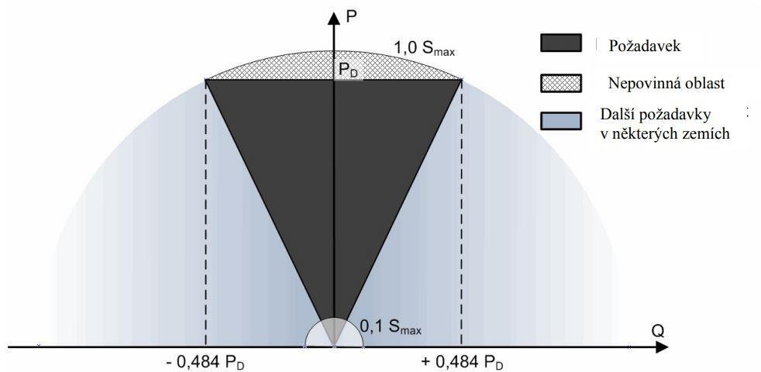

According to ČSN EN 50438, microgenerators upto 800 W must have power factor higher than 0, 95, if the output power is higher than 20 % of nominal power.

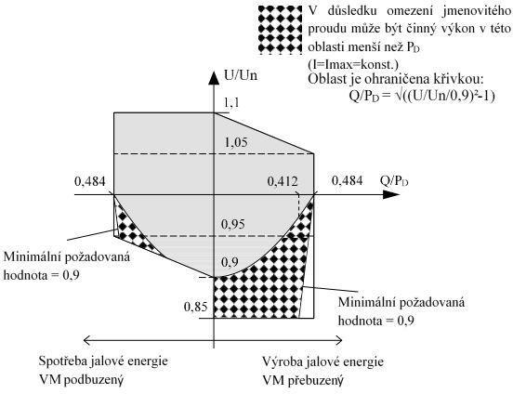
If the voltage differs from nominal value, but behaves in the range for continuous operation, the generating unit must behave to the diagram (A1).

Reactive power voltage control (A2, B1, B2, C, D)

Standards actualization brings changes in regulation range. Before the actualization, the range was equal to LV grids.

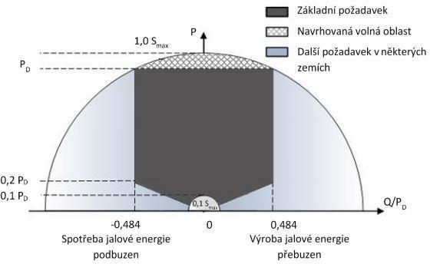

Further, it is necessary that synchronous units B2, C, D are capable to feed or draw reactive power necessary for compensation of e.g. charging power of cable between PCC and high voltage terminals of block transformer. In case of asynchronous units, the requirement is only necessary reactive power.

New standards define also range, where the unit (synchronous or asynchronous) must behave in case of full output power.

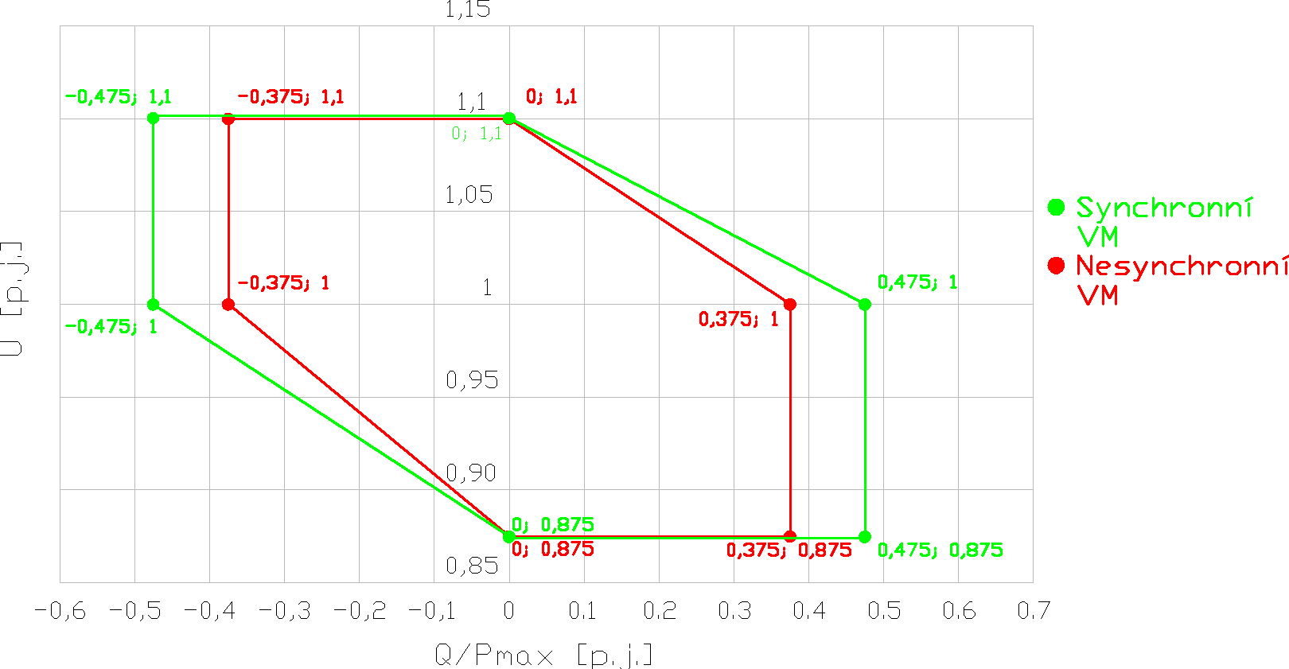

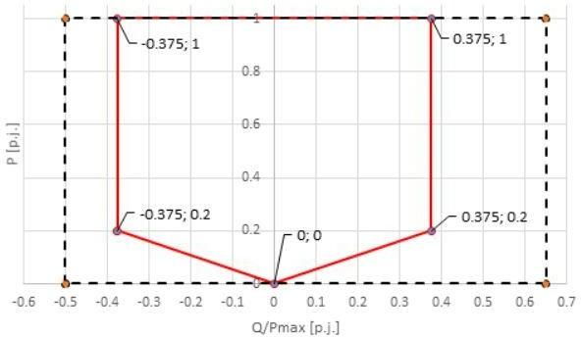
If the output power is lower than maximal, the asynchronous unit must behave according to the diagram.

Dynamic regulation
In this case, the voltage is to be kept, if the voltage in transmission grid is decreased, to avoid generating units to disconnect from HV and LV grids.

Generating units connected to LV, HV and 110 kV grids must offer dynamic regulation, so that during failures such as 1-phase shortcut stay connected.

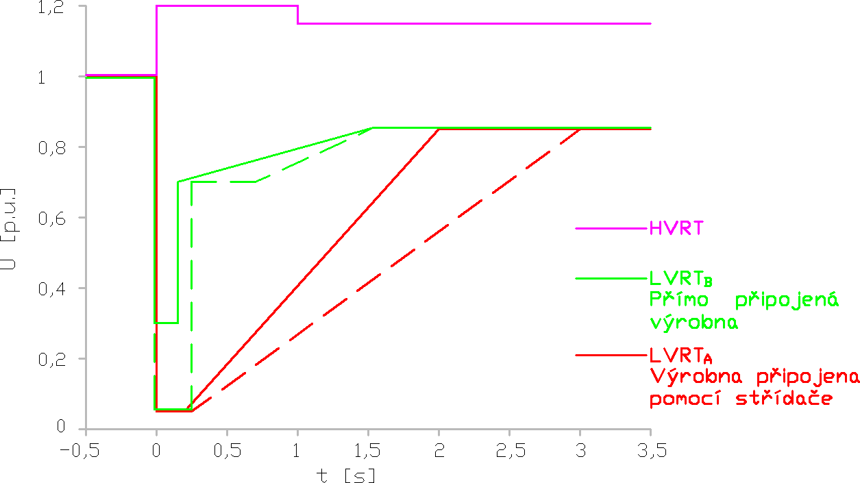
Requirements on voltage holding

Through active power restrictions
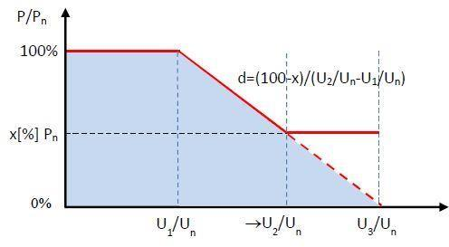
Generating units connected to LV grids using inverter upto 16 A and units above 16 A each phase must be equipped with generator capable for voltage control through active power. Generators without inverter must behave according to solid line, while generators with inverters must behave according to dashed line. DNO defines the specific values.

Through reactive power regulation
DNO defines the regulation., because it depends on particular PCC. Generating units with installed power higher than 100 kW must have controllable reactive power. The reactive power is regulated between power factor 0, 9 capacitive and 0, 9 reactive.

Reactive power regulation behaviour:
- fixed power factor value Cos φ fix
- voltage dependent reactive power Q (U)
- fixed voltage value U fix
- active power dependent reactive power Q (P)
- fixed reactive power value Q fix
- voltage dependent power factor Cos φ (U)
- active power dependent power factor Cos φ (P)

New requirements define that asynchronous modules B2, C, D must practice the reactive power change immediately, at latest in 4 s, to 90 % of required value. Parameters must be stabilized in 30 s.

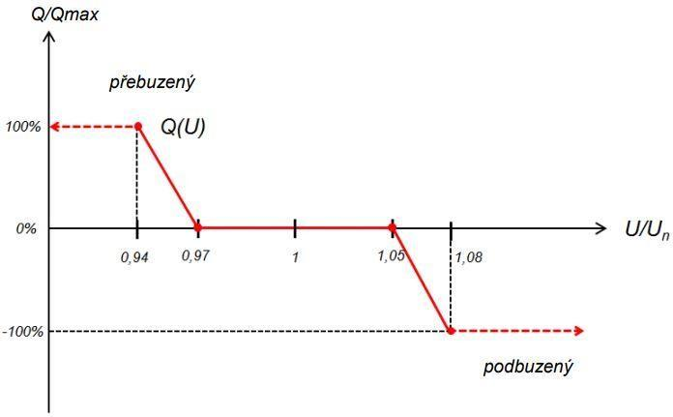
SIMPLIFIED ASSESSMENT PROCEDURE FOR GENERATING INSTALLATIONS

INPUT DATA

NETWORK

Necessary data:
short-circuit power at PCC - S_{kV}

Detailed data:
short-circuit impedance at point of connection (PCC) - Z_{kV}
EMBED Equation.3 EMBED Equation.3
short-circuit impedance phase angle -
EMBED Equation.3

GENERATION STATIONS

Necessary data:
nominal active power of generation station - P_{nG}

Default data:
power factor of generation station
- cos _{G} = 1

Detailed data:
Adjusted (operational) power factor of generation station
- cos _{G}

wind power station
- 10–min maximum of average active power p_{10min} = 1,01
- 1–min maximum of average active power p_{1min} = 1,1
- station flicker coefficient c = 4

LIMITS

Voltage rise and change
Δu _{LV} 3 %
Δu _{MV} 2 %
Long term flicker intensity
EMBED Equation.3

ALGORITHM OF CONNECTION ASSESSMENT

Data input

Load flow #1 without generating units

Maximum delivered output of generating units
for each node with connected G
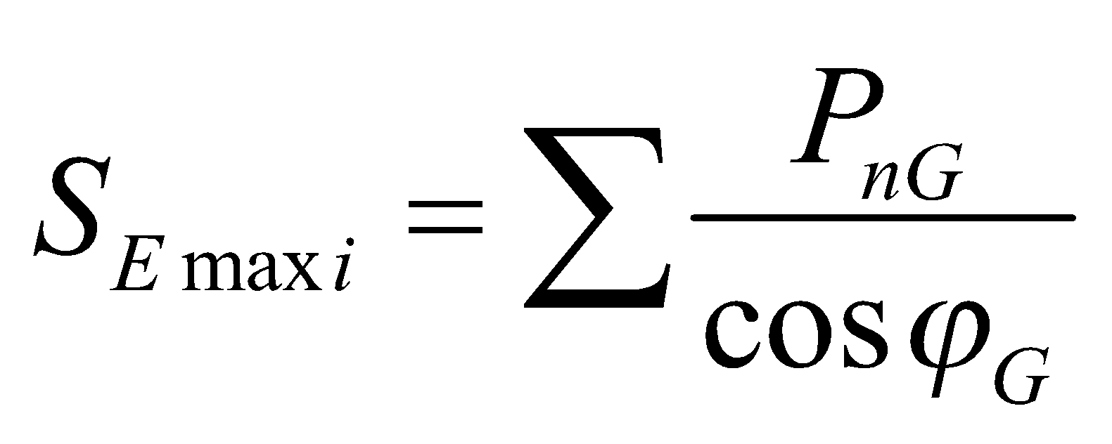
Load flow #2 with all generating units

Check of network elements’ capacity  for each branch j  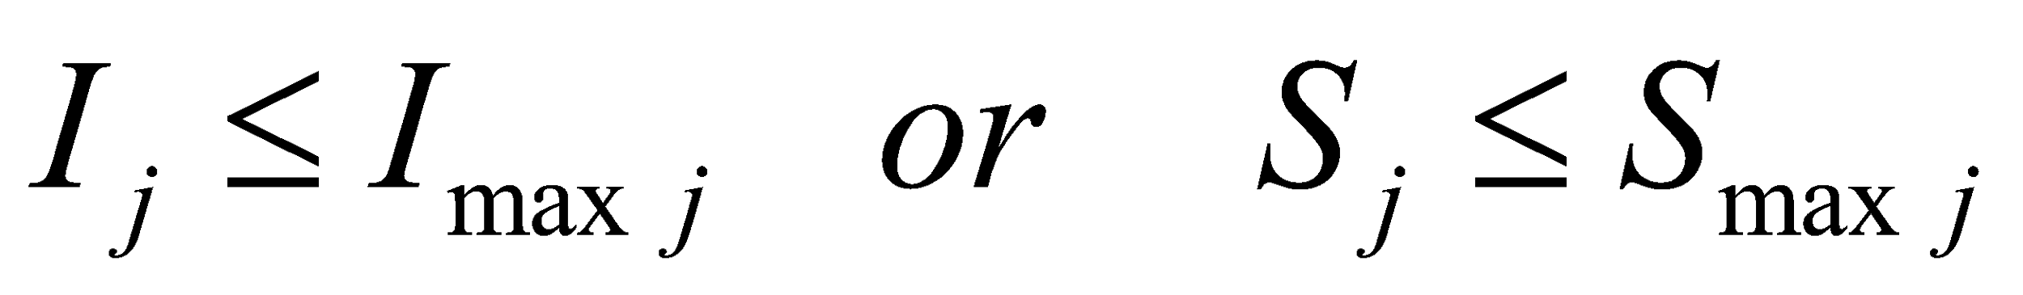  YES |  | Imax – limit (maximum) loading of a network element (ampacity or operational limit)  if NO measures are necessary
Check of relative voltage rise ⊗u_{A}  for each node i  LV-networks: Δu _{i} ≤ 3 %  MV- and HV networks: Δu _{i} ≤ 2 %  YES |  | difference between load flow #1 and #2  if NO measures are necessary
Check of voltage limit  for each node i  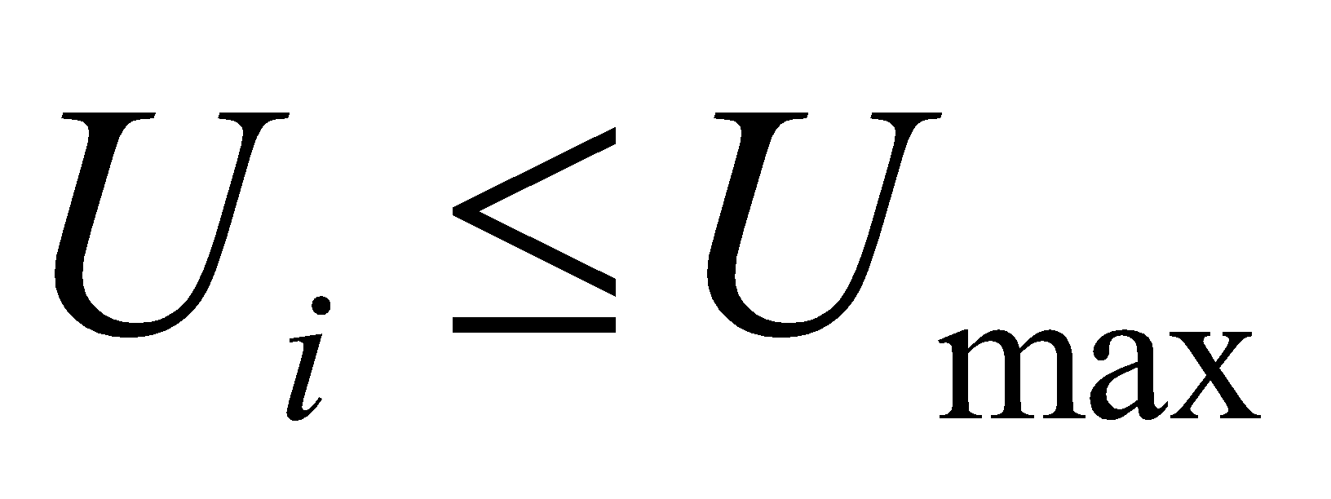  YES |  | Umax – limit (maximum) voltage  if NO measures are necessary
Connection approved

