
Decentralized generation
installed in MV and LV grids
in the Czech Republic
University of West Bohemia (Západočeská univerzita v Plzni)
Department of Electrical Power Engineering

2019

Content

- local generation in MV and LV system
  - total installed output in MV and LV system
  - distribution according primary energy (PV, biogas, water, wind...)
  - typical installed outputs ?
  - location of distributed generation
  - trend of installed outputs in time

Requirements for connecting a generator

- connectivity conditions (technical and regulatory)
- regulation capability and requirements on the regulation
      - characteristic curves and limits for regulation
      - Types of regulation (Const. Voltage, Q(V)) -> wind turbines on czech side (CEZ)

ENERGY MIX, TRENDS

Support for renewable energy sources
Actual legislative originate from international treaty UNFCCC signed 1972. Basic concept and support principles for renewable energy sources were 1997 defined in White book. Kjoto protocol from 1997 contracted signers to decrease CO2 emissions until 2012 and it was extended for period 2013 – 2020. Common European energy policy was defined in Green book in 2006.
First practical support for renewable energy sources originating from mentioned principles was defined in the law 180/2005 Sb. It was substituted with the law 165/2012 Sb. defining new support for particular renewable energy sources. The original law 180/2005 Sb. was inspired by similar german law and its principles and pricing (price decrease 6,5 %).

Basic principles defined in the law 180/2005 Sb.:
- Obligator purchaser is local DNO,
- guaranteed payback return period:
- PV: 15 years,
- small hydro: 30 years,
- other RES: 20 years,
- price for new installations can be decreased at most for 5 %,
- price for current installations is guaranteed to increase according to actual inflation.
In comparison with other European countries, the support for PV installation did not depend on the installed power and location of the unit. Installations in Germany were stratified into 5 categories (roof up to 30 kW, roof 30 – 100 kW, roof above 100 kW, roof above 1 MW, stand alone) during this era.
Initial prices 6,04 Kc/kWh and high purchase costs did not met the expectations, so ERU announced price 13,20 Kc/kWh for 2006 and fixed support 15 years.
Prices for 2007 are raised according to inflation to 13,46 Kc/kWh and first 4 large installations (Pinst > 0,5 MW) were commissioned. The support for PV installations was increased up to 20 years (364/2007 Sb.).
German legislative was novelized in 2008. The support for PV installations now depends on the installed power from previous year. The prices should be annually decreased for 8 – 11 % during 2009 – 2011. Prices for other RES should be decrease for 1 – 1,5 %. Czech legislative did not respond to this behavior. ERU only classified PV installations into 2 categories (up to 30 kW and above 30 kW. The price varied only about 1 %. Prices of PV panels started to decrease.
Lower prices of PV panels took effect in CR at the beginning of 2009 and solar boom has started. ERU reported misrepresented data and novelisation of 180/2005 Sb. is suspended. Prices for PV installations were decreased only to 12,79 Kc/kWh. The most daring demands expected total installed power 300 MW at the end of 2009. The real number was 465 MW.
Prices for 2010 were also only minimally decreased to 12,15 Kc/kWh and total number of installations reached 1953 MW of installed power.
Novels 211/2011 Sb. and 165/2012 Sb. redefined the support and pricing from renewable energy sources. Prices for PV installations were decreased to 7,50 Kc/kWh. Also new solar tax for installations commissioned between 1.1.2010 and 31.12.2010 was declared (26 % for fixed prices and 28 % for green bonus) for period 2011 - 2013. Since 2014 the tax was changed to 10 % for fixed prices and 11 % for green bonus.

Novel 310/2013 stopped support for new installation since 1.1.2014. Support for existing units was stratified into 3 schemes:
- fixed price,
- green bonus:
  - annual model,
  - hourly model.
The pricing schema can be changed annually.

Prices for renewable energy sources

Actual prices are defined in ERU price regulation 6/2019 and depend on category of the generation unit.

Categories for electricity generation:
- hydro power stations,
- solid biomass burning,
- biogas and landfill gas burning,
- wind power systems,
- solar systems,
- geothermal systems.

The real price depends not only on the category of the RES, but also on the date of commissioning. ERU announces the prices annually in detailed table. The prices for PV systems described above are valid not more, because the prices are redefined each year according to the level of industrial inflation. The numbers above serve only for description of the evolution of legislative, installed power and pricing.
There are basicly two actual methods of pricing. The producer can swap between the methods annually.
First one (and older one) is called fixed prices. All generated energy is sold to local DNO. Prices are fixed for entire period and for whole production. This model tends to be more simple, stabile and safe for the user. Prices do not depend on the situation on the market.
Second method is called green bonus. The produces is free to find a subject to sell generated energy for commercial prices. He receives green bonus to this price. This method tends to be more risky but usually more reliable for the producer. The real price depends on the situation on the market. The price varied between 1,20 Kc/kWh and 1,50 Kc/kWh during last year.
At the beginning, almost all producers used the system of fixed prices. Now, the situation has changed and green bonus is used more commonly. If we compare both methods, we can say that fixed price for PV system (commissioned until 31.12.2005) is 8,353 Kc/kWh and green bonus gives 7,282 Kc/kWh plus 1,20 Kc (respectively 1,50 Kc) thus 8,482 Kc/kWh or 8,782 Kc/kWh. Average price was 1,32 Kc/kWh so the real profit was 8,602 Kc/kWh, what means 0,249 Kc/kWh better price than the fixed price.
Also the electricity have been used to be supported, no similar mechanism has been to be used for heat generation.
Fixed prices for PV systems vary between 2,794 Kc/kWh for systems commissioned between 1.7.2013 and 31.12.2013 and 17,529 Kc/kWh for systems commissioned between 1.1.2006 and 31.12.2007. Although announced prices in following year were higher (13,46 Kc/kWh in 2007 versus 13,20 Kc/kWh in 2006), calculation of the inflation balanced the final prices.
Analogical situation is for green bonus. The bonus varies between 1,559 Kc/kWh for systems commissioned between 1.7.2013 and 31.12.2013 and 16,458 Kc/kWh for systems commissioned between 1.1.2006 and 31.12.2007.
It is evident from the table, that since 2010 the support for PV was slowly decreased according to valid legislative. The dramatic change in 2011 and following years has background in the change of legislative leading to practical stop of support for PV systems since 2014. Also gradual process of stratification of PV systems is evident since 2009. Smaller systems have had higher support because of higher relative purchase costs.

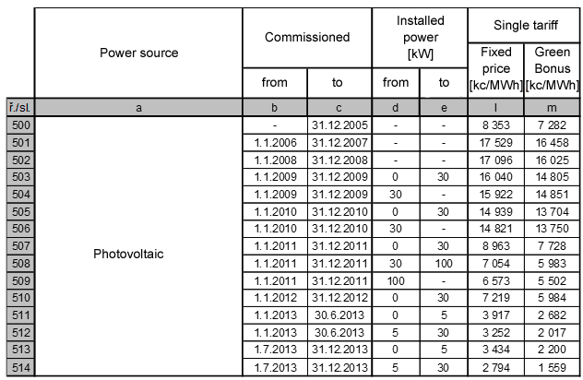

Fixed prices for eolic systems vary between 1,930 Kc/kWh for systems commissioned between 1.1.2020 and 31.12.2020 and 4,254 Kc/kWh for systems commissioned before 31.12.2003.
Analogical situation is for green bonus. The bonus varies between 1,048 Kc/kWh for systems commissioned between 1.1.2020 and 31.12.2020 and 3,372 Kc/kWh for systems commissioned before 31.12.2003.
Although it is evident from the table, that since 2009 the support for eolic systems was slowly decreased, there was no dramatic change like in PV business. In contrast to photovoltaic, some definite support for eolic systems still exists. Actual prices are approximately double of commercial electricity prices.
Another interesting fact is that the support was never so high as for the PV systems. The difference in the years with maximal support for PV systems (2006 – 2009) was roughly 12 Kc/kWh. This difference originated in the payback period for both systems at that time.

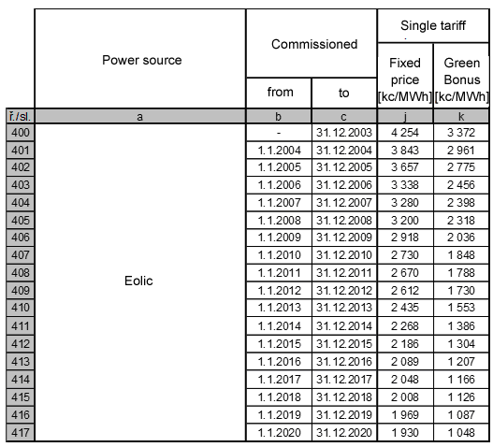
Fixed prices for biogas systems vary between 2,183 Kc/kWh for sewage gas systems commissioned between 1.1.2013 and 31.12.2013 and 4,120 Kc/kWh for effective biogas stations commissioned before 31.12.2012.
Analogical situation is for green bonus. The bonus varies between 1,049 Kc/kWh for sewage gas systems commissioned between 1.1.2013 and 31.12.2013 and 2,948 Kc/kWh for effective biogas stations commissioned before 31.12.2012.
It is evident from the table, that since 2014 the support for biogas systems was stopped. The support history shows no dramatic change similar to PV systems. Actual prices depend on the source of the biogas (mine gas, sewage gas and biogas).
Another interesting fact is that the support was never so high as for the PV systems. The difference in the years with maximal support for PV systems (2006 – 2009) was roughly 12 Kc/kWh. This difference originated in the payback period for both systems at that time. Similar to PV systems, smaller biogas stations (until 55 kW) have had higher support because of higher relative purchase costs.

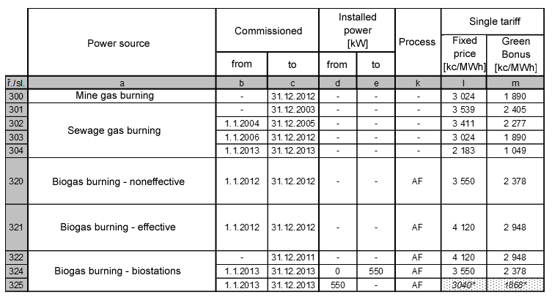
Fixed prices for small hydro plants vary between 2,214 Kc/kWh for existing or reconstructed plants commissioned between 1.1.2020 and 31.12.2020 and 3,737 Kc/kWh for new build plants commissioned between 1.1.2012 and 31.12.2012.
Analogical situation is for green bonus. The bonus varies between 1,269 Kc/kWh for existing or reconstructed plants commissioned between 1.1.2020 and 31.12.2020 and 2,792 Kc/kWh for new plants commissioned between 1.1.2012 and 31.12.2012.
Although it is evident from the table, that since 2014 the support for small hydro plants was slowly decreased, there was no dramatic change like with PV systems. Similar to eolic systems, some definite support for small hydro plants still exists. Actual prices are a bit higher than in case of eolic systems, because of different payback period.
The support also depends on the state of the plant. New build plants have higher support than existing (recommissioned) and reconstructed plants. Unlike the other RES, small hydro plants can be operated in two tariff model (existing and reconstructed plants since 31.12.2013 and new build between 1.1.2006 and 31.12.2007 and between 1.1.2011 and 31.12.2011).

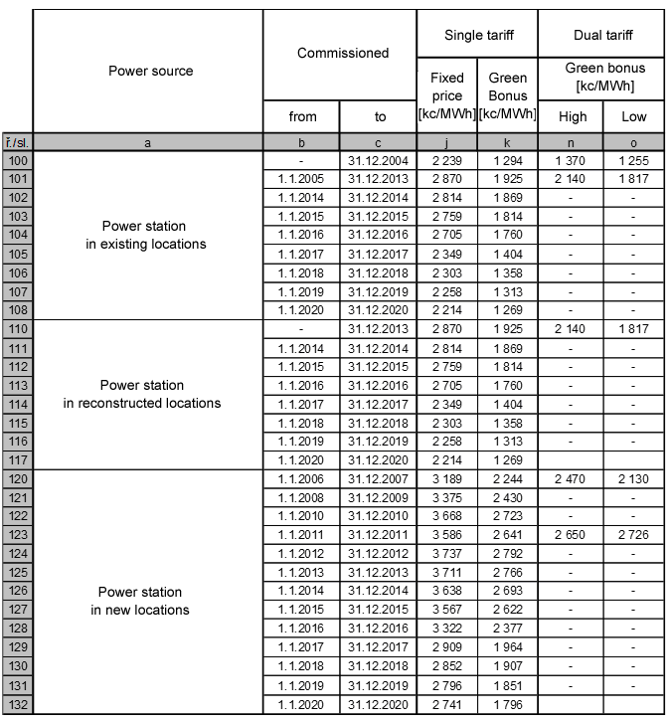

Fixed prices for biomass burning systems vary between 0,812 Kc/kWh for systems using biomass coburning S3, parallel burning with non RES P3 and coburning with secondary source DS3 commissioned until 31.12.2020 and 4,580 Kc/kWh for biomass burning processes O1 commissioned between 1.1.2008 and 31.12.2012.
Analogical situation is for green bonus. The bonus varies between 0 Kc/kWh for systems using biomass coburning S3, parallel burning with non RES P3 and coburning with secondary source DS3 commissioned until 31.12.2020 and 3,408 Kc/kWh for biomass burning processes O1 commissioned between 1.1.2008 and 31.12.2012.
Although it is evident from the table, that since 2012 the support for particular systems using biomass burning was slowly decreased, there was no dramatic change analogical to PV systems. Similar to eolic systems and small hydro plants, some definite support still exists and also actual prices are a similar.
The support also depends on the process classification of the plant. Plants using processes in 3rd class have very limited support and also plants using processes in 2nd class have lower support.
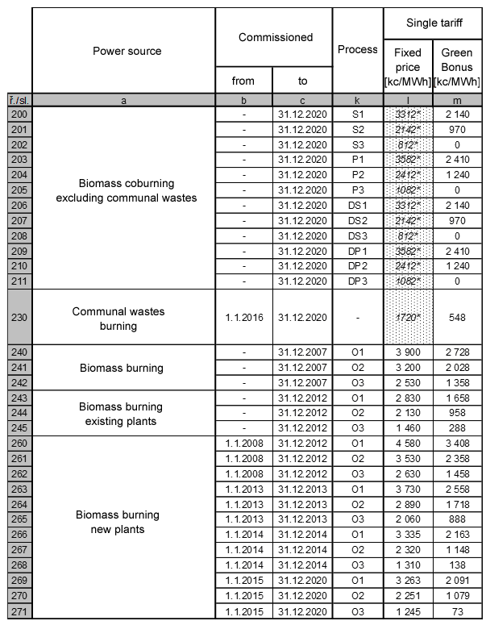

Power source |  |  | Actual support | Support trend | Max. support  [kc/kWh] | Min. support  [kc/kWh]
photovoltaic | existing | < 5 kW | depending on commissioning | decreasing from 2009, stopped from 2014 | 17,529 | 3,434
photovoltaic | existing | 5 kW – 30 kW | depending on commissioning | decreasing from 2009, stopped from 2014 | 17,529 | 2,794
photovoltaic | existing | 30 kW – 100 kW | depending on commissioning | decreasing from 2009, stopped from 2012 | 17,529 | 7,054
photovoltaic | existing | > 100 kW | depending on commissioning | decreasing from 2009, stopped from 2012 | 17,529 | 6,573
photovoltaic | new build |  | no | stopped from 2014 | 0 | 0
eolic | existing |  | depending on commissioning | decreasing from 2003 | 4,254 | 1,969
eolic | new build |  | yes | decreasing from 2003 | 1,930 | 1,930
biogas | existing | mine gas | limited | stopped from 2013 | 3,024 | 3,024
biogas | existing | sewage gas | depending on commissioning | decreasing from 2004, stopped from 2014 | 3,539 | 2,183
biogas | existing | biomas – effective | limited | stopped from 2013 | 4,120 | 3,040
biogas | existing | biomass – noneffective | limited | stopped from 2014 | 3,550 | 3,040
biogas | new build |  | no | stopped from 2014 | 0 | 0
small hydro | existing | existing locations | depending on commissioning | decreasing from 2014 | 2,870 | 2,239
small hydro | existing | reconstructed locations | depending on commissioning | decreasing from 2014 | 2,870 | 2,258
small hydro | existing | new locations | depending on commissioning | decreasing from 2013 | 3,737 | 2,796
small hydro | new build | existing locations | yes | decreasing from 2014 | 2,214 | 2,214
small hydro | new build | reconstructed locations | yes | decreasing from 2014 | 2,214 | 2,214
small hydro | new build | new locations | yes | decreasing from 2013 | 2,741 | 2,741
biomass | existing | biomass burning | depending on commissioning | depending on process, stopped from 2013 | 3,900 | 1,460
biomass | existing | biomass coburning | yes | decreasing from 2012, depending on process | 3,582 | 0,812
biomass | existing | waste buring | yes | decreasing from 2016 | 1,720 | 1,720
biomass | new build | biomass burning | depending on commissioning | decreasing from 2012, depending on process | 4,580 | 1,245
biomass | new build | biomass coburning | yes | decreasing from 2012, depending on process | 3,582 | 0,812
biomass | new build | waste buring | yes | decreasing from 2016 | 1,720 | 1,720

Power generation from renewable energy sources

Power generation from renewable energy sources consist from:
- electricity generation,
- heat generation.

All RES have contributed with 10,54 % to the mix of primary power sources during 2018. The most significant contributor to energy generation (electricity plus heat) is biomass with more than 65 % (40,18 % households plus 25,21 commercials) followed with biogas (13,49 %).
PV systems with total installed power 2065,9 MW (approximately 10 % from power sources mix) produce only 0,44 % from all generated energy (4,18 % in renewable energy sources).

Power source | Produced energy  [GJ] | Percentage in total energy production [%] | Percentage in RES energy production [%]
Biomass (industry) | 47 584 709 | 2,66 | 25,21
Biomass (household) | 75 817912 | 4,24 | 40,18
Hydro plants | 6 730 074 | 0,38 | 3,57
Biogas | 25 459 055 | 1,42 | 13,49
Communal waste | 3 853 432 | 0,22 | 2,04
Liquid bio fuels | 13 197 851 | 0,74 | 6,99
Heat pumps | 5 223 499 | 0,29 | 2,77
Solar thermal systems | 826 865 | 0,05 | 0,44
Wind plants | 2 127 737 | 0,12 | 1,13
PV plants | 7 896 125 | 0,44 | 4,18
Total | 188 717 259 | 10,54 | 100,00

Electricity generated from RES varies in years 2013 – 2018 between 5,68 and 11,77 %, while PV systems alone produce between 1,96 and 2,88 % from whole sum of generated electricity.

Source | 2013  [%] | 2014  [%] | 2015  [%] | 2016  [%] | 2017  [%] | 2018  [%]
RES – total | 5,68 | 10,95 | 11,77 | 10,11 | 7,60 | 6,17
solar | 1,96 | 2,63 | 2,88 | 2,77 | 2,14 | 2,07
wind | 0,47 | 0,57 | 0,71 | 0,63 | 0,45 | 0,22
hydro | 1,93 | 2,56 | 2,67 | 1,15 | 1,43 | 0,77
geothermal | 0,00 | 0,00 | 0,00 | 0,00 | 0,00 | 0,00
biomass | 1,33 | 2,19 | 2,34 | 5,57 | 3,58 | 3,11
other | 0,00 | 2,99 | 3,17 | 0,00 | 0,00 | 0,00
Fossil – total | 57,65 | 52,77 | 55,10 | 59,53 | 57,40 | 56,95
brown coal | 40,71 | 41,27 | 42,15 | 43,91 | 43,77 | 44,63
black coal | 6,11 | 5,78 | 6,31 | 6,97 | 5,38 | 4,18
gas | 8,30 | 5,52 | 6,41 | 8,40 | 5,45 | 5,80
oil | 0,01 | 0,06 | 0,05 | 0,05 | 0,06 | 0,04
other | 2,52 | 0,14 | 0,18 | 0,20 | 2,73 | 2,30
Nuclear- total | 36,67 | 36,28 | 33,13 | 30,36 | 35,01 | 36,88

Local generation |  |  | ČEZ Distribuce | E.ON Distribuce
Photovoltaics
- installed output | MW | 1025 |  | 965
- number of power plants | number |  |  | 9317
Small water power plants
- installed output | MW | 266 |  | 202
- number of power plants | number |  |  | 438
Wind power plants
- installed output | MW | 286 |  | 26
- number of power plants | number |  |  | 22
Biogas power plants
- installed output | MW |  |  | 122
- number of power plants | number |  |  | 237
Biomass combustion power plants
- installed output | MW | 1956 (incl. biogas) |  | 218
- number of power plants | number |  |  | 23
Others
- installed output | MW |  |  | 2374
- number of power plants | number |  |  | 281

Progress of power generation and prediction of installed power in RES
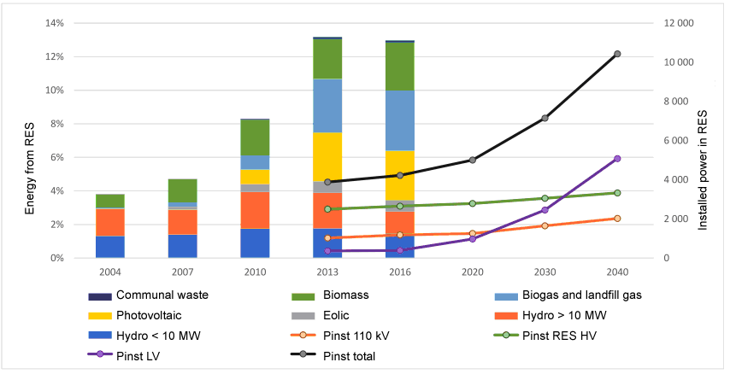
Particular types of RES show increments since 2004 according to legislative support. Most significant increase until 2013 is in PV installations and corresponds with solar boom until the support was stopped. It is expected that RES installed power will be tripled until 2040 and that new generation units will be connected to LV grids.

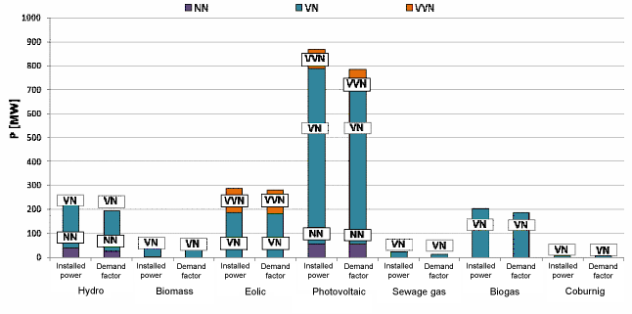
Demand factor for particular RES is almost equal to corresponding installed power. The only exception is photovoltaic, what corresponds with emplacement of units and changeful weather conditions across the territory.

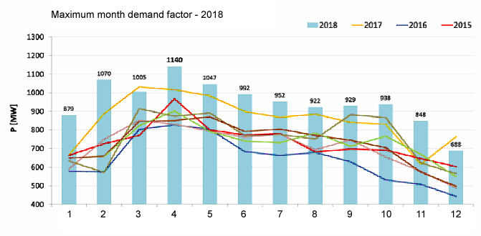
Demand factor shows also seasonal fluctuation, what corresponds with weather conditions (photovoltaic and eolic) and with seasonal streams flow fluctuations.

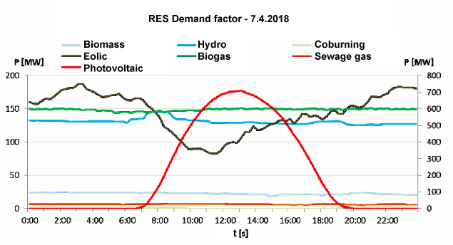
The demand factor of particular RES corresponds with the features of the RES. Hydro plants, biogas stations and, sewage gas station and biomass burning or coburning is almost constant, while eolic systems respond directly the weather conditions. Demand factor of photovoltaic systems vary from zero to maximum value and traced the solar radiation.
Annual curves of maximum demand correspond with curves of seasonal demand factor for particular RES.
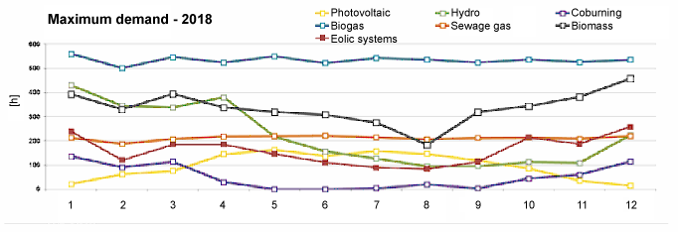
Hydro plants generate approximately constant energy meaning 85 % in 2003 and 20 % since 2013. Biomass and biogas increased rate from 20 % in 2003 – 2006 to almost 50 % since 2013. Also landfill gas increases significantly rate from zero to 20 % at presence. Wind power stations have changed their part from zero in 2005 to 5 % since 2011 and PV systems from zero in 2005 to 2 % at presence.
Heat generation is in fact domain of biomass burning in households and commercials.

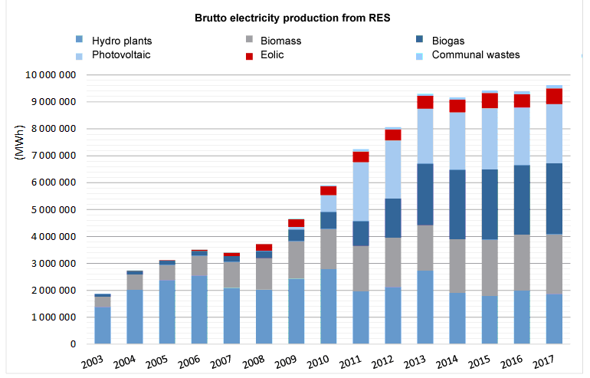
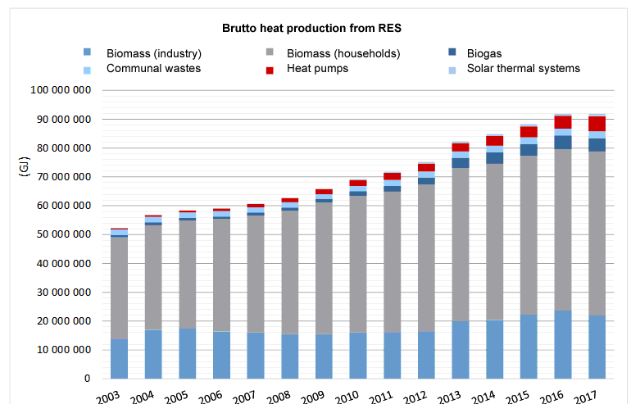
Generated electricity from RES depends on the season. The maximum is 31 % during april, while the minimum is 21 % in November. The amount is mostly covered from PV installations during summer while the winter season is covered usually from eolic and hydro plants. The biogas units usually generate constant power except coldest months, when the bio processes are slower.
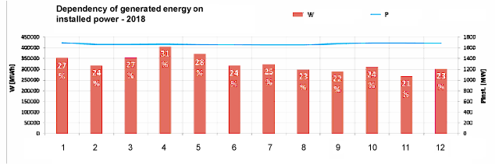

Photovoltaic plants in western Bohemia
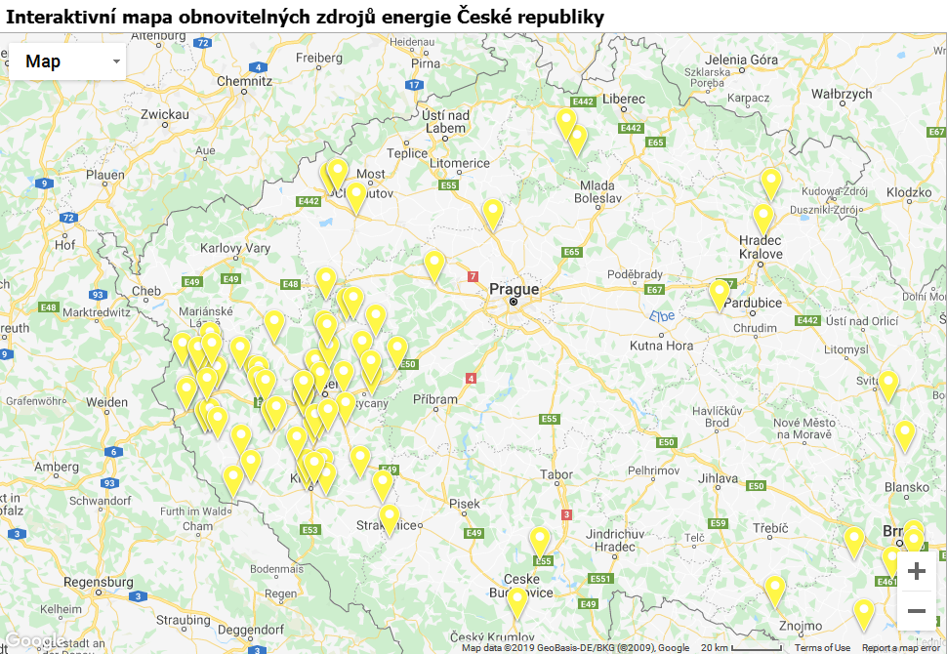

Wind plants in western Bohemia
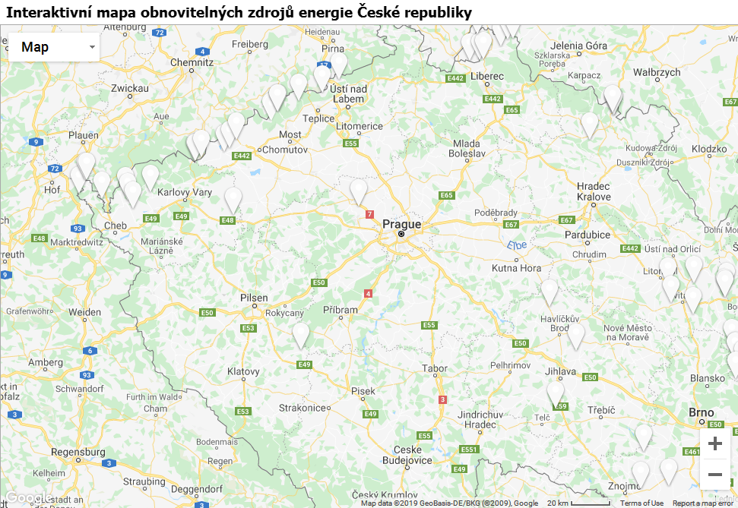

Hydro plants in western Bohemia
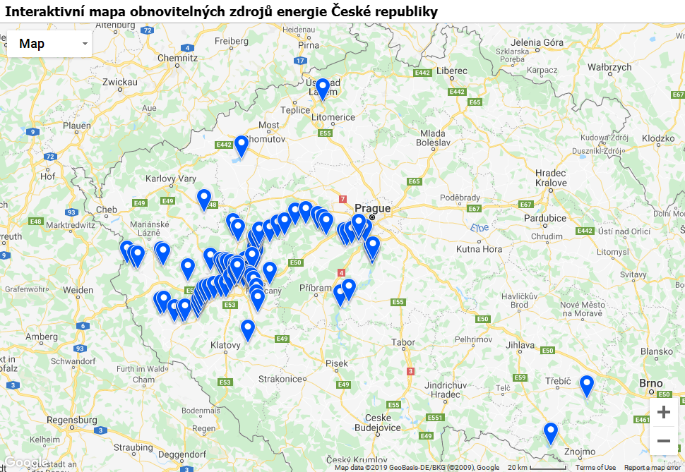
Renewable power sources financial support
 | 2013  [mio kc] | 2014  [mio kc] | 2015  [mio kc] | 2016  [mio kc] | 2017  [mio kc] | 2018  [mio kc]
RES | 34 922 | 38 361 | 41 098 | 40 752 | 43 154 | 43 689
Photovoltaic | 23 279 | 24 601 | 26 804 | 25 911 | 27 002 | 29 203
fixed price | 6 927 | 8 252 | 9 494 | 10 312 | 11 071 | 12 495
green bonus | 16 352 | 16 349 | 17 310 | 15 599 | 15 932 | 16 707
Eolic | 936 | 1 017 | 1 215 | 1 100 | 1 332 | 1 273
fixed price | 548 | 906 | 1 085 | 1 019 | 1 275 | 1 227
green bonus | 388 | 111 | 130 | 80 | 57 | 46
Hydro | 1 803 | 1 861 | 1 927 | 2 057 | 2 541 | 1 837
fixed price | 1 661 | 1 702 | 1 792 | 1 891 | 2 390 | 1 711
green bonus | 142 | 158 | 136 | 166 | 152 | 127
Biomass | 2 490 | 3 331 | 3 458 | 3 787 | 4 115 | 3 641
fixed price | 2 361 | 3 225 | 3 450 | 3 778 | 4 107 | 3 633
green bonus | 90 | 106 | 8 | 7 | 0 | 0
com. wastes | 39 | 0 | 0 | 2 | 8 | 8
Biostations | 6 413 | 7 551 | 7 694 | 7 897 | 8 163 | 7 735
fixed price | 5 296 | 6 430 | 6 794 | 6 973 | 7 312 | 6 979
green bonus | 493 | 420 | 228 | 181 | 110 | 42
Waste gas | 361 | 402 | 375 | 431 | 394 | 391
fixed price | 347 | 386 | 363 | 427 | 390 | 387
green bonus | 14 | 16 | 12 | 4 | 4 | 4
Mine gas | 264 | 299 | 296 | 312 | 348 | 324
Secondary sources | 126 | 136 | 137 | 150 | 147 | 116
Mine gas | 99 | 107 | 112 | 126 | 124 | 93
Other | 27 | 29 | 25 | 24 | 24 | 24
Cogeneration | 1 970 | 1 664 | 1 899 | 1 933 | 1 934 | 2 124
Decentr. generation | 310 | 241 | 203 | 0 | 0 | 0
Heat from RES | 129 | 183 | 171 | 188 | 214 | 199
Total | 37 458 | 40 585 | 43 509 | 43 023 | 45 448 | 16 128

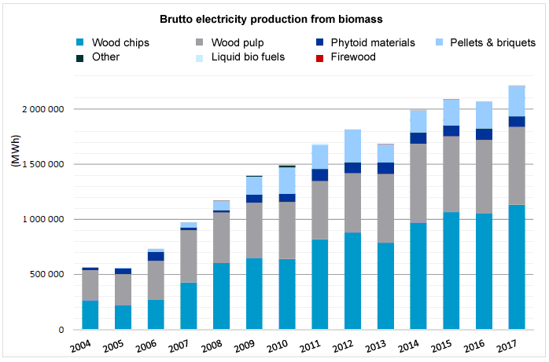

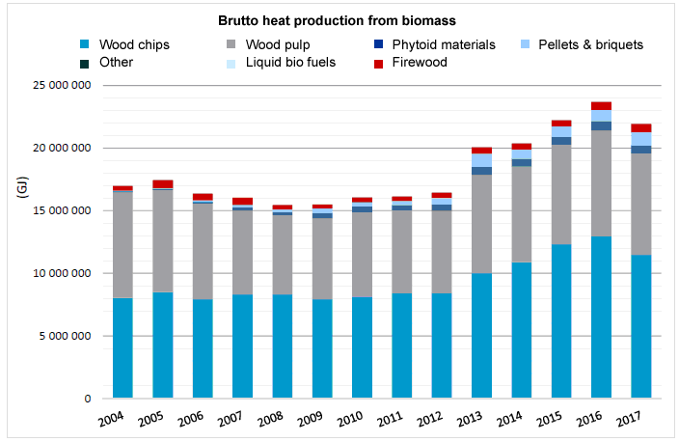
Either electricity or heat production from biomass is mostly covered from burning of wood chips and wood pulps. Burning of pellets, firewood and liquid fuels only supplements utilized technologies.
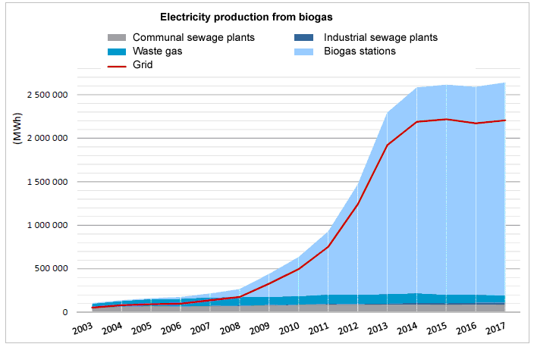

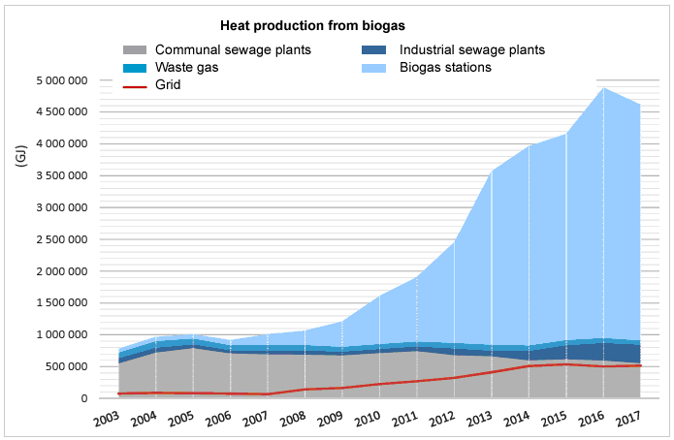
Both(electricity and heat) production from biogas is mostly covered from biogas stations with rising tendency. Approximately 10% of heat production is covered from communal sewage plants.

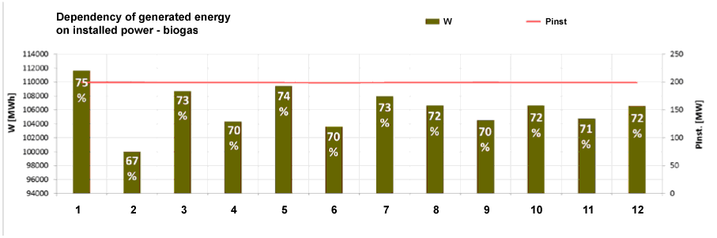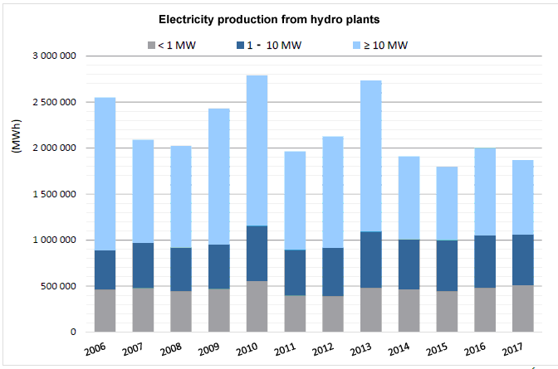

Annual electricity production from hydro plants is almost constant with particular variations during 2010 and 2013 because of pleasant weather conditions. Dependency on seasonal variation of stream flow is evident.

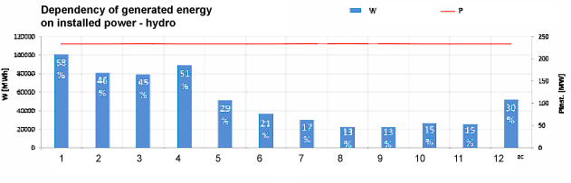
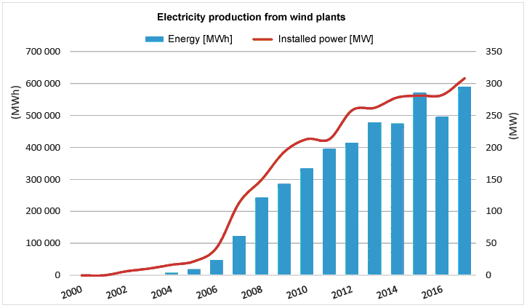

Annual production from wind stations shows rising tendency from 2004 with maximal increments between 2006 and 2015. Strong seasonal dependency on weather is evident.

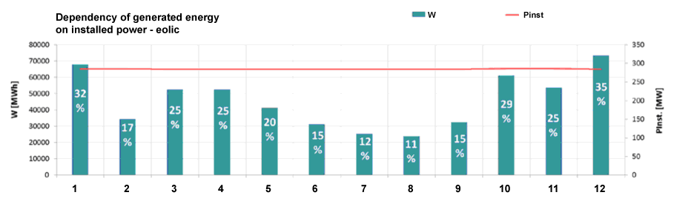

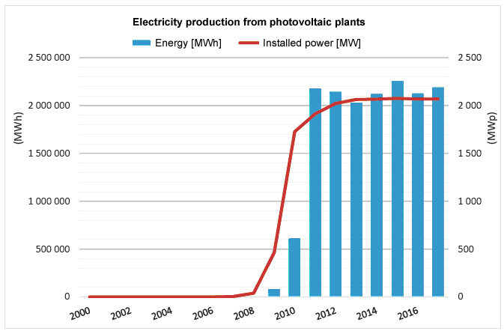

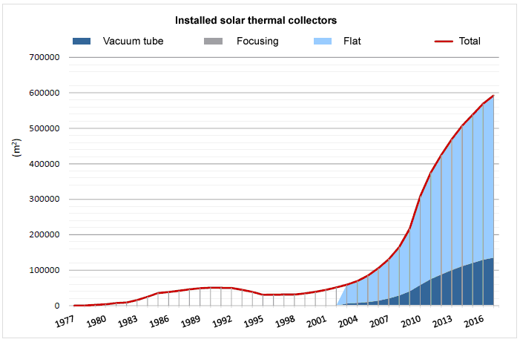
Electricity production from photovoltaic plants shows rapidly rising tendency from 2007 to 2012, while amount of solar thermal collectors is rising all the time. Massive financial support of PV systems caused handicaps for thermal systems. Strong seasonal dependency is evident and corresponds with annual distribution of solar radiation, radiation duration and solar energy. Month energy production is ten times higher in summer than during winter.
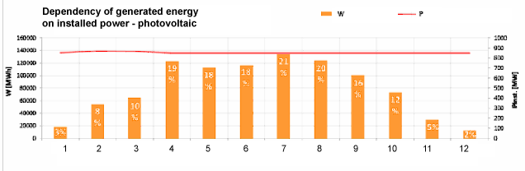

REQUIREMENTS FORGENERATING PLANTS

Generally, the connectivity of a generating plant have to be assessed with respect to 4 aspects:
- Capacity of network elements – with respect to the maximum delivered output of generating unit/plant
- Network disturbances caused by generating units/plants
The emission limits for generating installations are usually stricter than for loads. There are assessed following voltage characteristics:
- Voltage rise
- Switching-related voltage change
- Voltage changes and flicker
- Harmonics
- Voltage unbalance
- Influence of ripple control (HDO)
Permitted limits are given by the Czech Distribution Code – supplement no.4: Rules for parallel operation of electricity generation and accumulation facilities in distribution networks, 2019, chapters 10 and 11.
Generating units are also expected to be compatible with voltage characteristics at the point of connection, as described in EN 50160.
- Requirements for static and dynamic support of the network according to the RfG NC (“Network Code for Requirements for Grid Connection applicable to all Generators” established by Commission Regulation (EU) 2016/631).
- Normal operating range
  - Operating frequency range
  - Continuous operating voltage range
- Immunity to disturbances (dynamic support)
- Rate of change of frequency (ROCOF) immunity
- Low voltage ride-through (LVRT)
- High voltage ride-through (HVRT)
- Power response to voltage changes
- Voltage support by reactive power – capability (PQ diagrams) and Q control modes
- Voltage-related active power reduction – P(U)
- Short circuit current requirements on generating plants
- Active response to the frequency deviation
- Power response to over-frequency
- Power response to under-frequency
- Specific requirements for network support – starting, island operation, synchronization
- Requirements for the connection interface
- Protections
- Interface switch
- Remote information exchange – remote controlling, monitoring and operation parameter setting

All requirements apply to the Point of Connection (POC). POC is the point in the public electricity supply grid where a power-generating plant is or can be connected.

Assessment of connectivity and network disturbances caused by generating plants

The connectivity assessment of the sources is made according to Czech Distribution Code – supplement no. 4 - chapters 10 and 11, and standard PNE 33 3430-0, in which the document “D – A – CH – CZ Technical Rules for Assessment of Network Disturbances” was included.

Assessment procedure
The general assessment procedure is divided into 2 stages.
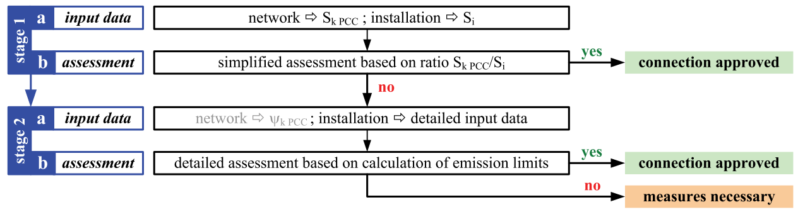
S_{k PCC} is the short-circuit power at the point of common coupling (PCC or POC)
S_{i} is the agreed power of the network user (installation power)
The first stage consists of a very simple but more conservative assessment based on a few, easy-to-obtain parameters. If stage 1 fails, a more detailed assessment based on a more detailed description of the customer installation is necessary. In case of a positive result, the connection of the customer installation can be allowed by the DSO. Otherwise, corrective measures are required.
Furthermore, in the case of a failing stage 2 assessment, a more detailed network study (e.g. based on intensive simulations) that is usually done by external experts can be carried out and however may result in approval of the customer installation.
According to the Distribution Code, if the rate of short-circuit power S_{kV} and installed power capacity S_{nG} of a new generating unit is higher than 500 [Distribution Code], disturbance assessment is not required.
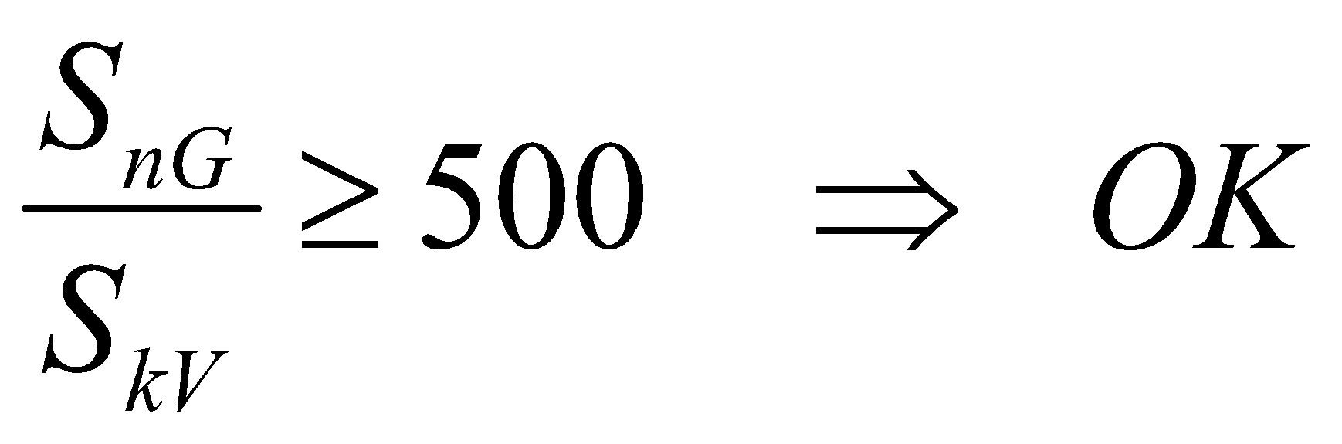
Maximum delivered output of generating unit/units
The maximum output of a generating unit S_{Emax} is used for the assessment of network capacity.
- Wind power plants: 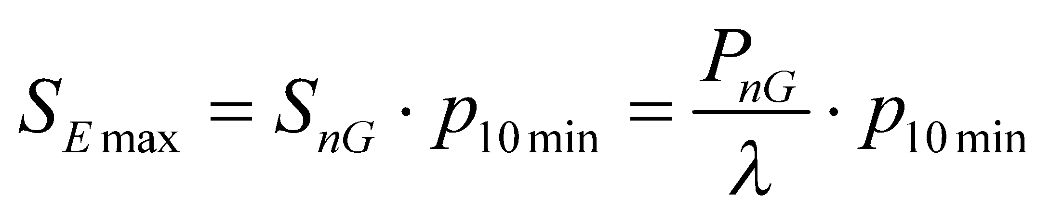
S_{nG,} P_{nG} - nominal apparent, active output of a generator
p_{10min} – maximum of average active power (10–min interval) – from generator test report (p_{10min} ≈ 1,01)
λ - power factor at maximum power
- Other generating plants: 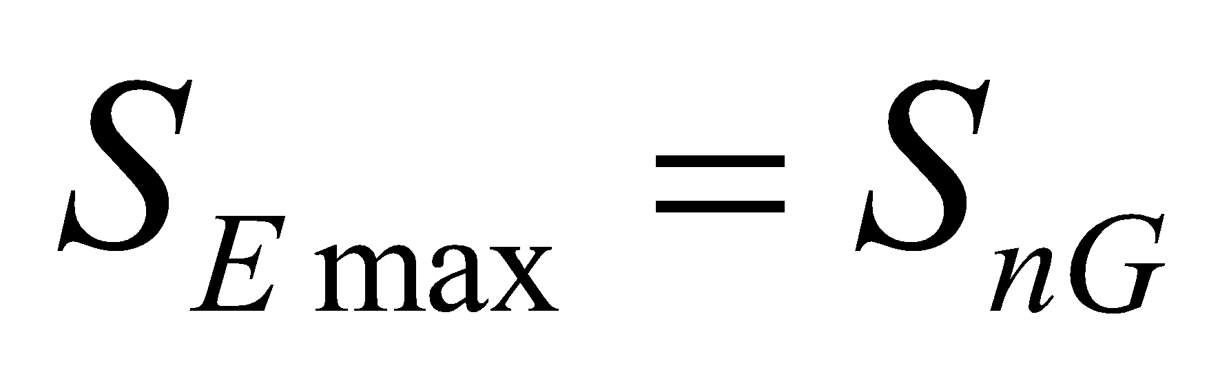
In the case of several generation units connected at one POC, maximum output is the sum of individual maximum outputs ΣS_{Emax} .

The different approach of Czech DSOs to connectivity assessment
According to the Distribution Code (chapter 10.1),the whole PQ operation range (between cosϕ = 0,90 inductive and 0,90 capacitive) of generating units should be taken into account in network disturbance assessment. For generating units with output above 100 kVA, the reactive power has to be controllable in the above-mentioned range. For connectivity assessment, power factor of a generating unit at the POC has to be considered equal to 1 (cosϕ = 1), unless the DSO determines a different power factor to verify the connectivity of the generating unit(due to e.g. reactive energy balance in a given part of the network, voltage level). This can only be done in case of generating units equipped with regulation PF = f (U), Q = f (U) or P = f (U).
The E.ON Distribucestrictly follows the clause of the Distribution Code and adheres to a conservative approach to connectivity assessment, i.e. cosϕ = 1 of a generating unit is considered.
Because the maximum installed capacity of generating units is mainly limited by permissible voltage rise at POC, since 2018 the ČEZ Distribucehas decided to use the power factor of MV power plants with Q(U) resp. P(U) regulation according to the actual voltage and power conditions in the given MV network. For connectivity assessment,cos ϕ= 0,95 is considered. It should lead to an increasing installed capacity of generating units.

Requirements for network disturbances of generating units
Relative voltage rise Δu_{A}
Voltage rise at each POC in a network caused by the totality of all generating plants in this network must not exceed (worst case)
LV-networks: Δu _{LV} ≤ 3 %
MV- and HV networks: Δu _{MV} ≤ 2 %
During abnormal conditions (e.g. network configuration change due to reconstruction works)
MV- networks: Δu _{MV perm}≤ 5 %
Simultaneously, voltage at each POC must not exceed voltage limit (U_{max}) according the standard EN 50160.
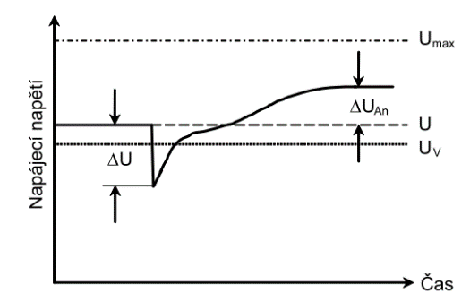
U_{max} – maximum limit of supply voltage
Uv – (nominal) voltage at POC
U – supply voltage (napájecí napětí)
ΔU – voltage change
ΔU_{An} – voltage rise caused by connected generator
Δu_{An} =ΔU_{An} / Uv – relative voltage rise

For single installation, the relative voltage change can be estimated (for symmetrical conditions):
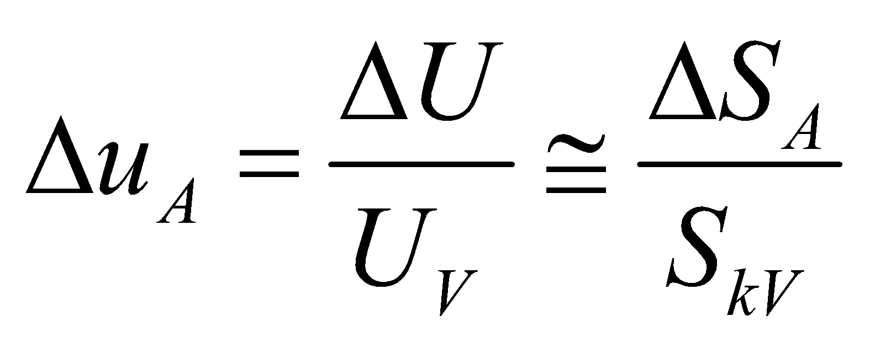
Uv – (nominal) voltage at POC
ΔS_{A} – change of the apparent output of a generator
S_{kV} – short-circuit power at point of connection (POC)

For wind power plants, the voltage rise should be calculated for output:
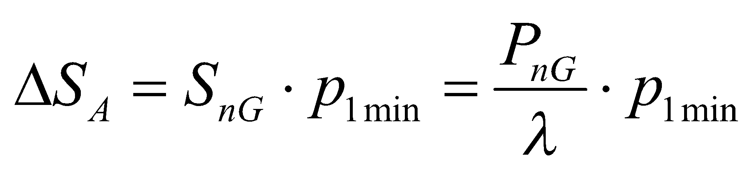
S_{nG,} P_{nG} - nominal apparent, active output of a generator
p_{1min} – maximum of average active power (1–min interval) – from generator test report (p_{1min} ≈ 1,05-1,1)
λ - power factor at maximum power
For the assessment, it is important to take into account the totality of all generating units in a considered network. In the case of generating units connected to several points of connection, or complicated network configurations (ring or meshed networks), the relative voltage rise must be calculated by power flow analysis.
If detailed data are not available, the worst case is estimated as [DC]:
- LV networks: network without loading and with full outputs of generators
- MV networks: 25% loading of the network

Connection-related voltage change (start or switching)
In contrast to voltage rise due to permanent operation, voltage changes due to connection-related operation (start, switching) are caused by transient effect mainly in electromechanical generators.
Voltage changes at the point of connection due to switching or starting must be
LV-networks: Δu _{LV max}≤ 3 %
MV- and HV networks: Δu _{MV max}≤ 2 %
For occasional voltage changes (e.g. intermittent starting no frequently than 1 time in day)
LV-networks: Δu _{LV max}≤ 6 %
MV-networks: Δu _{MV max}≤ 4 %

Voltage unbalance
The total output of 1-phase generating installations at one POC must be lower than 3,7 kVA.
In the case of 1-phase units, the inverse component of voltage has to be du₂ ≤ 0,7 % Un. Voltageunbalance at the POC has to also comply with EN 50160, the inverse component of voltage u₂ shall not exceed 2% of positive component.

Long-term flicker intensity
At the POC, long term flickerin the MV and LV networks, regardless of single units or several generating units connected to one POC.
The calculation procedure is described in the Distribution Code.
a) For single generating unit at one POC,
the flicker can be also determined with a station flicker coefficient c (given in test report mainly for wind power plants, c ≈ 4):
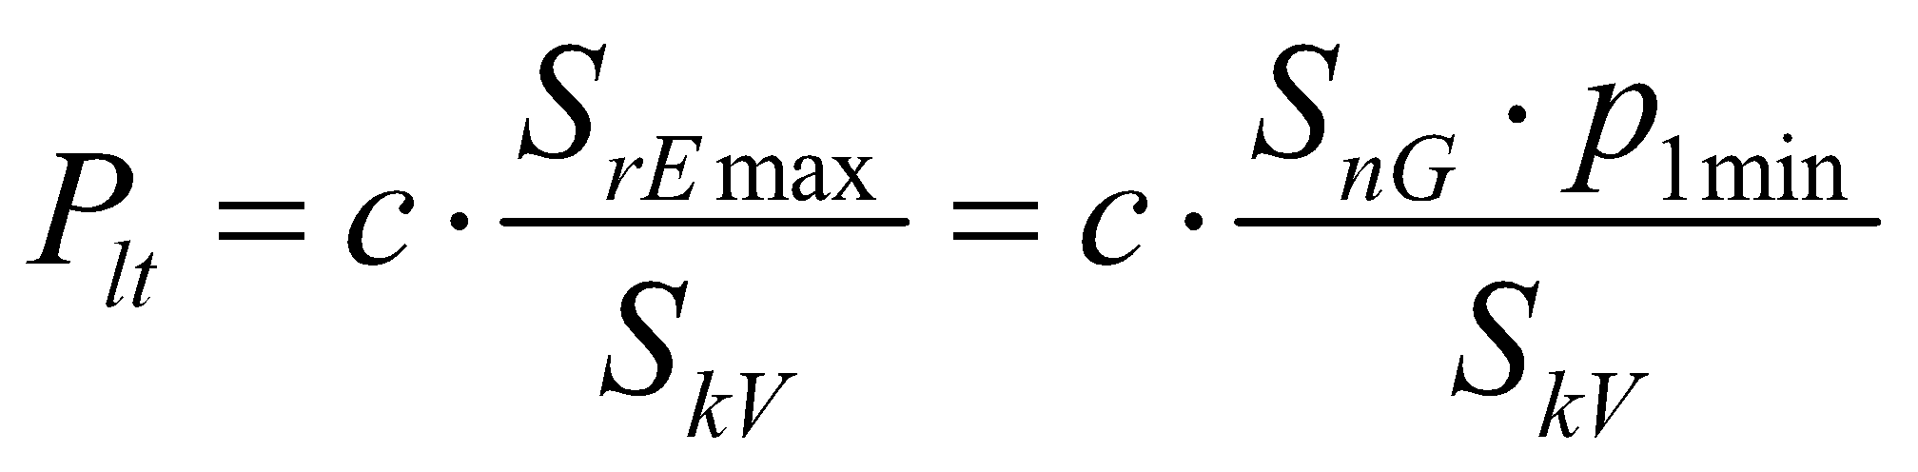
b) For several generating units at one POC,
the summation is formed from individual P_{lti} values
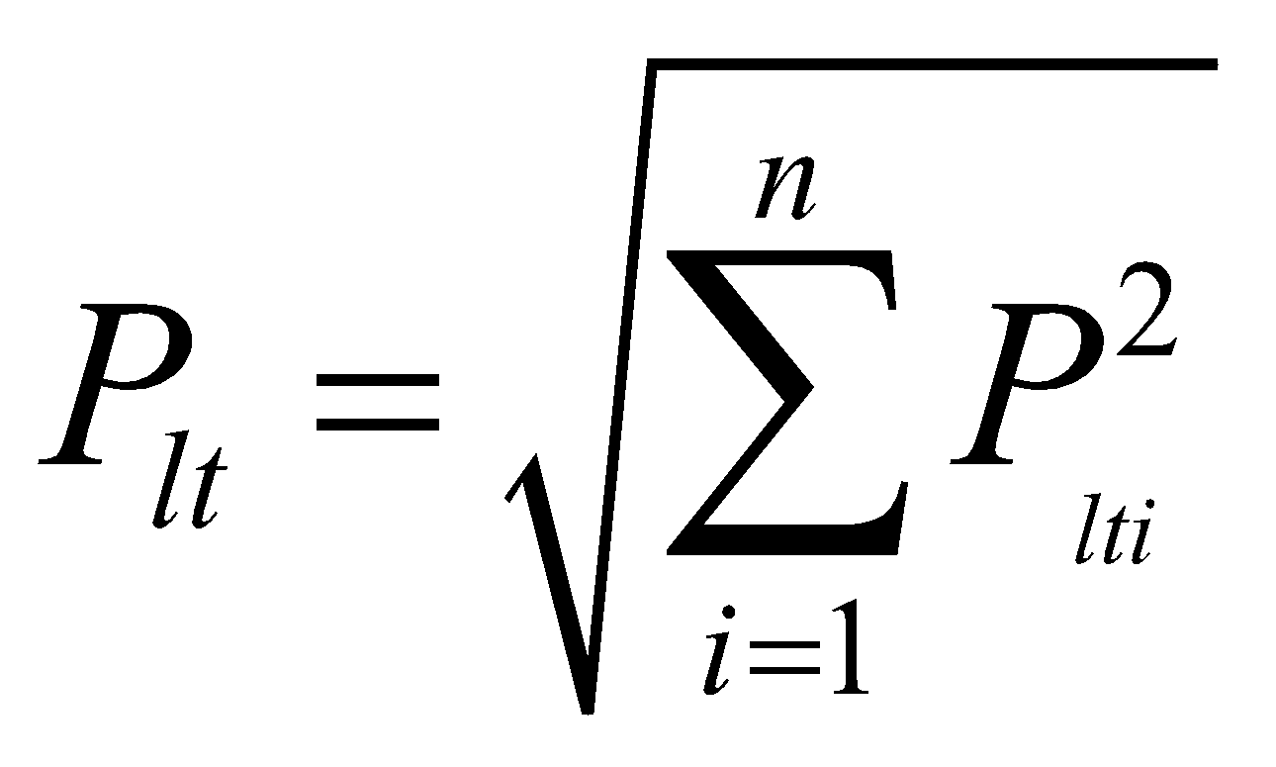 or for the plant with n same units 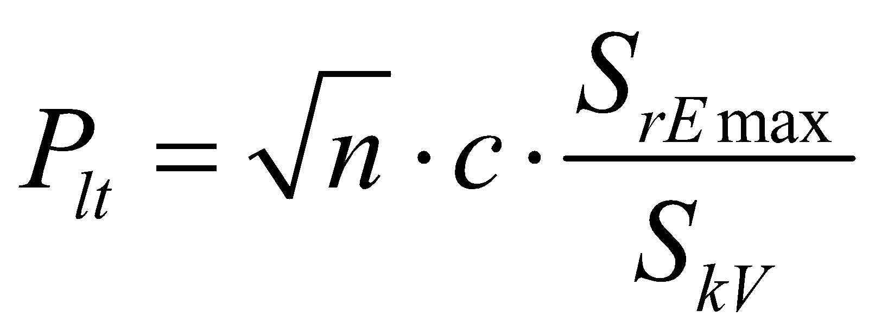

Harmonics
Assessment of harmonics is made only if generation units are connected to the network via frequency converters or inverters.Harmonic currents emitted by the generating unit are given by its manufacturer.If the LV source complies with standard EN 61000-3-2 (current up to 16 A) or EN 61000-3-12 (current >16 A and ≤75A), the levels of emitted harmonic currents are permissible. If the levels in these standards are exceeded or in case of MV generating units, permissible harmonic currents derived fromshort-circuit power at the POC are calculated and compared with harmonic currents emitted by generating unit/units. Description of assessment procedure and values of permissible reference currents i_{ν} are in the Distribution Code.
Permissible harmonic currents: 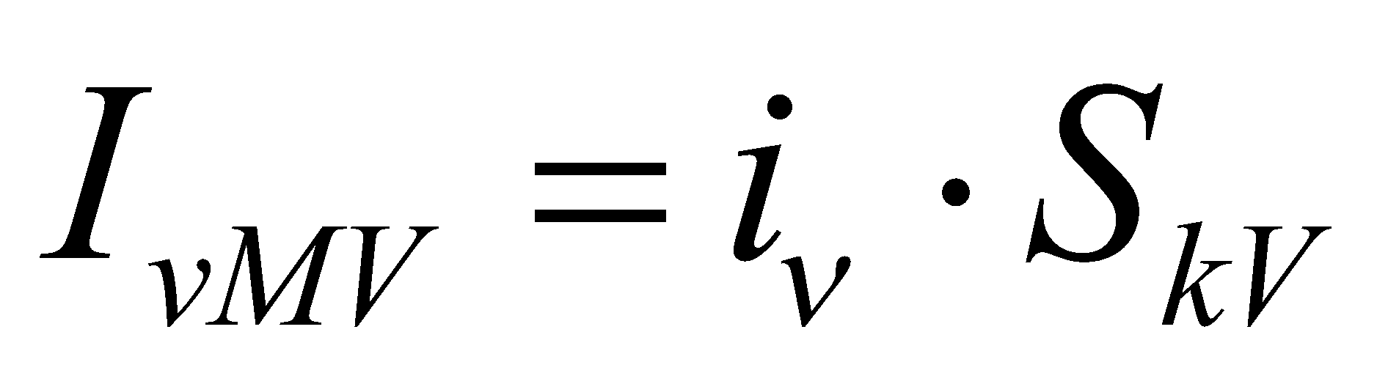

Impact on ripple control
It must be ensured that the ripple control (HDO) signal is not affected. The loading of the HDO transmitter should be taken into account. After the connection of generating a plan, an increase of transmitter loading must not less than 5 A for transmitters at 110 kV grid or 2 A for transmitters at the MV grid. If the transmitter loading is close to its maximum, it is not possible to connect the plant unless certain action is taken.

Requirements for static and dynamic support of the network

Requirements for generators are defined in the Distribution Code (DC). They are valid for all sources regardless of the kind of primary energy. Requirements for generators, specified by RfG NC (“Network Code for Requirements for Grid Connection applicable to all Generators” established by Commission Regulation (EU) 2016/631), were implemented into the Distribution Code. New power-generating plants connected to the grid after 27 April 2019 must comply with the requirements. Existing power-generating plants connected to the grid before this date are exempt from the requirements.
Requirements for static and dynamic support of the network:
- Tolerance of frequency and voltage deviations
  - Normal operating range
- Operating frequency range
- Continuous operating voltage range
  - Immunity to disturbances (dynamic support)
- Rate of change of frequency (ROCOF) immunity
- Low voltage ridethrough (LVRT) – tolerance on voltage dips
- High voltage ride through (HVRT) – tolerance on voltage swells
- Power response to voltage changes
- Voltage support by reactive power – capability (PQ diagrams) and Q control modes
- Voltage-related active power reduction – P(U)
- Short circuit current requirements on generating plants
- Active power control
  - Active response to the frequency deviation
- Power response to over-frequency
- Power response to under-frequency
  - Voltage-related active power reduction – P(U)
  - Constraint functions - active power reduction according to operation conditions (emergency control functions)
- Specific requirements for network support – starting, island operation, synchronization

Categories of generators given by Distribution Code
The requirements are divided into different power-generating plant types/categories based on the total size of the plant at the Point of Connection (POC). Due to Czech legislative (mainly Order concerning to dispatcher control), categories of generators A and B are subdivided into A1 and A2, respectively B1 and B2.
Categories of generators given by the Distribution Code
Category of generators | Subcategory | Levels of P_{inst} | Voltage level
A | A1 | 800 W ≤P_{inst} ≤ 11 kW | LV
A | A2 | 11kW ˂P_{inst} ˂100kW | LV, MV*
B | B1 | 100 kW ≤ P_{inst} ˂ 1 MW | LV*, MV
B | B2 | 1 MW ≤ P_{inst} ˂ 30 MW | MV
C | C | 30MW ≤ P_{inst}˂75MW | MV
D | D | P_{inst} ≥ 75 MW | 110 kV
* Exceptionally, generators can be connected to this voltage level.
Requirements for generating-plants up to 800 W are given by the standard ČSN EN 50438 (micro-generators). If the requirements for generators A1 apply also for micro-generators, this must be stated in writing in the Distribution Code.
Synchronous unit - A generating unit is based on a synchronous machine which is directly coupled to an electric power system. Frequency of generated voltage and generator speed are constantly synchronous with grid frequency. The synchronous generating unit can be e.g. biogas station or wind turbine with a synchronous generator without any power electronics.
Non-synchronous unit - A generating unit is connected non-synchronously to an electric power system. Non- synchronous units are connected to the grid via convertor based technology. Typical example is a PV plant or wind turbine with an asynchronous generator.
Micro-generator – A generating unit connected to the LV grid, no other generating unit is at the PCC, the nominal output of the unit is P ≤ 10 kW and nominal current is I ≤ 16 A. No license for producers is required. Connectivity assessment of micro-generators is simplified if they comply with requests of the DSO (impedance of supply network at PCC and no backflows to the network with the exception of short-term backflows).

Tolerance of frequency and voltage deviation

Normal operation of generating plants
Agenerating plant shall be capable of operating continuously when frequency and voltage at the POC stay within the operating range.
Operating frequency range and tolerance to the frequency change
A power-generating plant must be capable of continuous generation without disconnecting in the 49.0 Hz - 51.0 Hz frequency range.Operating range for voltage and frequency defines the operating period for particular values of the change.
Frequency range | Time period for operation
47 – 47, 5 Hz | 20 s
47, 5 – 48, 5 Hz | 30 min
48, 5 – 49 Hz | 90 min
49 – 51 Hz | unlimited
51 – 51, 5 Hz | 30 min

All generating units, except units upto 800 W,have to comply with RoCoF (requirements on rate-of-change-of-frequency), i.e. they must not be disconnected upto value of +/- 2 Hz/s. This value is to be measured as the average value during an interval 500 ms.
Continuous operating voltage range
Micro-generators upto 800 W, units A1 and A2 connected to the LV grid have to be able to operate if the voltage varies between -15 % Un and +10 % Un at the POC. If the voltage at the POC is lower than Un, the generating unit can decrease the power to match relative voltage change (Un – U) / Un.
Generating units B and C connected to the MV grid to be able to operate in the range given in the table below.
Voltage range | Time period for operation
0, 8 – 0, 9 Un | 60 min
0, 9 – 1, 118 Un | unlimited
1, 118 – 1, 15 Un | 60 min

Immunity to disturbances (dynamic support)
A power-generating plant must comply with the requirements for tolerances of voltage deviations. A power-generating plant must be capable of withstanding voltage dips or swell as shown in the figure below.
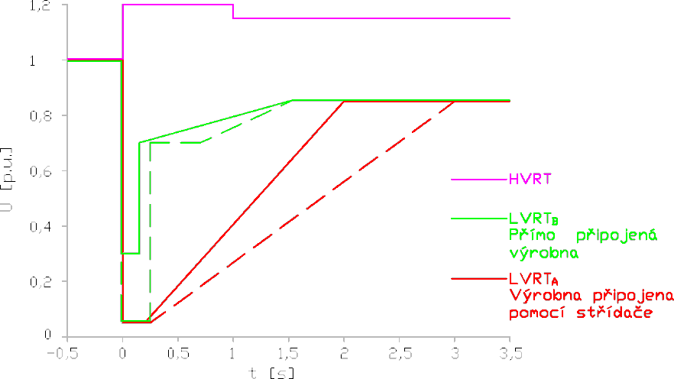
High voltage ride through (HVRT) – tolerance on voltage swells – violet color
Low voltage ride through (LVRT) – tolerance on voltage dips (solid line = standard requirement, dash line = stricter requirement)
Green color- synchronous generating plants
Red color – generating plants with convertors
In the case of voltage dips below the solid line, it is allowed to disconnect the plant from the grid. This applies to both symmetrical and asymmetrical faults.
For LV plants are evaluated line-to-ground voltages, for MV and HV plants line-to-line voltages. The lowest and highest of 3 measured voltage must comply with LVRT respectively with HVRT characteristic.
Application of LVRT function
LV grid – only non-synchronous generating plants A2 and B1 (new-installed P > 11 kW)
MV and HV grid – all new-installed generating plants

Active power control of generating units
All generating plants connected to the DS must be able to reduce the active power automatically depending on the frequency and the conditions in the network and according to the commands from the DSO´s control center or automatically disconnect from the DS.

Power response to overfrequency – P(f)
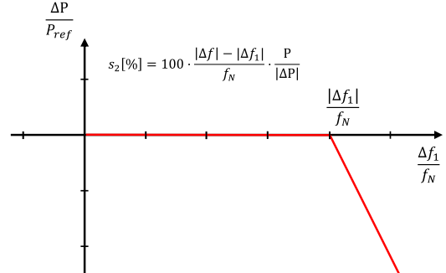
A power-generating plant must be capable of downward regulation of its active frequency at overfrequency. The frequency threshold for commencement of frequency response is set on 50,2 Hz withdroop s₂ is 5%.
f < 50,2 Hz – no reduction of P
50,2 < f < 51,5 Hz – according to characteristic P(f)
f > 50,2 Hz and f <47,5 Hz – disconnection from grid

Application of P(f) regulation
all new-installed generating plants regardless of voltage level or category

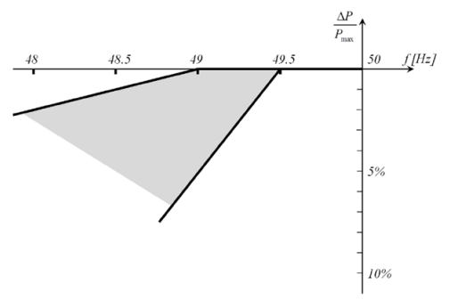
Power response to underfrequency
A power-generating plant is permitted to reduce the active power within the 49,5 Hz - 47.5 Hz frequency range. The diagram represents the limits defined by the DSO.

Voltage-dependent active power reduction - P(U) regulation
In order to avoid disconnection due to overvoltage, generating plants/units are allowed to reduce active power output as a function of this rising voltage.
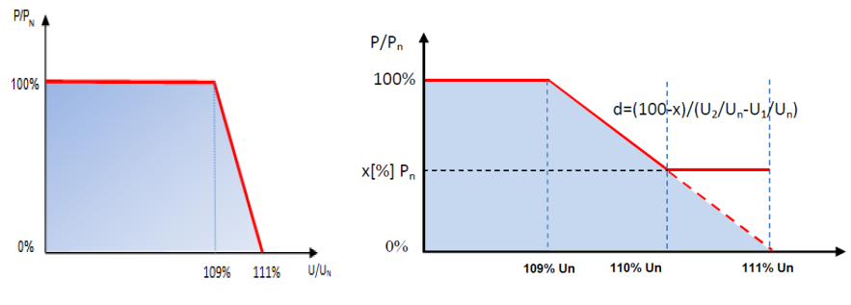
Non-synchronous (with inverter) generating plants Synchronous generating plants
Characteristics of autonomous P(U) control
Application of P(U) regulation
all new-installed generating plants with installed output P < 100 kW regardless of voltage level or category (for plants without inverter a less strict variant of the characteristic can be applied

Constraint functions –ceasing and active power reduction according to operation conditions
A power-generating plant must be equipped with a number of active power constraint functions. The requirements depend on the plant type.
A power-generating plant must be capable of limiting its maximum active power. Absolute power limit is used to limit the active power from a power-generating plant to a set point-defined maximum power limit at the Point of Connection (POC). An absolute power limit is used to protect the public electricity supply grid against overload in critical situations.
A power-generating plant must be equipped with an emergency control function that, following a downward regulation order,is capableof quickly adjusting the active power supplied from a plant to one or more predefined set points.

The following default setpoints are:
1.60%, 30% and 0% of rated power (power plants P > 100 kW)
2. 75%, 50% and 0% of rated power (for biogas power plants P > 100 kW)
3. 0% of rated power.
0% means that the power-generating plant is stopped, but it must be technically possible to reduce output to 0% without automatically disconnecting the plant from the grid.

Application of ceasing and active power reduction
a) Existing power-generating plants connected to the grid before April 2019
Generating plants 30 kW <P < 100 kW - operative disconnection by remote control
Generating plants 0 kW < P < 30 kW - operative disconnection by remote control (from 2017/18)
Generating plants P ≥ 100 kW - active power reduction, remote adjusting to predefined setpoint (small water plant excluded)
b) New power-generating plants connected to the grid after 27th April 2019 (RfG)
Generating plants P > 100 kW - active power reduction, remote adjusting to predefined set point
Generating plants 11 kW <P ≤ 100 kW – operative disconnection by remote control
Generating plants P ≤ 11 kW – operative disconnection by ripple control
The application of ceasing and active power reduction is expected only for emergency states.

Ceasing and active power reduction used by the DSO “ČEZ Distribuce, a.s.”
Voltage level | Category of generators | Active power reduction | Notes
LV | A1  800 W ≤ Pinst ≤ 11 kW | 0%, 100% | ripple control, disconnection
LV | A2  11 kW ˂ Pinst ˂ 100 kW | 0%, 100% | ripple control, disconnection
LV | B1  100 kW ≤ Pinst ˂ 1 MW | PVs, wind power  0%, 30%, 60% and 100%  other  0%, 50%, 75%, 100% | remote adjusting to predefined set point
MV | A2  11 kW ˂ Pinst ˂ 100 kW | 0%, 100% | ripple control, disconnection
MV | B1, B2, C  100 kW ≤ Pinst | PVs, wind power  0%, 30%, 60% and 100%  other  0%, 50%, 75%, 100% | remote adjusting to predefined set point
HV | D | PVs, wind power  0%, 30%, 60% and 100%  other  0%, 50%, 75%, 100% | remote adjusting to predefined set point

Reactive power control of generating units
Requirements for voltage support by Q control are described in the Distribution code – appendix no.4: Rules for parallel operation of sources and DSO’s distribution system, chapters 9.2.1 and 9.4.
A source has to participate in voltage support if network conditions require voltage support and the DSO requests it.Generating units and plants must be able to support voltage by reactive power control, i.e. to keep it in normative range, in normal operation state.
Static voltage support by reactive power (normal operation state)
- minimal requirement for delivery/consumption of reactive power if U = Un, during normal operation state,
- and also for U ≠ Un for new installed generating units (from 04/2019)
- operational requirements for reactive power control - if DSO requires it, a generator has to be able to regulate its power factor in the range between 0,9 inductive and 0,9 capacitive.

Requirements for the reactive power range

LV generating plants A1
Graphical representation of minimum and optional requirements for reactive power delivery/consumption at the nominal voltage Un is shown in the figure below, where P_{D} is the design active power of the plant. The power factor is in range 0,9 inductive to 0,9 capacitive.
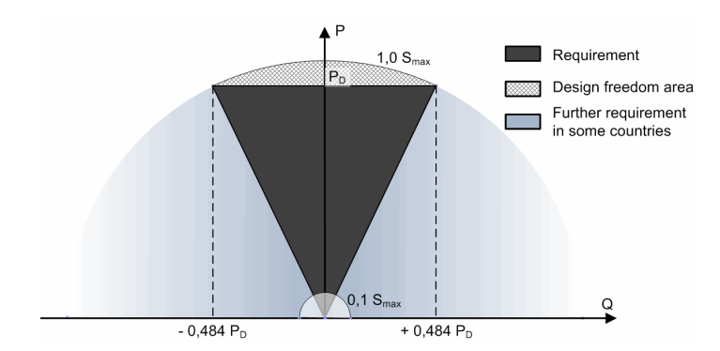
The working area of LV generators at the nominal voltage Un

According to ČSN EN 50438, a micro-generator up to 800 W must have power factor higher than 0, 95, if the output power is higher than 20 % of its nominal output.
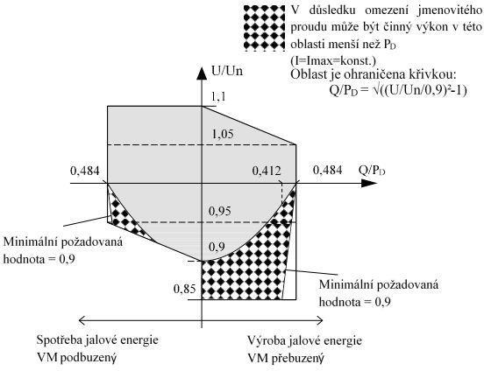
If the voltage differs from the nominal value but is in the range for continuous operation, the generating unit must behave to the diagram below.
Q-import / Underexcited Q-export / Overexcited
The working area of generator A1 at a voltage different from Un, at design power P=P_{D}

Generating plants A2, B1, B2, C and D
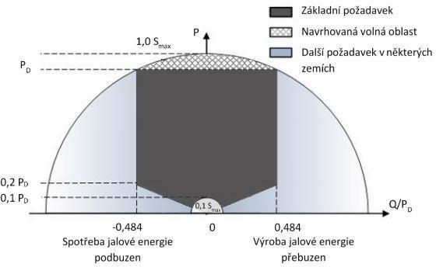
The working area of generators (A2, B, C, and D) at the nominal voltage Un
Further, it is necessary that synchronous units B2, C, D are capable to deliver or consume additional reactive power necessary for compensation of e.g. charging power of cable between POC and high voltage terminals of block transformer. In the case of asynchronous units, the requirement is requirements only to deliver the necessary additional reactive power.
New standards define also range, where the unit (synchronous or non-synchronous) must behave in case of maximum output power.
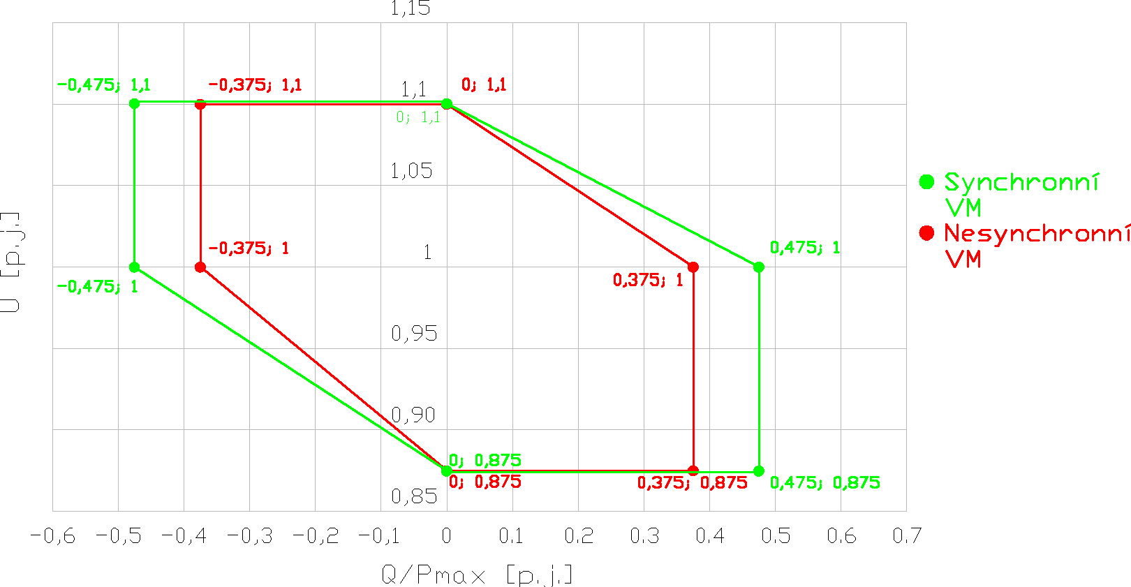
The working area of generator A2, B, C and D at a voltage different from Un, at maximum output

If the output power is lower than the maximum output, the non-synchronous unit must behave according to the diagram below.
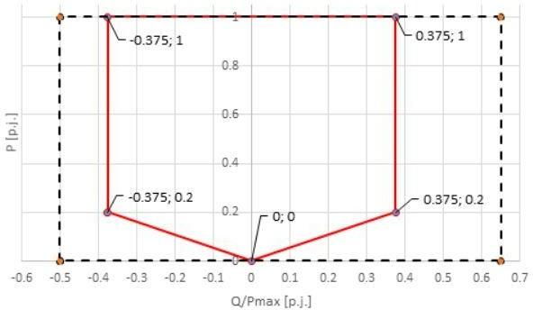
The working area of generator A2, B, C and D at power lower than maximum output

Operational requirements for reactive power control
A power-generating plant must be capable of supplying reactive power. Only one of the following required control functions can be active at a time. The power-generating plant must be capable of controlling its reactive power using the functions and characteristics described below.
According to the Distribution Code, (MV and HV) power plants P ≥ 100 kW have to be included in the remote control system of DSO and their Q to be regulated in the range of power factor between 0,9 ind and 0,9 cap in any time (support of voltage quality). Q control with PF outside the above mentioned range is possible, if it is in contract between the DSO and the producer (network support service).
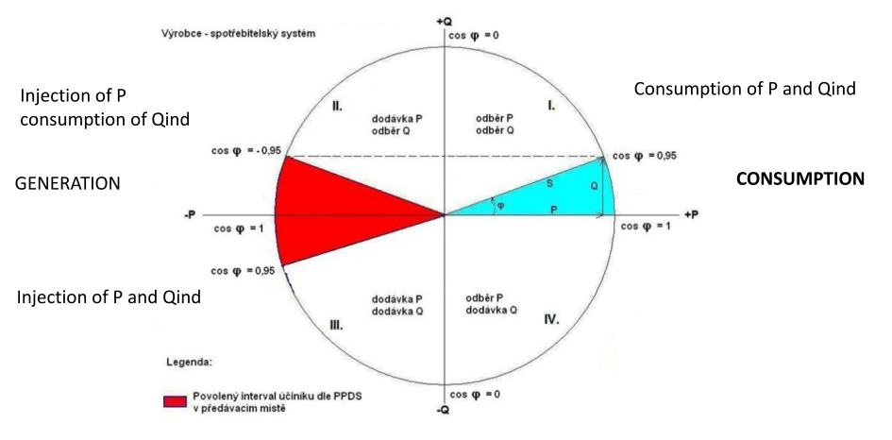
Working quadrants of generating units
Power plants are usually operated with a neutral power factor.
The strategy of reactive power control depends on the location of the power plant and is determined by DSO after consultation with the power plant operator.

Strategies of reactive power control (Q control modes)
- fixed value of power factor PFfix
- value of Q depending on voltage Q(U)
- required value of U Ufix (U/Q)
- fixed value of Q Qfix
- value of Q depending on active power Q(P)
- value of PF depending on voltage PF(U)
- value of PF depending on active power PF(P)
For each power plant, strategy of reactive power control, respectively required value of Q is set by DSO individually with respect to local conditions. DSO has to respect technical capabilities of the given power plant.
Q(U) control mode - Characteristic curve Q=f(U) has to be adjustable. Adjusting is given by the DSO with respect to the local condition in the distribution system.
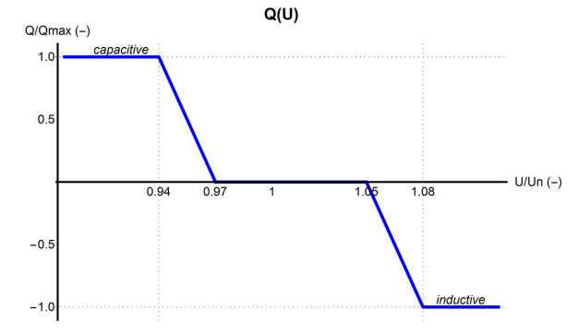
Characteristic of autonomous Q(U) control

Application of Q control modes in DS

a) Existing power-generating plants connected to the grid before April 2019
PF fix – PF is kept in given PF range, almost all sources, P ≥ 100 kW included in remote control system of DSO (remote adjusting the setpoint)
U fix – selected MV or HV sources included in ASRU (Automatic system of voltage control), remote adjusting the setpoint (P ≥ 100 kW), power factor outside neutral range is not charged, from 2017/18
Q fix – Q is set according to system operator requirements (110 kV sources not included in ASRU), remote adjusting the setpoint,power factor outside the neutral range is not charged.

b) New power-generating plants connected to the grid after 27th April 2019 (RfG)
Q control modes used by the DSO “ČEZ Distribuce, a.s.”
Voltage level | Category of generators |  | Q control mode | Deactivation of PF charging | Working area
LV | A1  800 W ≤ Pinst ≤ 11 kW | with convertor | Q(U) | yes | all quadrants
LV | A1  800 W ≤ Pinst ≤ 11 kW | without convertor | PF fix | no | quadrants 2 and 3
LV | A2  11 kW ˂ Pinst ˂ 100 kW |  | Q(U) | yes | all quadrants
LV | B1  100 kW ≤ Pinst ˂ 1 MW |  | Q(U) | yes | quadrants 2 and 3
MV | A2  11 kW ˂ Pinst ˂ 100 kW |  | Q(U) or PF fix | if Q(U) yes  if PF fix no | if Q(U) then all quadrants
MV | B1, B2, C  100 kW ≤ Pinst |  | Q(U) or U fix | yes | quadrants 2 and 3
HV | D |  | U fix | yes | quadrants 2 and 3

A2 in MV systems – individual consideration of suitable Q control mode, PF-fix mode is preferred in points with high short-circuit power
B, C – individual consideration, Q(U) mode is preferred in points with high loading

ČEZ Distribuce
The DSO “ČEZ Distribuce” uses autonomous regulation Q(U) for LV generating plants (except synchronous units A1).Their operation uses only local voltage measurement at the connection point, thus it is not dependent on any communication with the central control unit. At a voltage close to Un, the plant operates with a neutral power factor. If the voltage drops significantly, the plant goes into the capacitive mode and tries to increase the voltage in the grid. On the other hand, in case of a higher voltage increase, the factory switches to the inductive mode and tries to reduce the voltage. In both modes, a power factor limit of 0.9 is required by Distribution Code. If there is a very significant voltage increase in the network despite full activation of the Q (U) function, P (U) function is activated to reduce active power produced. P (U) regulation is an extreme measure to maintain the voltage and should not be activated too often due to the reduction of the energy produced.
According to the Distribution Code, (MV and HV) power plants P ≥ 100 kW have to be included in the remote control system of DSO and their Q to be regulated in the range of power factor between 0,9 ind and 0,9 cap in any time (support of voltage quality). New installed MV power plants with a power output above 100 kW use “U/Q control”, i.e. regulation of reactive power to fixed voltage (U fix) at the connection point to the grid. At the same time, this type of regulation is gradually supplemented to existing plants with an output usually above 1 MW, in agreement with the plant operators. The most common operating range of the power factor is between 0.95 ind and 0.95 cap.

Requirements for the connection interface

- Protections – distribution Code, appendix no. 4, chapter 8
- Interface switch – chapter 7 and 5
- Remote information exchange – remote monitoring and operation parameter setting – chapter 5.1
Interface switch, having a breaking and making capacity corresponding to the rated current of the generating plant,and short-circuit protection. The interface switch for power plants P ≥ 100 kW must be remote controlled and equipped by status signaling.
Power plants A1, A2 and B1 (P < 1 MW) – remote-controlled switch for remote disconnection of the source (e.g. by means of ripple control)
Power plants A2, B and C (P > 11 kW)- have to be included in the remote control system of the DSO
- remote controlled switch (mainly for emergency states – remote disconnection)
- active power reduction on set point
- Q and U control
- Interface for data transfer (data are transferred to the substation control system if the source is connected directly to a substation, or to dispatching center of the DSO)
- for A2, only preparation of needed interface is now sufficient

Application of remote control and information exchange of generating plants (ČEZ Distribuce)
Generating plants P ≥ 100 kW
- P control (reduction) – PV, wind plants 100%, 60%, 30%, 0%
- P control (reduction) - other plants 100%, 75%, 50%, 0%
- U/Q regulation (U fix) can be requested regulation on U fix (MV, HV)
- Exchange of measurement data and signaling with dispatching center of the DSO
Generating plants P < 100 kW
- P control (reduction) 100%, 0% (disconnection) by ripple control
- No request on remote information exchange (measurement, signaling)

OPERATIONOF GENERATING PLANTS

Permissible range of power factor is between 0,9 ind and 0,9 cap. The most common operating range of the power factor is between 0.95 and 0.95 ind (neutral PF).
Generating plants use autonomous regulation or remote control from the control center of the DSO.

Autonomous regulation
P(U) regulation
- all new-installed generating plants with installed output P < 100 kW regardless of a voltage level or category
Q(U) regulation
- LV generating plants, except synchronous P < 11 kW (A1)
- MV generating plants P < 100 kW – autonomous Q(U) or PF fix regulation
- MV generating plants P ≤100 kW – autonomous Q(U) or remote adjusting U fix regulation
LVRT
This regulation is required for new-installed plants:
- LV grid – only non-synchronous generating plants A2 and B1 (new-installed P > 11 kW)
- MV and HV grid – all new-installed generating plants
P(f) regulation
- all new-installed generating plants regardless of voltage level or category

Remote control
Ceasing and active power reduction
Ceasing and active power reduction is possible only in emergency states. Since 2019, ceasing and active power reduction applies to all new-installed power plants regardless of their primary energy. Until 2019, small water power plants were excluded from this regulation.
Generating plants P ≥ 100 kW - active power reduction, remote adjusting to predefined set point
- P control (reduction) – PV, wind plants 100%, 60%, 30%, 0%
- P control (reduction) - other plants 100%, 75%, 50%, 0%
Generating plants P < 100 kW
- P control (reduction) 100%, 0% (disconnection) by ripple control
Q control
- MV generating plants P ≥100 kW – autonomous Q(U) or remote adjusting U fix regulation

Ceasing and active power reduction is possible only in emergency states. Emergency state (according to Energy Act No. 458/2000) is the condition that arose in the electricity system as a result of:
a) natural disasters,
b) measures of state authorities in emergency, state of emergency or war,
(c) accidents or accumulation of failures at installations for the production, transmission, and distribution of electricity;
d) smog situations according to special regulations,
(e) a terrorist act;
f) unbalance of the electricity system or its part,
(g) transmission of a failure from a foreign electricity system; or
(h) where the physical safety or protection of persons is at risk
and causes a significant and sudden lack of electricity or endangering the integrity of the electricity system, its safety and reliability of operation in all or part of the national territory.
The producer, i.e. operator, of the generating plant concerned, shall not be entitled to financial compensation from the network operator.
For example,the producerin Germany shall be entitled to financial compensation from the network operator (see “Einsman” – Einspeisemanagement, P > 100 kW, solar P> 30 kW).

References:
[1] Czech Distribution Code – supplement no.4: Rules for parallel operation of electricity generation and accumulation facilities in distribution networks, 2019
[2] Czech standard PNE 33 3430-0 – Výpočetní hodnocení zpětných vlivů odběratelů a zdrojů distribučních soustav (Assessment of distribution network disturbances caused by customers and sources), 3rd edition, 2015
[3] D – A – CH – CZ Technical Rules for Assessment of Network Disturbances, 2nd edition 2007
[4] Standard EN 50 160 - Voltage characteristics of electricity supplied by public distribution systems, 3rd edition, 2011

COMPARISON CZ –DE

Issue | Czech Republic | Germany
Category/Types of generating plants
Category/Types of generating plants | According to RfG NC – A, B, C, D  But A and B are divided into 2 sub-categories:  A1800 W ≤P_{inst} ≤ 11 kW  A211kW ˂P_{inst} ˂100kW  B1100 kW ≤ P_{inst} ˂ 1 MW  B21 MW ≤ P_{inst} ˂ 30 MW  also  micro-generators in LV grids  (P ≤ 10 kW, I ≤ 16 A)
Connectivity and network disturbance assessment
Connectivity assessment | ČEZ Distribuce  LV PF = 1  MV (from 2018) PF =0.95 ind  (similar effect as U/Q regulation of MV generators)  E.ON Distribuce  PF = 1
Connectivity for micro-generators | No license for producers is required. Connectivity assessment is simplified.
1-phase generating installation at a POC | P ≤ 3,7 kVA
Connectivity assessment  (main issues) | Voltage rise at each POC (all generating plants connected)  LV networks: Δu ≤ 3 % MVnetworks: Δu ≤ 2 %  during abnormal conditions (e.g. network reconfiguration due to reconstruction works)  MV- networks: Δu ≤ 5 %  Voltage at each POC must not exceed voltage limit according the standard EN 50160 (Un ±10%).
Network disturbance assessment  (other issues) | Voltage rise  Connection-related voltage change (start or switching)  Voltage unbalance  Long-term flicker intensity  Harmonics (injected currents)  Impact on ripple control
Requirements for network support (regulation capabilities)
Power factor range | Power factor range is between 0,9 ind and 0,9 cap  ČEZ: The most common operating PF range is between 0.95 ind and 0.95 cap.  Micro-generators: between 0.95 ind and 0.95 cap.
PQ working area | LV generating plants A1 (P ≤ 11 kW)  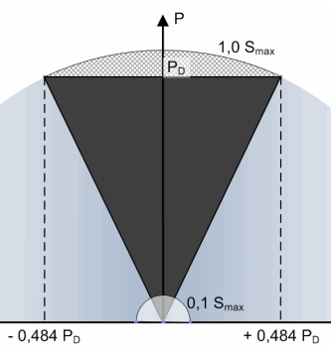  LV, MV and HV (P > 11 kW)  A2, B, C and D  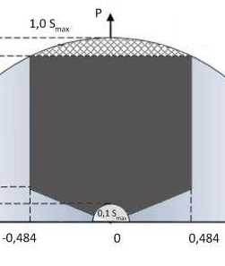
Reactive power control (Q control)
Q control modes used | fixed value of power factor - PF fix  Q depending on voltage - Q(U)  required value of U - U fix (also called U/Q) | PF fix ???  Q(U)  PF (P)
Q control characteristics | Q(U)  X1 = 0,94; x2 = 0,97; x3 = 1,05; X4 = 1,08  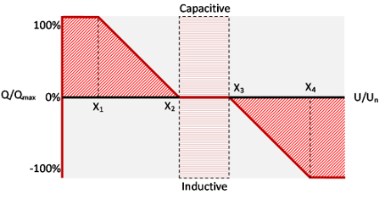
LV generating plants | Existing generating plants  PF fix  New-installed ones (after 04/2019)  Q(U) regulation, except synchronous plants P ≤ 11 kW (PF fix)
MV generating plants | P < 100 kW: Q(U) or PF fix  P ≥ 100 kW: U fix or Q(U)
Remote versus autonomous Q control | LV: autonomous Q(U) or PF fix (predefined)  MV: P ≥ 100 kW remote control, adjusting setpoint U fix or PF fix (mainly predefined PF but remote adjusting should be feasible),  or P > 11 kW autonomous Q(U)
Active power control (P control)
Power response to frequency – P(f) | 47,5 < f < 50,2 Hz – no reduction of P  50,2 < f < 51,5 Hz – according to characteristic P(f), s = 5%  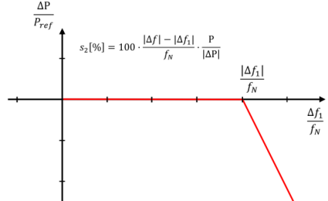  f > 50,2 Hz and f <47,5 Hz – disconnection from grid
P(U) regulation – voltage support | All new-installed generating plant P < 100 kW  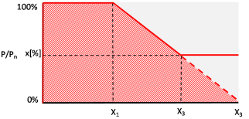  X1 = 109% Un, X2 = 110% Un, X3 = 111% Un  Less strict characteristic for plants without inverter
Active power reduction | P ≤ 100 kW – only operative disconnection by remote/ripple control  P > 100 kW –P reduction, remote adjusting to predefined set point,  PV, wind: 100%, 60%, 30%, 0%  other plants: 100%, 75%, 50%, 0%  Possible only in emergency states
Active power reduction – financial compensation | No | Yes,  “Einsman” – Einspeisemanagement, P > 100 kW, solar P > 30 kW
Remote control and informationexchange
Remote control(regulation) | P ≥ 100 kW included in the remote control system of the DSO  (P reduction, Q and U control)  for A2 (11kW ˂ P ˂100kW), only preparation of needed interface is now requested  all plants: remote-controlled switch for remote disconnection of the source
Information exchange | P ≥ 100 kW exchange of measurement data and signaling with dispatching center of the DSO  P < 100 kW no request on remote information exchange

