INPUT INSPECTION OF MATERIAL, RAW MATERIALS AND BATHS

Paint (NH) pouring

Determination of the degree of pourability of NH
- selection for suitable application technologies

- the ability of a constant amount of paint of known consistency and temperature to form a continuous layer on a perfectly wettable, smooth, horizontal glass plate
- pour scale: diameter of a pattern formed over a period of time after spilling 20 ml of paint over the surface of a board
- usual reading intervals after 15 s up to 180 s
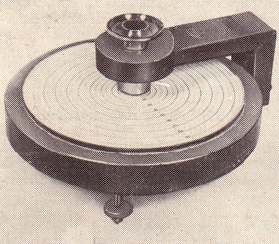

Equipment for measuring the pourability of paints (NH)
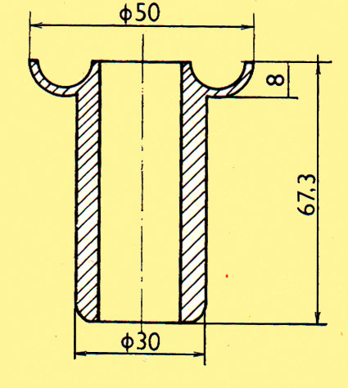

Design of a measuring cylinder for measuring the pourability
NH spreadability

- paints intended for brush application

- the paint is applied with a brush over an area of minimum size
180 x 240 mm

- the applied thickness must correspond to the data of the technical standard

Evaluation of spreadability in three stages:

Grade | Test result
1 | Paint easily blends from the brush;  it can be spread for more than 1 minute; it does not resist
2 | Paint is more difficult to flow from the brush; it gives a slight resistance, after 1 minute of application the paint peels off
3 | Paint cannot be spread in an even layer; paint peels off after only 30 seconds

Castability of NH

- the ability of NH to form, on the surface, a coating film perfectly smooth, fused, without structure and traces after application

Carrying out the test – similar to determining the spreadability;
is applied until it is perfectly spread

Evaluation: immediately after completing a test coating,
possibly 30 minutes after spreading

Evaluation according to the time required for traces on the surface of the paint to vanish
Grade | Test result
1 | The paint blends; perfectly smooth surface within 10 minutes
2 | The paint blends 10 to 15 minutes after brushing
3 | The paint does not blend for more than 15 minutes
Evaluation according to the appearance of the coating 30 minutes after application |  | Evaluation according to the appearance of the coating 30 minutes after application
Grade | Test result
1 | The paint is smooth and blended
2 | Slight traces of brush strokes
3 | Clearer traces of brush strokes
4 | Obvious traces of brush strokes
5 | Deep traces of brush strokes extending to the substrate

NH sprayability

- the ability of NH to disperse with a stream of compressed air or high pressure and to form a coating of uniform thickness on the surface of an object

Evaluation of suitability for application by pneumatic or high-pressure airless spraying

Principle:

- evaluation of the size of the injection pattern

- position of the nozzle of the spray gun:
perpendicular at a distance of 200-350 mm from the sprayed surface

- the full flow of paint is opened for 5 s
- pressure: 0.25 to 0.35 MPa for pneumatic application
9 to 16 MPa for high pressure application

Evaluation
- ease of spraying
- injection pattern size
- % of area with uniform coating
(min. thickness 12 μm or 30 μm)
- coating appearance

Sprayability is indicated by three degrees:

1. paint is perfect; smooth surface without noticeable structure
2. paint is blended; on the surface, the structure has the character of orange peel
3. paint is uneven; the surface has a rough structure

NH opacity
ability of the coating to cover the substrate (usually a contrast of black and white stripes)

Visual method
On a colour-constant substrate, most often black and white, it is to be determined how many layers of paint film are needed to completely cover it

Grade | Test results
1 | Excellent; black stripes do not show under one layer
2 | Good; black stripes do not show under two layers
3 | Sufficient; black stripes do not show under three layers
4 | Insufficient; black stripes show even under three layers

Wedge test
- the paint is applied to the underlying glass plate (270 x 80 x 9 mm)
- a cover glass plate is attached; spaced on one side by inserting a spacer (h = 0.05; 0.1; 0.2; 0.3; 0.4; 0.5 mm)
- a contrasting black and white rectangle (4 x 10 mm) moves under the base plate
- in a place where the contrast is not clear, the thickness of the coating is determined:
h_{l}:
h₁ = b₁ . h / b
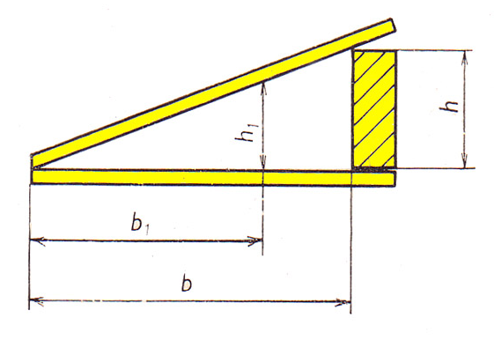
- the determination is carried out within 60 s of the construction of the test wedge layer

Method of objective determination
Principle:
- application of loose paint film on a grey contrast scale
- finding out when the grey scale is perfectly covered

Drying of NH
the ability to form a continuously non-sticking solid film at normal or prescribed elevated temperatures
Factors: - coating thickness: uniform, corresponding to technical
conditions
- temperature (18-25°C)
- relative humidity (55-75%)
Principle:
evaluation of adhesion of paint film under graded conditions
seven stages of gradual drying:

Degree of drying | Test conditions | Test result
1 | Sprinkling glass balotina | Balotina can be completely removed with a brush without damaging the paint
2 | Load weight 20 g | The paper does not adhere to the paint
3 | Load weight 200 g | The paper does not adhere to the paint
4 | Load weight 2,000 g | The paper does not adhere to the paint, a trace of load
5 | Load weight 2,000 g | The paper does not adhere to the paint, without any trace of load
6 | Load weight 20 kg | The paper does not adhere to the paint, a trace of load
7 | Load weight 20 kg | The paper does not adhere to the paint, without any trace of load

Qualitative evaluation method
two stages of drying: - paint dried against dust
- paint does not stick
Degree of drying | Test conditions | Test result
A | Dusting with lycopodium (powder) | Can be wiped off without damaging the paint
B 1 | Load weight 20 g | The paper does not adhere to the paint
B 2 | Load weight 200 g | The paper does not adhere to the paint
B 3 | Load weight 500 g | The paper does not adhere to the paint
B 4 | Load weight 1,000 g | The paper does not adhere to the paint
B 5 | Load weight 2,000 g | The paper does not adhere to the paint

Yield of NH

- is directly proportional to the dry matter content
- is inversely proportional to the thickness of the paint film and the density of the paint
- is expressed as an area [m²] coated with 1 kg of paint of optimal qualities

Principle:

- weighing the container with paint and brush
- painting 1 m² of area
- weighing the container with paint and brush
- it is possible to proceed similarly when spraying (minimize losses by spraying)

Evaluation:

a = 1000 / (b - c)
b - weight of the paint container and brush [g]
c - weight of the paint container and brush after painting 1 m² of area [g]

Particle size and shape (granulation)

- evaluation of: - powder paints
- metallic and non-metallic powders for thermal spraying
- powders for enamelling (frits)
- the shape of the particles affects:
- the fluidity of powders
- the uniformity of spray performance
- the quality of the resulting coating
- rheological properties of enamel suspensions
- workability of enamels and their melting ability

Vibrational sieve analysis

Principle: - sorting of powders using a system of sieves with graduated mesh sizes
Procedure: - pouring the batch into the upper sieve
- sorting over a specified period
- weighing the shares captured on the sieves
- conversion to percentage by weight
- if there is a risk of electrostatic charge, about 0.5 wt.% of antistatic active powder is admixed (e.g., aluminium oxide - γ modification)

Usual conditions of a sieve analysis:

Conditions | Polymer powders, frits | Powders for thermal spraying
Particle size | 0-200 μm | 0-200 μm
Batch weight | 20 g ± 0.1 g | 100 g
Mesh size | 320, 250, 100, 80, 63 μm | 150, 120, 90, 75, 50, 40 μm

Modification of a sieve analysis
- sorting with a stream of air
- wet sorting - to determine the fineness of grinding of suspensions
(particle size from 5 to 100 μm)
Moisture of powders

- the amount of physically bound water in the powder
- expressed in weight percent
- weight and analytical methods

Excessive moisture in powder materials affects the following:

- storability
- tendency to agglomerate
- corrosion processes
- technical properties
- fluidizability
- electrical properties
- quality of the processed coating
- molecular and supramolecular structure
- homogeneity of the coating
- porosity of the layer

Drying over a desiccant

Determination of weight loss of the sample on drying to a constant weight

Procedure:

- a specified amount of powder material (1 to 10 g) is weighed in a glass container with a sharpened lid
- drying is carried out, e.g., over P₂O₅ (hygroscopic substance), at a certain temperature, to a constant weight

Flowability of powder materials
(organic powders, enamel powders and thermal sprays)

determination by discharge
funnel for testing the flowability of powders (diameter of the hole according to the type of powders):

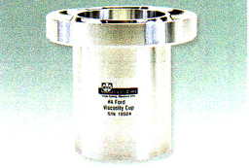

Bulk angle

characterizes the flowability and flow properties of powder materials:

Rating for polymer powders:
- the angle formed by the cone with the base during pouring under defined conditions
- the quality of the surface of the resulting cone, which is expressed by the fragmentation or the smoothness of the cut edge to the plane of the cone axis

Bulk density

Bulk density = mass of a given volume of loose powder

Principle:
- weighing the determined volume of loose powder in a measuring container

Bulk device – funnel for testing the flowability of powders
Flowability of polymer powders

affects:
- appearance
- maximum achievable coating thickness
- its ability to cover the edges of the product.

Principle
- evaluation of the change in melt viscosity in the polymerization, polycondensation or polyaddition process

Procedure
- preheating the glass plate to the required temperature
- laying a tablet extruded from powder resin
- placing the plate in the oven at an angle of 60°
- leaving the plate in the oven at 200°C for 15 minutes
- measuring the length of the longitudinal axis of the image formed by flow, i.e., the flow measure

Flow diagram

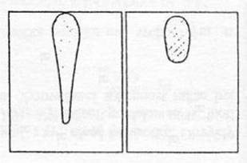
Interval of processing temperatures of polymer powders

Principle
- controlled melting of polymer powder layer on a chrome-plated electrically heated plate
Procedure
- stabilization of thermal conditions
- applying an even layer of powder
- measuring the time required for the powder to completely melt and to degrade at a certain temperature

Evaluation
- appearance of the coating surface (gradually changes to a mirror-shiny and smooth state)
- change in appearance after prolonged exposure to heat (wrinkles, depressions, craters, etc.)

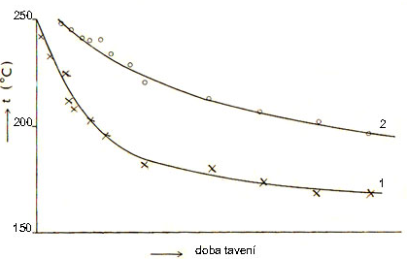

Temperature curves of processing polyethylene
1 – beginning of melting
2 – beginning of degradation

Ability to form glassy coatings
- determination by monitoring the flowability of a standardized sample extruded from an appropriate frit or dried suspension

Meltability - depends on the temperature and time of heat treatment
Workability of enamel suspension

- aqueous suspension – ground frit with additives = colloidally dispersed system

Workability determined by the combination of:

- physical properties (particle size, fineness of grinding, density, etc.)
- rheological properties (viscosity, flow limits, etc.)

Workability affects - the suitable way of applying the suspension
- required stability
- achieving optimum coating properties

Relative viscosity - measured by flow

Flowability of the suspension

Procedure
- heat treatment of a tablet extruded from the dried test material on a tilted pad until a hemisphere is formed
- tilt by 45°
- firing until the length of the melted track is min. 40 mm
- calculation of flow:

x = a / b

a - measured track length
b - measured length of a standard track

Total workability of an enamel suspension:

- coating a standard plate (100 x 100 mm)
- are evaluated: - flow time
- final weight of the coating

Melting process and extent of firing interval of enamel suspension

Procedure

- firing of samples with applied enamel in an electric gradient oven with a certain temperature gradient
- firing time is constant
- sample and standard are processed under the same conditions
- evaluation by comparison
- monitoring (temperature dependence)
- the beginning of the melting of a glassy coating
- extent of firing interval
- optical or chemical properties
- occurrence of defects, etc.

Melting process

- monitoring with a high-temperature microscope
- observation and documentation of changes in standard tablets extruded from test material

