EVALUATION OF SURFACE TREATMENTS

- ORGANIC COATINGS

powder plastic paints and coatings
- 70% of surface treatments in mechanical engineering

Substrate protection - barrier function of the coating
- ability of the coating not to let the
active components of the environment aggressively penetrate
- surface blocking
- the ability to prevent the occurrence of corrosion processes due to the physical and chemical bonds of the substrate with the coating
Formation of degradation caused by:
- penetration of the corrosive environment through the coating system
- disruption of the coating
- impairing the adhesion between the base material and coating

Degradation caused by:
dusting, chalking, blistering, swelling, cracking, undercorrosion, loss of adhesion, etc.

2. INORGANIC NON-METAL COATINGS

conversion coatings, enamels, thermal sprays, silicate coating, carbide-based coatings, silicides, borides, cermets, etc.

Protection mechanism - barrier effect
- blocking of the surface

Degradation - damaged integrity under increased stress
- loss of adhesion
- loss of gloss

3. METAL COATINGS

20% total production of surface treatments
12% generated electrochemically (galvanically)
5% by immersion in molten metal
3% by thermal spraying
0.5% by physical methods

Mechanism of protection
- immunity - thermodynamic improbability of corrosion
- passivity - formation of thin, compact layers on the surface
- protective layer of corroding products

Major causes of degradation
- damage to the integrity of the protective coating
- local damage of passivity
- disruption of the protective layer
- exposure of the substrate (loss of adhesion)
- corrosion of the base material

4. COMBINED COATINGS

The most common combinations (double and multilayer coatings):

- heat-formed metal coating + paint

- heat-formed metal coating + powder plastic

- heat-formed metal coating + silicate coating

- organic coating + vacuum-steamed + organic coating

Mechanism of protection

depends on the type of combination

Manifestations of degradation
- depends on the nature of the loss of protective and functional properties of individual coatings

INPUT INSPECTION OF MATERIAL, RAW MATERIALS AND BATHS

Input inspection - verification of material and raw material properties
for creating coating systems
(paints, powders, frits, etc.)
or for the preparation of baths (chemicals, etc.)
- or basic properties of newly deployed baths

Viscosity - inner friction of fluids
- resistance of fluid to tangential stress
at laminar flow:
- liquid particles adjacent to walls do not move
- the velocity of particles increases towards the axis of the tube

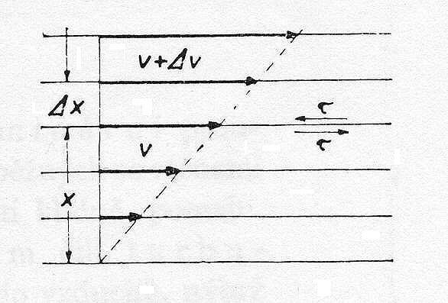
- tangential stress τ [MPa] created by internal friction at the contact surface of two layers of different velocities v:
τ = η
- speed gradient
η - viscosity (dynamic) - internal friction coefficient (dynamic) [Pa.s]
υ =
υ - kinematic viscosity - kinematic coefficient of internal friction [m² s⁻¹]
ρ - density [kg.m⁻³] ρ =
Determination of viscosity according to Hőppler

Hőppler viscometer test tube inclined at an angle of 10 ° to the vertical axis in a tempering jacket
Tempering: measurement of the time of passage of the ball between two marked places on the inclined tube

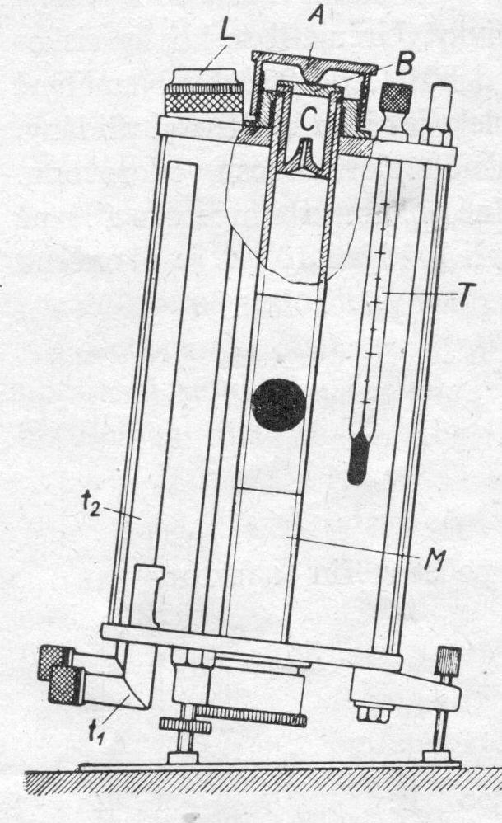

M - measuring tube
A - screw head
B - metal plate
C - vent insert
t₁ - supply tube
for tempering liquid
t₂ - drain pipe
for tempering liquid
T - thermometer
L - spirit level

Determination of viscosity according to Hőppler

Working procedure:
- Close the measuring tube at the bottom with a stopper and a screw cap
- Fill the tube with liquid to about 2.5 cm below the edge
- Using tweezers, insert the ball
- Insert the vent insert and close the tube with a tight cap
- Place the viscometer stand in a horizontal position
- Using rubber hoses, connect the tempering jacket of the viscometer to the thermostat
- Set the temperature, turn on the pump and heating
- Turn the viscometer and measure the passage time of the ball
- After the measurement, unscrew the bottom cap and release the ball into the catcher

Calculation of dynamic viscosity:
η = K (ρ_{k} - ρ_{t}) . t
η – dynamic viscosity
K – device constant
ρ_{k} – density of the test ball
ρ_{t} – density of the test liquid
t – average time of ball fall

Bubble viscometer

Principle: comparing the passage of the bubble in the sample with substances of known viscosity
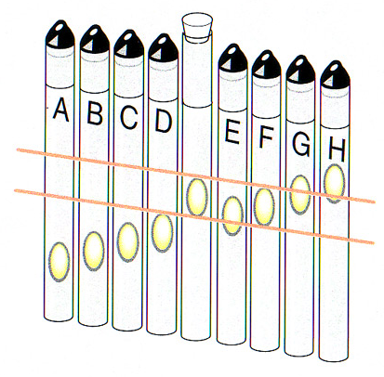
Consistency - depends on viscosity, characterizes fluidity,
and thus the workability of the paint
Orientation determination - perfect mixing of the sample with a spatula, length about 250 mm, width 25 mm
- the spatula is removed from the container and tilted at an angle of about 60°
Consistency is expressed in the following degrees:
- very little viscous – very thin (e.g. water)
- slightly viscous – thin (e.g. pure oil)
- medium viscous – medium (e.g. glycerine)
- highly viscous – very thick (e.g. gear oil)

Outflow time measurement

- simple, fast-operating, even laboratory method
Consistency determined by the outflow time of a given volume from a standard cup (outflow diameter 4 mm) at a temperature of 20ºC
Workflow
- the outlet of the cup fixed in the stand is closed
- the paint is poured over the rim into the cup
- excess material is removed with a glass plate
- the measurement determines the time from the release of the nozzle to the moment of the first rupture of the continuous stream of outflowing paint

Application | Outflow time [s]
Brush, glove | 50-80
Pneumatic spraying | 20-35
Hot spraying | 70-100
Soaking, watering | 20-40
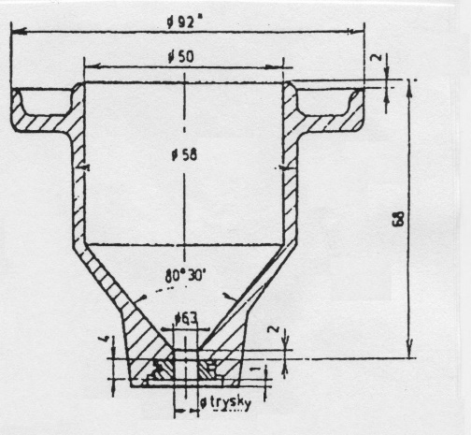
Determination of viscosity: it is read from a table or graph
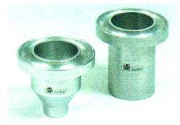
Sedimentation

- difficulty in mixing the pigment sediment
- the force required for the test tool to penetrate the deposit to the bottom of the container in which the paint is stored

ASTM method - handling of a spatula weighing 45 g with a 21 mm wide and 121 mm long metal plate is evaluated
Pigment deposit:
- easy to mix
- miscible
- difficult to mix
- immiscible

Density (specific gravity)
ρ = [kg.m⁻³]
Relative density - a dimensionless number indicating the ratio of the weight of a certain volume of, e.g., paint to the weight of the same volume of water at a specified temperature

Determination of density by immersion densitometer

Densitometer
- sealed glass tube calibrated to a certain temperature
- floats in a liquid in a vertical position
- then immerses deep until the weight of the expelled liquid is equal to the weight of the densitometer (Archimedes' law)
- the depth of immersion depends on the density of the liquid
- the density value is read on the scale of the densitometer
Disadvantages of the method:
- the need for a larger sample
- small measuring range
- cannot be used for measuring pigmented paints
and high-viscosity varnishes

Determination of density by pycnometer

Principle: the known volume of the test sample is weighed

Water value of the pycnometer (measuring container):

O = (b – a) / 0,99823
a - weight of empty pycnometer,
b - weight of the pycnometer filled with water
0.99823 [kg.m⁻³] – density of water at 20°C

Sample density:

ρ_{v} = (c – a) / O
c - weight of the pycnometer with the sample

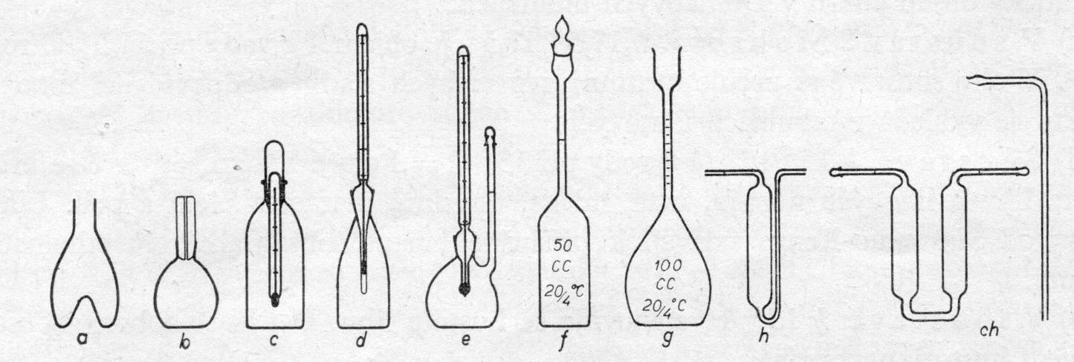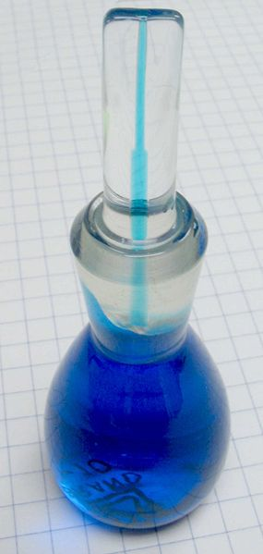

Determination of density with a metal cup

More suitable for paints: determination of weight in a metal cup containing 100 ml
- the volume of the test vessel is determined with distilled water
- after tempering the container and the sample, the container is filled
- after a further 30 minutes of tempering, the excess sample is removed by pressing the lid

Density ρ₂₀ [kg. l⁻¹]:

ρ₂₀ = (G₃ – G₁) / V
G₃ - empty container weight [g]
G₁ - filled container weight [g]
V - container volume [ml]

Content of non-volatile components

Non-volatile components (dry matter) - a summary of film-forming and solid substances
after evaporation of solvents and thinners they remain as a protective layer on the surface
the content of non-volatile components – affects
- the course of coating formation
- thickness and protective properties
expression: weight in %

The essence of measuring methods - determination of the residual amount of paint after heating the sample under the prescribed conditions
According to the ČSN 67 3031standard:
- asphalt, oil, synthetic NH 2 hours at 135°C
- synthetic firing NH 3 hours at 135°C
- nitrocellulose, polymeric NH 4 hours at 80°C

Determination of non-volatile components in drying oven
Sample of paint in a petri dish
- weighed on an analytical balance
- heated at the prescribed temperature and time in the drying oven
Non-volatile matter content: ratio of the weight of the sample after drying to the weight of the original sample

In operation instead of a petri dish, lids made of tin coated with paint are used
Determination of dry matter in %:

S = .100 %
a – lid weight [g]
b - weight of the lid with a sample of paint [g]
c - weight of the lid after drying [g]

Dilutability

Ability of the paint to be diluted with the appropriate thinner while maintaining the required technical properties of the paint and the required paint quality
In practice: simple empirical methods (based on experience)

Qualitative test

Suitability of the respective diluent
Glass beaker:
- 50 g sample of paint
- intensive mixing
- addition of diluent to a weight ratio of 1: 1, possibly. 1: 2
there must be no clouding (varnishes), villi or precipitation of the binder

Maximum diluent addition test

- until the formation of permanent turbidity of paints
- until the formation of precipitates in pigmented paints

Test to determine the amount of diluent for a given consistency

- weighing 120 ml of the paint sample
- adding 5 weight% diluent
- mixing
- determination of consistency with a spout cup
- repeating with a new sample of paint and adding more diluent
- creating a course of dependence of the change in consistency on the amount of the diluent
Flash point of paints

Flash point – the lowest temperature [°C] at which a substance heated under defined conditions generates so many vapours that their mixture with air ignites when the initiating flame approaches, and immediately goes out

Burning mixtures with a flash point lower than room temperature T

According to the value of the flash point - classification of NH into a safety class
- important for transport, storage and processing of NH
I. - flammable liquids with a flash point up to 21°C (alcohol, petrol, etc.)
II. - flammable liquids with a flash point from 21°C to 65°C (diesel, kerosene, etc.)
III. - flammable liquids with a flash point between 55°C and 100°C
IV. - liquids with a flash point above 100°C
Liquids up to a flash point of 250°C are considered flammable

Pensky-Martens device
with integrated fire extinguisher

Combustion temperature – the lowest temperature at which a substance heated under defined conditions generates so many vapours that their mixture with air ignites when the initiating flame approaches.
Ignition temperature – the lowest temperature at which a mixture of vapours or gases of a given substance with air ignites under prescribed conditions (only by the action of heat)
pH value (acidity number)

- negative decimal logarithm of hydrogen ion activity
- to determine the acidity or alkalinity of baths
- is checked during the preparation of baths
during technological processes
(chemical and electrochemical processes)
for waste products, etc.
Potentiometric measurement measurement of the potential of a cell formed by a measuring glass and comparative calomel electrode in the measured environment

For evaluation of paint substance pH, the
acidity number is used:
the amount of KOH needed to neutralize the free components in 1 g of sample
high acidity number – effect:
- on the corrosion of the substrate under the paint
- for film ageing and storage
For varnishes: determination by titration (volumetric analysis)
- titration flask
- weight: 10 to 50 g of paint
- dissolves with a neutral mixture of benzene and ethanol (2:1)
- the sample can be heated for better dissolution
- cooling
- KOH is titrated (dripped) until a pink colour appears (phenophthalein)
- end of titration - colour does not change within 30 s

Calculation of acidity number:

A.n. = a . f . 5,611 / b

a – KOH consumption [ml]
f – KOH factor
b – sample weight [g]

