AEL4 Unit 9ab: Inventions
Printer-friendly version of exercises + key to exercises

1) AEL4U9ab_L_Test_Report.jcl
Listening: Test Report
Gap-fill exercise
Listen to Recording 29 that comes with your coursebook (alternatively, you can read the transcript on p. 124 in your coursebook). You will hear part of a radio car chat reviewing two vehicles. The speakers will speak about the new Spyder roadster and compare it against the Zoomster XL motorcycle. As you listen, mark the following statements as True or False (t X f) in the second column of the table below. Then listen again and correct the false statements by filling in the third column of the table. If the statement is correct, type in the word CORRECT in the gap.
STATEMENTS:  The Spyder… | TRUE OR FALSE?  (t X f) | CORRECTION  The Spyder…
- has brakes which are a great deal more powerful than the Zoomster's.  - reaches the same maximum speed as the Zoomster.  - accelerates as quickly as the Zoomster.  - is much more difficult to steer than the Zoomster.  - has much better suspension than the Zoomster on a bumpy road.  - is a lot less stable than the Zoomster when taking a bend at speed.  - is slightly less safe than the Zoomster.  - is about three times more expensive than the Zoomster. | - ________  - ________  - ________  - ________  - ________  - ________  - ________  - ________ | - ________.  - ________.  - accelerates ten percent ________ ________.  - Correct.  - has much ________ suspension.  - is much ________ ________ on bends.  - is much ________.  - is fifty percent ________ ________.
Task adapted from: Bonamy, D. (2011). Technical English Level 3 Coursebook. Pearson Longman, p. 68.
Key:
STATEMENTS:  The Spyder… | TRUE OR FALSE?  (t X f) | CORRECTION  The Spyder…
- has brakes which are a great deal more powerful than the Zoomster's.  - reaches the same maximum speed as the Zoomster.  - accelerates as quickly as the Zoomster.  - is much more difficult to steer than the Zoomster.  - has much better suspension than the Zoomster on a bumpy road.  - is a lot less stable than the Zoomster when taking a bend at speed.  - is slightly less safe than the Zoomster.  - is about three times more expensive than the Zoomster. | - true  - true  - false  - true  - false  - false  - false  - false | - Correct.  - Correct.  - accelerates ten percent less quickly.  - Correct.  - has much worse suspension.  - is much more stable on bends.  - is much safer.  - is fifty percent more expensive.
2)
AEL4U9ab_Gr_Criteria.jcl
Grammar: Asking about Criteria
Gap-fill exercise
Look at the criteria on the left and complete all the questions related to them.
Criteria | Questions
- Price (€)  - Top speed (km/h)  - Length (cm)  - Width (cm)  - Height (cm)  - Weight (kg)  - Engine output (kW/hp)  - Max range (km) | - How ______ is it? What does it ______? What is the ______? (in Euros)  - What is the maximum speed? What is the highest speed it can make? (in kilometres per hour)  - What is the length? How ______ is it? (in centimetres)  - What is the width? How ______ is it?  - What is the height? How ______ is it?  - What is the weight? How much does it ______? How ______ is it? (in kilograms)  - What is the engine output? How powerful is it? What is the ______? (in kilowatts or in horsepower)  - What is the maximum range? How ______ can it go per full tank? (in kilometres)

Key:
Criteria | Questions
- Price (€)  - Top speed (km/h)  - Length (cm)  - Width (cm)  - Height (cm)  - Weight (kg)  - Engine output (kW/hp)  - Max range (km) | - How much is it? What does it cost? What is the price? (in Euros)  - What is the maximum speed? What is the highest speed it can make? (in kilometres per hour)  - What is the length? How long is it? (in centimetres)  - What is the width? How wide is it?  - What is the height? How high is it?  - What is the weight? How much does it weigh? How heavy is it? (in kilograms)  - What is the engine output? How powerful is it? What is the performance? (in kilowatts or in horsepower)  - What is the maximum range? How far can it go per full tank? (in kilometres)

3) AEL4U9ab_Gr_comparatives_superlatives_adj.jcl
Grammar: Comparatives and Superlatives of Adjectives
Gap-fill exercise
Complete all the gaps in the sentences below using the correct form of the adjectives in brackets and the information from the table below.

 | The Spyder | The Carver | The Segway | The Skycar
Price (€) | 21,260 | 42,000 | 5,500 | approx. 2m
Top speed (km/h) | 180 | 180 | 20 | 630
Length (cm) | 267 | 340 | 48 | 550
Width (cm) | 150 | 130 | 64 | 270
Height (cm) | 115 | 140 | variable | 180
Weight (kg) | 316 | 620 | 43 | 1,000
Engine output (kW/hp) | 79/106 | 48.5/65 | 1.5/2 | 716/960
Max range (km) | 406 | 630 | 19 | 1,450
Source of the information: several Google searches.
- The Carver is ________________________ than the Segway but ________________________ than the Skycar. (expensive)
- The Skycar is the ________________________ car of them all. (expensive)
- The Spyder is as ________________________ the Carver. (fast)
- The Segway´s range is ________________________ than the Spyder´s range. The Segway has the ________________________ range of all the vehicles. (bad)
- The Skycar is ________________________ than the Spyder. It is the ________________________ vehicle of all. (long)
- The Skycar is the ________________________ vehicle. It is ________________________ than the other three vehicles. (heavy)
- The Skycar is the ________________________ vehicle. (big)
- The Spyder is ________________________ than the Carver, but ________________________ than the Segway. The Segway is the ________________________ car. (cheap)
Key:
- The Carver is more expensive than the Segway but less expensive than the Skycar. (expensive)
- The Skycar is the most expensive car of them all. (expensive)
- The Spyder is as fast as the Carver. (fast)
- The Segway´s range is worse than the Spyder´s range. The Segway has the worst range of all the vehicles. (bad)
- The Skycar is longer than the Spyder. It is the longest vehicle of all. (long)
- The Skycar is the heaviest vehicle. It is heavier than the other three vehicles. (heavy)
- The Skycar is the biggest vehicle. (big)
- The Spyder is cheaper than the Carver, but less cheap than the Segway. The Segway is the cheapest car. (cheap)

4) AEL4U9ab_Gr_comparative_adv.jcl
Grammar: Comparative Adverbs
Gap-fill exercise
Read each sentence carefully and complete each gap with a comparative adverb, so that it fits the context.

- This knife cuts well, but after sharpening it, it cuts even ____________.
- I work fast, but in order to manage everything in time, I need to work even ____________.
- This electromagnet attracts the metal arm effectively, but after increasing the amount of power, it will attract the metal arm even ________________________.
- This engine works efficiently, but after tuning it up, it will work even ________________________.
- We can produce the part cheaply, but after buying robots, we will certainly produce them in series, which means even ________________________.
- The disaster damaged the machinery seriously, but human workers were injured even ________________________.
- Robots can sometimes be unreliable, but humans often work even ________________________.
- We are not satisfied with the way this neuron network has been trained. It is really bad, but without at least this short training, the recognition system would work even ________________________.
- I had to get up early yesterday, but tomorrow, I will need to get up even ________________________ in order to catch the morning train.
- People have problems seeing in the dark, but with these new night-vision lenses, they will see ________________________.

Key:
- This knife cuts well, but after sharpening it, it cuts even better.
- I work fast, but in order to manage everything in time, I need to work even faster.
- This electromagnet attracts the metal arm effectively, but after increasing the amount of power, it will attract the metal arm even more effectively.
- This engine works efficiently, but after tuning it up, it will work even more efficiently.
- We can produce the part cheaply, but after buying robots, we will certainly produce them in series, which means even more cheaply.
- The disaster damaged the machinery seriously, but human workers were injured even more seriously.
- Robots can sometimes be unreliable, but humans often work even less reliably.
- We are not satisfied with the way this neuron network has been trained. It is really bad, but without at least this short training, the recognition system would work even worse.
- I had to get up early yesterday, but tomorrow, I will need to get up even earlier in order to catch the morning train.
- People have problems seeing in the dark, but with these new night-vision lenses, they will see better.

5) AEL4U9ab_Practice_Comparing_Bulbs.jcl
Comparison: An Incandescent Bulb vs. a CFL Bulb
Gap-fill exercise
Look at the specifications on p. 69 in your coursebook (Bonamy, D. (2011). Technical English Level 3 Coursebook. Pearson Longman) and compare the two types of bulbs by choosing the correct option from the list.
(Note: an incandescent bulb = a “normal” bulb; CFL bulb = compact fluorescent bulb)

Phrases to fill in:
almost five times greater; almost twice as; four times as much; longer; many more watts; much more; slightly less output; times as long as
- A normal bulb consumes ___________________________, in other words, ___________________________ energy than a CFL bulb.
- A CFL bulb lasts more than six ___________________________ a normal bulb. Can you imagine that? Six times ___________________________!
- A CFL bulb has ___________________________ in lumens than a normal bulb.
- For 10,000 hours, you need more than ___________________________ normal bulbs as CFL bulbs.
- A CFL bulb costs ___________________________ much as a normal bulb.
- A normal bulb uses more than ___________________________ electricity as a CFL bulb.
- The total cost of using a normal bulb is ___________________________ than using a CFL bulb.
Sentences from: Bonamy, D. (2011). Technical English Level 3 Coursebook. Pearson Longman, p. 69.

Key:
- A normal bulb consumes many more watts, in other words, much more energy than a CFL bulb.
- A CFL bulb lasts more than six times as long as a normal bulb. Can you imagine that? Six times longer!
- A CFL bulb has slightly less output in lumens than a normal bulb.
- For 10,000 hours, you need more than six times as many normal bulbs as CFL bulbs.
- A CFL bulb costs almost twice as much as a normal bulb.
- A normal bulb uses more than four times as much electricity as a CFL bulb.
- The total cost of using a normal bulb is almost five times greater than using a CFL bulb.
Sentences from: Bonamy, D. (2011). Technical English Level 3 Coursebook. Pearson Longman, p. 69.

6)
Writing: Comparing Processors
Look at the specs of some AMD processors below and compare them using the modifying comparatives and superlatives covered in this unit. It is up to you which of the processors features you will compare, but write at least six sentences. Submit them via a Moodle portlet.
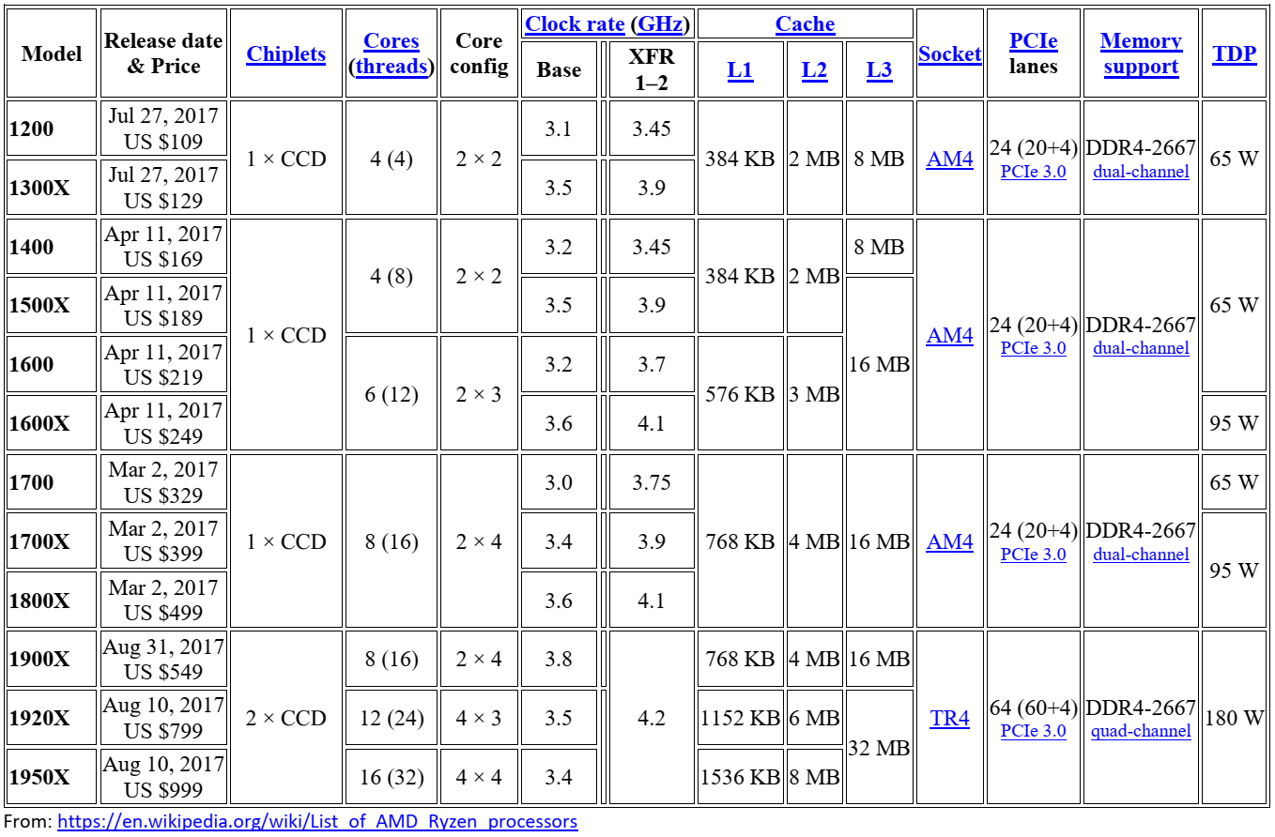

7) AEL4U9ab_R_skycar.jcl
Reading: The Skycar
Gap-fill exercise
Read the text and complete the tasks.
Moller's latest design, the Skycar M400, is designed to take off and land vertically, like a Harrier Jet, in small spaces. It can reach speeds of 400 mph (644 kph), but will cruise at around 350 mph (563 kph), and it has a range of 900 miles (1449 km). Gasoline, diesel, alcohol, kerosene and propane can be used to fuel the Skycar, and its fuel mileage will be comparable to that of a medium-sized car, getting 20 miles (32.2 km) to the gallon. The initial cost of a Skycar will be about $1 million, but once it begins to be mass produced that price could come down to as low as $60,000.

The four-seat Skycar is powered by eight rotary engines that are housed inside four metal housings, called nacelles, on the side of the vehicle. There are two engines in each nacelle so that if one of the engines in one of the nacelle fails, the other engine can sustain flight. The engines lift the craft with 720 horsepower, and then thrust the craft forward. The Wankel engine replaces pistons of a conventional engine with a single triangular rotor spinning inside an oval-shaped chamber, which creates compression and expansion as the rotor turns. There are three combustion chambers in the Wankel, with a crankshaft between them.

To make the Skycar safe and available to the general public, it will be completely controlled by computers using Global Positioning System (GPS) satellites, which Moller calls a fly-by-wire system. In case of an accident, the vehicle will release a parachute and airbags, internally and externally, to cushion the impact of the crash.

MACRO Industries' SkyRider X2R will also use this fly-by-wire system to safely transport passengers to their desired destinations. Drivers will simply get in, turn on the power and enter the address or phone number of their destination. SkyRider will do the rest. MACRO said that the system will be almost fully automatic, but may allow some manual control. Commands will be entered just by telling the car what you want it to do.

Adapted from: http://travel.howstuffworks.com/flying-car2.htm

TRUE OR FALSE?
The Skycar needs a long runway to take off and land. (1)______________________
More than one type of fuel can be used with the Skycar. (2)______________________
After being mass produced, the price of the Skycar will go down. (3)______________________
There is one extra motor on each side of the Skycar. (4)______________________
There are the same pistons in the Skycar engine as they are in a conventional engine. (5)______________________
In the future, the Skycar will be voice-controlled. (6)______________________

ANSWER THE QUESTIONS:
What is the maximum speed the Skycar can reach? - (7)______________________ mph ((8)______________________ kph)
How far can it go after fully filling the tank? - (9)______________________ km
How many people can be transported in the Skycar? - (10)______________________
What is the special engine with 3 combustion chambers called? - (11)______________________
Which satellites will be used for the navigation of the Skycar? - (12)______________________
When will a parachute and airbags be released? - (13)______________________

FIND THE WORDS IN THE TEXT THAT MEAN THE FOLLOWING:
Almost the same = (14)______________________
Car = (15)______________________
Price = (16)______________________

----------Key----------
Reading: The Skycar

TRUE OR FALSE?
The Skycar needs a long runway to take off and land. False
More than one type of fuel can be used with the Skycar. True
After being mass produced, the price of the Skycar will go down. True
There is one extra motor on each side of the Skycar. True
There are the same pistons in the Skycar engine as they are in a conventional engine. False
In the future, the Skycar will be voice-controlled. True

ANSWER THE QUESTIONS:
What is the maximum speed the Skycar can reach? - 400 mph (644 kph)
How far can it go after fully filling the tank? - 1449 km
How many people can be transported in the Skycar? - 4
What is the special engine with 3 combustion chambers called? - The Wankel
Which satellites will be used for the navigation of the Skycar? - GPS
When will a parachute and airbags be released? - In case of an accident

FIND THE WORDS IN THE TEXT THAT MEAN THE FOLLOWING:
Almost the same = comparable
Car = vehicle
Price = cost

