Writing: How CD Players and Laser Printers Work
The diagrams and text below give descriptions of two devices that both use a laser beam: a CD player and a laser printer. However, the description of the two devices are mixed up in one text. First, separate the two texts and then choose one of them to describe the principle of either a CD player or a laser printer in your own words, following the outline for describing a machine.
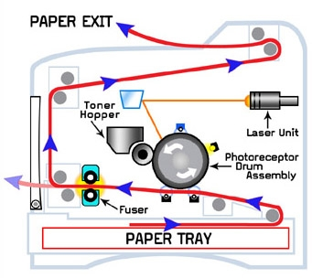 | 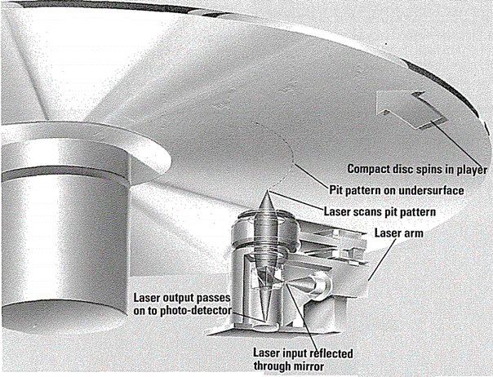
With their shining silvery surfaces, compact discs, or CDs, provide almost fault-free sound reproduction. The secret to how laser printers work is static electricity. This is because they store sounds, not magnetically or by wavy grooves, but in the form of numbers, which are digitally translated into microscopic pits burned into the surface of a disc by a laser beam. A component called the drum is given a positive electrostatic charge via electrical current; a small laser then draws the needed images onto the drum, creating what is called an electrostatic image – sort of a negative image where the background is negatively charged and the foreground – the images you want printed – are positively charged.
To make a compact disc, the signals from a studio microphone are first changed into numbers (digitalized). Toner is then sprayed onto the drum – with a positive charge, the toner clings to the negatively charged areas of the drum. The image is then ready to be transferred to a sheet of paper. These numbers are then translated into instructions to the laser beam, which etches the surface of the blank rotating master disc accordingly. The sheet of paper itself is then given a negative charge – stronger than the one on the drum – so that the toner is pulled away from the drum. As in ordinary disc manufacture, the master disc is used to make stampers that press out the CDs. As the sheet of paper rolls along the drum it is discharged – otherwise it would cling to the drum itself.
In the player, the compact disc spins around over a laser beam. Next for the paper is a trip through the fuser – basically two hot rollers – which melts the toner onto the page, fixing the image. As the disc spins in a CD player, a laser beam scans its partly pitted surface. The beam is reflected by a prism or semi-silvered mirror on to the disc. When reflected straight back from a flat part of the disc, the beam passes through to the photo-detector. Paper is always warm coming out of a laser printer, and that is why. This changes the flashes of reflected laser light into electrical pulses, which are used to reconstruct the original analogue sound signals. After each sheet is printed, the drum is discharged by a bright light called the discharge lamp, and the entire surface again given a positive charge, ready for the next image. However, when the beam strikes a pit on the disc, it is scattered and no current flows from the photocell. Dust or scratches on a CD have little effect on the amount of light reflected from the surface, so the sound reproduction is free from crackles.
Texts and diagrams from:
https://imsinkspot.com/laser-printers-work/
https://archive.org/stream/QuestTechnology/quest%20technology_djvu.txt

