Writing: Describing a Machine
Now, it is your turn to describe a machine or a system. Choose one picture from this document or come up with your own and describe it. Your description should consist of the following parts:
- An introduction giving the name of the device and explaining what it is used for;
- A list of parts it consists of (+ their material and location if necessary);
- An explanation of how the system works and/or how it should be operated/controlled;
- A conclusion evaluating the function of the device and some predictions about its future development.
Your text should have a minimum of 400 words.

Systems to Describe

- The Eco-Wave Power System Picture from: https://www.ecowavepower.com/our-technology/how-it-works/
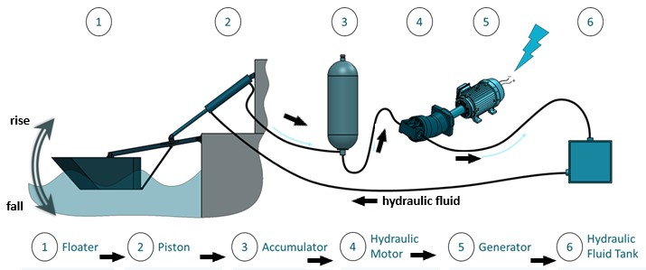
Look at the diagram, which shows a system of clean energy generation based on the motion of sea waves. Follow the individual steps and describe how the system works using the active and passive voice (at least twice). Use sequencers and cause-effect expressions. Finally, evaluate the system, discussing its advantages and drawbacks. Useful vocabulary: compress, decompress, fluid, release, turn/rotate, generate, store, move, convert, monitor, control.

- Photovoltaic Panels Picture: https://www.evoenergy.co.uk/technology/how-solar-panels-work/
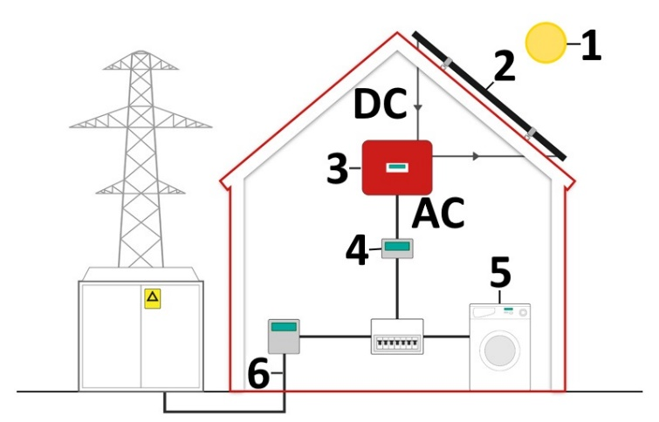
Look at the diagram and describe how solar panels work. What is this system used for? What does it consist of? How does it work? What happens if the sun does not shine? What is the efficiency of the system? What happens to the surplus of electricity not used in the home? How does the system influence the national grid? Discuss pros and cons of the system and predict its future development.
Useful vocabulary: turn into, convert, generate; 1 - light source, 2 - PV cells, 3 - converter, 4 - meter and home consumer unit; 5 - powering the home; 6 - national grid.
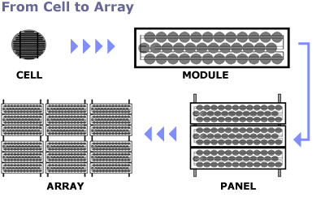  Diagram from: https://www.solardirect.com/archives/pv/pvlist/pvlist.htm | Cells | They are semiconductor devices that convert sunlight into direct current (DC) electricity.
 | Modules | They consist of PV cell circuits sealed in an environmentally protective laminate and are the fundamental building blocks of PV systems.
 | Panels | They include one or more PV modules assembled as a pre-wired, field-installable unit.
 | Arrays | They are the complete power-generating units, consisting of any number of PV modules and panels.
A Photovoltaic Cell
C = cause; E = effect (Add some relevant cause/effect expressions to the clauses to produce good complex sentences.)
- the layers doped with boron on one side and phosphorous on the other side (C)
- a surplus of electrons produced on one side and a deficit of electrons on the other side (E)

- the wafer bombarded by sunlight (C)
- photons in the sunlight knock off some of the excess electrons (E) / (C)
- the excess electrons try to move to the deficit side (E) / (C)
- there is a voltage difference of 0.5 volt between the two sides (E)

- an external circuit attached to the contacts (C)
- the electrons can get back to where they came from (E) / (C)
- a current flows through the circuit (E)

- the amount of current (E)
- the number of electrons that the solar photons knock off (C)

- bigger cells, more efficient cells, or cells exposed to more intense sunlight (C)
- more electrons delivered (E)

- How Does a Wind Turbine Work?

Using some cause-effect phrases and the word list below, describe how the machine works.
Useful vocabulary: 1 - wind, 2 - rotor blades, 3 - drive shaft, 4 - gear box (converts the low-speed rotation of the drive shaft to high speed), 5 - generator, 6 - anemometer (measures the wind speed and direction, 7 - motor rotating the top part to face wind (or a brake applied), 8 - cable, 9 - transformer (converts electricity to about 50 times higher voltage for efficient transmission)

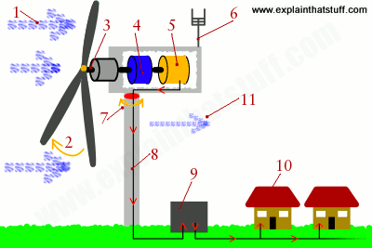
- The electric current produced by the generator flows through a cable running down through the inside of the turbine tower.
- A step-up transformer converts the electricity to about 50 times higher voltage so it can be transmitted efficiently to the power grid (or to nearby buildings or communities). If the electricity is flowing to the grid, it's converted to an even higher voltage (130,000 volts or more) by a substation nearby, which services many turbines.
- Homes enjoy clean, green energy: the turbine has produced no greenhouse gas emissions or pollution as it operates.
- Wind carries on blowing past the turbine, but with less speed and energy and more turbulence (since the turbine has disrupted its flow).

- How a Nuclear Power Reactor Works
Look at the diagram below and the information in the table below the picture. Explain how the individual parts (1 to 9) of a nuclear power station work. Use some sequencers (first, then, after that, next, finally) and a variety of cause-effect phrases that you have learned so far.
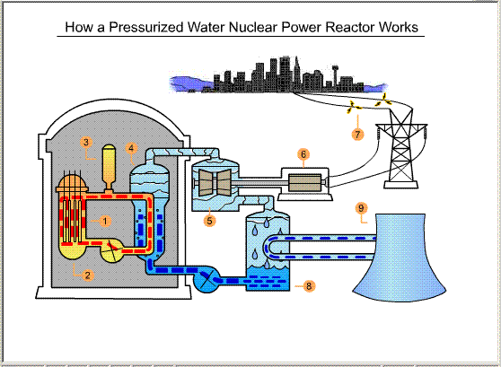
1 Reactor Core  Fuel: uranium-235  Control of the fission rate: rods made of metal, e.g. cadmium and boron  Function of the rods: to absorb neutrons | 4 Heat Exchanger  The superheated water from the reactor goes there through pipes  The water boils in this tank  Function: to make steam to drive a turbine | 7 Transmission Lines  Copper wires  Function: to distribute the electricity over long distances  2 types of transformers:  - to intensify the electricity to make it travel farther  - to decrease the electricity to the level used in electronics and appliances
2 Pressure Vessel  A sealed steel tank full of water  Location: around the core  More than 4,000 gallons of water pass through the core each second  Function of the water: to slow down released neutrons to moderate fission; to cool the reactor | 5 Turbine  Extremely efficient engine equipped with fan-like vanes  Steam makes the vanes rotate  Function: to rotate a shaft | 8 Condenser  Function: to change the steam back into water  Water reused
3 Pressurizer  Makes high pressure  Function: to keep the coolant water liquid in the reactor  Reason: the water in the reactor is hotter than its boiling point | 6 Generator  The shaft is connected to this  Function: to produce electricity (by spinning magnetic fields very fast)  The function of the magnetic fields: to cause electrons to “jump” from one atom to another  These moving electrons are essentially what we call electricity. | 9 Cooling Tower  Function: to give up some of the water’s heat to the air  Hot water sprayed from the middle of it  The hot water falls to the floor and vaporizes  Vapour then moves out the top of the tower as cool air rushes up from the bottom

- An Electric Bell
Using some cause-effect phrases, sequencers and the word list below, describe how the machine works.
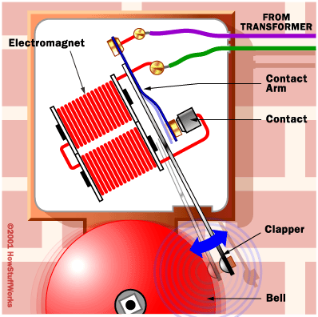 | Self-interrupting circuit, circuit closed, electromagnet, magnetized, pulls up on the contact arm, clapper attached to the contact arm, hit the bell, break the circuit, switch off the electromagnet, fall down, closing the circuit again, process repeated  Diagram: www.howstuffworks.com

- A Transformer
What does a transformer consist of? How does it work? Why do we need it?
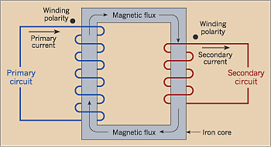 | Some useful phrases:  Current, pass through, coil, surrounded by, a magnetic field  Voltage, induced, mutual induction, principle of a transformer  Determined by, turns ratio 10:1, for example, primary winding 5000 turns, secondary winding 500 turns (primary voltage 240 volts, secondary voltage 10 times smaller)

- Steam Propulsion

Steam engines were the most popular form of propulsion for toy boats until the early 20th century. These engines had a small boiler heated by an alcohol burner. Steam propulsion was very powerful. It could drive boats for more than half an hour.

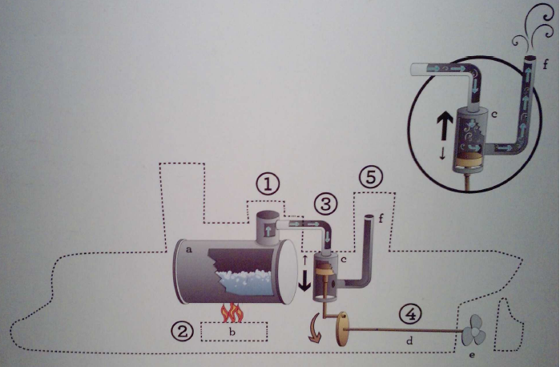

What does the system consist of? Label the picture with these words:
boiler, exhaust, piston inside a cylinder, propeller, shaft, spirit burner

a)  b)  c) | d)  e)  f)

How does the system work? Use the following words to describe it.
be filled with water  be lit  be released into the atmosphere  boil  drive the boat forward | produce steam  push the piston  the pressure of the steam  through an exhaust  turn
other expressions: if, first, after, after that, then, finally

