Section A - LISTENING
You will hear a recording. Answer the questions, complete the gaps and decide whether the sentences are true (T) or false (F). You will hear the recording twice.
Touch Screens
- A touch screen is an output device. T x F
- If the metallic layer is resistive, it cannot conduct electricity. T x F
- What are the two drawbacks of resistive touch screens?
_______________________________________________________________________________
- What are the two advantages of resistive touch screens?
_______________________________________________________________________________
- What happens to ultrasonic waves when an ultrasonic wave screen is touched?
_______________________________________________________________________________
- What part of the ultrasonic wave technology processes the information about the position of a touch-screen event? ____________________________________________________________________
“A capacitive touch screen panel is (7)_______________________ with a material that stores electrical charges. When the panel is touched, a small amount of charge is drawn to the point of contact. (8)_______________________ located at each corner of the panel then (9)_______________________ the charge (…). Capacitive touch screen panels must be touched with a finger, (10)_______________________ resistive and surface-wave panels that can use fingers and a stylus.”
10
Section B – USE OF ENGLISH
1. Gap filling. Complete the gaps with the most suitable word. Use ONE word only. Contracted forms count as one word.
- Open the lid _______________________ pushing it and turning it left.
- _______________________ the capacitive screen, the resistive one has two layers.
- As the system is very complicated, I will limit myself ________ a simple explanation for lay persons.
- If we had not saved money on the seal rings, the Challenger flight _______________________ have been a success.
- Even _______________ the number of items ordered is lower than 10, we guarantee free delivery.
- If the device had __________________ maintained regularly, the accident would not have happened.
6

2. Gap filling. Complete each sentence with a suitable word from this list. Change the form of the listed words if necessary.
experience | feature | improve | little | store | unlock
Adapted from: https://www.techadvisor.co.uk/test-centre/mobile-phone/best-smartphone-3677861/
Huawei Mate 20 Pro
At £899, Mate 20 Pro is Huawei's most expensive phone yet (though you’ll struggle to buy it in the US) and benefits from (1)_______________________ made to Huawei’s EMUI software. AI (2)_______________________ also improve the camera (3)_______________________ over the P20 Pro, and it adds 3D face (4)_______________________ and reverse wireless charging so it can charge other phones. It also has stereo speakers, waterproofing and 128GB (5)_______________________to ensure this is a phone that will last you into at (6)_______________________ two or three years of use.
6

3. Conversations. Complete the gaps in the short dialogues using suitable phrases, sentences or questions.
- A: ______________________________________________________________________________?
B: Sure. My question was whether the system would work inside buildings.
- A: How can an aerial be defined?
B: ______________________________________________________________________________.
- A: ______________________________________________________________________________?
B: We can offer a gross price of 144,000 Euro for 10 items as long as you order 10 items or more.
- A: You want to sum up your presentation. How will you introduce this section?
B: _____________________________________________________________________________.
8

4. Rephrasing. Use the words in brackets to rephrase the sentences so that the meaning remains the same.
- It is certain that the fault of the device was caused by poor maintenance. (MUST)
The fault ___________________________________________________________________.
- A hydropower plant has a turbine and a thermal power plant has a turbine as well. (BOTH)
______________________________________________________________________ a turbine.

4

Section C – READING Read the text and complete the tasks below.
How Augmented Reality Works Text adapted from: https://computer.howstuffworks.com/augmented-reality.htm
The basic idea of augmented reality is to superimpose graphics, audio and other sensory enhancements over a real-world environment in real time. Some of the most exciting augmented-reality work began taking place in research labs at universities around the world. In February 2009, technophiles at the TED conference were all excited because Pattie Maes and Pranav Mistry presented a groundbreaking augmented-reality system, which they developed as part of MIT Media Lab's Fluid Interfaces Group. They called it SixthSense, and although the project has stopped, it's a good overview of basic components that are found in many augmented reality systems: a camera, small projector, smartphone, and a mirror. These components were strung together in an apparatus that the user wore around his neck. The user also wore four coloured caps on the fingers, and these caps were used to manipulate the images that the projector emitted.
SixthSense was remarkable because it used these simple, off-the-shelf components that cost around $350. It was also remarkable because the projector essentially turned any surface into an interactive screen. Essentially, the device worked by using the camera and mirror to examine the surrounding world, feeding that image to the phone (which processed the image, gathered GPS coordinates and pulled data from the Internet), and then projected information from the projector onto the surface in front of the user, whether a wrist, a wall, or even a person. As the user was wearing the camera on their chest, SixthSense augmented whatever they looked at; for example, if they picked up a can of soup in a grocery store, SixthSense found and projected onto the soup information about its ingredients, price, and nutritional value.
By using capped fingers — Pattie Maes said even fingers with different colors of nail polish would work — a user could perform actions on the projected information, which were then picked up by the camera and processed by the phone. If the user wanted to know more about that can of soup than was projected on it, they could use their fingers to interact with the projected image and learn about, say, competing brands. Sadly, the SixthSense project went into a years-long break and will probably never reach markets.
1. Answer according to the text.
- What is the principle of augmented reality?
__________________________________________________________________________________
- Where must the SixthSense device be placed to work properly? _______________________________
- In terms of the components used in the system, what is the main advantage of SixthSense?
__________________________________________________________________________________
- What did Maes use to operate the projected data? __________________________________________
2. Are these statements true (T) or false (F)?
- SixthSense was first presented at a fair trade. T x F
- SixthSense was a university project. T x F
- SixthSense is now available for about $350. T x F
- The only limitation of the system is the special surface used to project data on. T x F
3. Find the words in the text which have a very close meaning to the following words.
- Overlay (1st paragraph) – _________________________________________________________
- Carry out (3rd paragraph) – _________________________________________________________
10
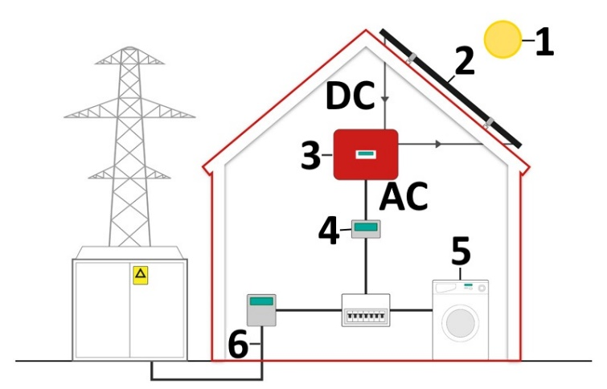
Section D – WRITING

Photovoltaic Panels

Look at the diagram and describe how solar panels work. What is this system used for? What does it consist of? How does it work? What happens if the sun does not shine? What is the efficiency of the system? What happens to the surplus of electricity you don´t use? How does the system influence the national grid? Discuss pros and cons of the system and predict its future development. Write a minimum of 8 full sentences (around 150 words). Picture: https://www.evoenergy.co.uk/technology/how-solar-panels-work/
Useful vocabulary: turn into, convert, generate; 1 - light source, 2 - PV cells, 3 - converter, 4 - meter and home consumer unit; 5 - powering the home; 6 - national grid
_________________________________________________________________________________
_________________________________________________________________________________
_________________________________________________________________________________
_________________________________________________________________________________
_________________________________________________________________________________
_________________________________________________________________________________
_________________________________________________________________________________
_________________________________________________________________________________
_________________________________________________________________________________
_________________________________________________________________________________
_________________________________________________________________________________
_________________________________________________________________________________
_________________________________________________________________________________
_________________________________________________________________________________
_________________________________________________________________________________
_________________________________________________________________________________
_________________________________________________________________________________
_________________________________________________________________________________
_________________________________________________________________________________
Evaluation: Grammar ___/4 Vocabulary ___/4 Relevance ___/4
12

