3 top most livable cities in the world
Melbourne | Vienna | Vancouver
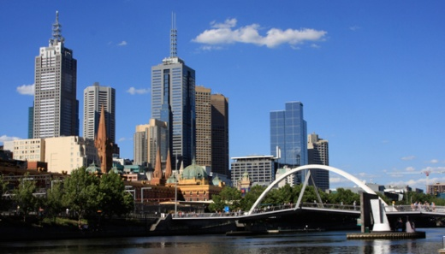  http://melbourneit.info/images/cities/Office-Locations---Melbourne.jpg | 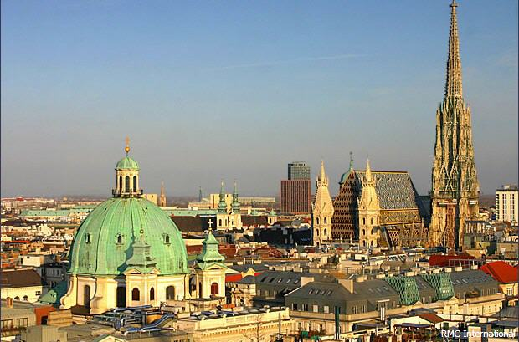  http://www.ceu.hu/sites/default/files/main_image/event/11677/viden05.jpg | 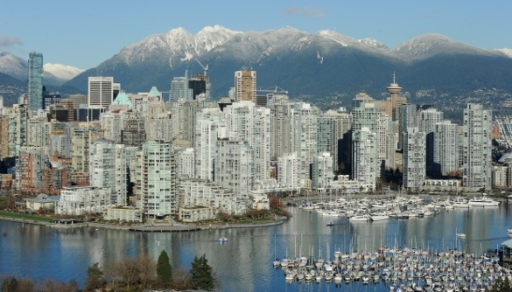  http://www.vancouversun.com/ethnicity/cms/binary/4053950.jpg

