Example 1:
Calculate initial short-circuit current at the 400 V switchboard:
- For supplying only from upstream network, without or with motors.
- For supplying from upstream network and local generator, without or with motors.
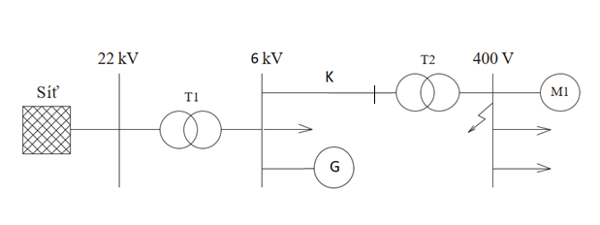
Parameters:
Upstream network: Un = 22 kV; Sk′′ = 250 MVA; c = 1,1
Transformer T1: Sn_{T1} = 40 MVA; uk = 7 %
Transformer T2: Sn_{T2} = 1 MVA; uk = 6 %
Generator: Sn_{G} = 10 MVA; x_{d} “= 12 %
Cable: X = 0,15 Ω/km; l = 1000 m
Motors M1: Pn₁ = 300 kW; cosϕ_{M} = 0,8; η_{M} = 0,95; iz = 5

Example 2:
Calculate initial short-circuit current at the 400 V switchboard:
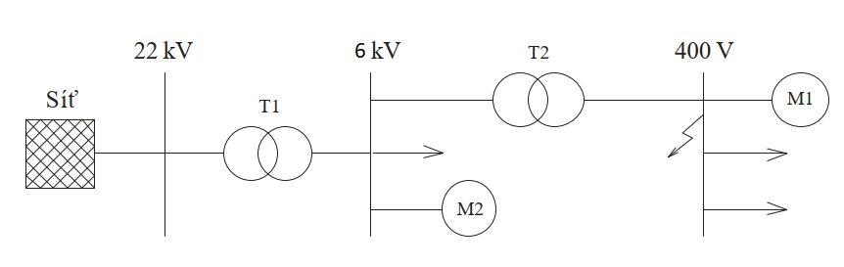

Parameters:
Upstream network: Un = 22 kV; Sk′′ = 250MVA; c = 1,1; X_{S} = 0,995 Z_{S} ; R_{S} = 0,1 X_{S}
Transformer T1: Sn_{T1} = 10 MVA; uk = 7 %; tr = 22/6,3; ΔP_{k} = 25 kW
Transformer T2: Sn_{T2} = 1 MVA; uk = 6 %; tr = 6/0,4; ΔP_{k} = 10,5 kW
Motors M2: 8 ks; Pn_{M2} = 200 kW; Un_{M} = 6 kV; iz = 5; cosϕ_{M} = 0,8; η_{M} = 0,95; k_{S} ≅ β = 0,75 (i.e. only 6 from 8 motors are running)
Motors M1:
2 x Pn₁ = 100 kW; 3 x Pn₂ = 50 kW (1 back-up motor, i.e. only 2 from 3 motors are running); Un_{M} = 400 V; iz = 6; cosϕ_{M} = 0,8; η_{M} = 0,95

Example 3:
Calculate initial short-circuit current at end of MV cable, without or with reactance coil:
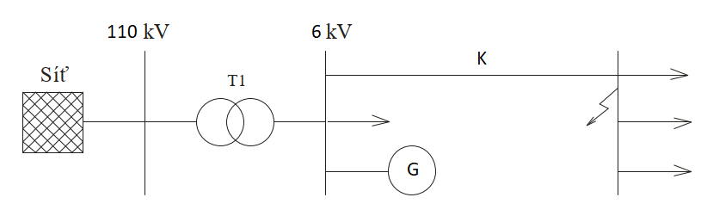
Upstream network: Un = 110 kV; Sk′′ = 2500 MVA; c = 1,1
Transformer: T1: Sn_{T1} = 40 MVA; u_{k} = 13 %
Generator: Sn_{G} = 25 MVA; x_{d} “= 14 %
Reactance coil: Un_{R} = 6 kV; In = 1000 A; u_{r} = 8 %
Cable: X = 0,1575 Ω/km; l = 1000 m

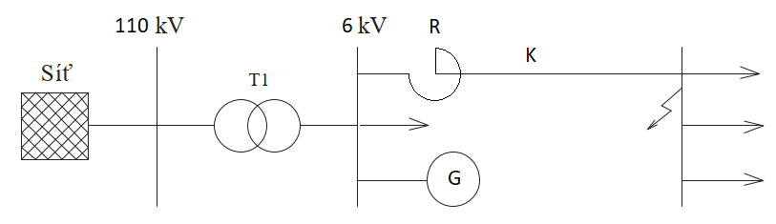

Example 4:
Calculate initial short-circuit current at end of MV cable, without or with reactance coil:
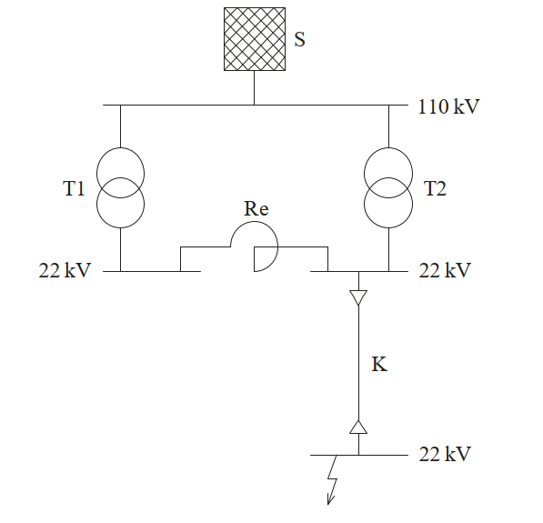
Network S:
Un = 110 kV; Sk′′ = 3500 MVA; c = 1,1
Transformers T1, T2:
Sn_{T} = 31,5 MVA; u_{k} = 10,5 %; 110/23 kV; ΔP_{k} = 175 kW
Reactance coilr Re:
u_{kR} = 12 %; S_{pr} = 10 MVA
Cable K:
R_{L} = 0,32 Ω/km; X_{L} = 0,12 Ω/km-1; l = 6 km

