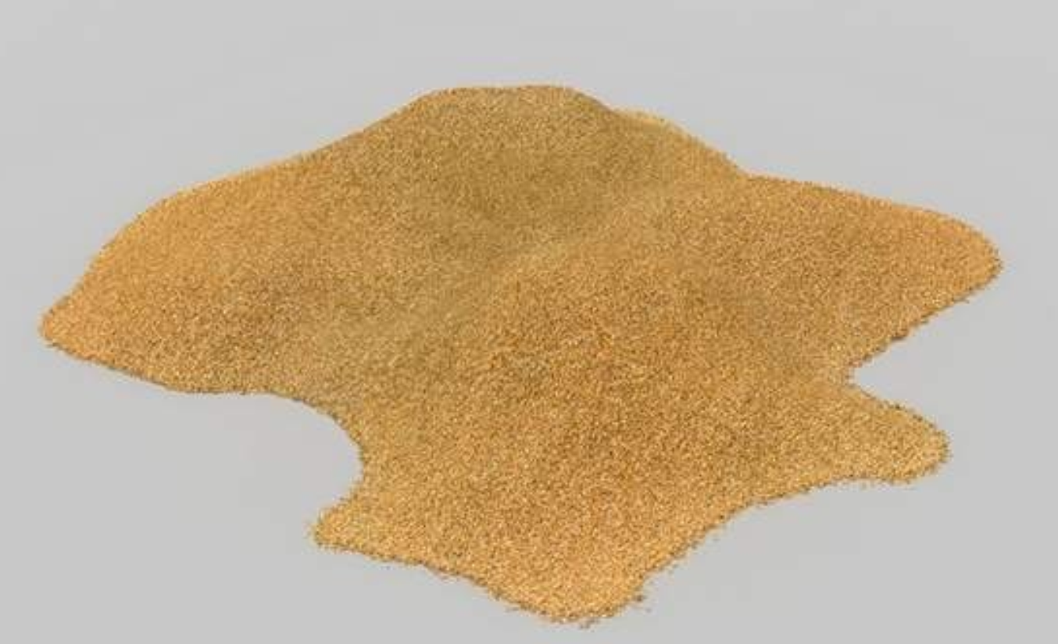
Figure 1: Silicon sand

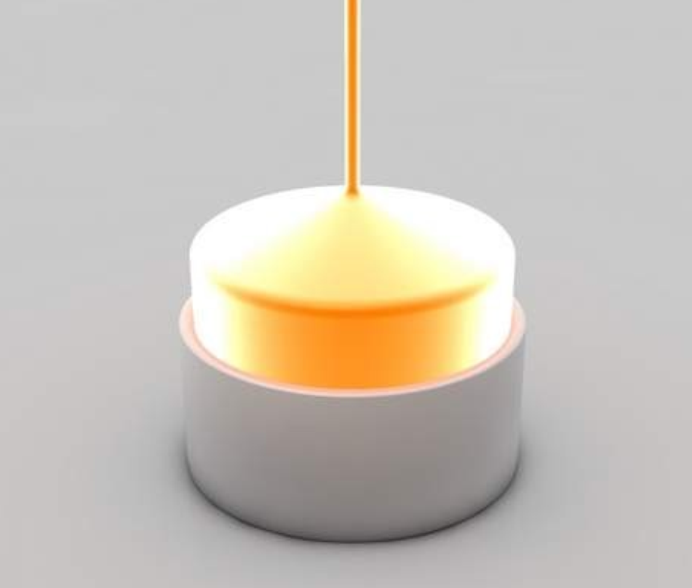
Figure 2: Silicon ingot growing

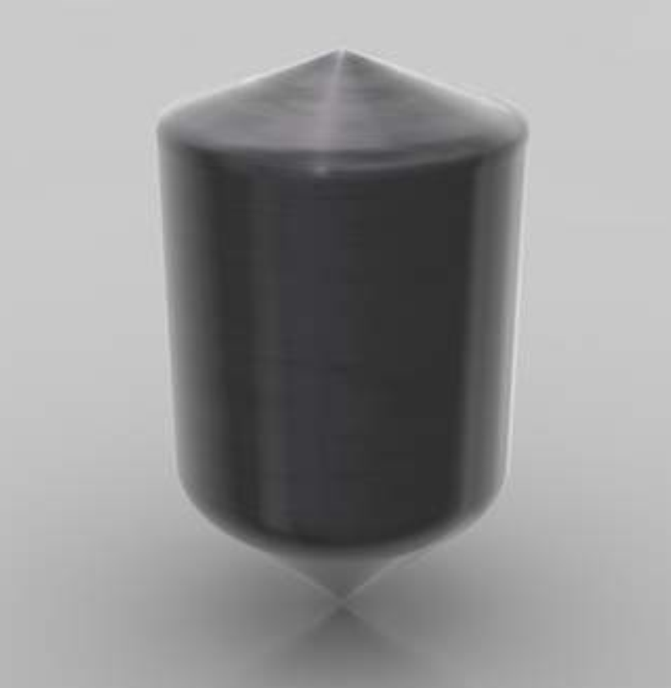
Figure 3: Silicon ingot finished

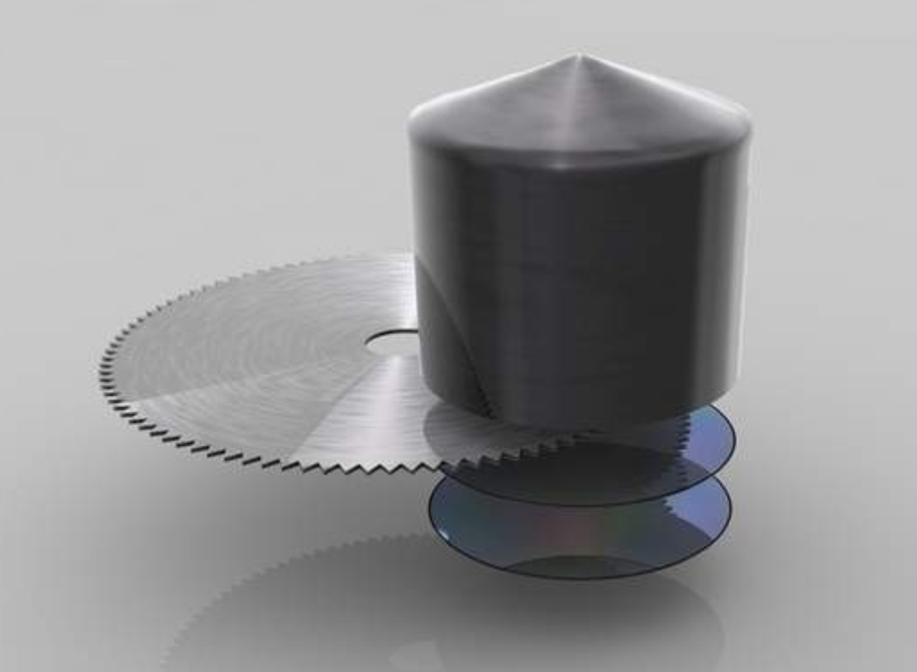
Figure 4: Silicon ingot slicing

Figures from: https://poli.cs.vsb.cz/eduapps/down/vyroba-cpu/vyroba-cpu.html

