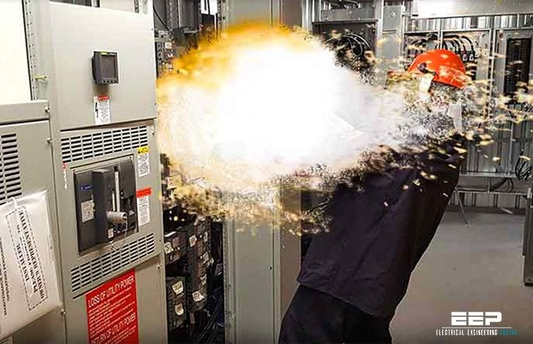  1 | 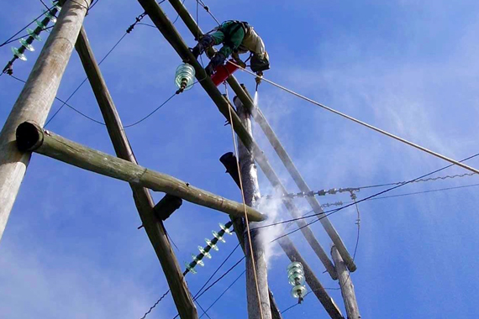  2
  3 | 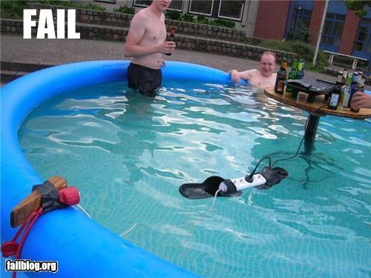  4
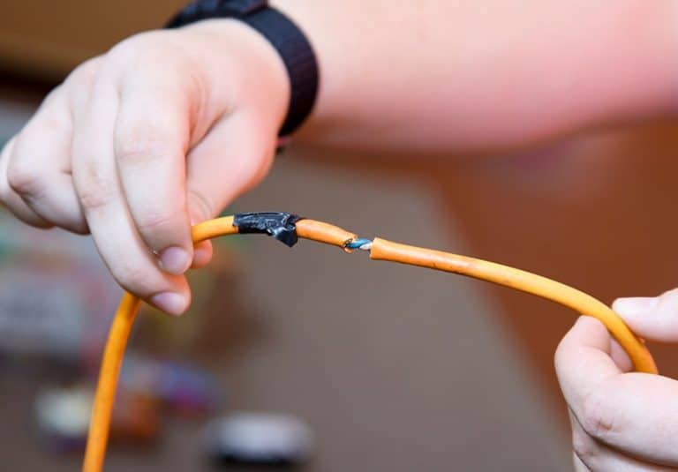  5 | 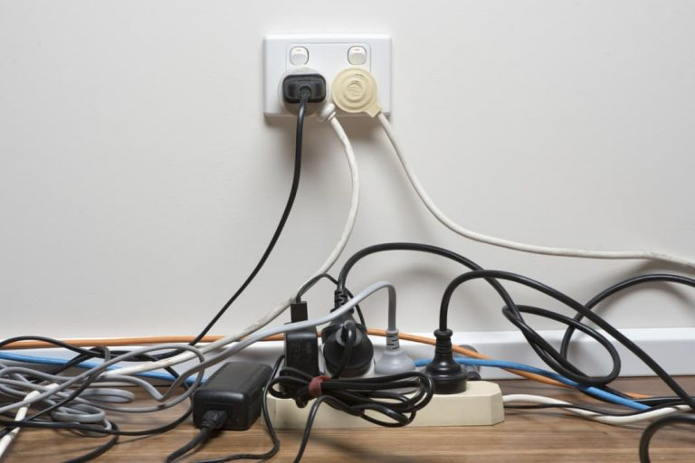  6
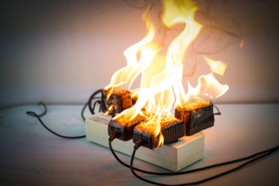  7 | video:  youtube.com/watch?v=HPUuRizKV3o&t=88s&ab_channel=WorkSafeQueensland  youtube.com/watch?v=CB5UXvMTNVo&t=49s&ab_channel=JoeChenoweth
pictures: https://www.todaysparent.com/wp-content/uploads/2011/09/ElectricalHazards.jpg
https://wirechiefelectric.com/wp-content/uploads/2019/11/frayed-electrical-cords-768x535.jpg
https://wirechiefelectric.com/wp-content/uploads/2020/05/OverloadedElectricaloutlet-768x512.jpg
https://www.kneeselectric.com/images/blog/overloaded-power-strip.jpg
https://electrical-engineering-portal.com/wp-content/uploads/2016/11/arc-flash-low-voltage.jpg
https://www.inmr.com/wp-content/uploads/2022/04/Comparing-Failure-Modes-of-Line-Insulators.jpg
https://i.chzbgr.com/full/3978639616/h6891F448/electrical-safety-fail

